Contents
Procurement planning 1
Purchase bids 38
Contracts 60
Maintain of the Register of mala fide suppliers 83

Procurement planning
To work with a yearly procurement plan, the user must have the "Customer" role. You can view the assigned powers in the Participant's Profile-Organization Employees section (details are described in the registration instructions)
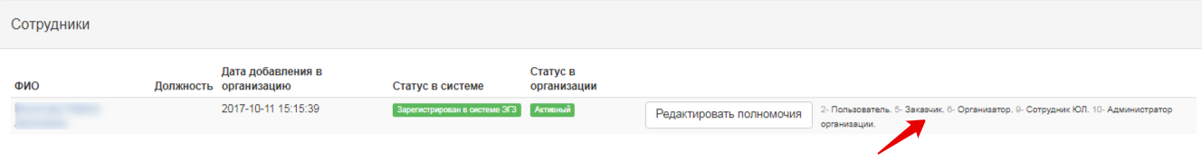
To work with the yearly plan, go to the section.
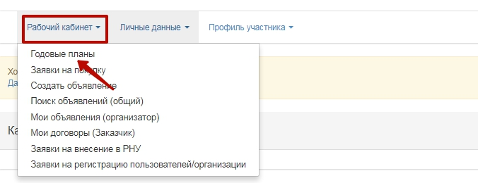
The Yearly Plans section is designed to work with the public procurement plan and is as follows:
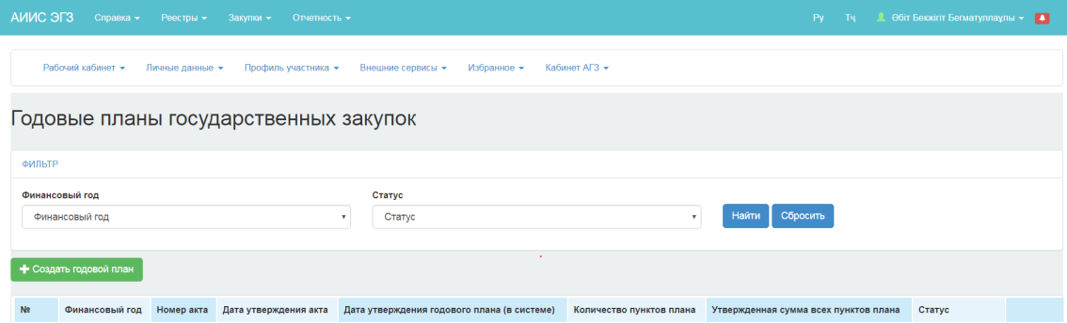

Creation of a yearly public procurement plan
To create a yearly plan draft, click on the "Create a new plan" button in the Personal Account- Yearly Plans menu.

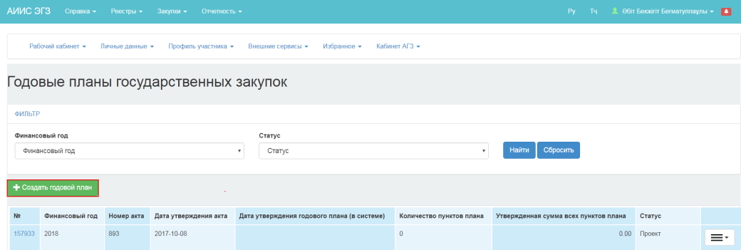
The Yearly Plan Creation page looks as follows:
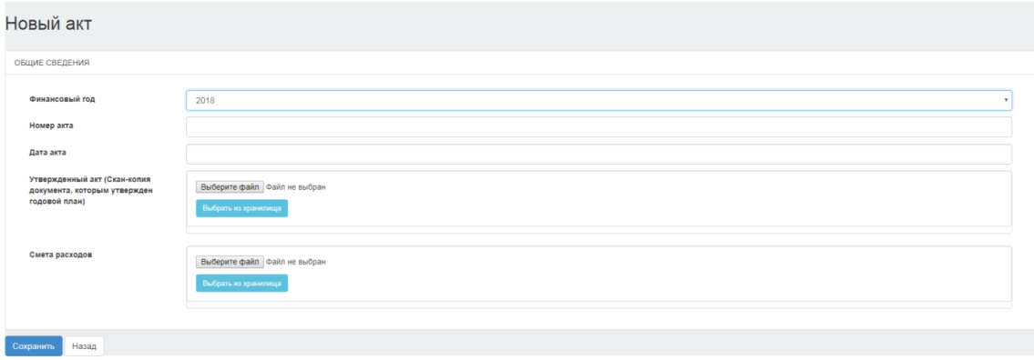

It is necessary to fill in the following fileds on Yearly Plan Creation page:
Fiscal year, Act number, Date of Act, and attach scan copies of documents upon which the Yearly Plan is approved (act, cost estimate). Click "Save" button. The system saves the draft annual plan and displays it in the list in yearly plans section with the "Draft" status.

If the customer has not completed the compulsory fields in the form of the Draft Yearly Plan creation, the system displays an error message.
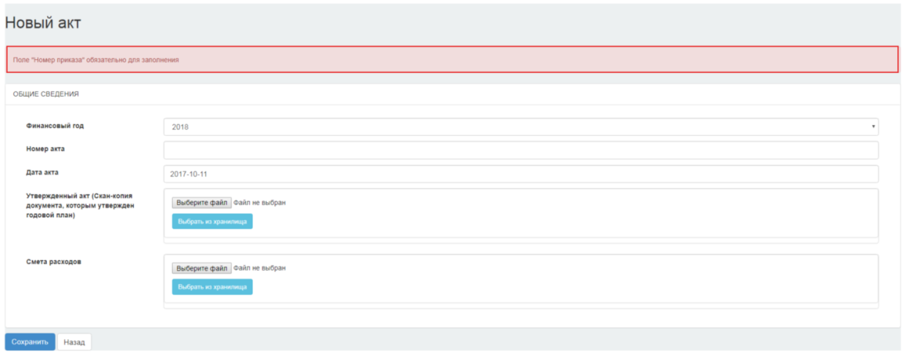

To attach a scan copy of the Act that approved the yearly plan, click the "Select File" or "Select from the Repository" buttons.
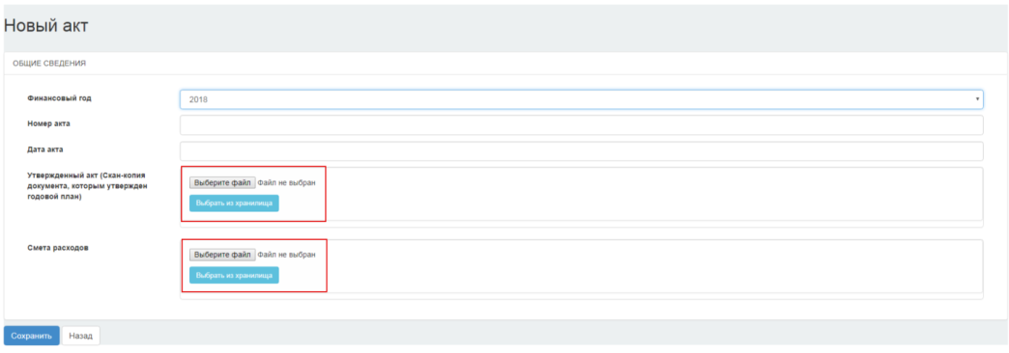
In the dialog box that appears, specify the path to the file that was previously prepared for the attachment, and then click "Open".
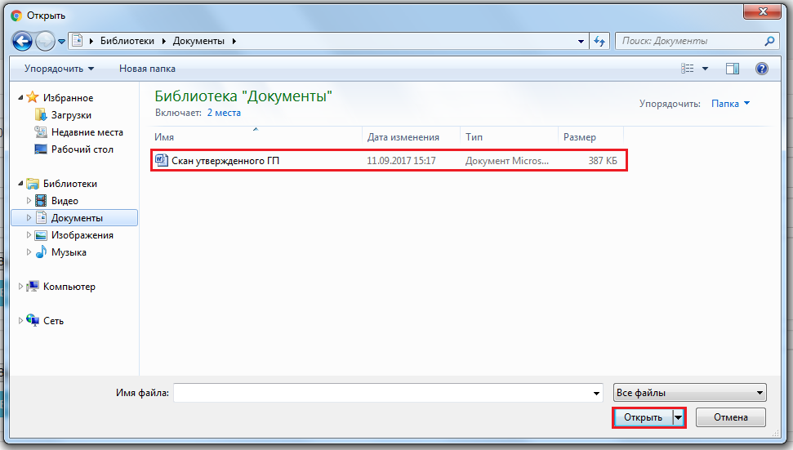
If the file is processed successfully, the following page appears.
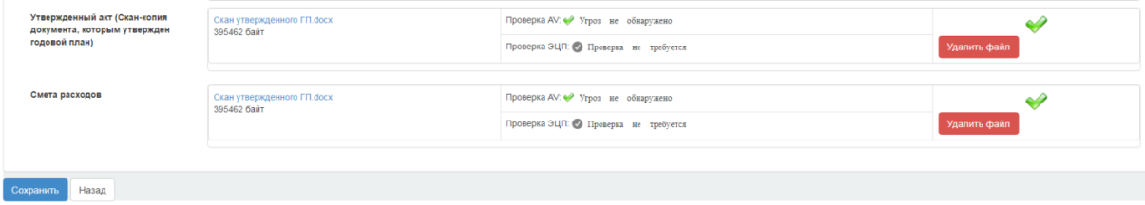
If you want to delete a file to attach another file, click the "Delete File" button.
Click the "Save" button to save the data entered.
To return to the previous menu without saving the data, click the "Back" button.

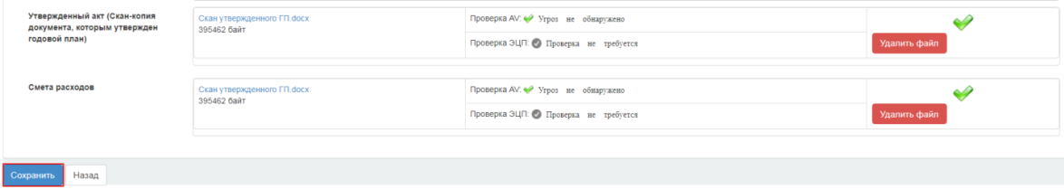

The yearly plan will be displayed in the Plan list on the Annual Public Procurement Plans page with the "Draft" status.

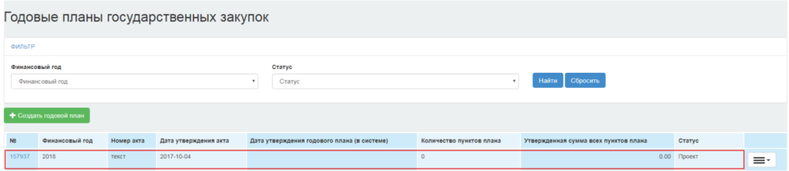
To work with the yearly plan, click the icon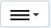:
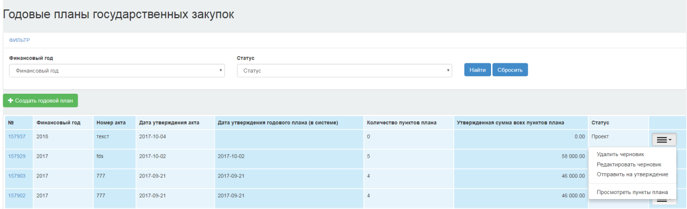
The "Delete Draft" action is intended to delete an yearly plan with the "Draft" status.
The "Edit Draft" operation is designed to edit the information in the act that approves the yearly plan.
The "Submit for Approval" operation is intended to send the AP draft for approval to the authorized body.
The "View Plan Items" operation is intended to view the items of the yearly plan

Deletion of the draft yearly plan
To delete the yearly plan draft, click the icon and select the "Delete Draft" operation.

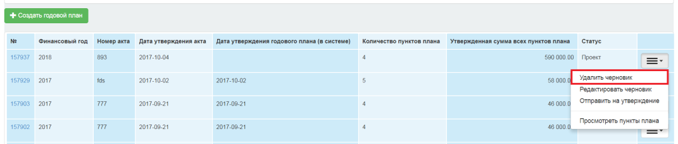

When you delete the yearly plan, the System requests confirmation of the selected action:

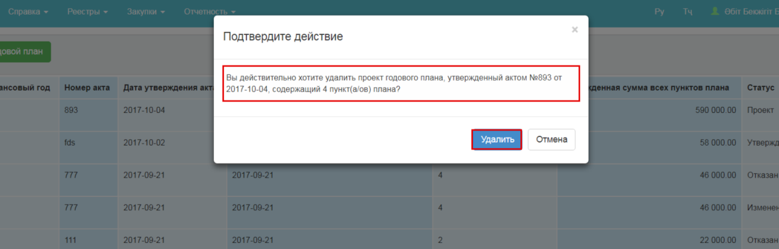

After confirming the operation, the system deletes the draft plan and displays the confirmation message:
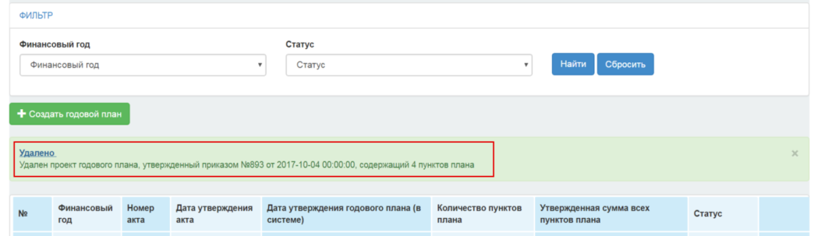

After the yearly plan is deleted, the system deletes all the plan items with the "Draft" status, "Reject Procurement" and returns the edited plan items to their original status.

Import yearly procurement plan
The "Import Yearly Plan" feature is intended to import a public procurement plan from a pre-filled template. This feature is implemented to speed up the process of transferring of the yearly plan to the public procurement web portal.
Attention! The yearly plan is imported only from a file that is filled in according to the electronic template of the yearly public procurement plan in .txt format.
For detailed information on filling out the Yearly Plan template, see Methods of filling out the template located in the template download file
Attention! You cannot change the structure of a template, add, remove, merge columns, or cells. Changing the structure of a template causes errors when the data is downloaded.
Note. The Yearly Plan Import feature does not provide for the selection of several items of expenditure and supply locations. To fill in this information, it is necessary to use the manual creation or editing the plan item feature.

Saving files
After you have filled in the public procurement plan file according to the template format, you must save it in Unicode Text format.
To do this, in Excel, click "Save As", and select the Unicode Text file type in the window that appears.
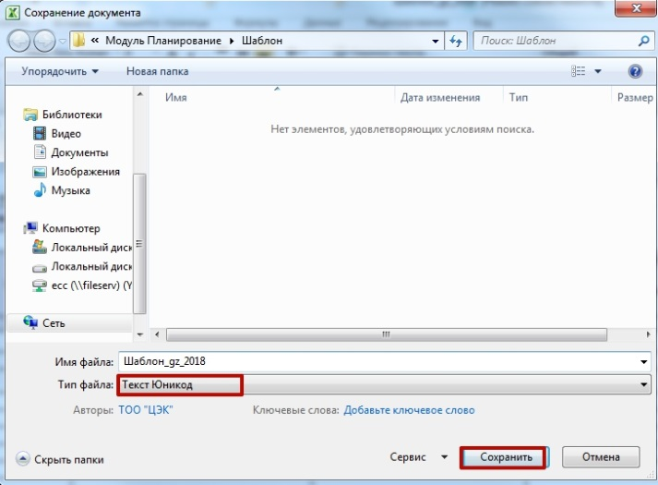
When you save the file in the message that appears, click OK.
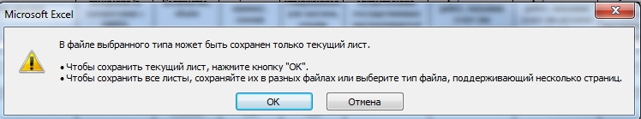
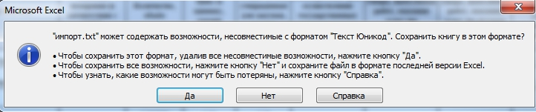
Then click "Yes" button.

Import file
After preparation of the file for downloading, it is necessary to import it into the public procurement web portal.
To download the Yearly Plan Template, go to the Personal Account-Annual plans menu. On the Yearly Plans page, click the active link of the yearly plan number, or select the "View Plan Items" operation from the drop-down list in the Yearly Plan with "Draft" status
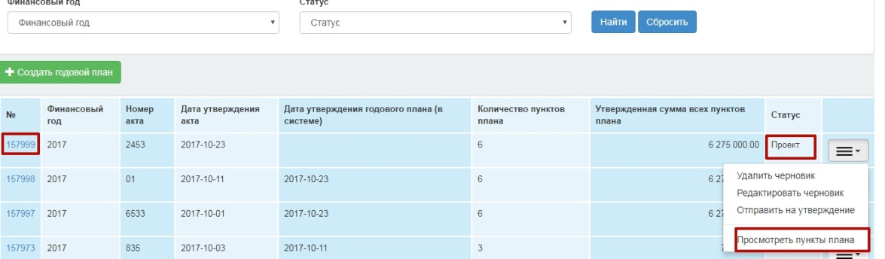
Click the"Import from Template" button in the opened Plan Items window.

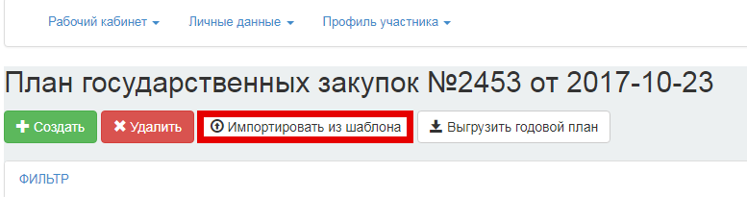

Clicking "Import from Template" button opens a page for downloading the templates. Click the "Select File" button.

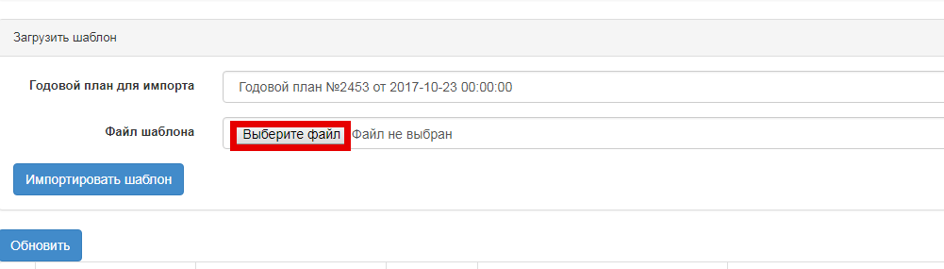
In the window that appears, specify the path to the file in * .txt (Unicode text), and then click "Open".

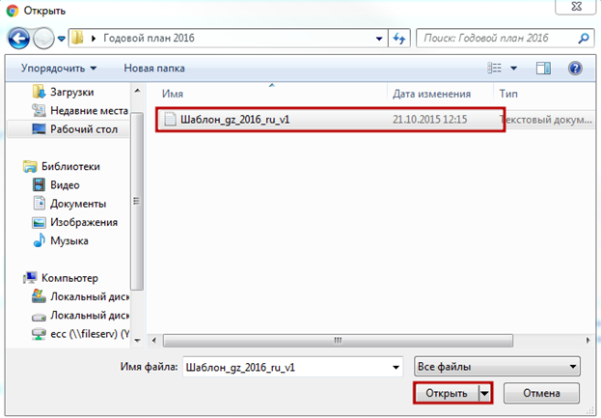

Next, click the "Import Template" button.

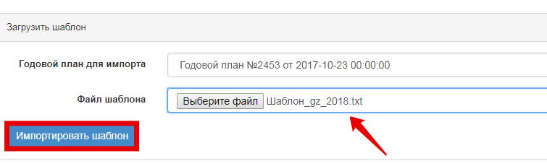
After file downloading to the public procurement web portal is over, a line that corresponds to the downloaded file appears in the list of downloaded files.

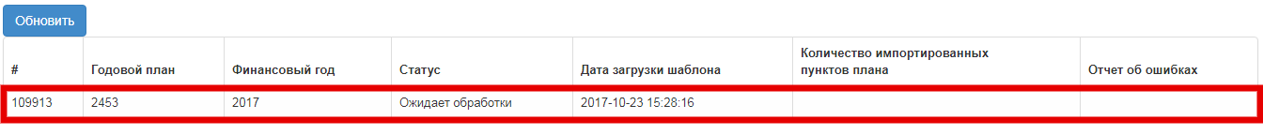

The "Status" field displays information about the stage of the downloaded public procurement plan file is at.
Attention! The downloaded file data processing procedure will be made as the file is processed in a queued order.
Click the "Update" button to update the status.
The following download statuses are available:
- Pending processing- the status is assigned if the template is queued for processing;
- Under processing - the status is assigned if the template is in process;
- Imported successfully - the status is assigned if no errors were found in the template.
- Error in the filled- in template - the status is assigned if an error occurred while filling the template in;
- "Import Error." Incorrect file format Incorrect "-the status is assigned if an error occurred while processing template
If the template is not filled in correctly, the status of the file will be changed to "Error in the filled- in template" and a link to view the reports is displayed. To view the report, click the "View" link.

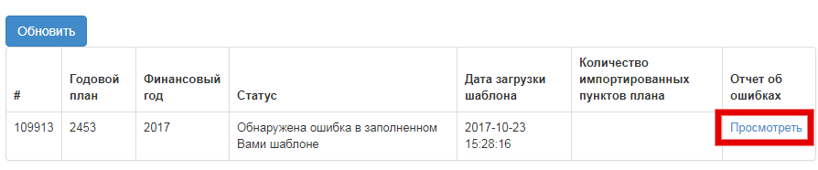

Attention! If there is an error in filling the template, the plan items are not imported. Import is possible only if there are no errors in all the items in the Yearly Plan template.

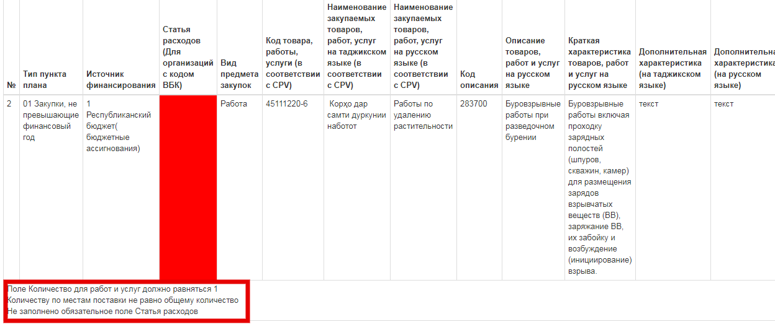

In the error report, the cell highlighted in red contains an error. Click the cell to view the error text.
If there are errors, correct the detected errors and re-download.
Attention! In case of successful import, plan items from the template automatically fall into the Yearly plan with the "Draft" status. In case of attempt to re-import to avoid duplicating of plan items, make sure that there are no previously imported items in the template.

Work with plan items
To place and work with plan items, go to the active Yearly Plan Number link or select "View Plan Items" operation.

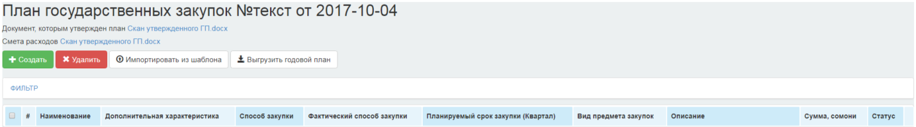
Attention! There are two ways to place a public procurement plan onto the Public procurement web portal:
- Load of a large number of plan items by importing from a file (described in Import from the Yearly Plan Template section).
- Creation of a single plan item (described in Creation of a Plan Item secton).
If the public procurement plan consists of a large number of plan items, we recommend that you use the Yearly Plan Import feature.

Creation of a plan item
To create a new plan item, click the "Create" button in the "Draft" of the Yearly plan.
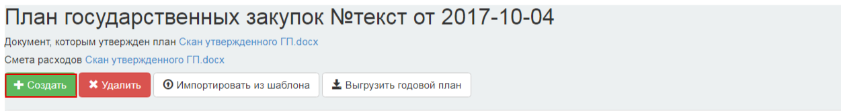

The New Plan Item Creation page is displayed.
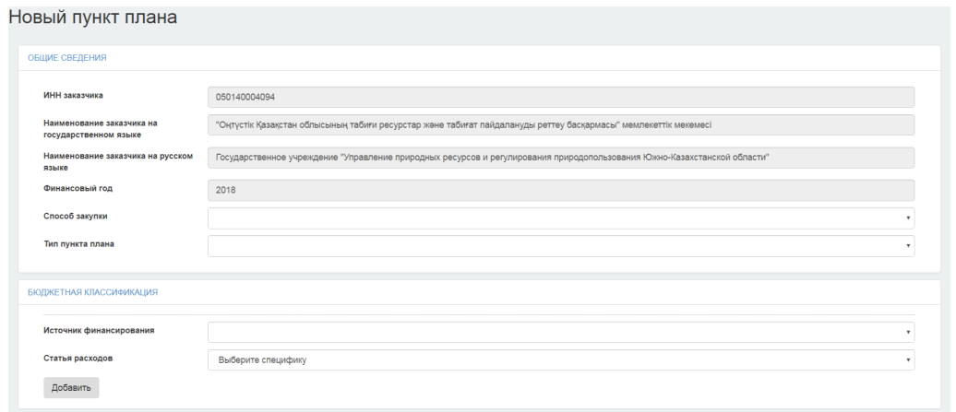
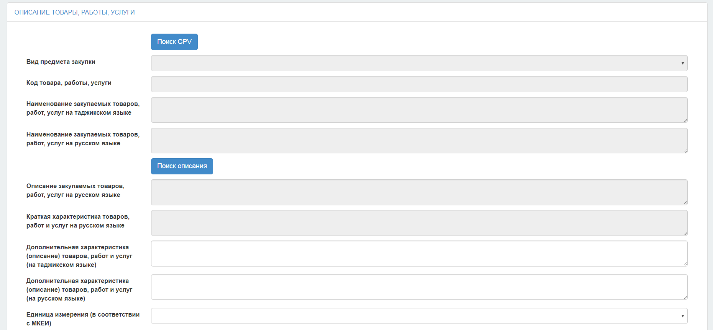
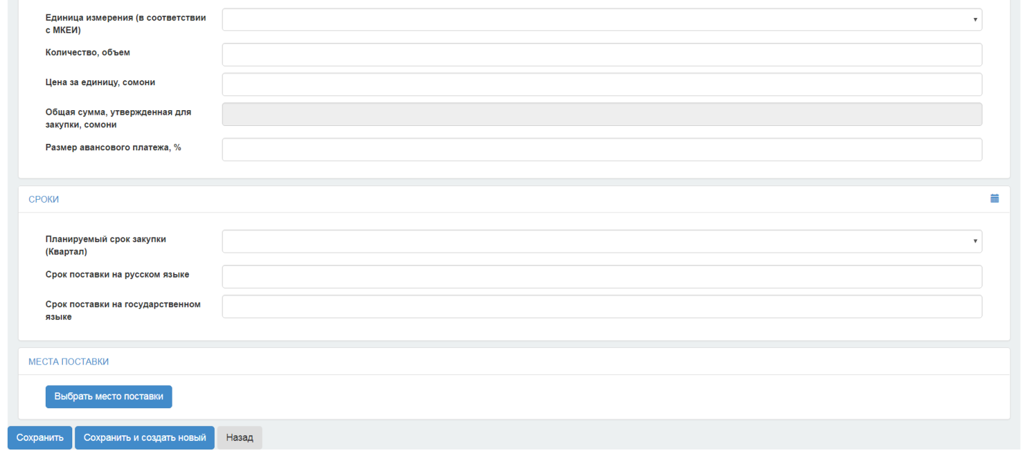
The Plan Item Creation form has the following sections:
- General information;
- Budget classification;
- Description of the goods, works or service;
- Time terms;
- Place of delivery

For convenience during viewing and filling out the plan item, an option to hide section fields is provided. To do this, click the active section name link.

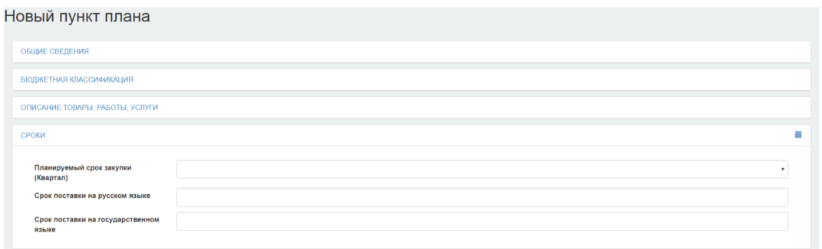

General Information Section
Fill in the "Procurement Method" and "Plan Item Type" fields from the drop-down list.
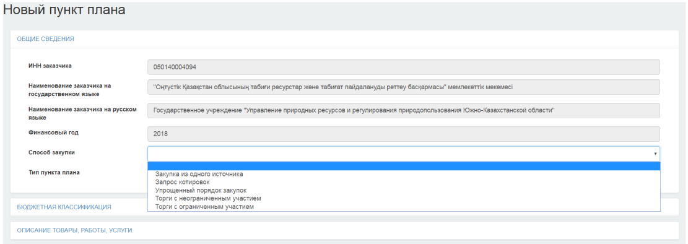
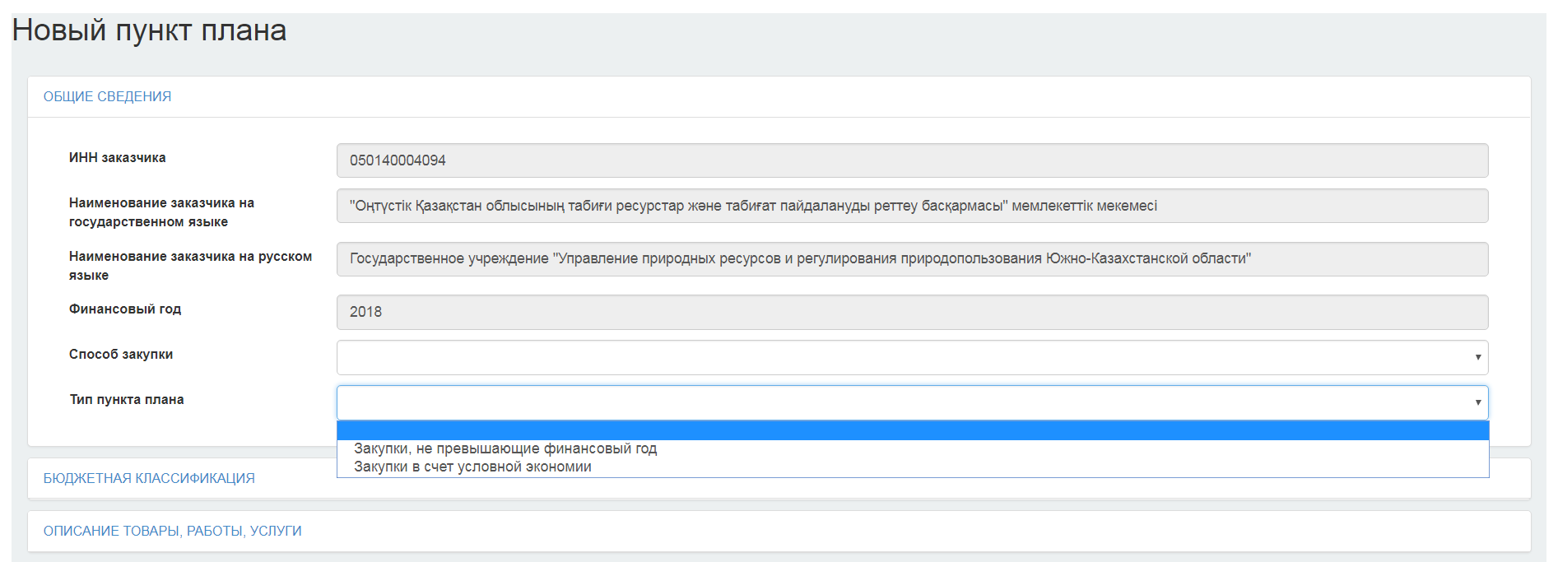

Budget Classification Section
In this section, the "Funding Source" and "Expenditure Item" fields should be filled in.
Attention! The "Expenditure Item" field should be filled in only by organizations with DBC code. For organizations without DBC code, this field is not displayed.
Attention! When saving the plan item in the yearly plan, if the "Funding Source" field content is set to "Credit funds", "Grant funds" then the system does not allow to choose a "Simplified procurement procedure" method. Otherwise, the system displays the following error text:
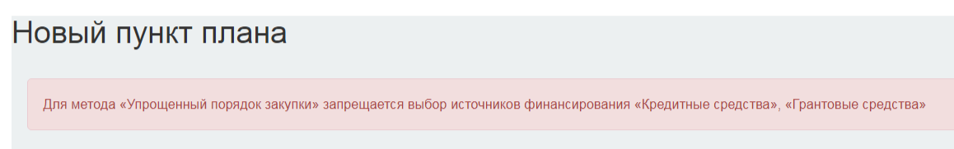
To add an additional expenditure item to a the plan item, click the "Add" button.
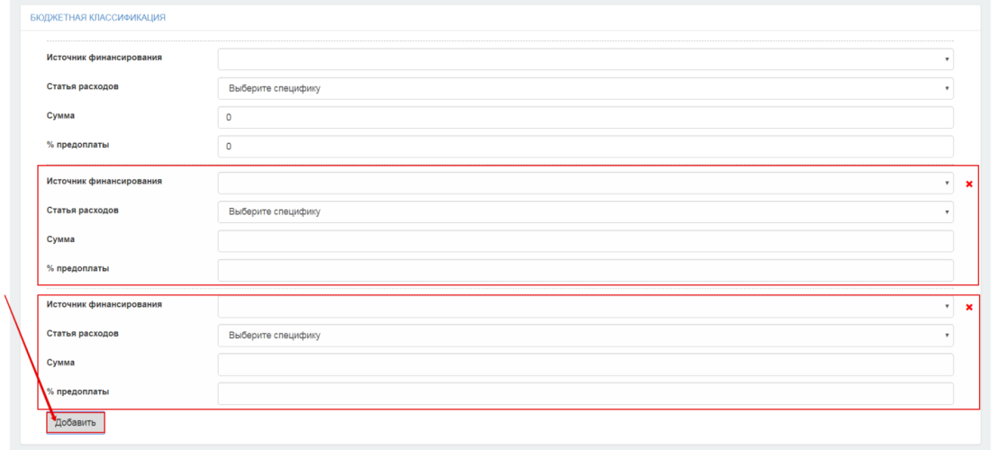
The Plan Item form provides for the option of adding several expenditure items/funding sources (the "Funding Source", the "Expenditure Item" fields) and the amounts for each expenditure item. In this case, the system checks that the total amount of expenditure items is equal to the "Total Amount Approved for Procurement, somoni" field.
Note. When saving, the system checks that the total amount of expenditure items is equal to the "Total Amount Approved for Procurement, somoni" field.

Description of Goods, Works and Services Section
To find the CVP code, you must select a type of purchase item from the drop-down list and in the "Code of the Goods, Works, Services" field, enter the desired value of the code, name or characteristics of the goods, works, services:
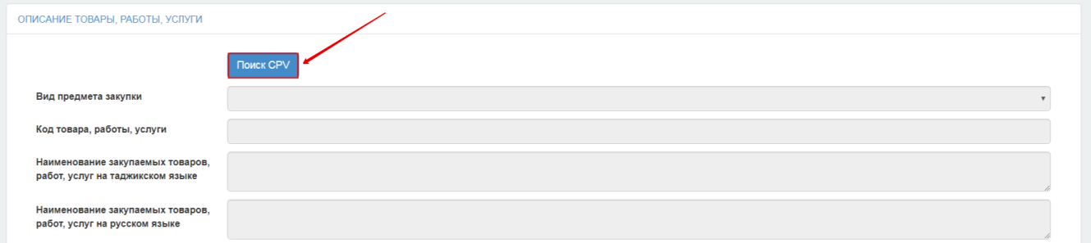
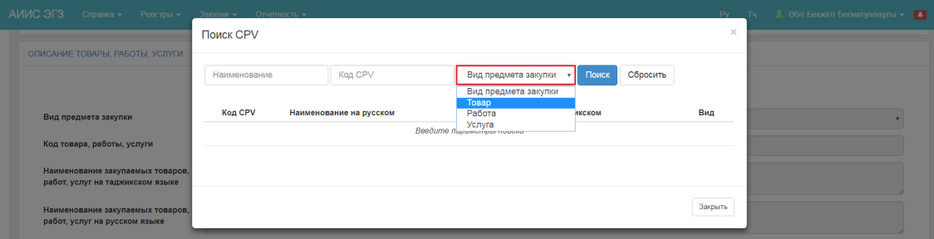
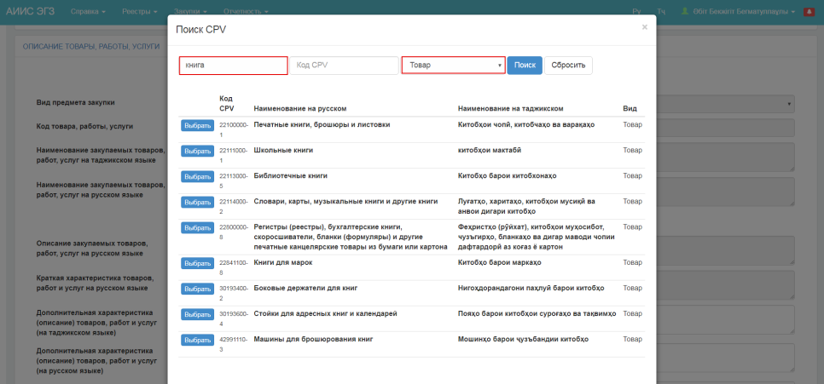
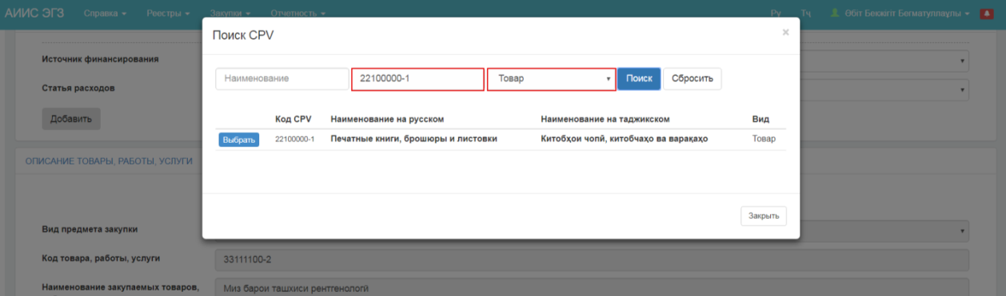
Next, click the "Search for Description" button

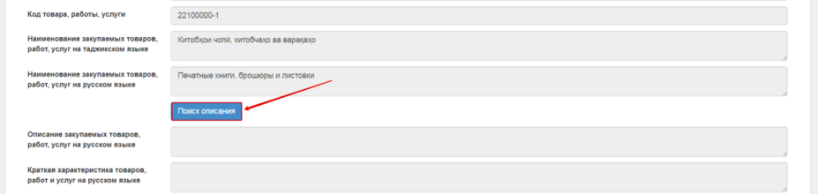
To find the Description of the goods, works, services in parameters, it is necessary to specify the name or the code, and the type of purchase item must be the same as the type in the CPV code.
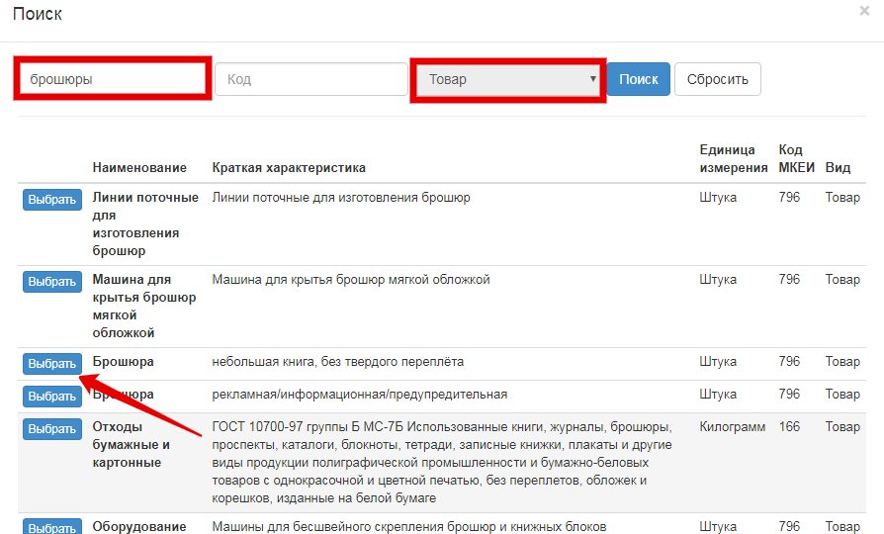

In addition to the main description of the goods, works, services, the user can specify an additional characteristic in the "Additional Characteristic" (description) field.
The "Unit of Measure" field is mandatory to be filled in. For plan items with the type of purchase item "Works" and "Services", selection of the unit of measure is unavailable except the writings "One work" and "One service", respectively. For the "Goods" purchase item, the system allows to specify the unit of measure from the drop-down list.
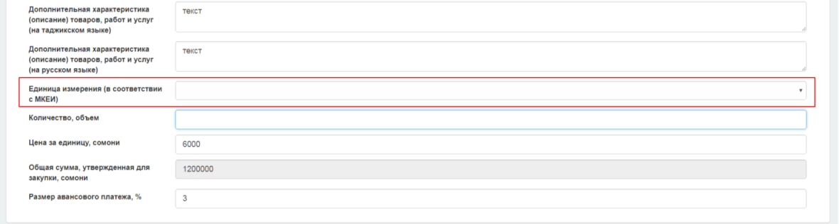
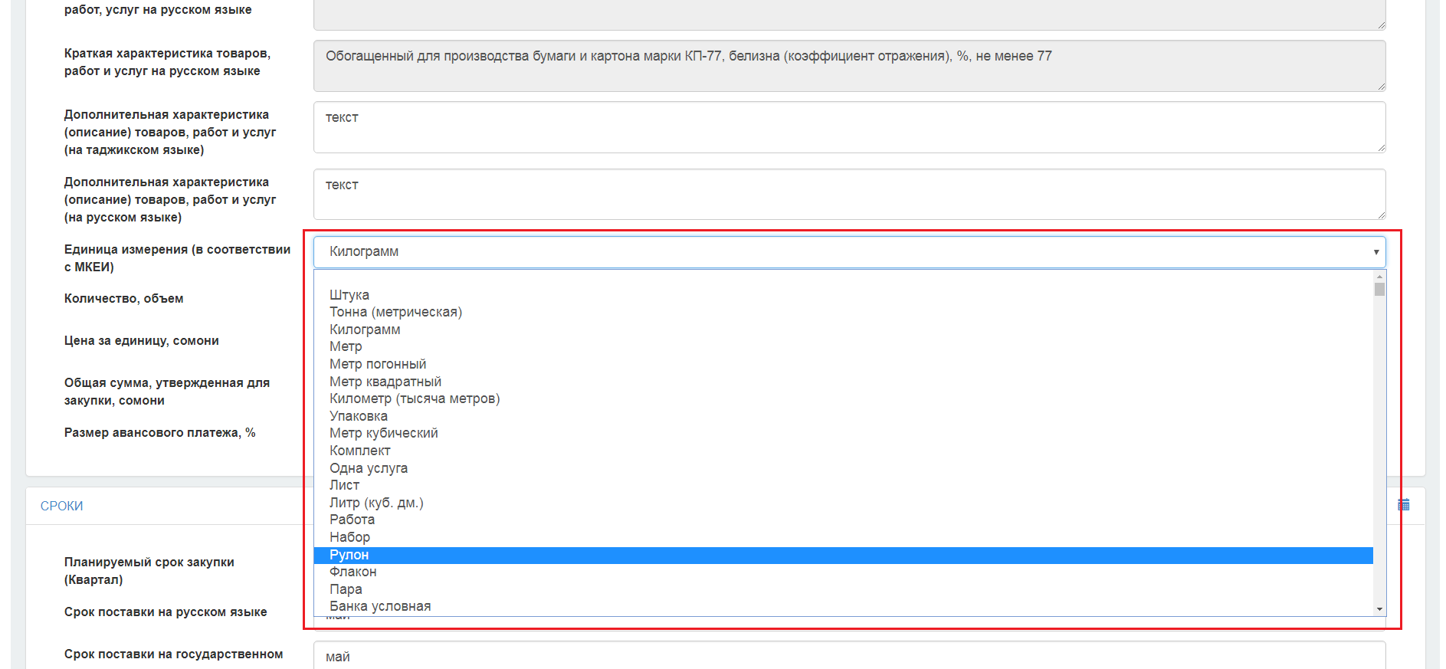

"Time Terms" Section
In this section the "Planned Procurement Time Term" (a Quarter) is specified and the "Delivery Date" field is filled in by typing manually.
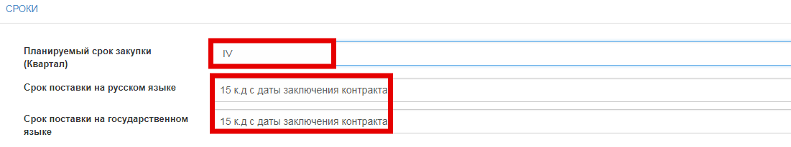

"Places of Delivery" Section
Is filled in accordance with the ATDC reference book. The "Delivery Address" field is subject to manual input to refine the final delivery address.
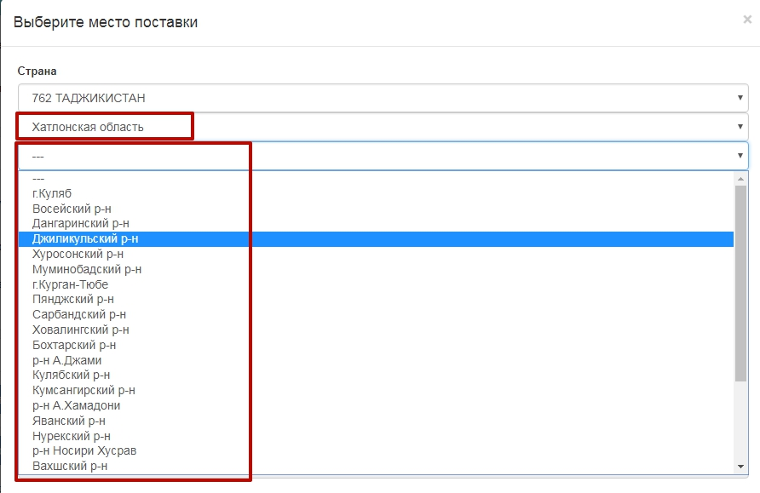
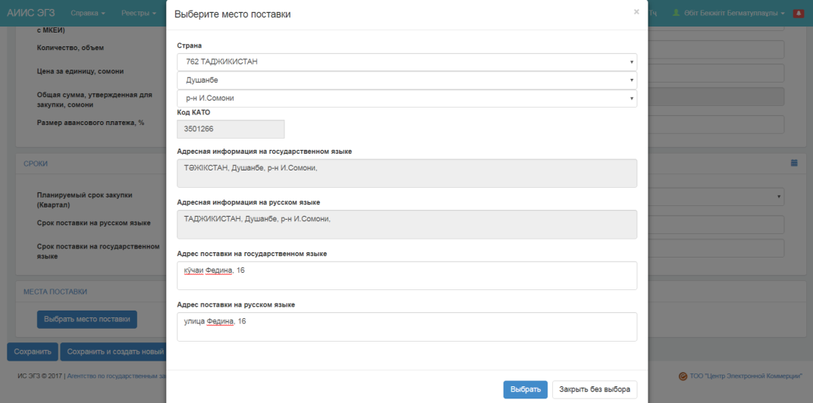
When selecting more than one location for the "Goods" purchase item type, the system checks that the total quantity for delivery locations is equal to the "Quantity, Volume" field.
If there are multiple delivery locations for the "Works" or "Service" purchase item type, you must fill in the "Quantity, Scope" field specifying the percentage for each location for the work and service deliveries. When selecting multiple ones, the system checks that the total value in the "Quantity, Scope" fields is 1 (100 percent).

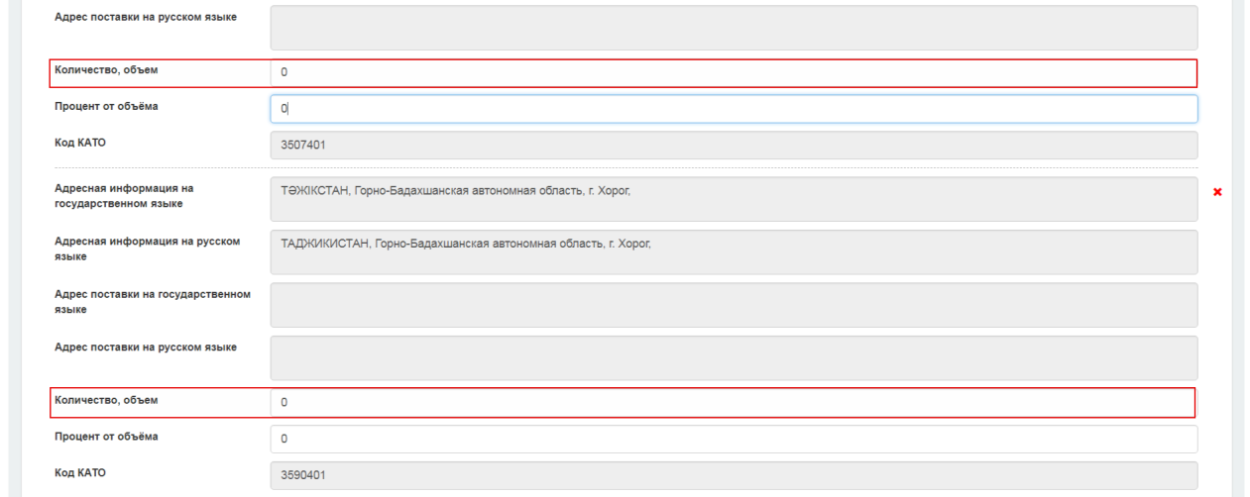
Click the icon to remove the delivery location.
After filling in all the fields, click the "Save" button to save the data.
Click the "Save and Create New" button to go to the new Plan Item form and save the information you entered for the plan item.
To return to the previous menu without saving the data, click the "Back" button.
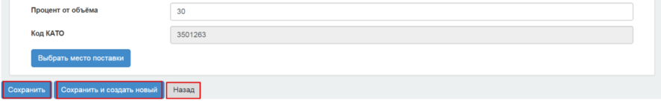
If the plan item is saved successfully, the system should assign the "Draft" status.
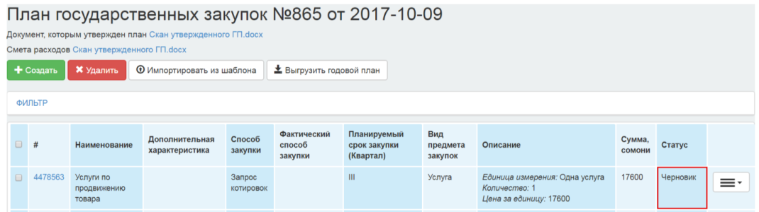

Copy plan item
The "Copy Plan Item" use case specifies the process of copying a previously created plan item in the yearly plan with the "Draft" status.

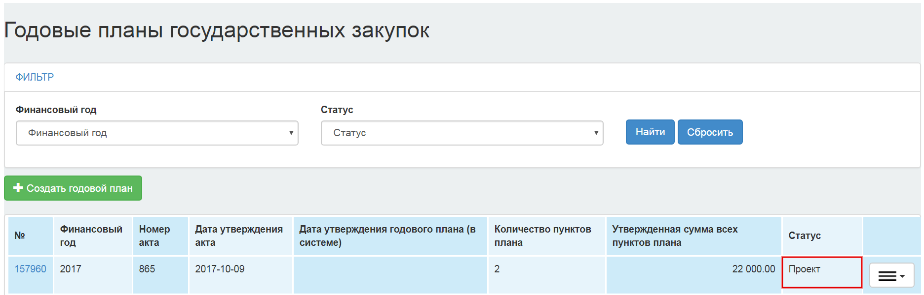

In the plan item view form, click the icon, and then select "Copy Plan Item" from the drop-down operations list.

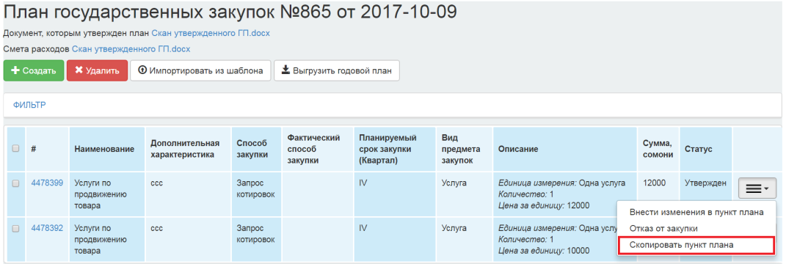
The "copy plan item" function is available for a plan item with any status. When copying the plan item, the system displays the plan item creation form with the pre-filled inn fields of the copied plan item.
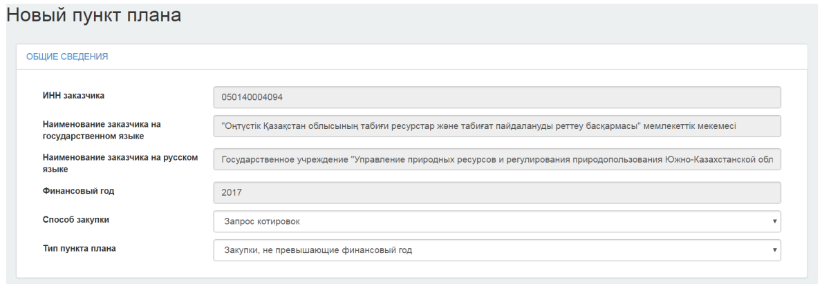

Editing the data in all sections of the plan item is available for the customer. After introduction of the changes, click the "Save" button.
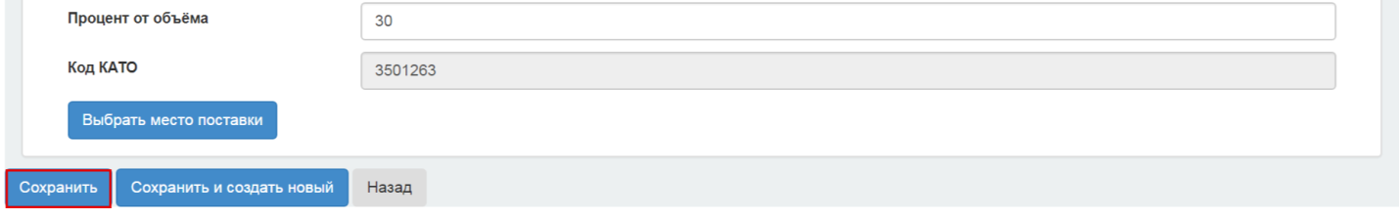
The requirements for filling in the form of a copied plan item are similar to those described in the paragraph "Creation of a plan item".
After saving of the plan item, the system should assign the "Draft" status.

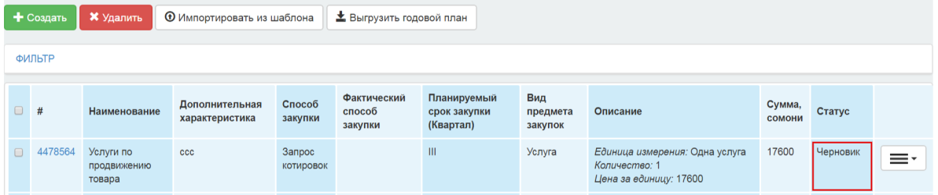

Deletion of a plan item
Deleting plan items is available for the yearly plan with the "Draft" status. Deletion of a plan item is available only with the "Draft", "Rejection of procurement" status.
To delete a plan item, click the icon and select the "Delete" opertion.
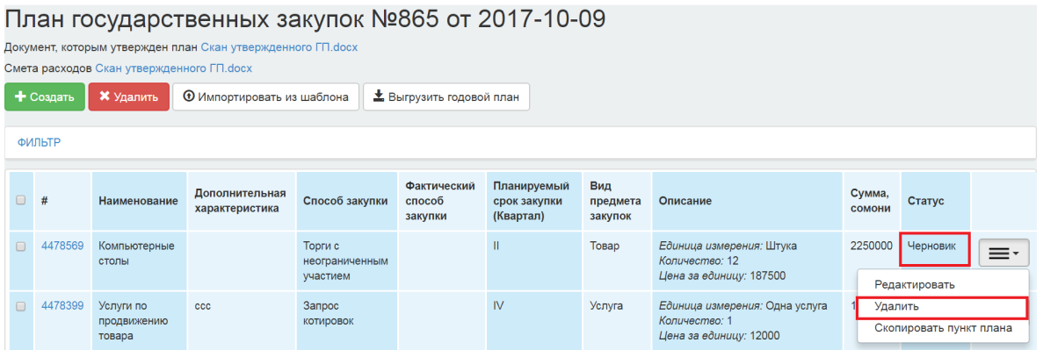
To delete several plan items, tick the desired plan items and click the "Delete" button.
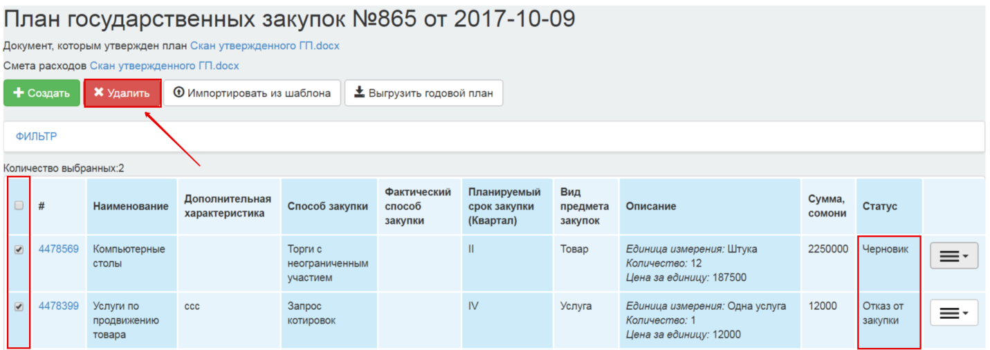
When you delete a plan item(s), the system requests confirmation of the selected action: "Are you sure you want to delete the selected plan items? {Quantity} plan items selected".
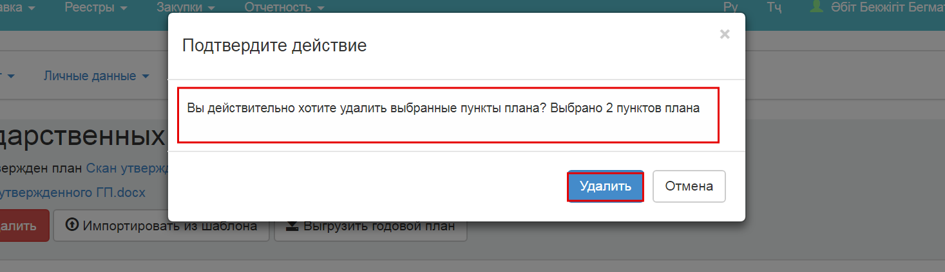
After the action is confirmed, the system deletes the plan items and displays the confirmation message "{Number of deleted plan items} deleted".
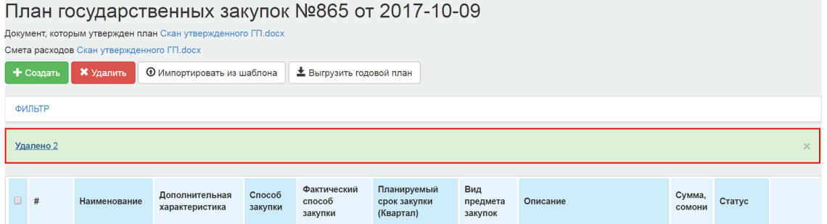
In case of deletion of plan items with additional ID for the modified plan item , the system returns the changed plan item to its original status.

Submission of the draft yearly plan for approval
To submit the "Draft" of the yearly plan for approval to the authorized body, the customer should click the icon from the drop-down list and select the "Submit for Approval" operation.
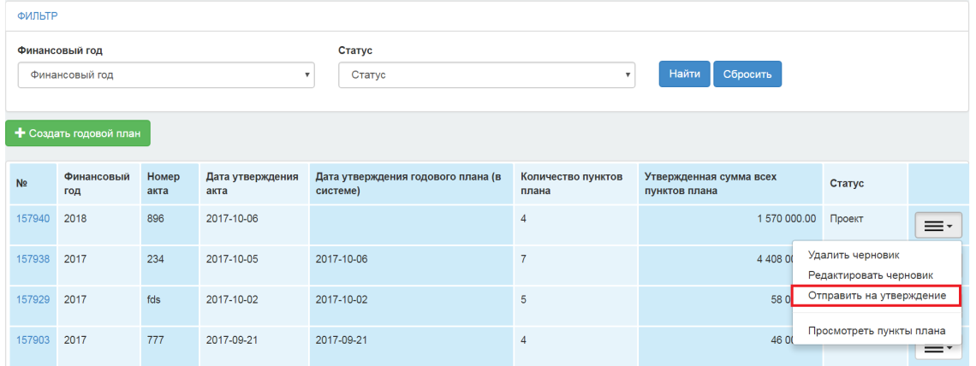
Upon the submission of the draft yearly plan for approval, the system requests confirmation of the selected action:

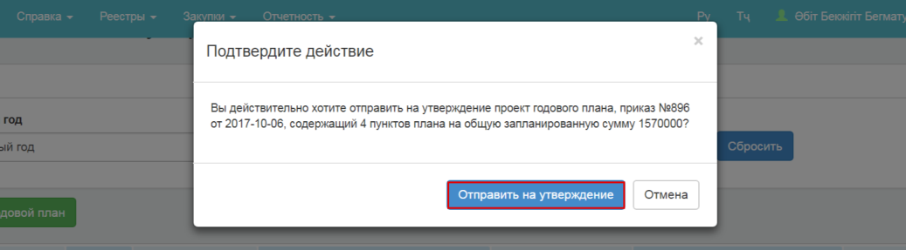

Upon the submission of the draft yearly plan for approval, the system checks:
-For organizations with DBC code: the plan items with the "Simplified Procurement Procedures" procurement method in which the same value of the "Purchase Item Type", "Planned purchase time term (a quarter)" and "Expenditure Item" fields, the sum of the "Total Approved Procurement Amount, Somoni" should not exceed the value of 250 indicators for calculation of goods and 350 indicators for works and services calculations.
Example:
Plan Field/Item | Funding Source | Expenditure item | Type of procurement item | Quarter | Total approved procurement amount, Somoni
Plan Item No. 1 | The Republican budget (budget allocation); | 2211 Inventory | Goods | I | 6000 somoni
Plan Item No. 2 | Local budget (budget allocation) | 2217 Payment for Public Utilities | Service | I | 9000 somoni
Plan Item No. 3 | Local budget (special funds) | 2215 Routine Repairs | Work | I | 5500 somoni
Plan Item No. 4 | Local budget (budget allocation) | 2217 Payment for Public Utilities | Service | I | 7500 somoni
Plan Item No. 5 | The Republican budget (budget allocation); | 2211 Inventory | Goods | I | 4000 somoni
Plan Item No. 6 | Local budget (special funds) | 2215 Routine Repairs | Work | I | 10000 somoni
Plan Item No. 7 | Local budget (special funds) | 2215 Routine Repairs | Work | I | 3000 somoni
Plan Item No. 8 | The Republican budget (budget allocation); | 2211 Inventory | Goods | I | 5000 somoni

Let's review the check results:
- The sum of the three plan items (No. 1, 5, 8) is 15000 somoni (6000 + 5000 + 4000). The amount exceeds 250 indicators for calculations (250 * 50 somoni = 12500) by 2500 somoni. In this case, the system reports an error;
- The sum of the two plan items (No. 2, 4) is 16500 somoni (9000 + 7500). It is less than 350 indicators for calculations (350 * 50 somoni = 17500). In this case, the system does not report an error;
- The sum of the three plan items (No. 3, 6, 7) is 18500 somoni (10000 + 5500 + 3000). The amount exceeds 350 indicators for calculations (350 * 50 somoni = 17500). In this case, the system reports an error;

-For organizations without DBC code: the plan items with the "Simplified Procurement Procedures" procurement method in which the same value of the "Purchase Item Type", "Planned purchase time term (a quarter)" and the same parent CVP code, the sum of the "Total Approved Procurement Amount, Somoni" should not exceed the value of 250 indicators for calculation of goods and 350 indicators for works and services calculations.
Plan Field/Item | CVP name | Parent CPV Code | Type of procurement item | Quarter | Total approved procurement amount, Somoni
Plan Item No. 1 | Charcoal and coal-based fuel | Petroleum products, fuel, electricity and other energy sources | Goods | I | 3500 somoni
Plan Item No. 2 | Services of member organizations | Provision of other public utility, social and personal services | Service | I | 9000 somoni
Plan Item No. 3 | Inslattaion of doors and windows | Construction works | Work | I | 5500 somoni
Plan Item No. 4 | Other services | Provision of other public utility, social and personal services | Service | I | 7500 somoni
Plan Item No. 5 | Propane-butane | Petroleum products, fuel, electricity and other energy sources | Goods | I | 4000 somoni
Plan Item No. 6 | Boiler installation works | Construction works | Work | I | 10000 somoni
Plan Item No. 7 | Guard services | Provision of other public utility, social and personal services | Service | I | 3000 somoni
Plan Item No. 8 | Natural gas | Petroleum products, fuel, electricity and other energy sources | Goods | I | 5000 somoni

Let's review the check results:
- The sum of the three plan items (No. 1, 5, 8) is 15000 somoni (3500 + 5000 + 4000). The amount is equal to 250 indicators for calculations (250 * 50 somoni = 12500). In this case, the system does not report an error;
- The sum of the two plan items (No. 2, 4, 7) is 16500 somoni (9000 + 7500 + 3000). The amount exceeds 350 indicators for calculations (350 * 50 somoni = 17500). In this case, the system reports an error;
- The sum of the two plan items (No. 3,6) is 18500 somoni (10000 + 5500). The amount is less than the indicators for calculations (350 * 50 somoni = 17500). In this case, the system does not report an error;

If FLT is failed, the system displays the following error text:

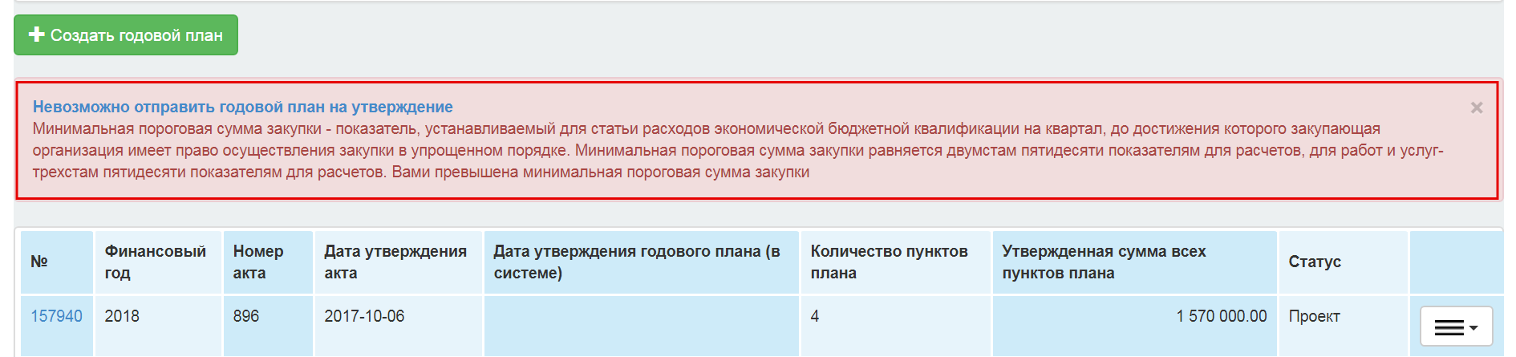
If the system does not detect an error, the status of the yearly plan changes to "Under approval".

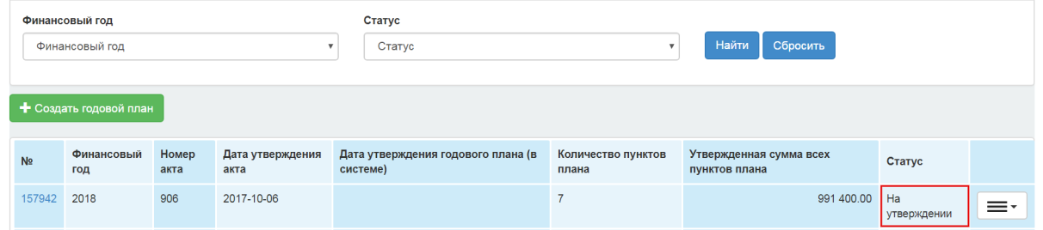

The system records the date and time of the submission for approval, and the user carrying out the opertion.

Approval of the yearly plan
To approve the yearly plans, the user of the authorized body with the "Approval sign-off person" role should go to the PPA Cabinet -Approval of Plans.
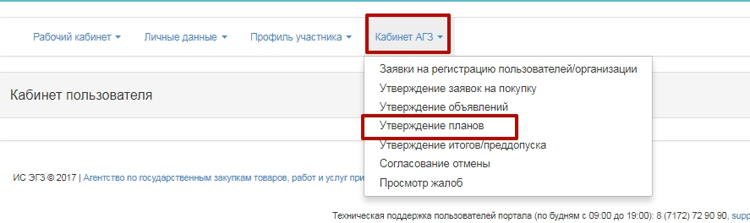

When moving to the section, the yearly plans review form is displayed. There is a filter on the review form to search for the desired yearly plan:
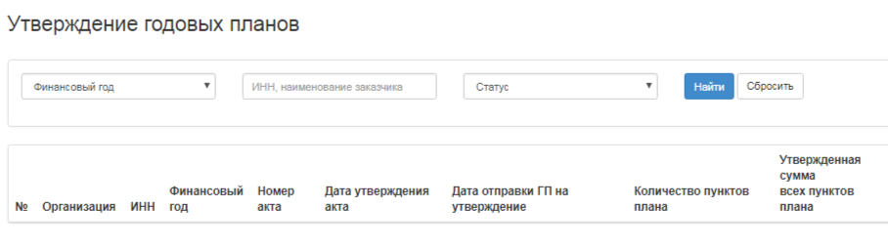
For easy searching, you can use the following filter:
- Fiscal year;
- INN/ Customer name;
- Status
To review the yearly approval plan "Under Approval", click the Yearly plan number

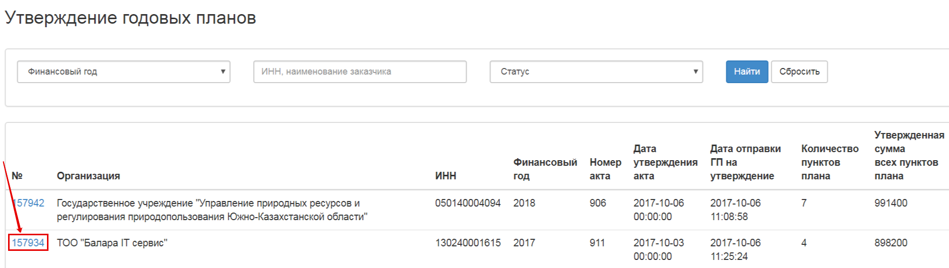

To view and approve plan items, click the number of the plan item.
Attention: plan items are available for review only in the "Draft" and "Reject procurement" status.
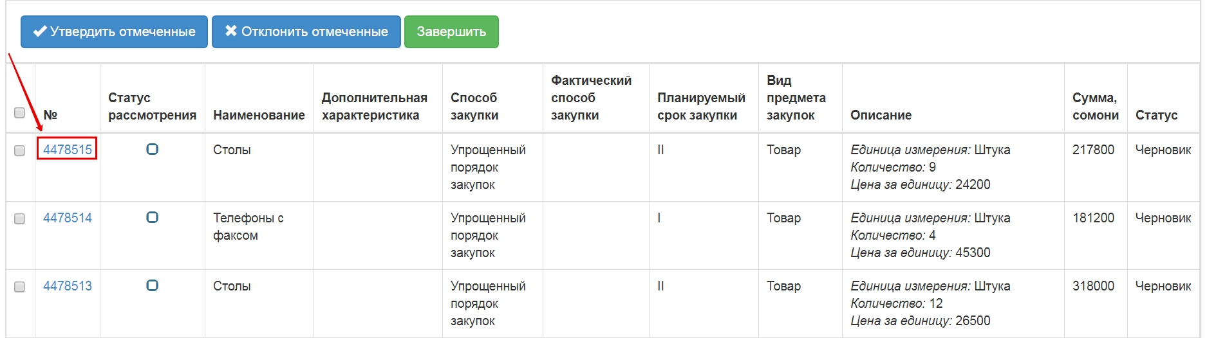
If you have made changes to a previously approved plan item, you can view the change history by clicking the "Version Review" action
In the review form of a plan item, select the "Approve" or "Reject" action. Click the "Go Back" button.
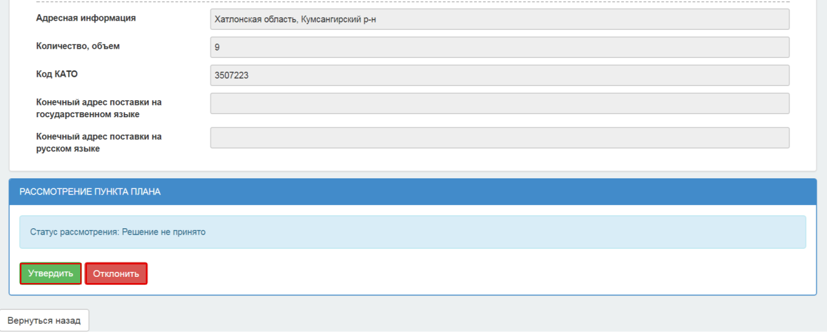
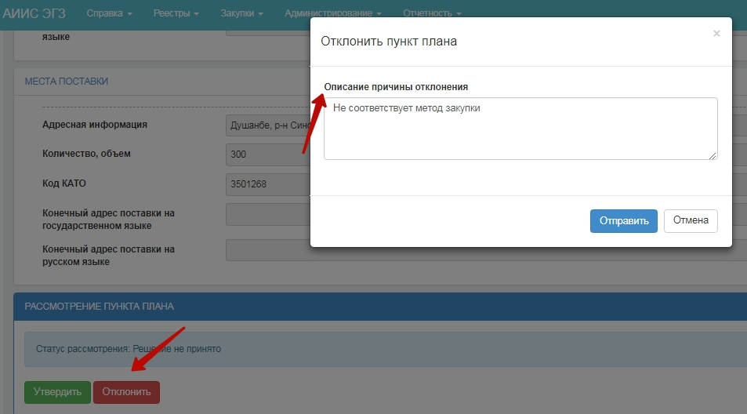
If a plan item has been confirmed, the "Review status" line will display the approval indicator;
If a plan item has been rejected, the "Review status" line will display the rejection indicator.
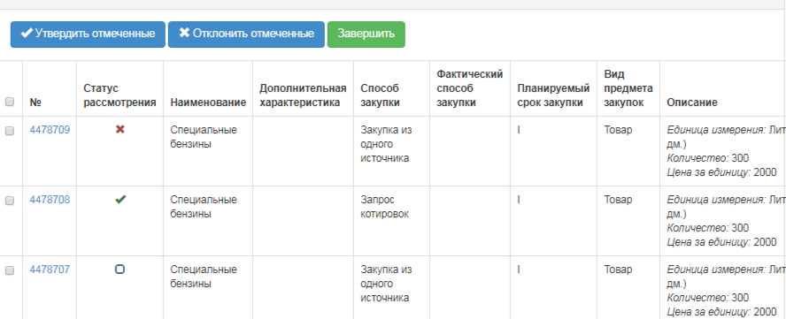

After the system has recorded the decisions for plan items, click the "Finish" button.
Before you click the "Finish" button, make sure that you have decided on all plan items. If the decision has not been taken for all plan items in the "Draft" and "Rejection of Procurement" status, the System will display an error message:
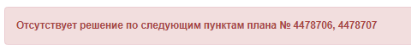

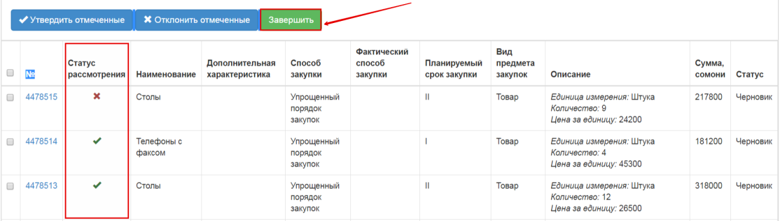
- If there is at least one approved plan item in the yearly plan:
- the status of the yearly plan is changed to "Approved", the previous approved yearly plan is given the"Changed" status;
- approved plan items change status to "Approved" or "Rejection of Procurement" (if the rejection was made);
- plan items that are rejected if there is no previous version of the plan item, if there is a previous version of the plan item, the system will restore the previous status of the plan item;
- If none of plan items has a confirmation indicator:
- the yearly plan status is changed to "Refused";
- the plan items status is changed to "Rejected by PPA";
- if the status was "Rejection of Procurement", the initial status is returned to the plan item;
- if there are unapproved changed plan items, the system returns them to their original version and status.
Upon completion of the review, the Customers will be notified in the personal accounts that the review of the yearly plan is completed. To view the notification, go to the "Member Profile" section-"Notifications":
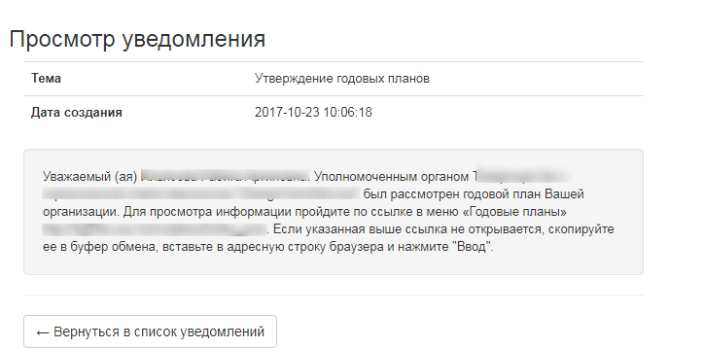
To view the report based on the results of the yearly plan approval, the Customer shall select the "View Report" action in the line of the required annual plan:
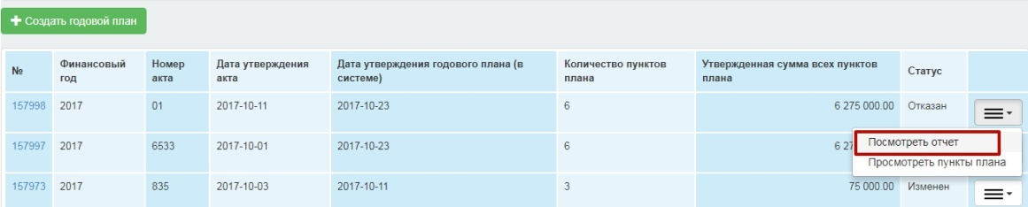
The form for the report review will be opened:
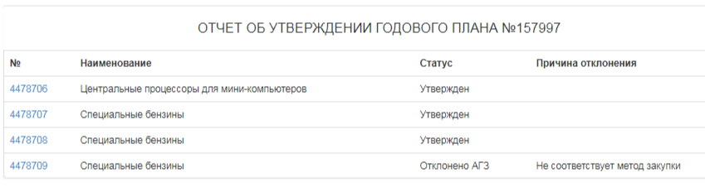

Making changes to the yearly plan
To make changes to the yearly plan, including plan items, it is required to use the editing functionality.
To do this, you shall create a yearly plan based on the old plan.
To create the draft yearly plan, click the button "Create a New Plan" in the Annual plans section of Personal Account. The Yearly Plan creation page is displayed.
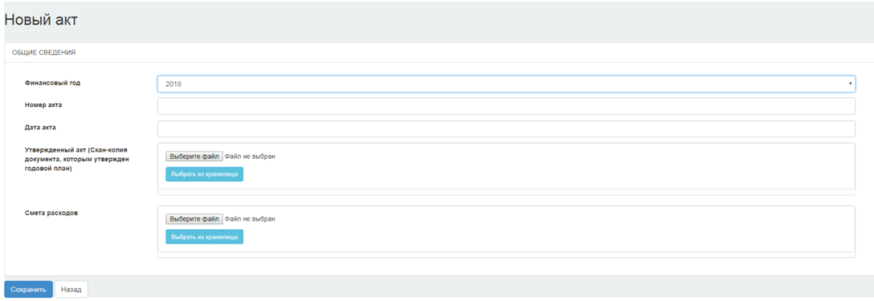
For a detailed description of how to complete this page, see Creating a Yearly Plan section.
If the Customer already has a yearly plan with "Draft" and "On Approval" statuses in the relevant fiscal year, the system prohibits making changes to the approved yearly plan this year.
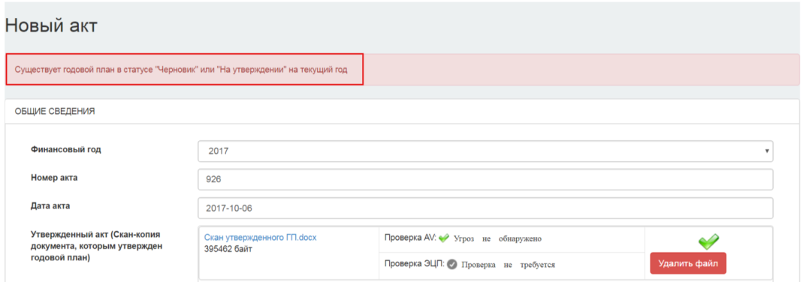
After saving the data entered on the page of creating the yearly plan in the section "Yearly Plans", there will be a new yearly plan with "Draft" status where all plan items have been copied from the previous yearly plan in the "Approved" status.
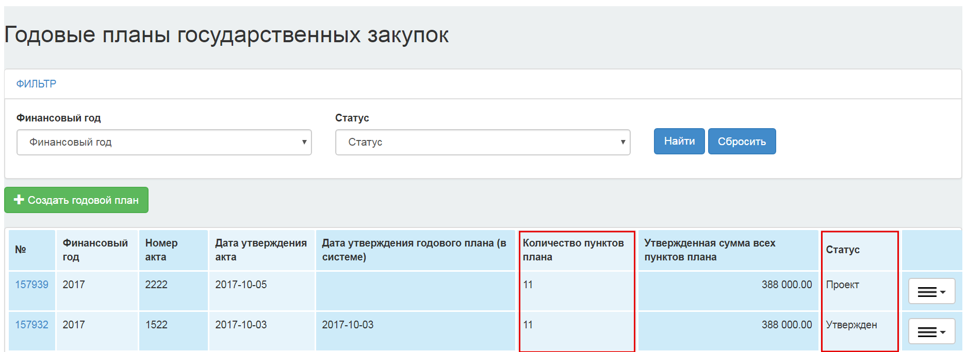
To work with the plan items, follow the live reference of the yearly plan number or select the "View Plan Items" action from the drop-down list in the icon.
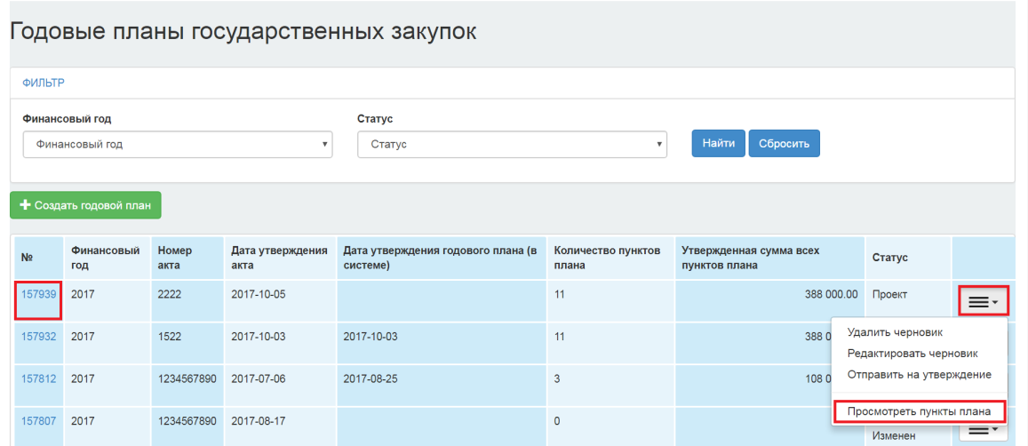
A page listing the yearly plan items is displayed.
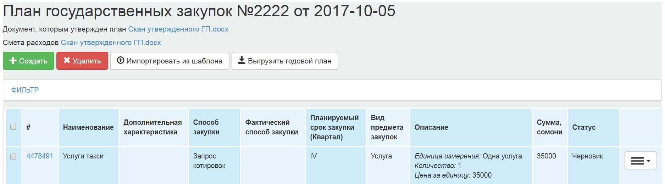
It is possible to add a new plan item or to make changes to the plan items in this yearly plan.
To add a new plan item, click the "Create" button.
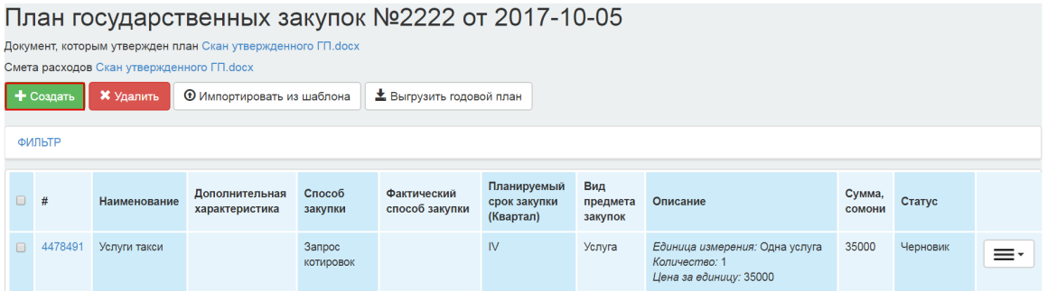

A detailed description of the process of creating a new plan item is presented in the "Creating a New Plan Item" section.
To make changes to a plan item, click the icon and select the "Make changes to Plan Item" action.
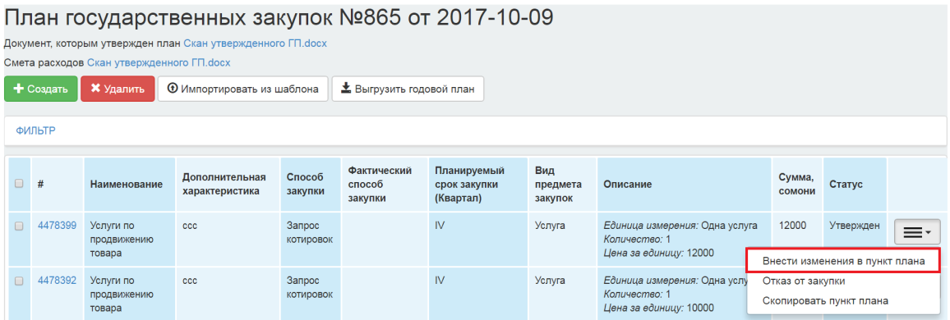
A detailed description of the process of creating a new plan item is presented in the "Creating a New Plan Item" section.

Change the plan item
The action "Make changes to the Plan Item" is available for plan items with the status "Draft", "Procurement Not Implemented", "Canceled", "Approved", "Procurement Not Implemented", "Contract Not Concluded", "Contract Not Executed. No Payments" in the yearly plan with the "Draft" status.
To make changes to a plan item, click the icon and select the "Make changes to the Plan Item" action.
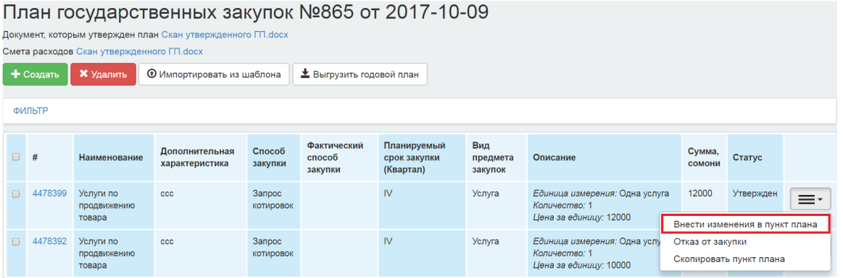
The system then copies the plan item and displays the plan item's editing form.
You shall make the necessary changes and click "Save" button.
After saving the modified plan item, the original plan item with the "Approved" status changes to the "Changed" status and the saved plan item is given the "Draft" status.

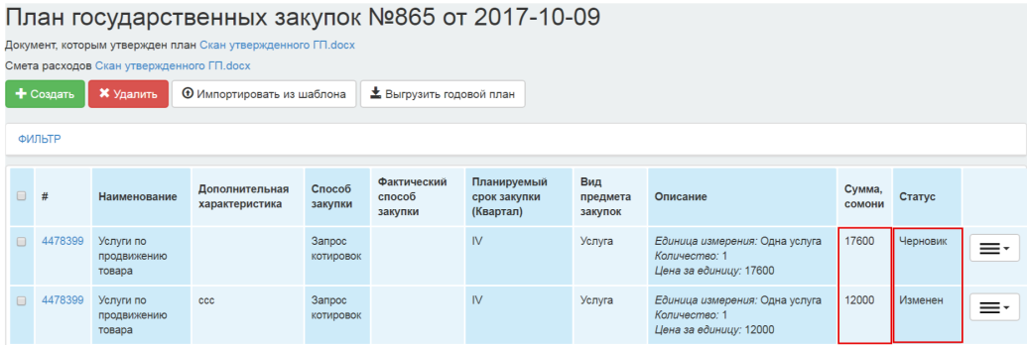
If you save the changed plan item, the initial plan item with the "Procurement Not Implemented" to the status of "Procurement Not Implemented". Changed", "Contract Not Concluded" goes into the status of "Contract Not Concluded. Changed", "Canceled" goes into the status "Canceled". Changed".
Saved plan items are assigned with the "Draft" status.
Summary of the statuses and possible actions is described below:
Status | Actions | Note
Draft | "Edit", "Delete"
Approved | "Make changes to the Plan Item",  "Rejection of Procurement"
Published | "Rejection of Procurement" | Changes are only possible if the lot status is "Published" (call for bids)
Procurement not implemented | "Rejection of Procurement", "Make changes to the Plan Item" | After the changes have been made, the status of the previous item "Procurement Not Implemented". Changed»
Canceled | "Make changes to the Plan Item", "Rejection of Procurement" | After the changes are made, the status of the previous item "Canceled. Changed»
Suspended | "Rejection of Procurement"
Contract not concluded | "Make changes to the Plan Item", "Make changes to UBC", "Reject Procurement" | After the changes have been made, the status of the previous item "Contract Not Concluded. Changed»
Contract not executed. No payments | "Make Changes to the Plan Item", "Rejection of Procurement" | After the changes have been made, the status of the previous item "Contract Changed"

Rejection of procurement
When choosing the "Rejection of Procurement" action in the draft yearly plan, the system displays the form of action confirmation with the directory of reasons for refusal to procure, which contains the following items:
- Reducing the expenditures for procurement of goods, works and services provided for in the approved (updated) yearly plan of public procurement (preliminary yearly public procurement plan) that occurred during the updating (adjustment) of the relevant budget in accordance with the legislation of the Republic of Tajikistan.
- Amendments and additions to the budget of the customer that exclude the requirement of acquisition of goods, works, services provided for in the approved (updated) yearly public procurement plan (preliminary yearly public procurement plan) in accordance with the legislation of the Republic of Tajikistan.
To reject the procurement in the plan item, click the icon and select the "Rejection of Procurement" action.
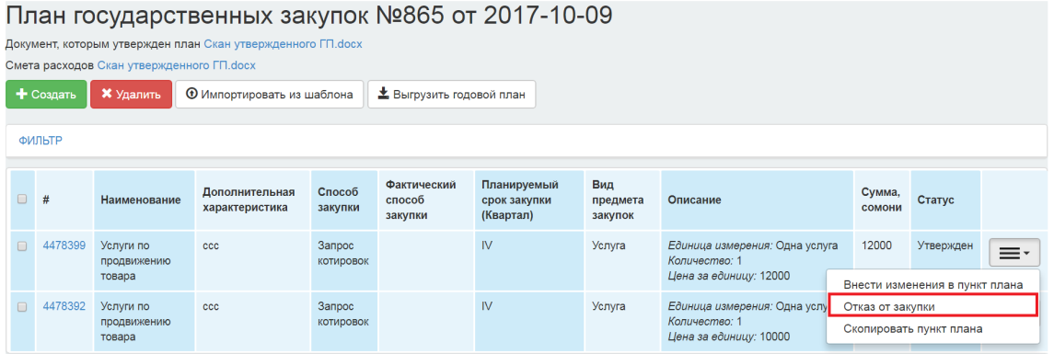
When performing an action, the system provides you with the option of selecting the justification from the directory. The system displays a field to enter the reason for the procurement rejection.
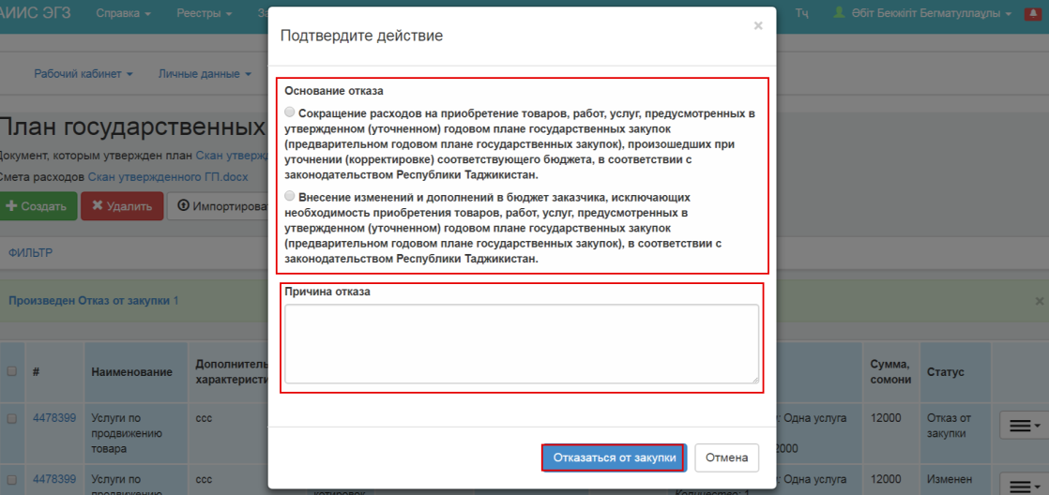
The system copies the plan item and assigns it with the"Rejection of Procurement" status, the plan item selected for rejection is given the "Changed" status.
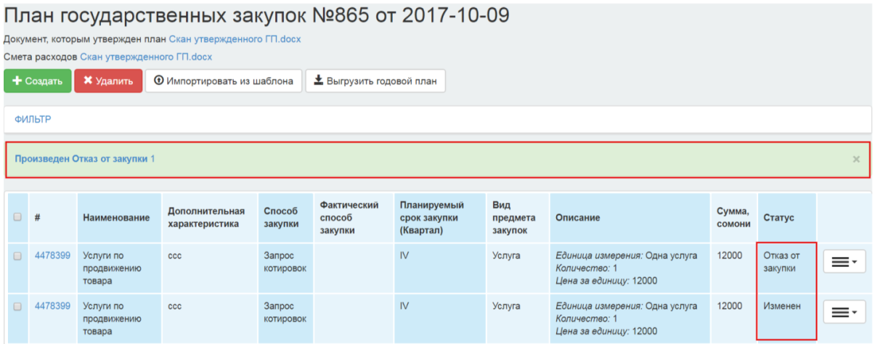
To cancel the rejection, you can delete the plan item in the status of "Rejection of Procurement" (provided that the rejection was made in the same draft yearly plan). The plan item will revert to its previous "Changed" status
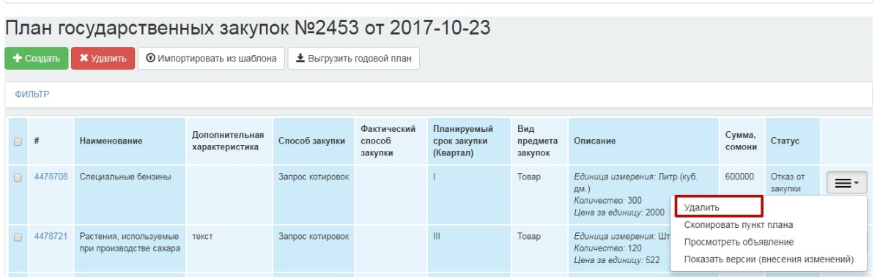
.
In the yearly plan in the "Approved" status the "Move" action is available for plan items in the "Procurement Implemented" status. When you select the "Move" action, the system checks for a yearly plan in the "Draft" status for fiscal year = (fiscal year PP + 1). In case of absence of the yearly plan, the following error text is displayed: "There is no yearly plan in the "Draft" status for the next fiscal year".
When you perform the "Move" action, the system displays the following forms with the feature of editing of fields (for organizations with DBC code).
When you click "Save", the system performs the following checks:
-The amount of expenditure should be equal to the total approved amount of the plan item;
When you perform the "Move" action by clicking "Save", the system copies the plan item to the yearly plan of the next fiscal year (new) changing of fiscal year to the following year with the reference to the lot, procurement and outcomes, and saving the status "Procurement Implemented". The status of the plan item in the (old) yearly plan shifts to "Changed". The system recalculates the amount of (old) yearly plan.

Unload yearly plan
To unload Annual Plan, a user with the "Customer" role, "PP Approver", shall go to Personal Account-Yearly plans.
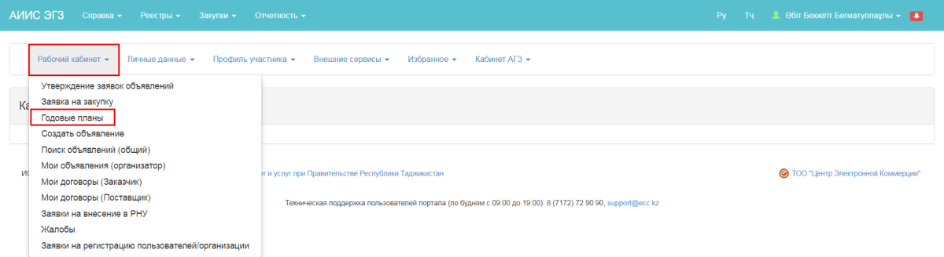
In the review form of yearly plans, click the active link for the yearly plan identification number.
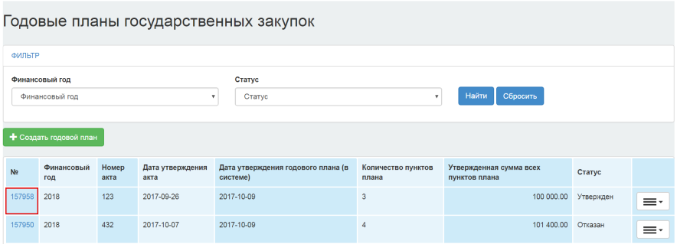
In the review form of the yearly plan items, click the "Unload the Yearly Plan" button.
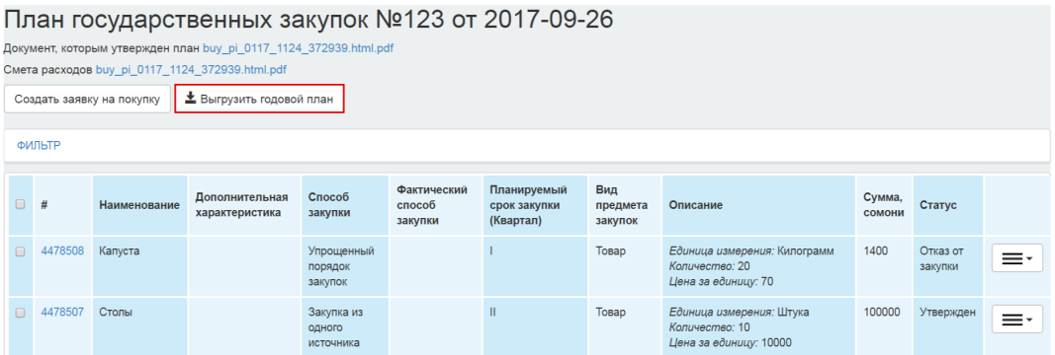
When you click the button, the system starts to unload the customer's yearly plan items with all the statuses in Excel format. The name of the generated file of the yearly plan "Unload from yyyy-hh-mm hh:mm:ss". 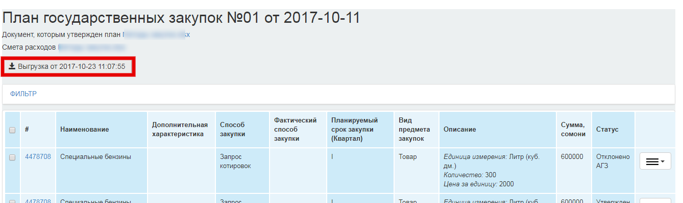
After clicking the button the file starts downloading.
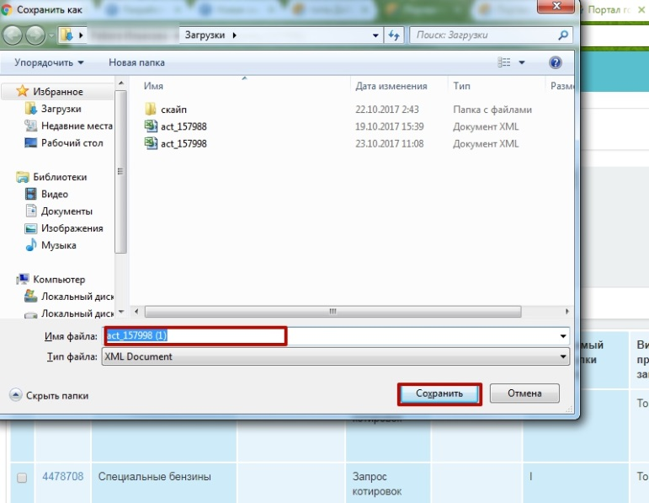
The generated document displays the date and time of the yearly plan upload.
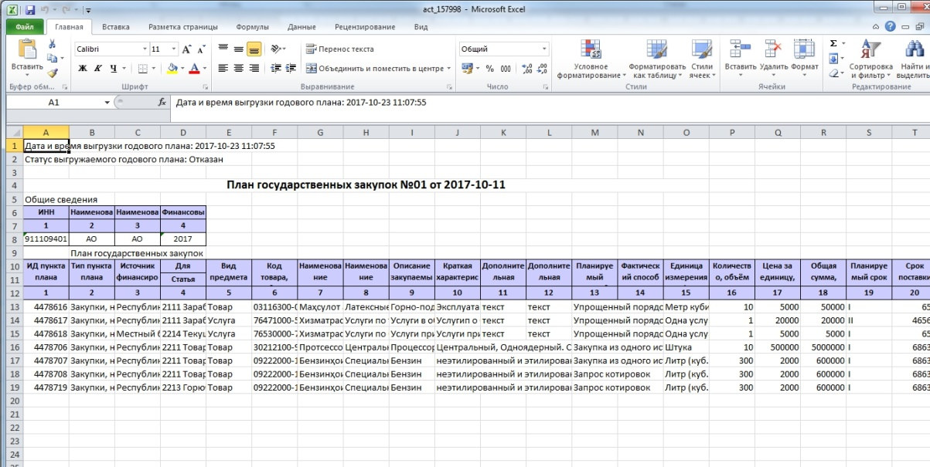
For the yearly plan in the "Draft" status, there is a possibility to delete the generated unload.
If the yearly plan has "Approved", "On approval", or "Changed" statuses, when you click the "Unload Yearly Plan" button, the system generates the file without the possibility of it deletion.

Purchase bids
To create a procurement, Customers shall create a purchase bid and submit it to the authorized body for consideration.
Bids are created for the plan items in the "Approved" status for all procedures except the "Simplified Procurement Procedure"

Creation of a purchase bid
To create a purchase bid, you must go to the "Personal Account" section-"Purchase Bid"
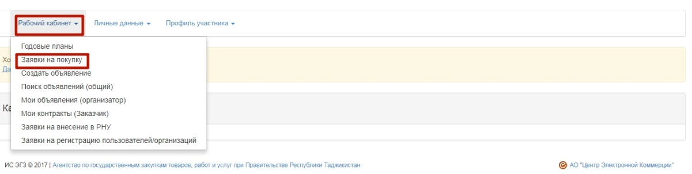
The form for searching and creating of a purchase bid is then displayed.
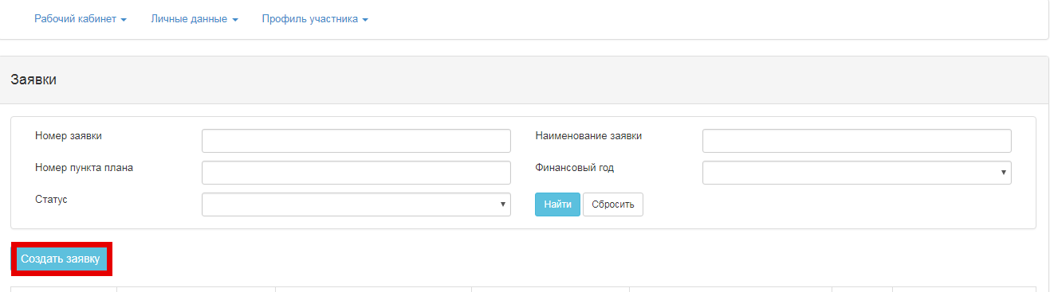

Form "Creation of a Purchase Bid"
To start, click the "Create a Purchase Bid" button.
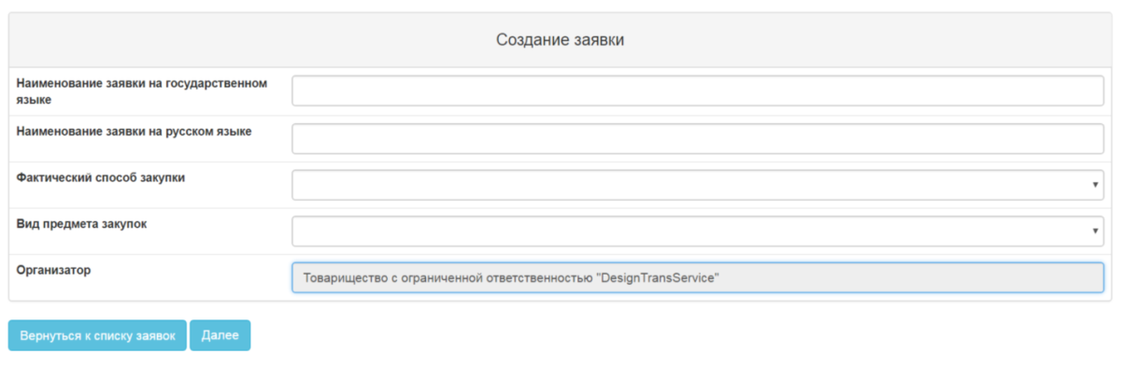
Fill in the following fields in the appeared form:
- Name of the bid in the state language
- Name of the bid in the Russian language
- Actual procurement procedure
- Type of procurement item
- Facilitator
The system automatically indicates the Authorized body (PPA) as a procurement facilitator, without possibility of editing, except in cases where the procuring entity is in the QPE list. In this case, the system gives the option to select the Facilitator: The organization of the Customer-QPE or the authorized body (PPA);
For the "Single Source procurement" procedure, you must fill in the additional "Justification for procedure usage" (select from drop-down list) and "Justification" (manual entry) fields
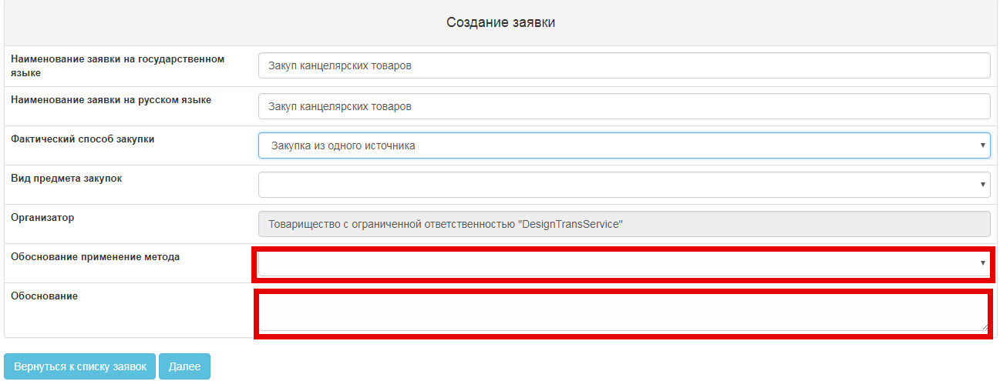
The justification for the procedure usage includes the following:
- additional orders within 6 months from the conclusion of the contract, not exceeding 15 per cent of the value of the previous procurement, and complies with previous rules, parameters and standards;
- signing of the contract in the conduct of research, experiments or the preparation of a scientific opinion
- given goods, works, services are available only from a particular vendor (contractor) or a certain vendor (contractor) has exclusive rights in respect of the goods, works or services
- carrying out procurement for a creative project or creative activity in art or culture sphere
- in the event of an urgent need for procurement due to circumstances that the procuring organization was unable to foresee (procurement procedure)
- in the event of an urgent need for procurement due to circumstances that the procuring organization was unable to foresee (direct conclusion of the contract)
- bidding process has been twice declared void on the Portal
Note. For bids of "Single Source" procedure where the basis code equals 1, 6, 7, the field "Facilitator" is not filled in.

After filling in the fields, click "Next" on the bid creation form.

Form "Add Plan Items to the Bid"
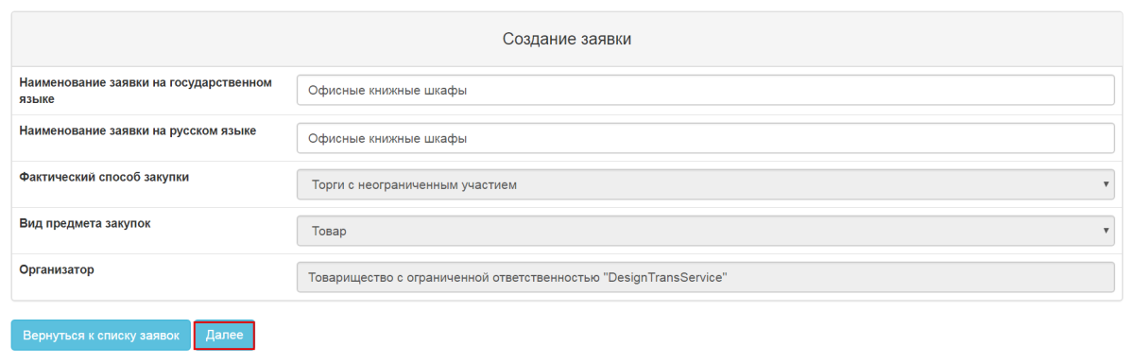
The form is displayed to add the appropriate lots to the purchase bid:
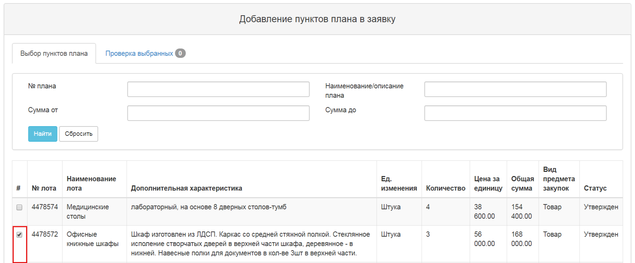
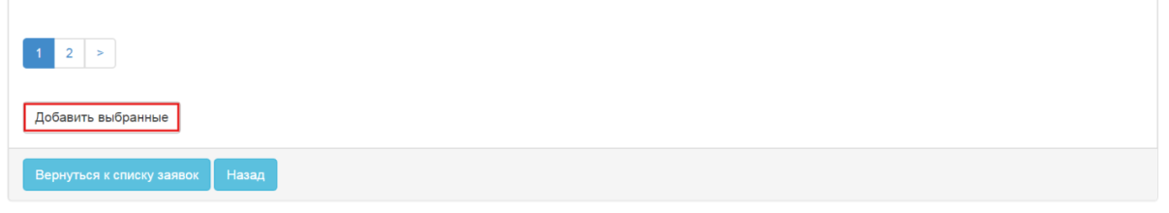
You must tick the desired plan items and click the "Add Selected" button After you add, the lots are transferred to the "Bid" status and the status of the bid is changed to the "Draft".
The system allows to add plan items, delete plan items in the bid in the "Draft" status.
In the "Check Selected" tab, the system allows removing previously selected lots from the bid. To do this, you shall tick the unnecessary lots and click the "Delete Lots from the Bid" button.
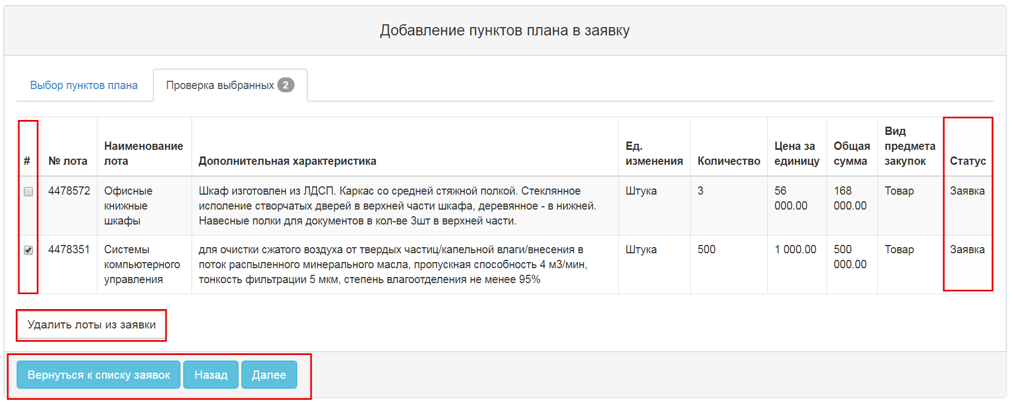
When you click the "Next" button for "Single Source Procurement", "Limited Bidding" procedures, the form for adding a vendor is displayed, and for the remaining procedures the form "Enter Data by Lots" is displayed.

Form "Vendor Selection"
In the appeared form, you must click the "Select" button and search using the Vendor's INN.
Attention! The search is performed only for the vendors registered in the System.
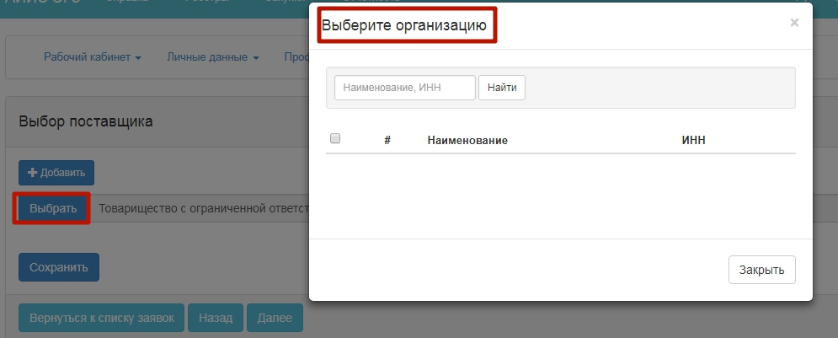
You shall enter a Vendor's INN and click the "Find" button. Next, click the "Select" button on the line with the desired vendor.
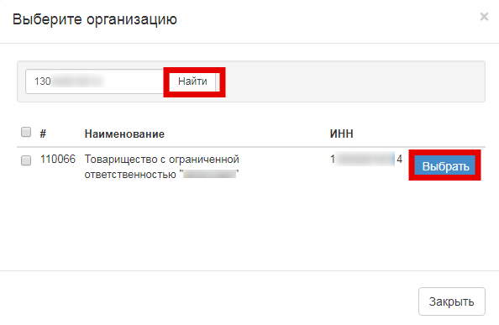
If you want to add more than one vendor, click the "Add" button. This results in another line to select the vendor:
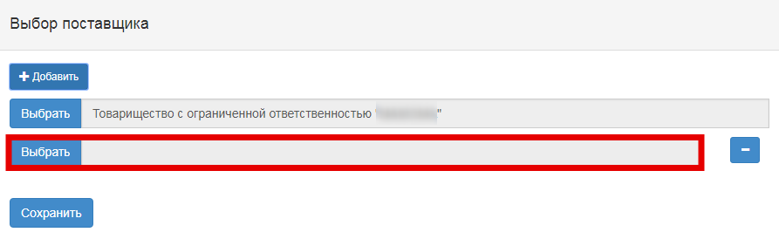
Attention! For the "Single Source Procurement" method, and if the basis code is =1, 6, 7, the system allows only one vendor to be selected.
When you click "Next", the system displays the "Enter Data by Plan Items" form

"Enter Data by Plan Items" form
For plan items with "Goods" procurement item type, it is possible to create a technical specification:
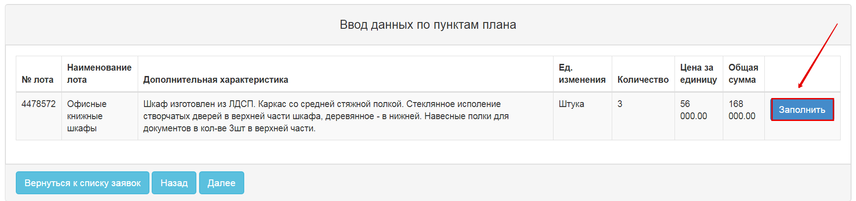
Click "Fill in" to display the form for filling in the technical specification:
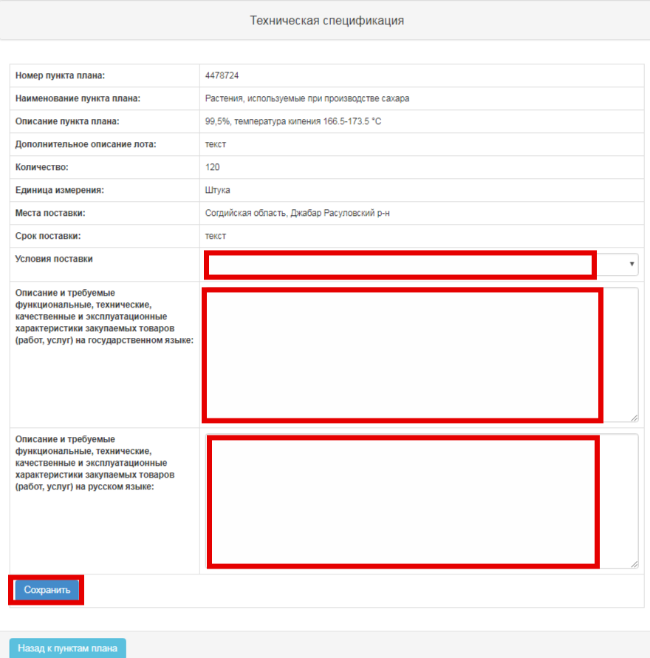
You must fill in the required fields and click "Save" button. The "Terms of Delivery" field is optional.
To generate a technical specification in PDF format after saving the document, click the "Generate file" and "Approve file" action:
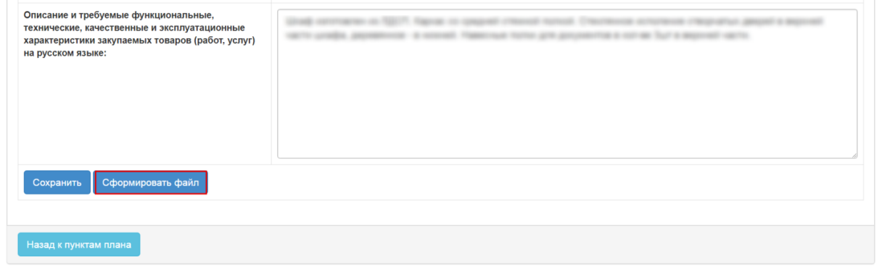
Use the "Delete file" button if necessary
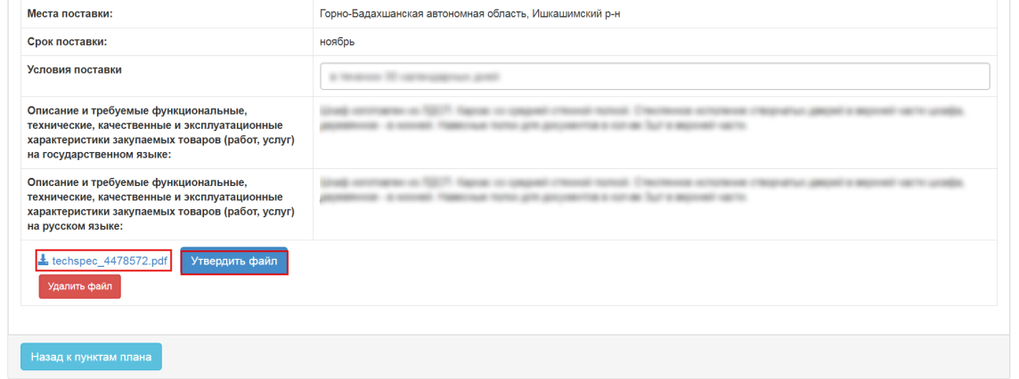
After approval, the generated technical specification is available for viewing
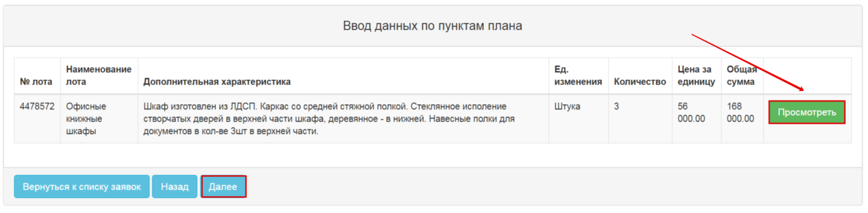
For plan items with "Work" or "Service" types, you can attach a file that describes technical specification.
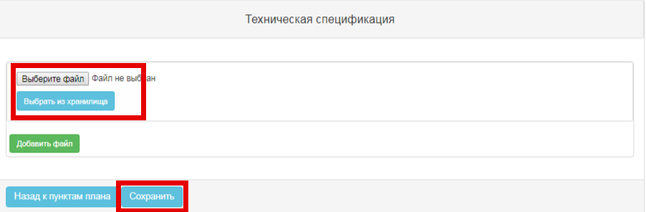
To download file from your computer, you must click the "Select File" button
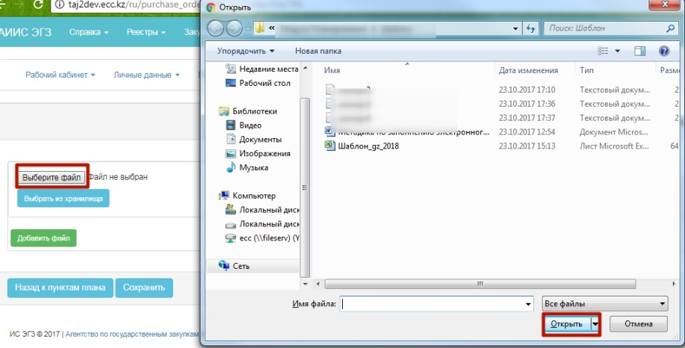
or "Select from Storage" if the file is in the file directory.
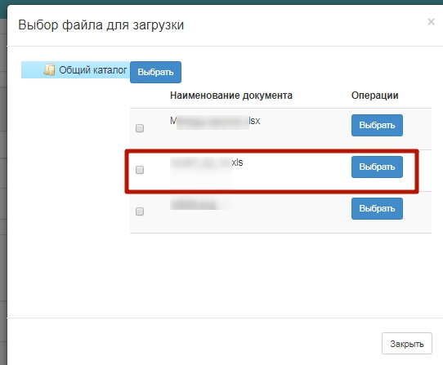
To attach another file, click the "Add a File" button.
After you approve the technical specification for all the plan items in the bid, click the "Next" button
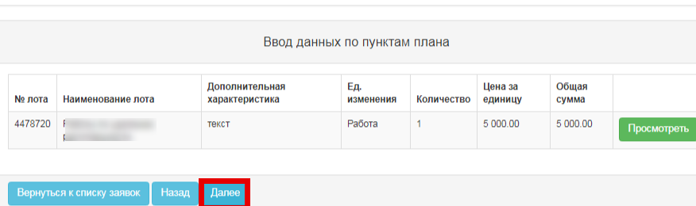
This opens the form of the next step "Contract details"

Form "Contract Details"
The system allows to attach a file to the section "Contract details".
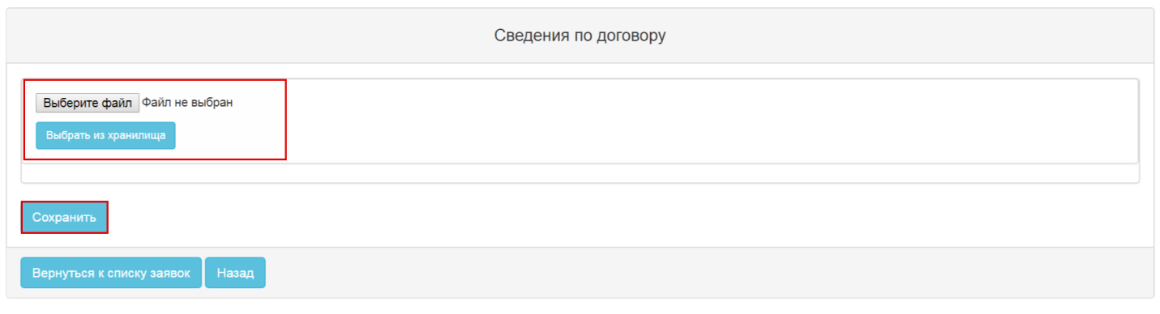
To download file from your computer, you must click the "Select File" button
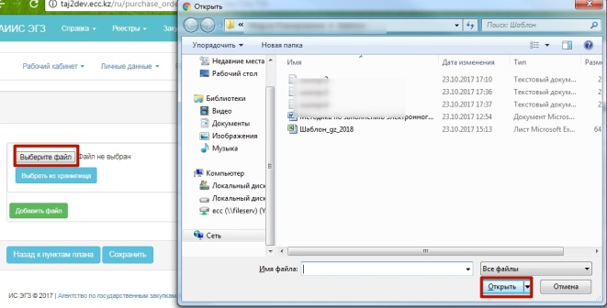
or "Select from Storage" if the file is in the file directory.
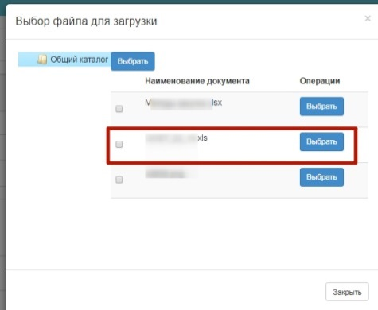
To attach another file, click the "Add a File" button.
After you save, you must click "Approve".
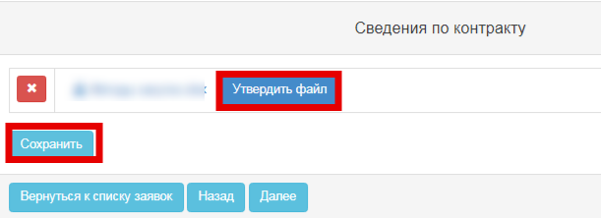
Attention! For the "Single Source Procurement" procedure and if the justification for applying this procedure is "Additional orders within 6 months from the conclusion of the contract, not exceeding 15 percent of the value of the previous purchase, and complies with the previous rules, parameters and standards" The Customer needs to attach the draft contract, scan of the concluded contract copy and vendor license (where applicable)
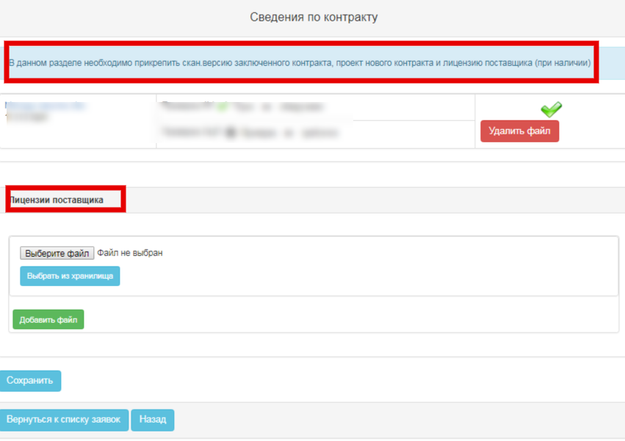
When you click the "Next" button, the form of adding commitee members appears, except for the "Request for Quotation" procedure

Form "Add Commitee Members"
Click the "Add" button to add members to the Commitee
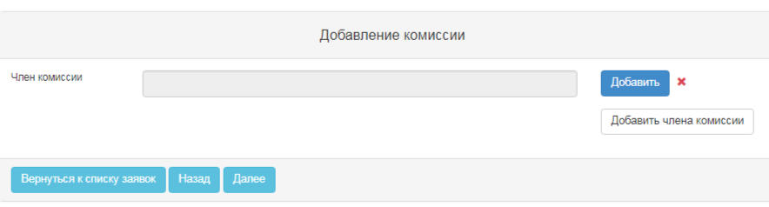
To search for users, enter the user's INN or full name. You can select users the same way from the drop-down list by clicking "Select" next to the name.
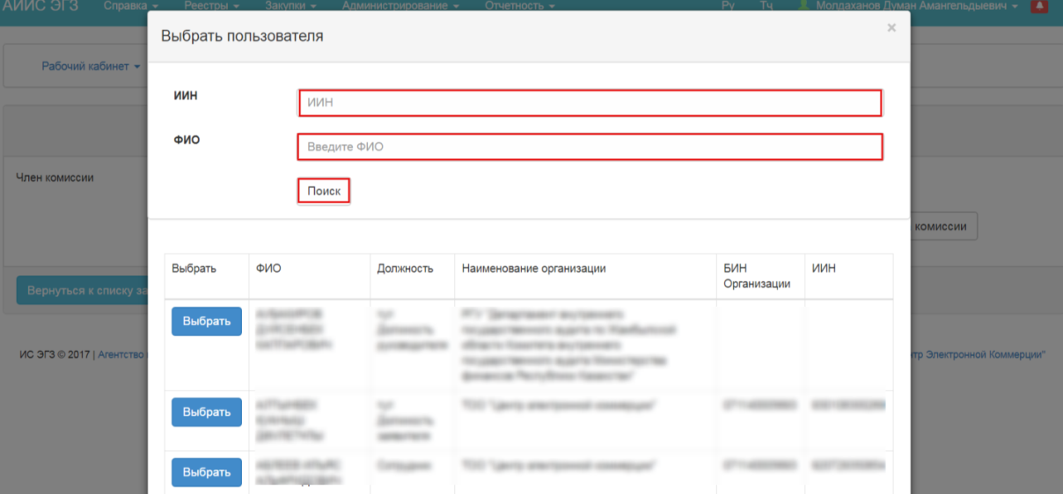
- during the formation of the commitee, the system does not allow for duplication of the members of the commitee;
- there should be at least two members of the commitee;
- if necessary, you can add more than two members of the commitee by clicking the "Add Commitee Member"
When you click "Next", the System displays the step of adding a tender bid if the bid has a plan item with one of the following funding sources:
- Republican budget (budget allocation)
- Republican budget (special funds)
- Local budget (budget allocation)
- Local budget (special funds).

Form "Enter tender bid data"
At this step, you can submit a request to receive information on the tender bid. To submit a request, you must specify the bid number and date.
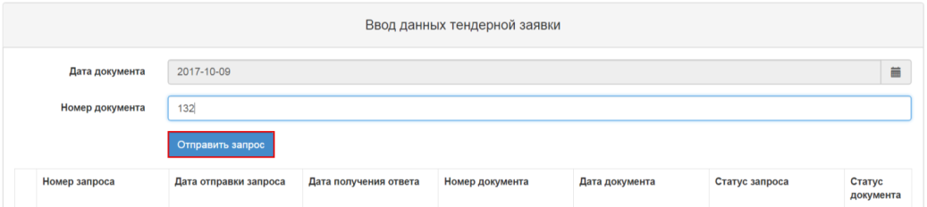
When you click the "Submit a Request" button, the system submits the request to the RT MF IS with data contents.
The system assigns the request with the following statuses:
-"Under processing" - the status is assigned when the bid processing is not completed.
- "Processed. Accepted" - the status is assigned when there is a tender bid in the "Processed" status on the parameters entered by the Customer;
- "Processed. Rejected by the Treasury" - the status is assigned when there is a tender bid in the status of "Rejected by the Treasury" on the parameters entered by the Customer;
- "Processed. Approved" - the status is assigned when there is a tender bid in the "Rejected Approved" status on the parameters entered by the Customer;
- "Processed. Ready for approval" - the status is assigned when there is a tender bid in the "Processed" status on the parameters entered by the Customer; Ready for approval";
-"Processing error" - the status is assigned when an error occurred during submitting the request or receiving a response.
The system allows you to attach a request to the bid in the "Processed" status only. Accepted".
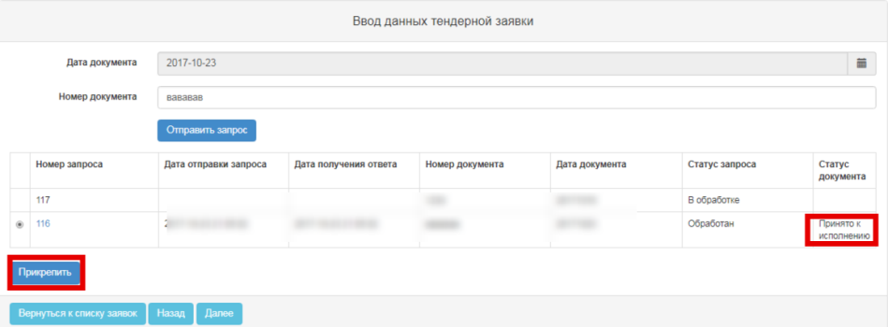
To see the details of the tender bid, click the hyperlink with the tender bid number. The result is a review form of the tender bid .
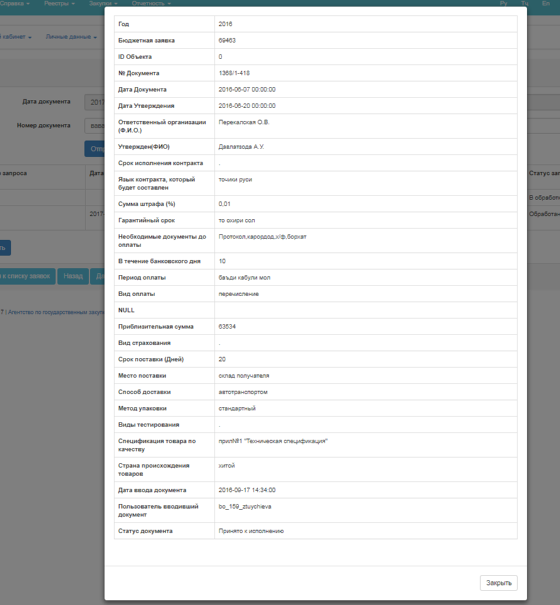
If there is a request attached to the bid, it is possible to detach the it. If you detach the request, the system will make the "Submit Request" button and edit the data entry form available.

Tender Bid Preview Form"
When you have filled in all the steps, you must verify in the review form of the bid that all the data entered is valid.
If the procuring entity is QPE and the actual procurement procedure is "Unlimited Bidding", and when the procuring organization is an Authorized Body, the "Complete" button is available in the bid review form:
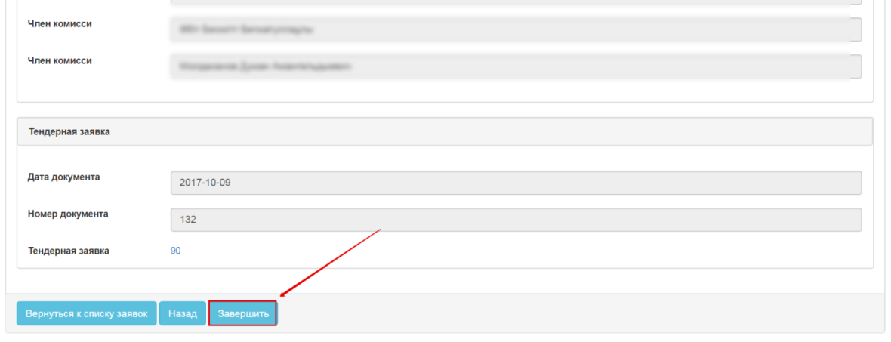
When click the button, the System will display a window to approve the bid:
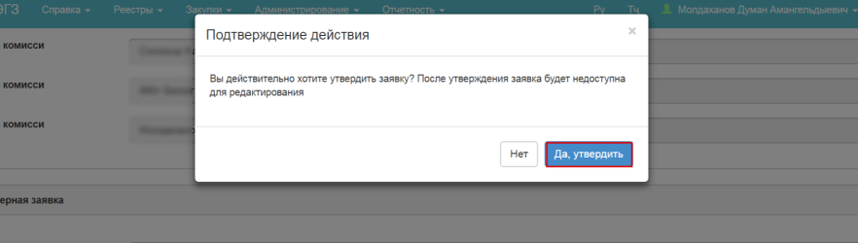
After approval, the bid changes the status to "Confirmed", in this status the bid is not available for editing.
For other cases, the "Submit to PPA" button is available on the review form:
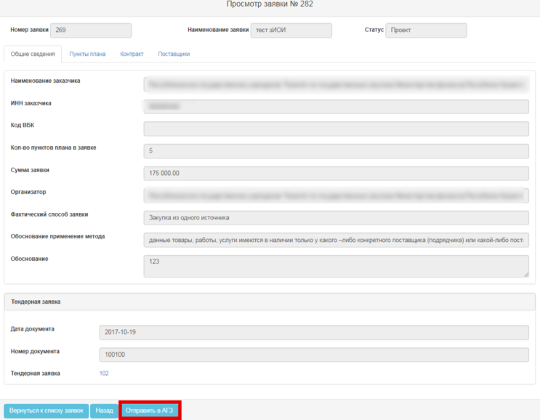
When you click the button, the system must display a modal view with the action confirmation:
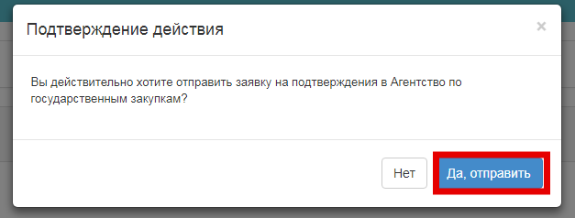
Once confirmed, the System changes the status of the bid to "On verification":
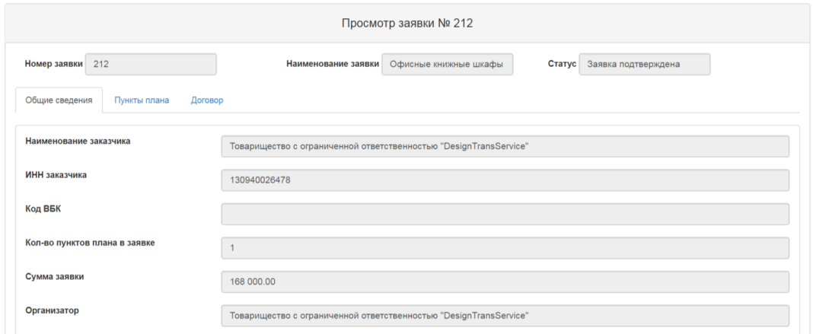

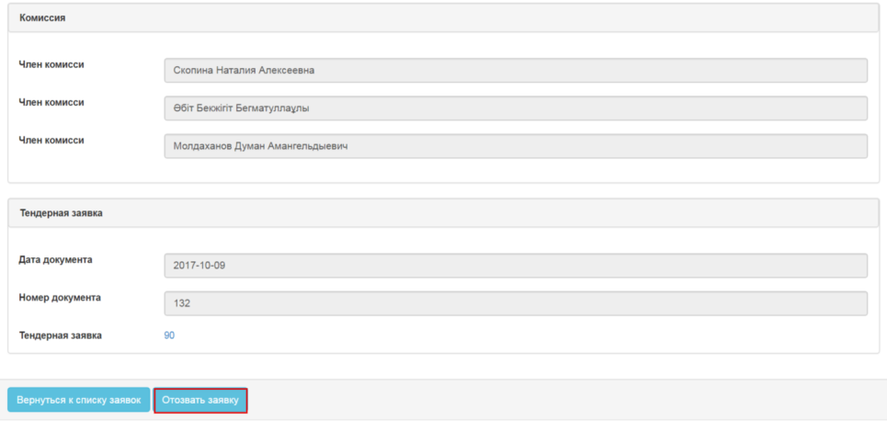

Editing a purchase bid
Editing a purchase bid is available to a user with the "Customer" role in the "Draft" "Bid Rejected", "Withdrawn" statuses.
To edit a purchase bid, go to the "Personal Account" section-"Purchase Bids".
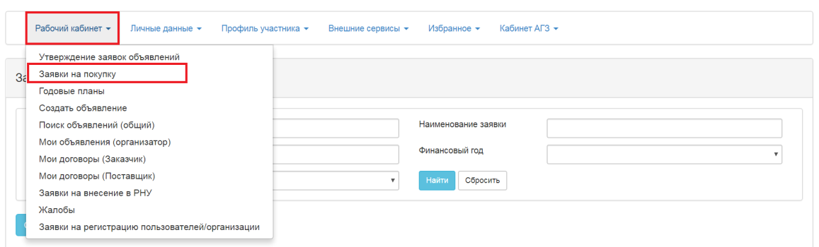
When you select "Edit" action, the bid opens in edit mode, and the step where you saved the data is displayed. You can edit the data in the bid creation form.
The system allows you to edit the data entered in the previous step by pressing "Back".
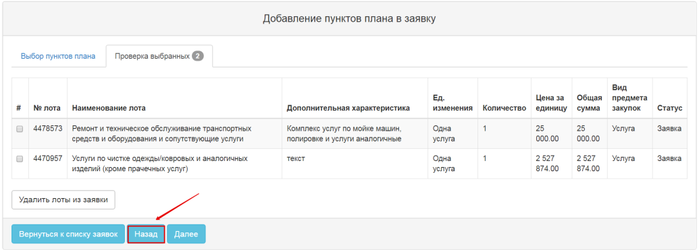
You cannot add/remove plan items in the bids, except for bids in the "Draft" status where there is no reference to an old bid.
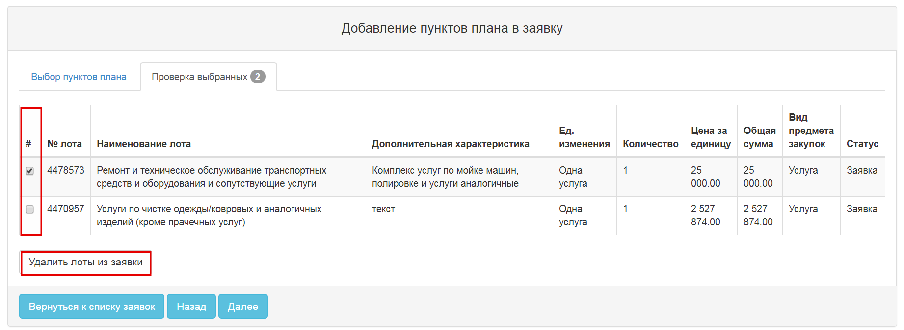
When you edit bids in the "Bid Rejected", "Withdrawn" statuses, the system will create a new bid with the reference to one you are editing (displayed in the new bid, the associated bid number), the previous one is assigned with the "Changed" status.

Withdrawal of a purchase bid
Withdrawal of a purchase bid is available in the status "On verification"/"Bid Rejected"/"Bid Confirmed". To withdraw, click the bid number in the form of working with bids:
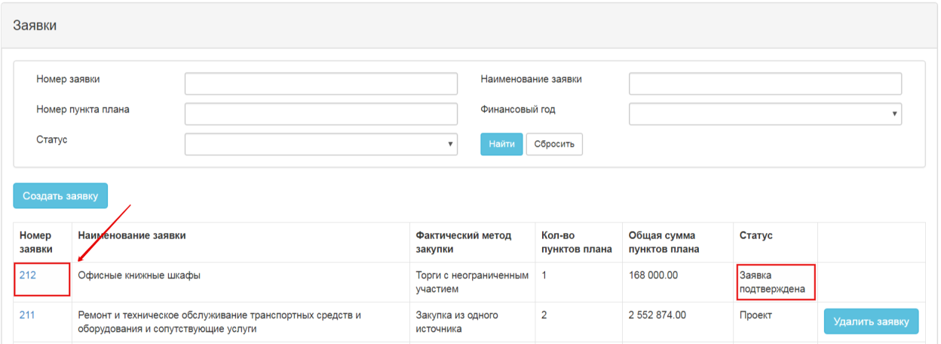
After the system displays it in the review form, click the "Withdraw the Bid" action
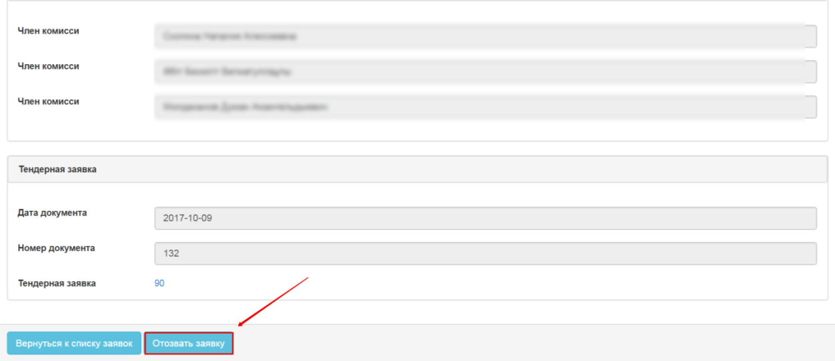
Next, the system requests confirmation of the bid withdrawal:
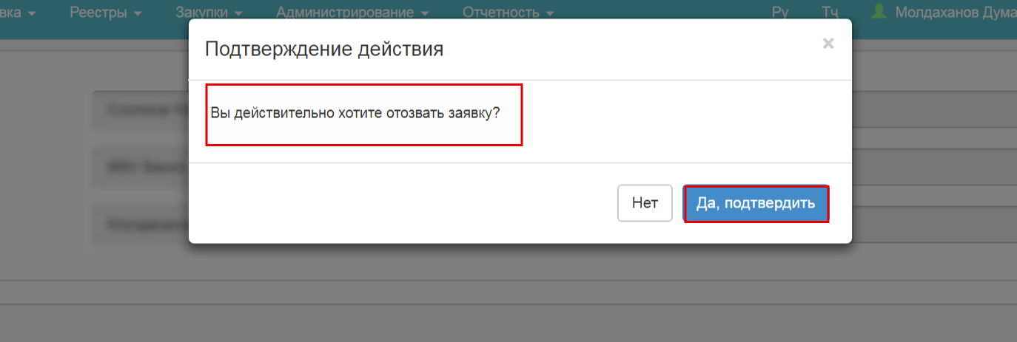
After the Customer has confirmed the withdrawal, the bid is changed to the "Withdrawn" status.
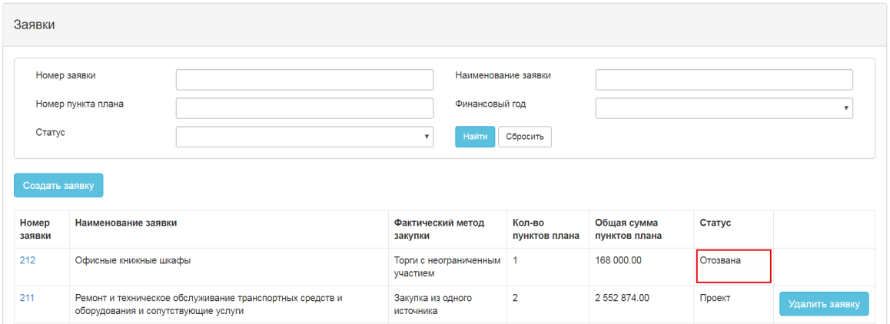
After the bid withdrawal, the system changes the status of the bid to "Withdrawn", the status of plan item to "Approved", in case when plan item status corresponds to "Bid", "Bid Confirmed", "Bid Rejected". In case the bid is being withdrawn in "Bid confirmed" status, and the status of the plan item is different from "Bid Confirmed", the System will delete the actual procedure in the plan item.

Delete a purchase bid
Deleting a purchase bid is available in the "Draft" status. To delete, in the form of working with bids next to the bid in the "Draft" status, click the "Delete the bid" action.
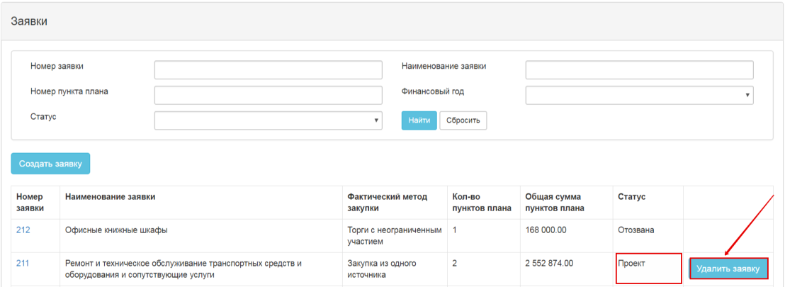
When you select deleting function, the system will require for the confirmation of the selected action:
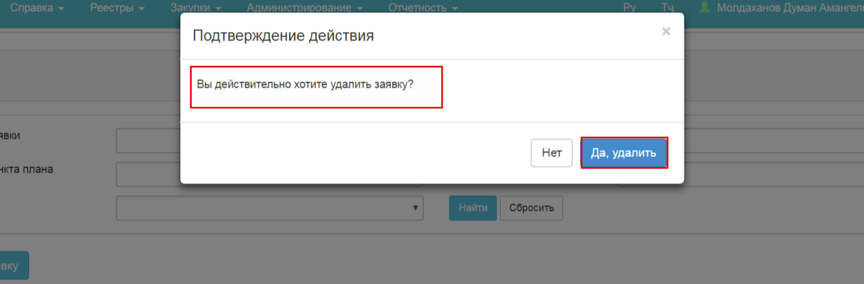
Once confirmed, the system will delete the draft bid.
After the bid is deleted, the system changes the status of plan items to "Approved";
And the plan items will return to the pool to recreate the bid, in the "Personal Account" menu- "Purchase Bids".
When you delete a bid that has a reference to another bid, the system restores the status of the original bid from "Changed" status to the previous one "Bid Rejected"/"Bid Confirmed", the status of plan items to the previous status of "Bid Rejected"/ "Bid Confirmed".

Submit for approval
The Customer can submit a bid for approval in the "Draft" status in cases when:
-the bid specifies as Facilitator the organization which is not PPA
-the procedure corresponds to "Unlimited Bidding".
To submit the bid for approval in the preview form, click the "Send To PPA" button:
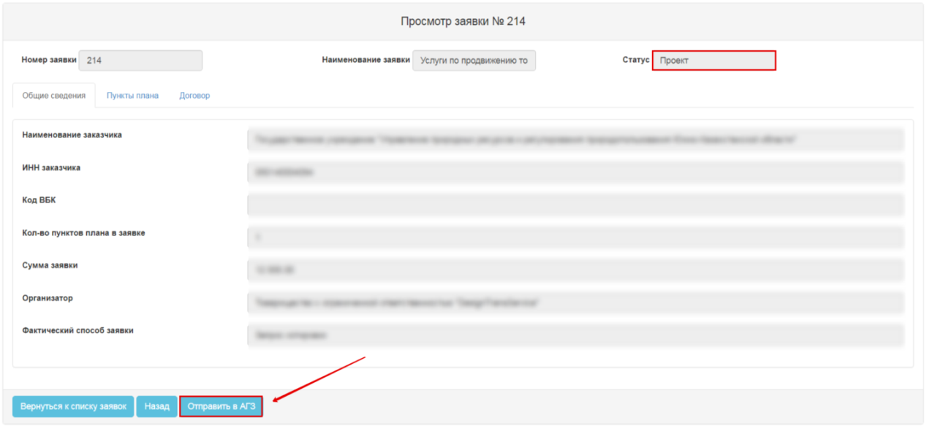
When you click "Send to PPA", the message is displayed:
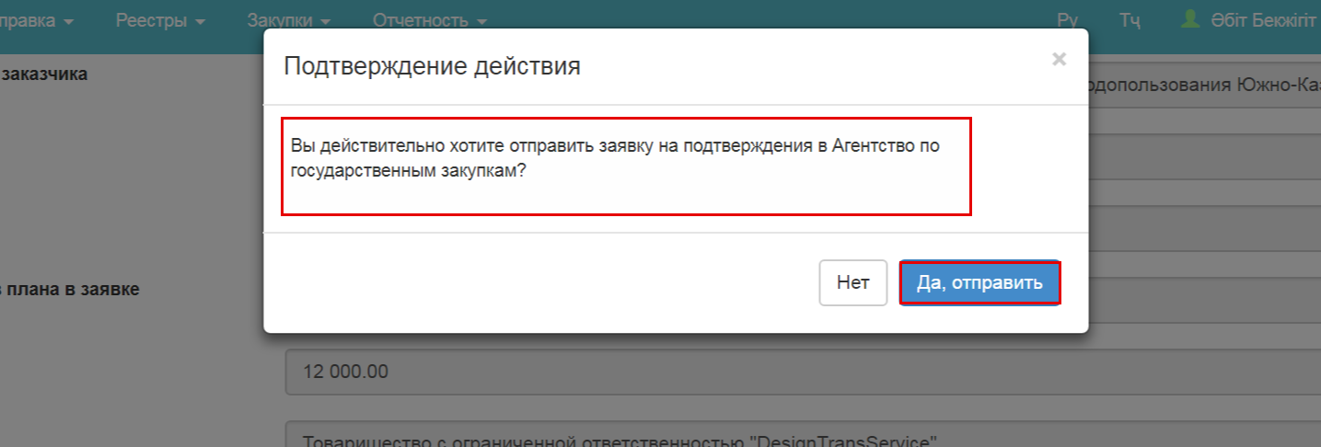
When you confirm the action, the system assigns the bid with the "On verification" status;

Consideration of bids
In order to carry out the procedure for approving a purchase order, it must first be assigned to the negotiator. After the purchase order has been sent for approval by the Procuring Entity, the system automatically sends a notice to the user with the role of "Appointing bids" (an employee of the GPA). After that the user with the specified role enters the entrance to the office of the GPA on the order viewing form.
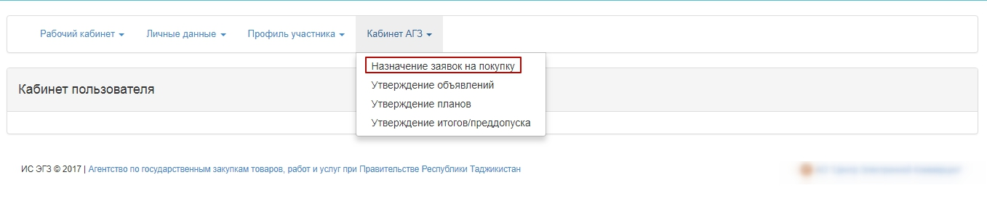
On the application review form, the Assignor needs to click on the "Assign" button
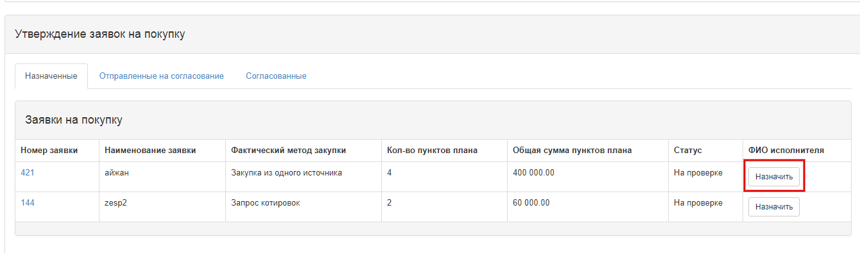
On the application review form, the Assignee determines the user who will subsequently make the approval of the bids
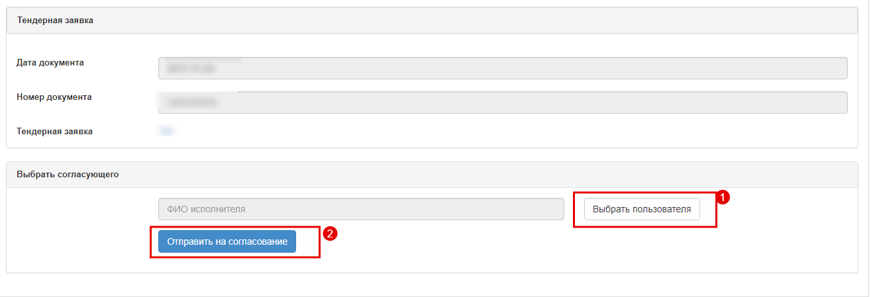
After the Nominating Buyer has selected the Approver, the function of approval of the applications becomes available to the selected user.
A user with the "Bid Approver" role can approve the purchase bid in the "On Verification" status.
To approve the application, go to PAA Back Office- Approval of purchase bids

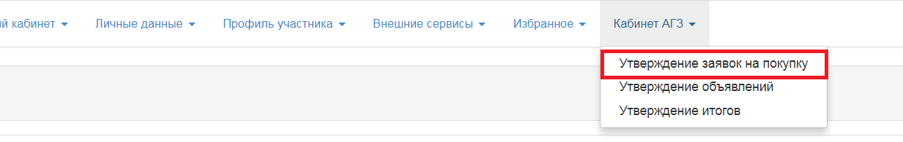
In the bid review form, click on the bid number with the status "On verification":
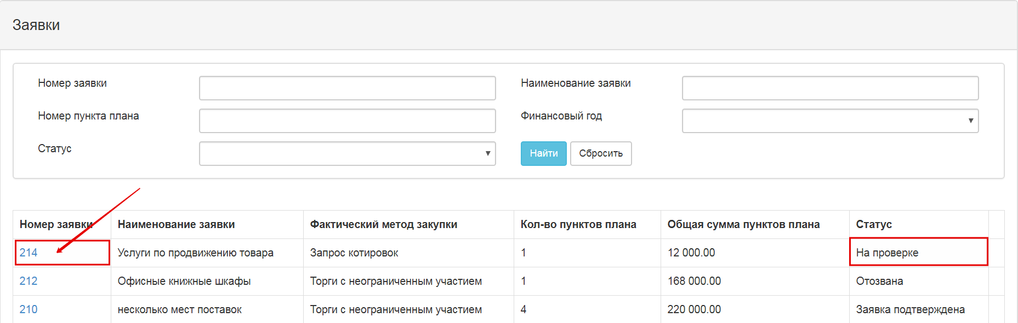
When you click the bid number, the bid review form is displayed without the possibility of editing.
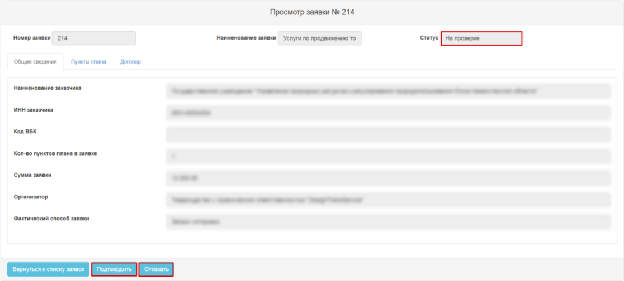
When you click "Confirm", the system changes the status of the bid and plan items to the "Bid Confirmed" status;

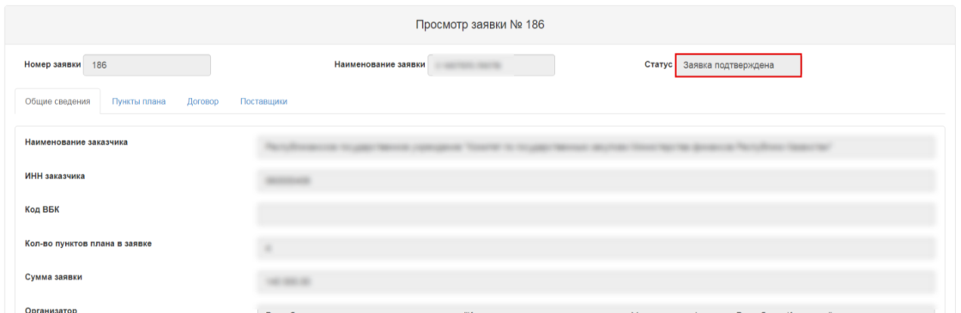
When you click the "Reject" button, a window is displayed to enter the reason for rejection.
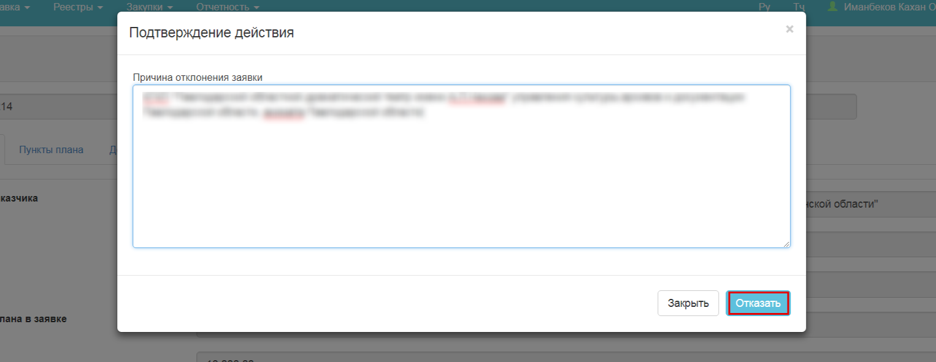
When you fill in the reason and click "OK", the system assigns the bid and plan items with the "Bid Rejected" status.

Contracts
The contract section is in the "Personal Account" tab- "My Contracts"
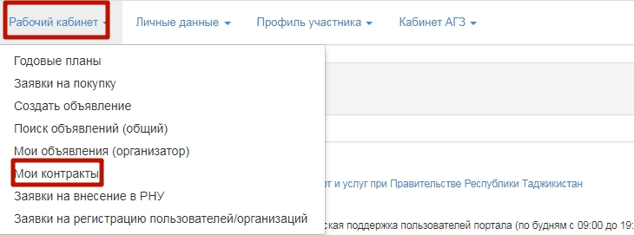

Contracts are created for the plan items in the status:
- "Procurement implemented" if the procedure "Unlimited Bidding", "Limited Bidding", "Request for Quotations", "Single Source Procurement" if the basis is equal to:
•signing of the contract in the conduct of research, experiments or the preparation of a scientific opinion
•given goods, works, services are available only from a particular vendor (contractor) or a certain vendor (contractor) has exclusive rights in respect of the goods, works or services
•carrying out procurement for a creative project or creative activity in art or culture sphere
•in the event of an urgent need for procurement due to circumstances that the procuring organization was unable to foresee (procurement procedure)
- "Bid Confirmed" if the procedure corresponds to "Single Source Procurement" and the basis is equal to:
•additional orders within 6 months from the conclusion of the contract, not exceeding 15 per cent of the value of the previous procurement, and complies with previous rules, parameters and standards;
•in the event of an urgent need for procurement due to circumstances that the procuring organization was unable to foresee (direct conclusion of the contract);
•bidding process has been twice declared void on the Portal;
- "Approved" if the procedure corresponds to the "Simplified Procurement Procedure".

Creation of a contract card
To create a contract card, click the "Create a Contract" button
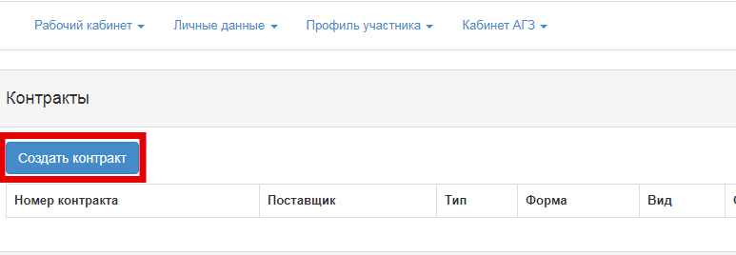
Clicking the button opens the contract creation form:
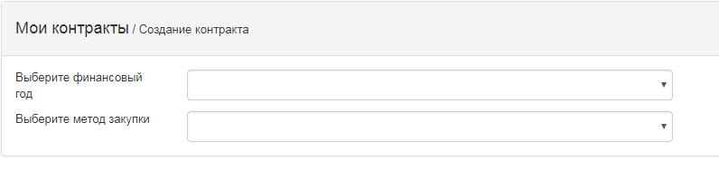
In this form, you must fill in the fiscal year of the plan item and procurement procedure.
Depending on the procurement procedure you select, different fields are displayed.
- For the "Single Source Procurement" procedure and if the basis is equal to the values:
•additional orders within 6 months from the conclusion of the contract, not exceeding 15 per cent of the value of the previous procurement, and complies with previous rules, parameters and standards;
in the event of an urgent need for procurement due to circumstances that the procuring organization was unable to foresee (direct conclusion of the contract)
bidding process has been twice declared void on the Portal
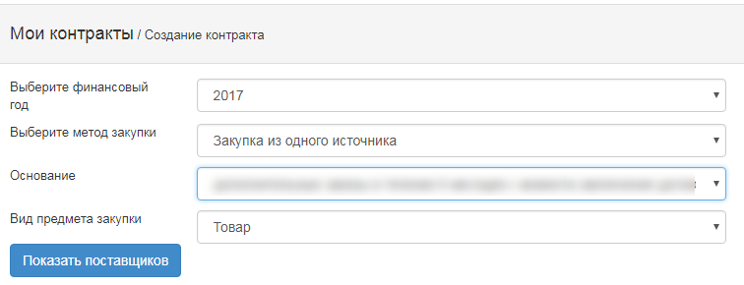

1 | Fiscal year | Select from drop-down list year of plan item
2 | Procurement procedure | Select from the procurement procedure drop-down list
3 | Justification | Select from the directory of justifications for applied procedure
4 | Type of procurement item | Selected from the directory of procurement item types
5 | Show Vendor | When you click the button, the vendor specified in the purchase bid is displayed

- For the "Single Source Procurement" procedure and if the basis is equal to the values:
• signing of the contract in the conduct of research, experiments or the preparation of a scientific opinion
•given goods, works, services are available only from a particular vendor (contractor) or a certain vendor (contractor) has exclusive rights in respect of the goods, works or services
•carrying out procurement for a creative project or creative activity in art or culture sphere
•in the event of an urgent need for procurement due to circumstances that the procuring organization was unable to foresee (procurement procedure)
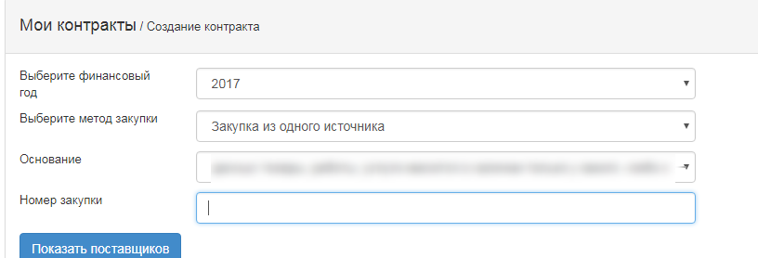

1 | Fiscal year | Select from drop-down list year of plan item
2 | Procurement procedure | Select from the procurement procedure drop-down list
3 | Justification | Select from the directory of justifications for applied procedure
4 | Procurement number | The number of the implemented procurement is filled in
5 | Show Vendor | When you click the button, the vendor specified in the purchase bid is displayed

- For "Unlimited Bidding", "Limited Bidding", "Request for Quotations" procedures:
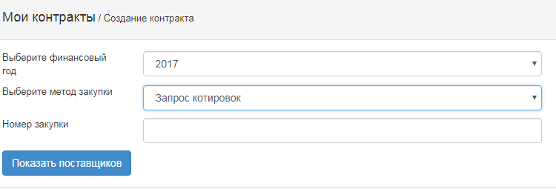
1 | Fiscal year | Select from drop-down list year of plan item
2 | Procurement procedure | Select from the procurement procedure drop-down list
3 | Procurement number | The number of the implemented procurement is filled in
4 | Show Vendor | When you click the button, the vendor which is winning bidder is displayed

- For the "Simplified Procurement Procedure":
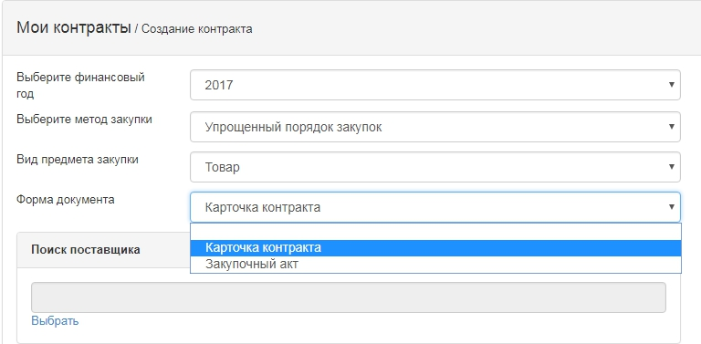

1 | Fiscal year | Select from drop-down list year of plan item
2 | Procurement procedure | Select from the procurement procedure drop-down list
3 | Type of procurement item | The number of the implemented procurement is filled in
4 | Document form | Select from the drop-down list:  Contract Card (if contract is concluded)  Procurement Act
4 | Vendor Search | When you click the button, the Vendor search form is displayed
In the window that appears, you must enter the Vendor's INN and click the "Find" button. If the Vendor is registered with the System, click the "Select" button:
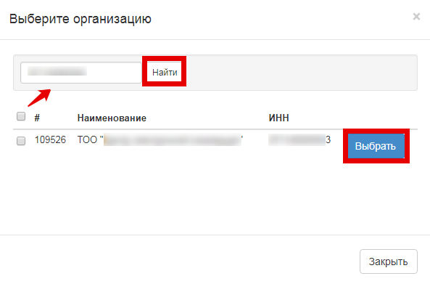
If the Vendor with the specified INN is not registered in the System, click the "Add a Vendor" button to add it manually
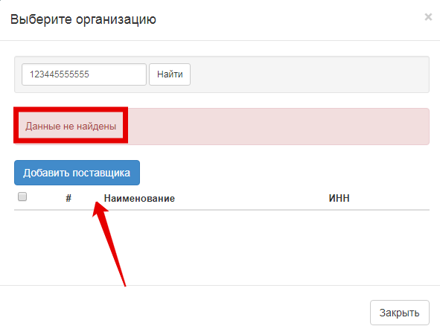
When clicking the button a window will be displayed with a form to fill in the vendor's data:
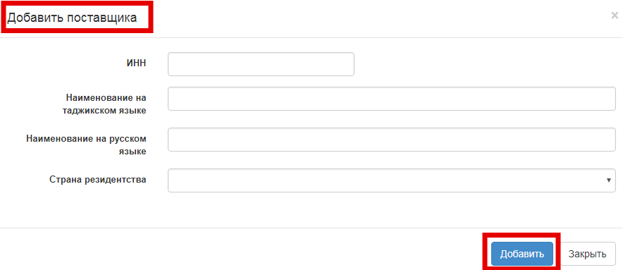

1 | INN; | Vendor's INN must be entered
2 | Name of the Vendor in the Tajik language | It is required to fill in the Vendor's name in the Tajik language
3 | Name of the Vendor in the Russian language | It is required to fill in the Vendor's name in the Russian language
4 | Country of residence | Selected from the directory of countries
When you have filled in all the fields, click the "Add" button
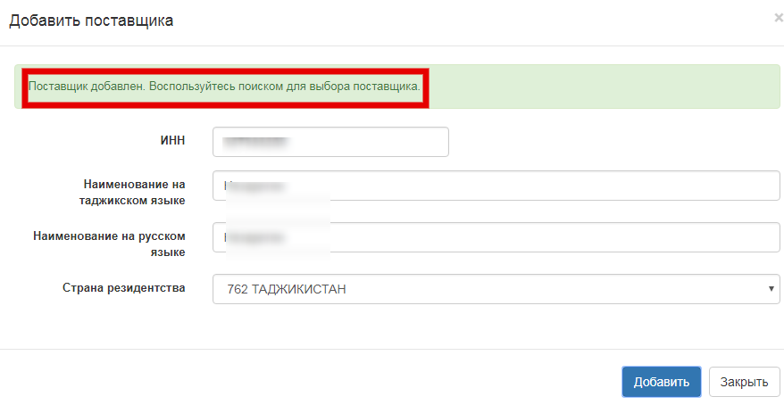
When you have filled in all the required fields on the Create a Contract Card form, click the "Create a Contract Card" button
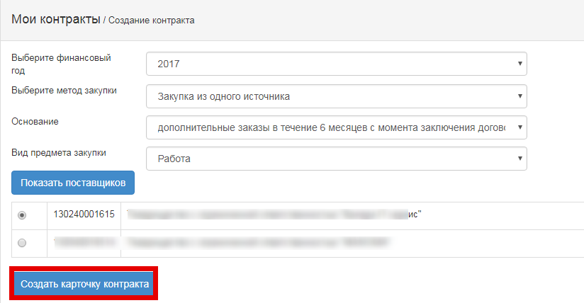
The system will create a contract card (or Procurement Act) and assign a 17-digit ХХХХХХХХХ/YYYYYY/ZZ system number to the contract in which:
- ХХХХХХХХХ-Customer INN
- YYYYYY-the serial number of this Customer's contract, where the first 2 digits represent the fiscal year of the plan item;
ZZ- contract type, if it is primary, 00, if supplementary agreement 01, 02 ... 0N (where N is the serial number of the supplementary agreement to the given contract).
When you create a card, the contract is assigned with the "Draft" status
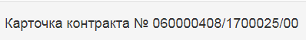
The contract card contains the following sections:
- General
- Contract items
- Contract Parties
- Contract

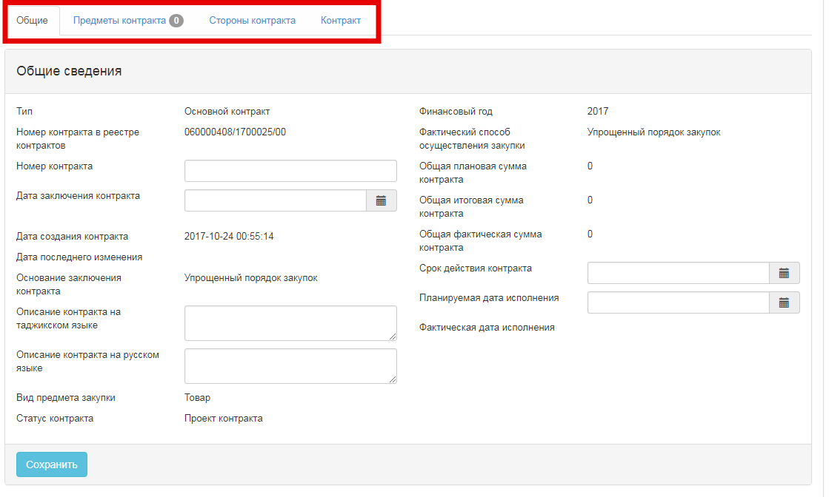
Fill in the required fields in the "General" tab:
- Contract number
- Contract date
- Description of the contract in the Tajik language
- Description of the contract in the Russian language
- Planned date of performance
- Term of agreement
After filling in, click the "Save" button.
The "Contract Items" tab contains two sections:
- Available items
- Selected items
The available items display the plan items that correspond to the criteria specified on the Creation of a Contract Card form.
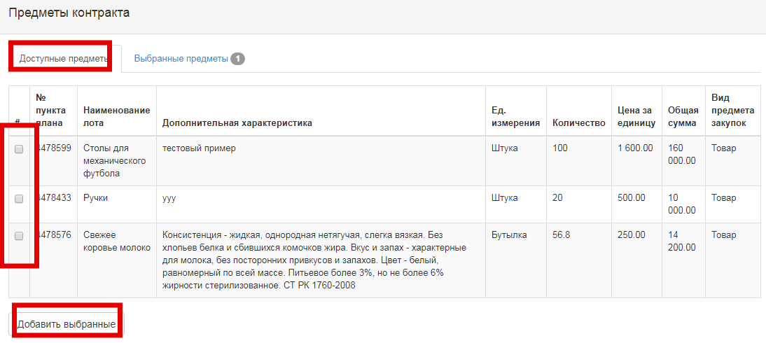
You must tick the desired plan items and click the "Add Selected" button.
The added items are displayed in the "Selected Items" section. If required, items added by mistake can be deleted by clicking on the "Delete selected" button.
The plan items that are added to the contract are assigned with the "Draft Contract" status.
Next, click the hyperlink with the item number.
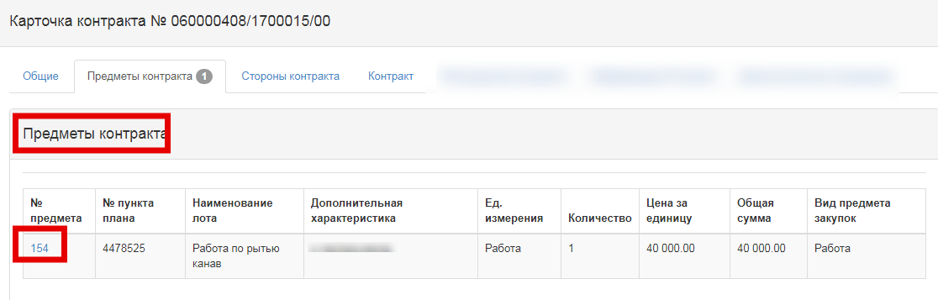
When clicked, a detailed review form of the contract item is disclosed:
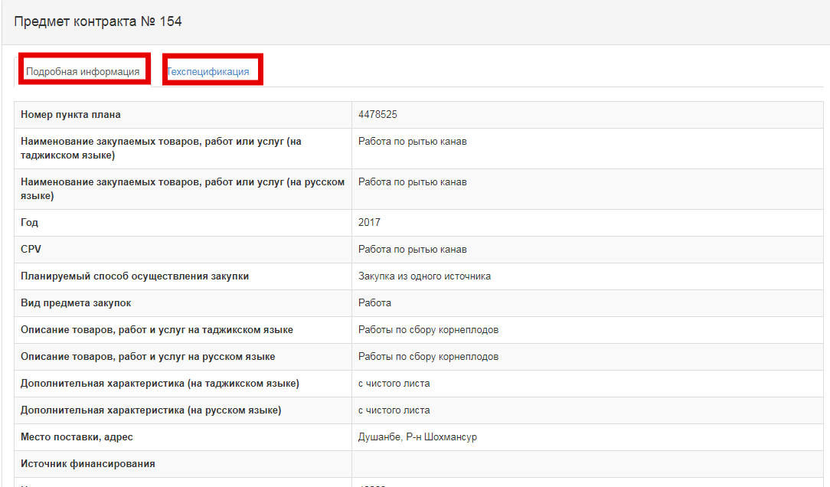
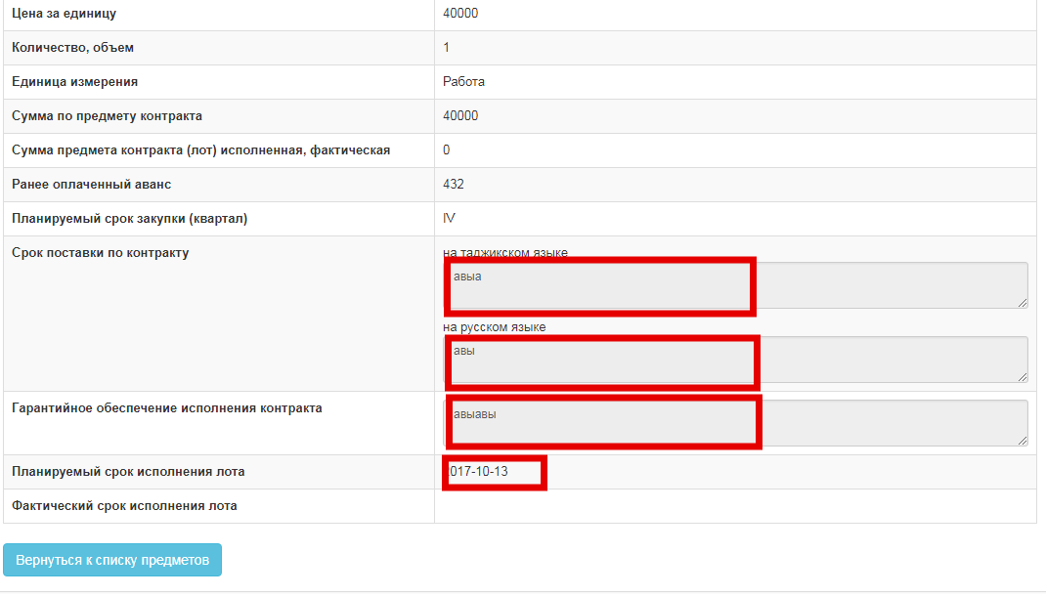
Fill in the required fields in the "Contract Items" tab:
- Contract Performance Guarantee;
- Term of delivery under the contract in two languages;
- The expected time of the lot implementation;
The "Unit Price" field displays the price proposal of the vendor-winning bidder if there was a procurement procedure and a planned price if there were no procurement procedures.
Attention! The unit price is available for editing only downward.
After you have filled in all the fields, click the "Save" button.
Next, you need to go to the "Technical Specification" tab.
In the Technical Specification tab, an attached technical specification of the vendor which is a winning bidder is automatically displayed if procurement procedure has been performed:
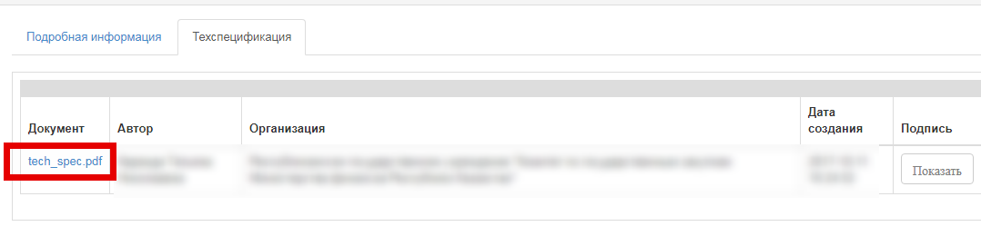 And files from a purchase bid that can be edited if there has not been the procurement procedure.
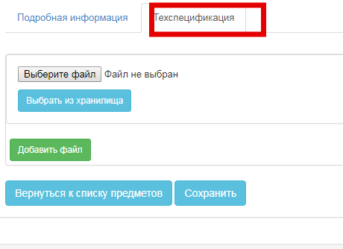
After you attach the technical specification, click the "Approve" and then "Save" buttons
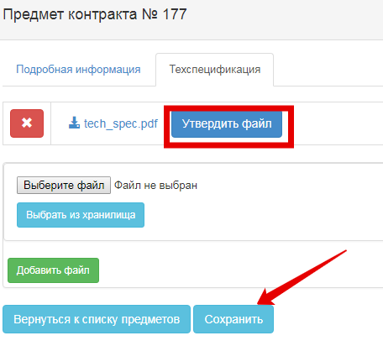
The Contract Parties tab displays information about the customer and the vendor. With the possibility to specify a VAT indication for the vendor:
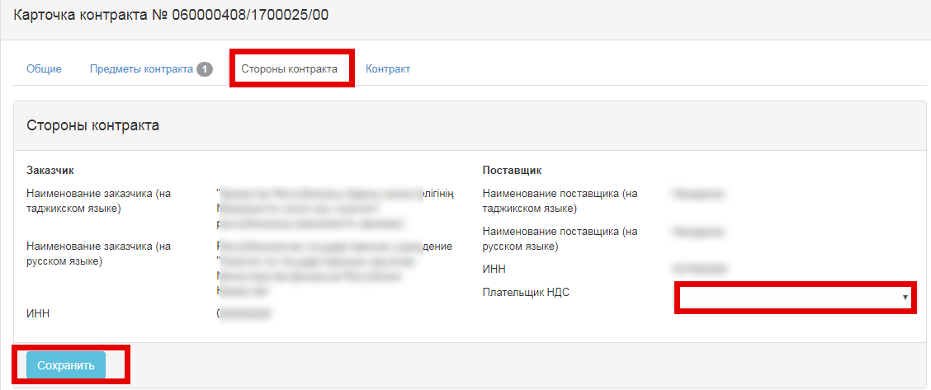
Once you have filled in the field, you should click on the "Save" button.
The Contract tab contains two sections:
- Contract;
- Cancel the contract conclusion.

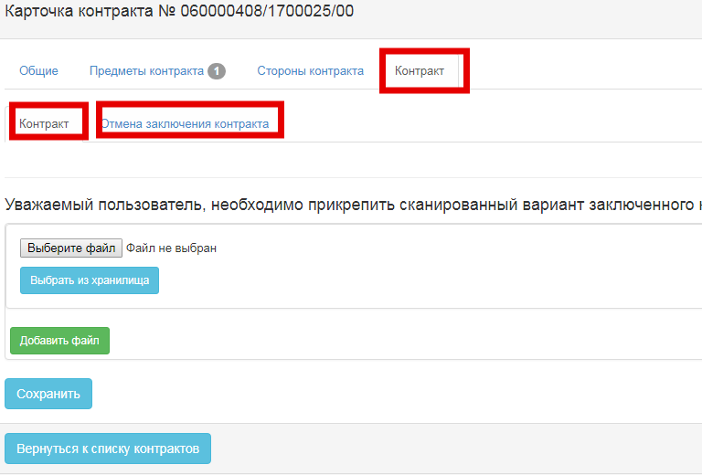

Delete the contract card
Deleting the contract card is available in the "Draft" status of the card. To delete, click the icon in the contract review form on the line with the required contract 
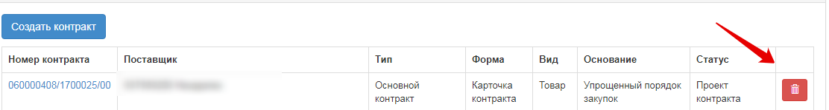
When you click the icon, the System will prompt you to confirm the action:
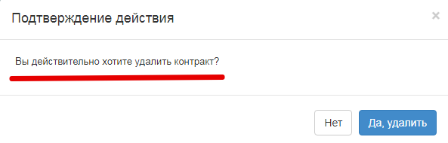
If it is confirmed, the contract card is deleted, the plan items in the contract are changed to their original status. In case of deleting a contract card of "Supplementary Agreement" type, when you delete the status of the main contract (or the previously concluded additional agreement) is changed from "Supplementary Agreement Created" to "Valid".

Edit Contract Card
Editing of the "General", "Contract Items", "Contract Parties", and "Contract" tabs is available in the "Draft Contract" card status.
To edit a card, click a link with the contract number:

Delete contract conclusion
If a contract has not been concluded, in "Cancellation of Contract Conclusion" you must fill in the field "Justification for the Cancellation of Contract Conclusion" and attach the scan of the confirming document

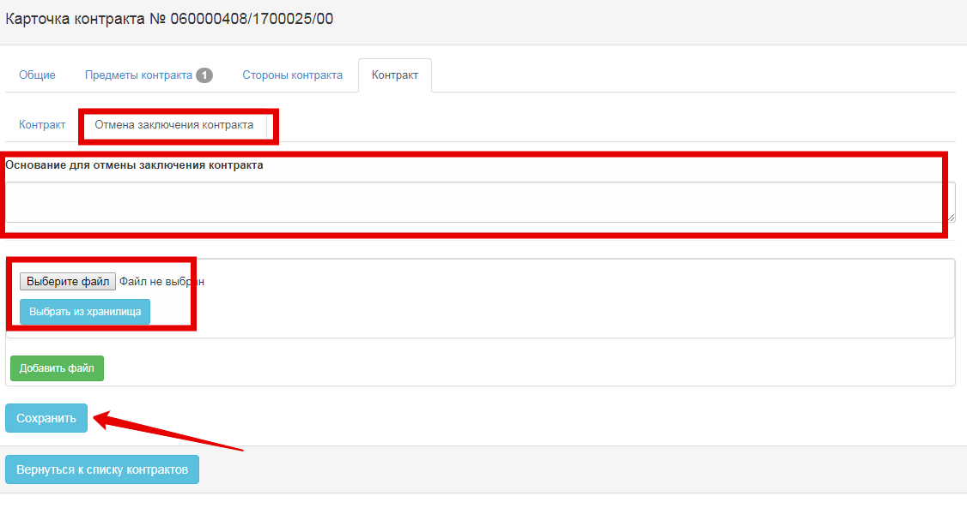
When you click the "Cancellation of Contract Conclusion" button, the system will prompt you to confirm the action:
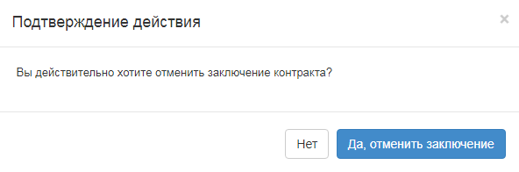
If an action is confirmed, the System changes the status of the card to "Not Concluded", and the status of the plan items to "Contract Not Concluded"

Contract with Next Bidder
The "Create contract with the next bidder" button is available for contracts in the status "Not concluded", and if the procedure matches "Unlimited Bidding", "Limited Bidding", "Request for Quotation", "Single Source Procurement".
Attention! The button is displayed if, according to the minutes of tender results, there are second, third bidders
The button is available in the "Contract" tab under "Cancel Contract Conclusion" section:
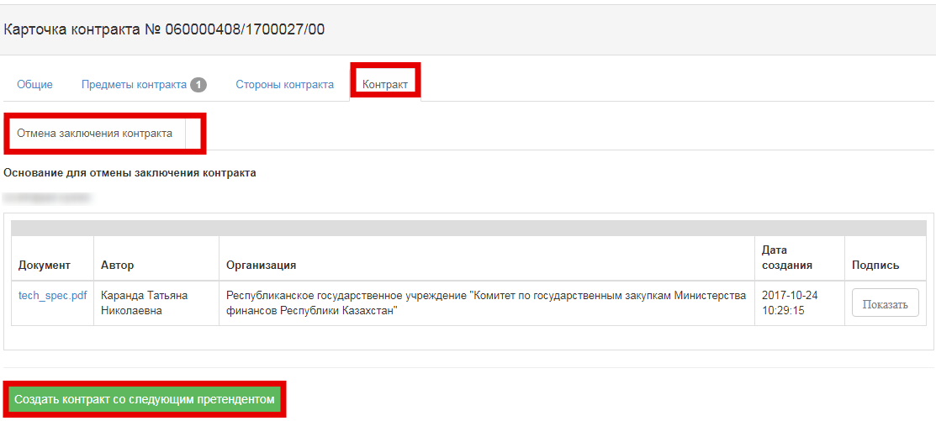
When you click the button, the System will prompt you for confirmation of the action:
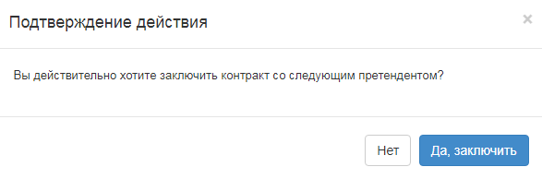
If confirmed, the System automatically creates a contract card in the "Draft" status with the following vendor.

Contract Card Approval
If the contract was concluded, attach the scanned version of the concluded contract to the "Contract" section
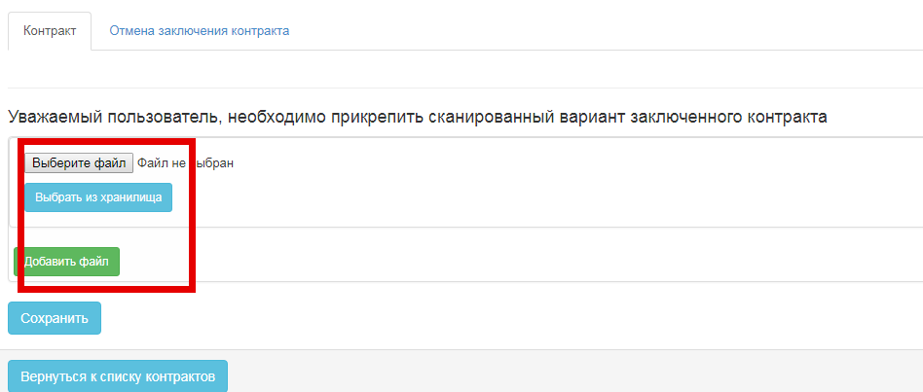
Before clicking the "Approve" button, check that the data in all the tabs is filled correctly. If this is correct, click the "Approve" button. When clicked, the status of the contract changes to "Valid", and the status of plan items to "Contract is Valid". The contract is not available for editing in the "Valid" status.

Contract Execution
To execute the contract, you must add payments to the "Payment Information" tab
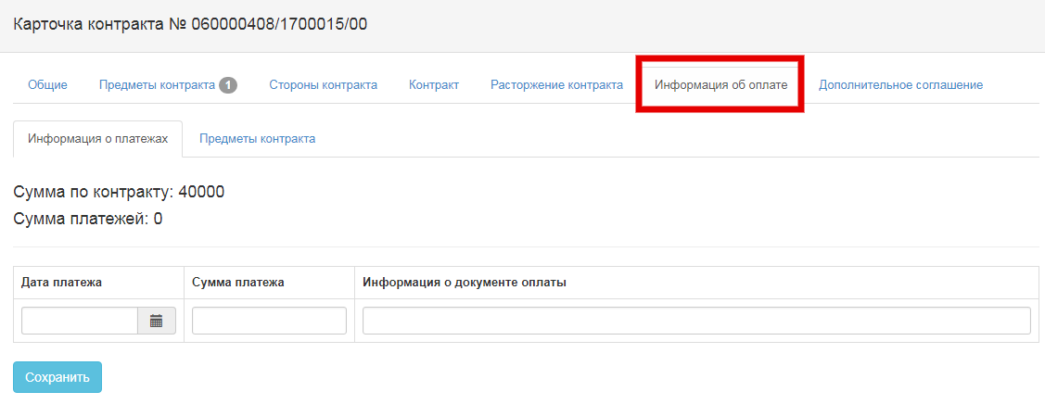
This tab contains sections:
- "Payment Information" - the tab is designed to make payments
- "Contract Subjects" - the tab is designed to distribute payments by purchase items.
To add a payment, you must fill in the date, amount, information about the payment document and click the "Save" button
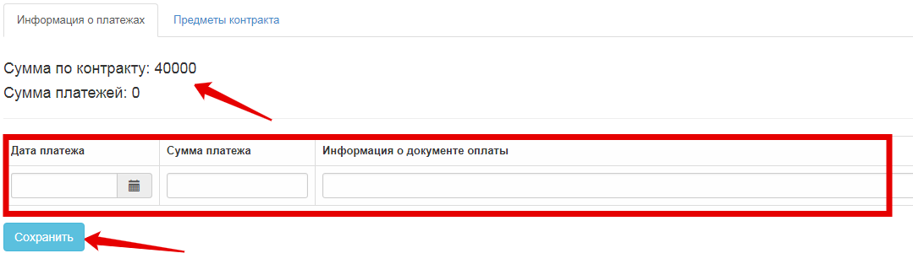
In the add payments form, the information is displayed to enter the correct amounts: "Contract Amount:" ХХХХХ»
Attention! The total amount of payments should not exceed the amount of contracts.
If the payment is saved successfully, it is displayed in the table of payments and is available for deletion
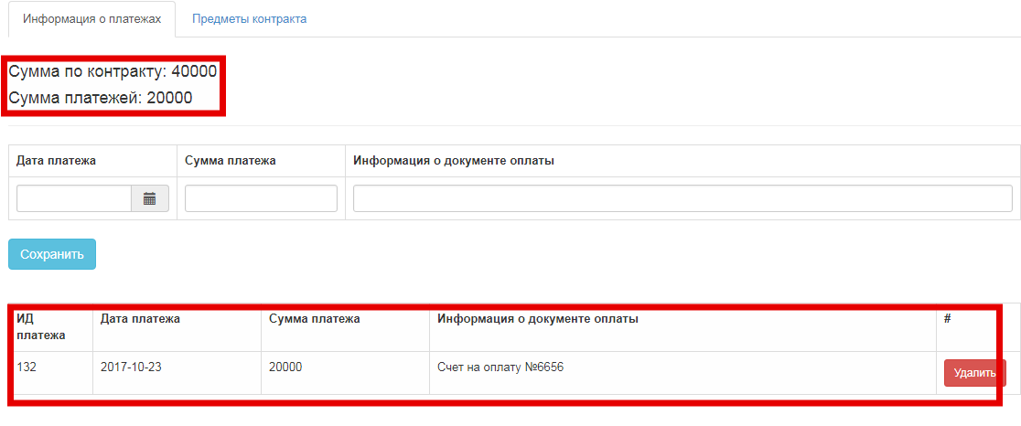
The delete payment function is available if the amount of the remaining payments after the payment is deleted is greater than the amount of the executed contract subjects. That is, if the contract has a subject with the"Executed" status, you can delete payments till the remaining amount overlaps the executed contract subject.
After you make payments, you must distribute the amounts by contract subjects in the "Contract Subjects" according to the delivery places. It is necessary to fill in the amounts of the contract subjects that are covered by the total amount of the added payments according to performed works/rendered services/delivered goods.
To do this, click the "Distribute Payment" hyperlink
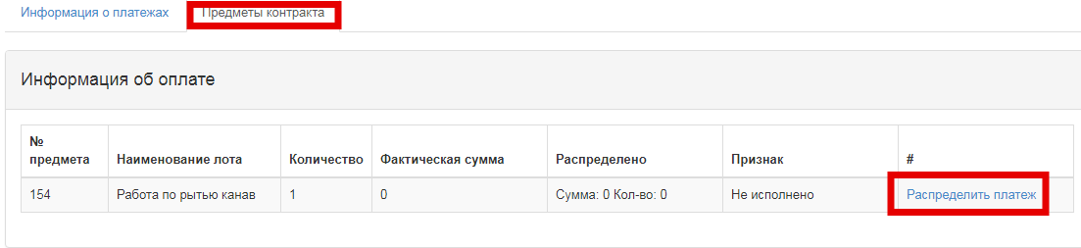
When you click the hyperlink, the payment distribution form opens
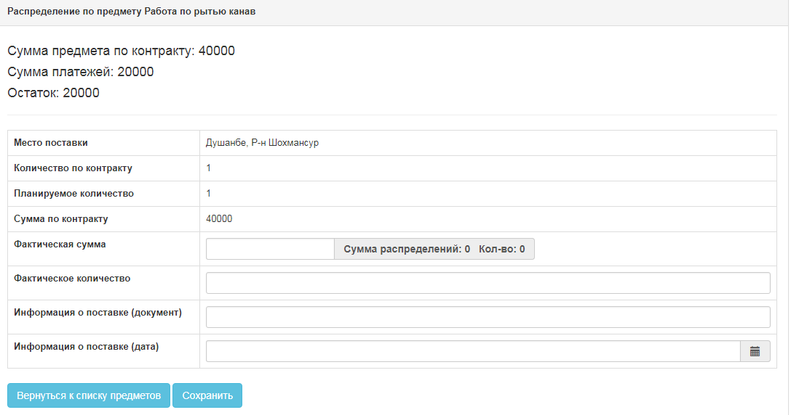
The following is an example of a payment distribution:
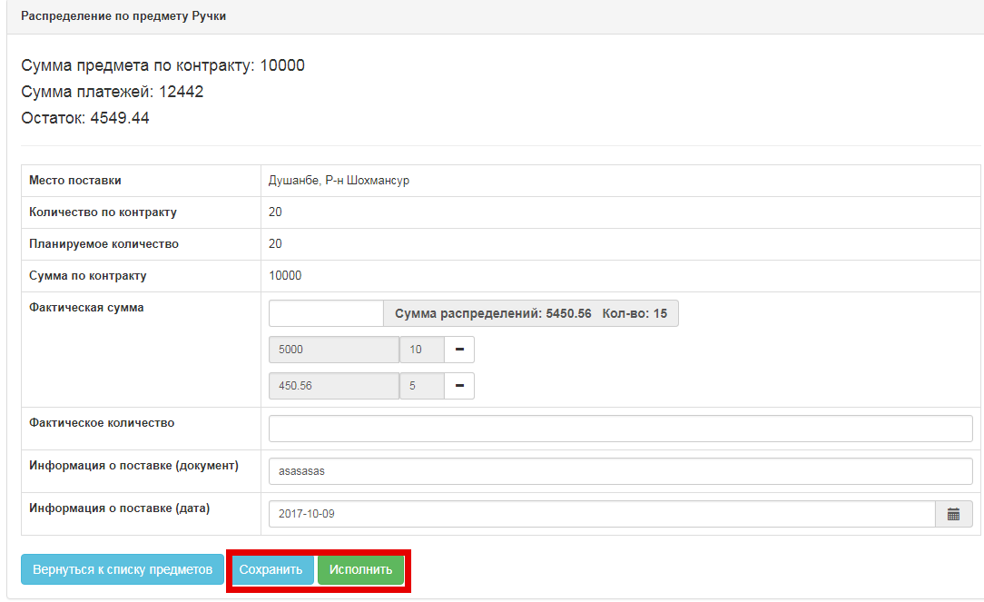
To execute the subject, you must click the "Execute" button in the payment distribution form. The system allows you to execute a subject by the amount that is less than the contract amount.
Example: planned amount -10,000 somoni,
the amount of contract concluded - 9,000 somoni;
the amount of actual payments - 7,000 somoni.
Attention! Before you execute the subject, make sure that the information you entered is correct and complete.
During execution, the System checks for:
- availability of distributed payment. If there is no payment, the System displays the error text: "No distributed payments for subject";
- The amount of the payments added must be equal to the amount of the distributed payments. If the amount of the distributed payments is less, the System displays the error text: "You have undistributed payments";
When you click the button, the System will prompt you for confirmation of the action:
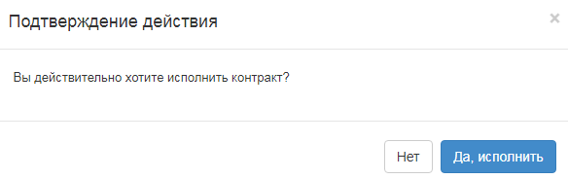
Upon confirmation, the System places the performance indicator on the subject, changes the status of the plan item to "Executed", if all subjects in the contract are fulfilled, changes the status of the contract to "Executed".

Contract termination
The system provides for the possibility of terminating the contract for the contracts of "Valid" status, unless the form of the card is "Procurement Act".
To terminate the contract, you must follow to the "Contract Termination" tab
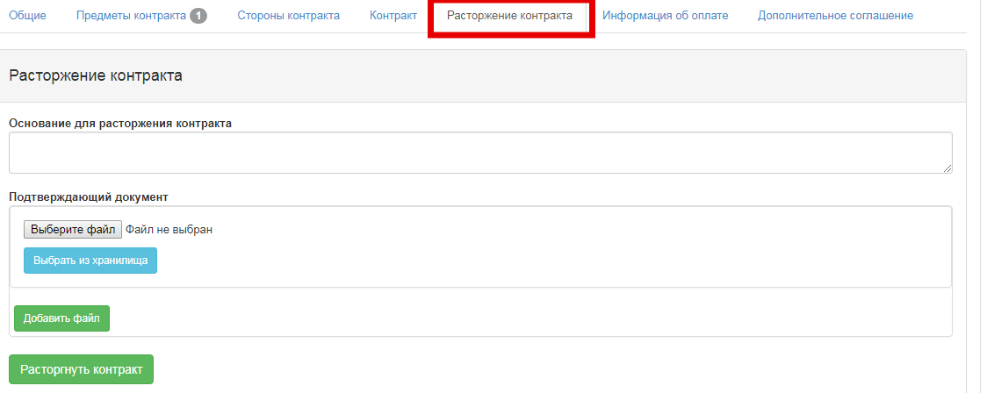
In this tab, you must fill in the "Justification for Contract Termination" field and attach a scan copy of the document confirming the termination.
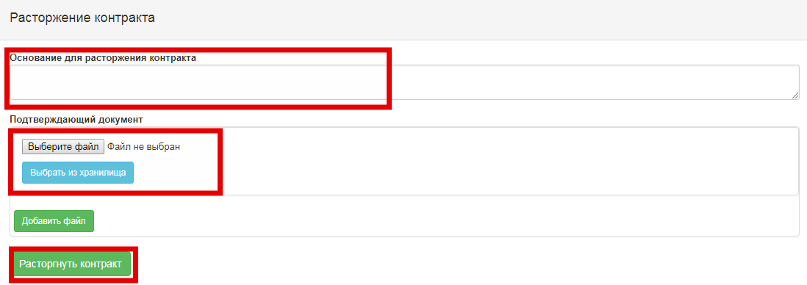
Next, you click the "Terminate Contract" button. When you click the button, the System will prompt you for confirmation of the action:
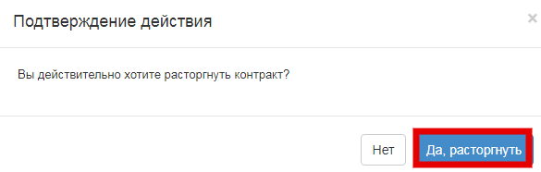
If confirmed, the system changes the contract status to "Terminated". The status of plan items changes depending on whether payments are made or not:
- If there are no payments for the subject, the status of the plan item is changed to "Contract Not Executed". No payments";
- If there are distributed payments under the contract subject, the status of the plan item is changed to "Partially executed";
Attention! It is not permitted to terminate a contract if there is one subject in the contract and there are distributed payments for it for the total amount of the contract.
If the amount of distributed payments is equal to the contract amount, the System displays an error message: "You have made payments for the full amount of the contract". "The contract must be executed or the payment data shall be aligned".

Create supplementary agreement
Creation of a supplementary agreement is available for the "Valid", "Executed" statuses of the contract

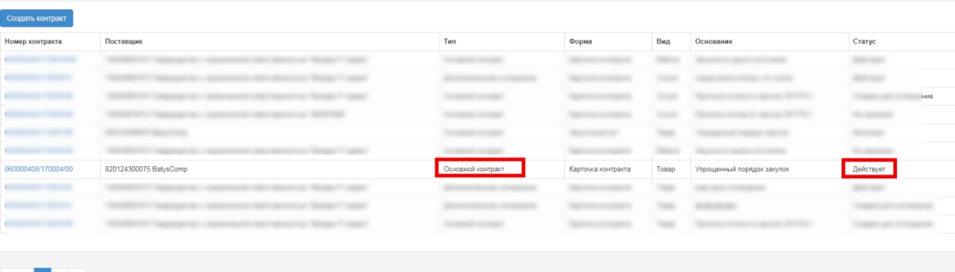

To create a supplementary agreement, go to the "Supplementary Agreement" tab
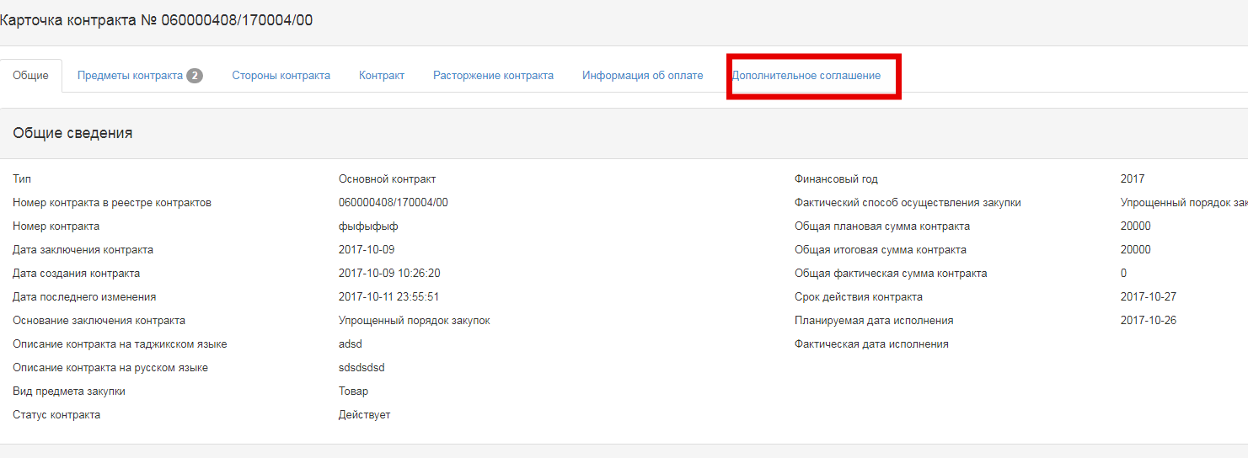
In the "Supplementary Agreement" tab, you must fill in the justification for creating a supplementary agreement and click the "Create Supplementary Agreement" button
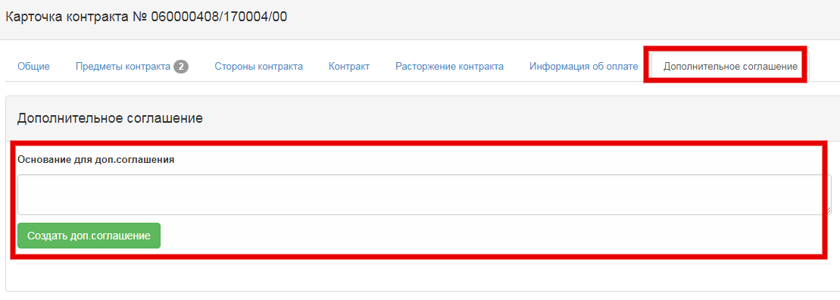
When clicked, the System automatically creates a draft card with the "Supplementary Agreement" type
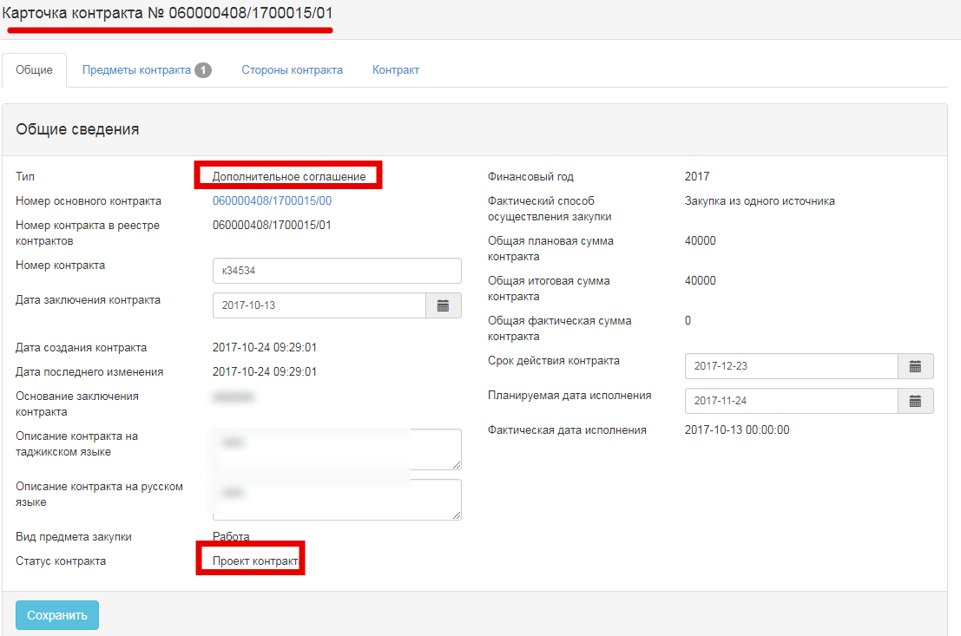
The supplementary agreement number is similar to the basic contract number with index 01 (02.03...).
Approval of the supplementary agreement is similar to the approval of the basic contract.
On the "Contract Items" tab, if there is more than one subject in the contract and supplementary agreement requires to edit the subject data, click the "Edit" button on the line with the required subject.
Attention! The supplementary agreement allows for an increase in the unit price
If a supplementary agreement has been created for the basic contract, the status of the basic contract is set to "Supplementary Agreement Created".
If a supplementary agreement has been created for the basic contract, the status of the basic contract is set to "Supplementary Agreement Created".
Actions in the basic contract are prohibited. All necessary actions are performed in a supplementary agreement. In particular, the following supplementary agreement shall be concluded in the current supplementary agreement.

Procurement Act
The "Procurement Act" form applies only to the "Simplified procurement procedure"
The procurement act contains the following sections:
- Contract items
- Vendor
- Information on confirming document
The description of the "Contract Items", "Vendor" tabs is the same as the tab descriptions for the contract card.
In the "Information on Confirming Document" tab, you must fill in the fields:
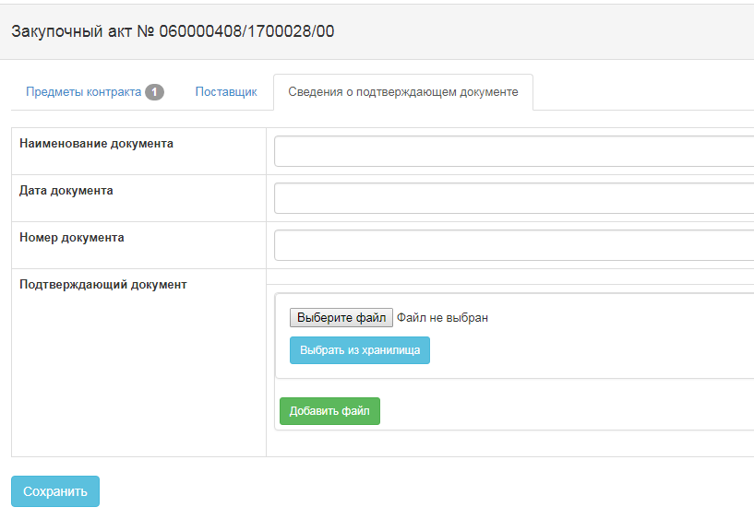
Attach a scan copy of the confirming document and then click the "Approve File" button
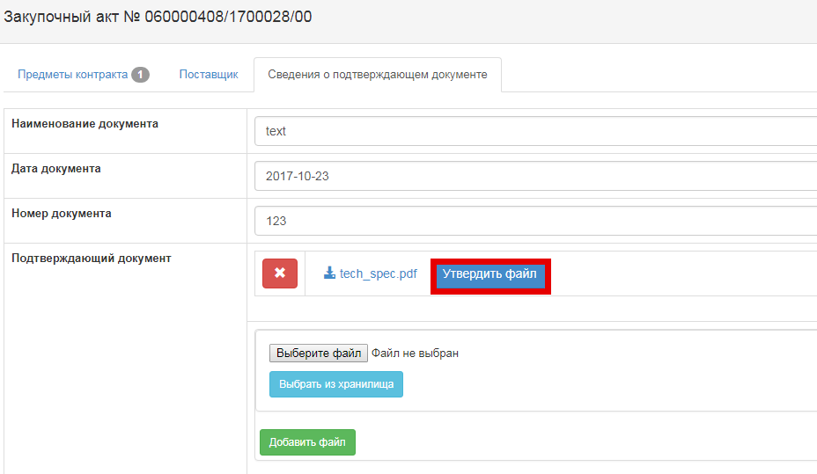
Then click the "Save" and "Execute" buttons
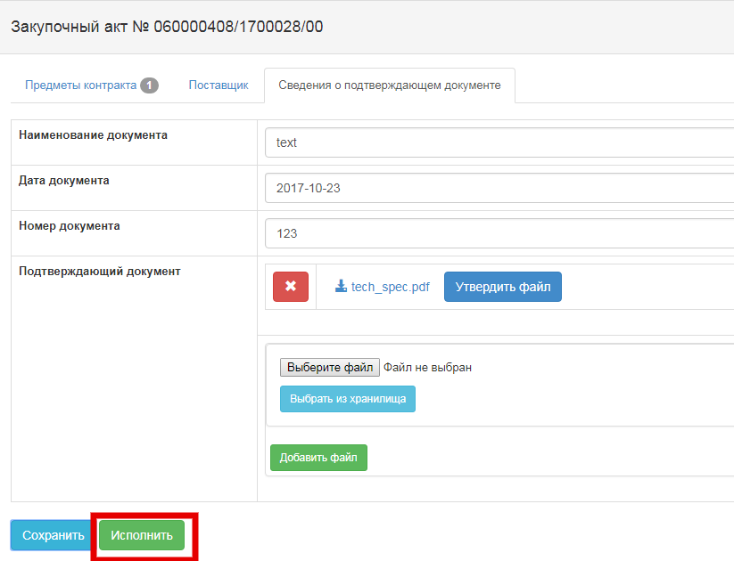
When you click the "Execute" button, the System blocks the actions on the agreement and the status is set to "Executed".

Maintain of the Register of mala fide suppliers
The Register of mala fide suppliers of public procurement (hereinafter-RMFS) is a list of justifications:
1) failure to fulfill its obligations at least in one public procurement agreement within two years prior to commencement of the procurement procedure
2) bankruptcy or in the process of bankruptcy
3) submission of knowingly false information, distortion of facts, deception of their qualifications
4) providing substantially inaccurate or incomplete information on their qualifications

Searching for bids to include in the Register of mala fide suppliers
The following search items are contained in the form of bid management of the authorized body with information:
• Vendor Name;
• Vendor BIN;
• Vendor INN;
• Customer Name;
• Customer BIN;
• Number of court decision;
• Bid Status;
• Date of submission to the Authorized Body "C";
•Date of submission to the Authorized Body "SW";
To search for bids to register of mala fide suppliers, the authorized body staff members are required to provide the necessary value and click the "Find" button
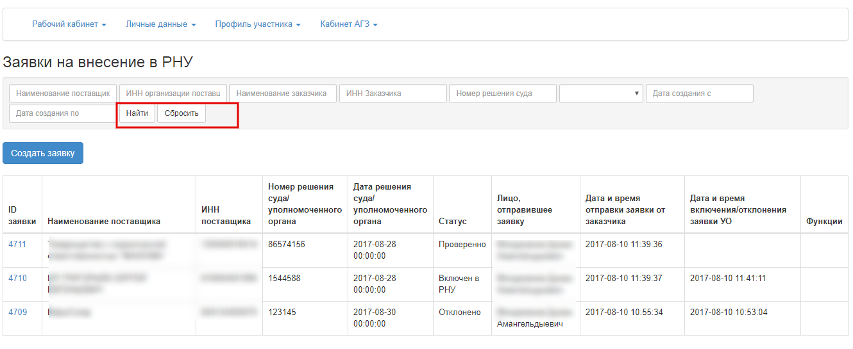

Creating and submitting a request to include a vendor in the Register of mala fide vendors
To maintain the Register of mala fide vendors through Web portal, it is required to assign the authority "Customer" in the Member Profile - Employees" section
To create and submit requests with information to include in the "Register of mala fide vendors", go to the "Personal Account" -"Requests for RMFV" section
To submit the Authorized Body a request with information for recognition of a potential vendor as a mala fide vendor of public procurement in the "Requests for RMFV" section, click the "Create a request" button:
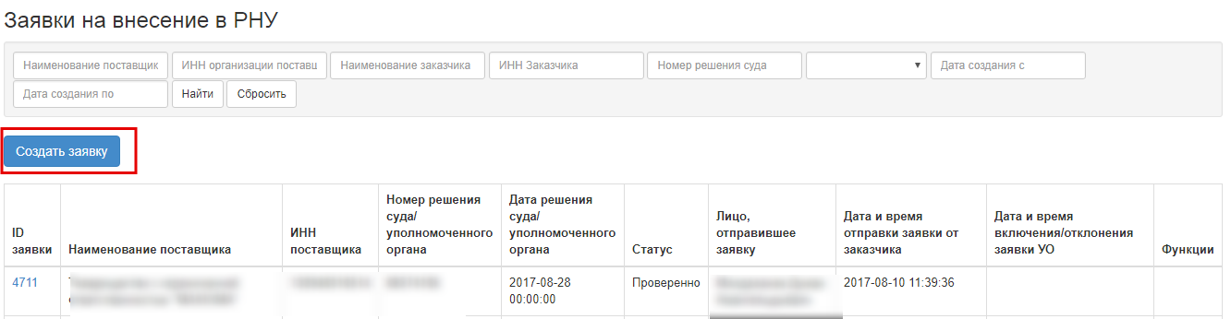
A window will be opened to create a request with information:
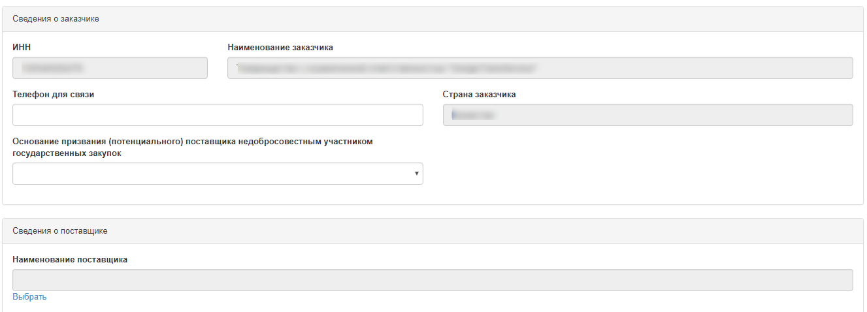
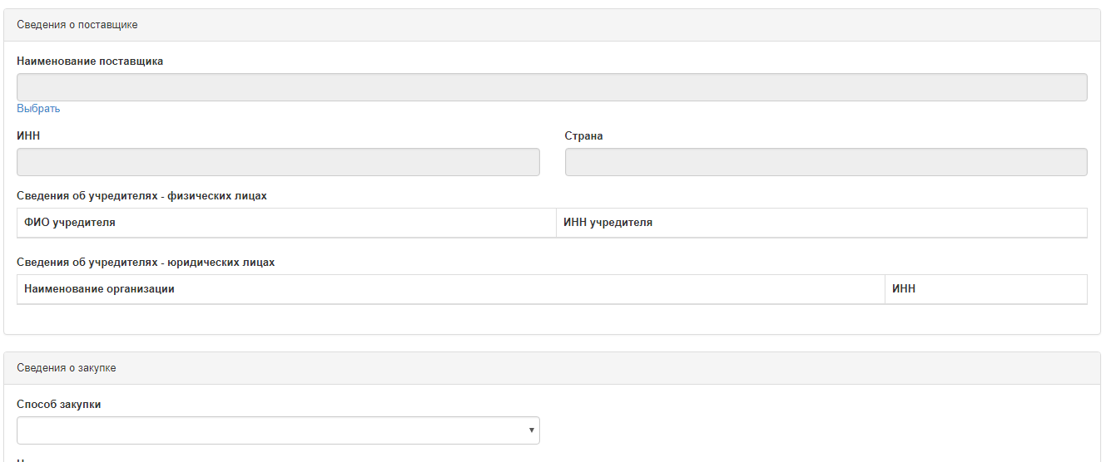

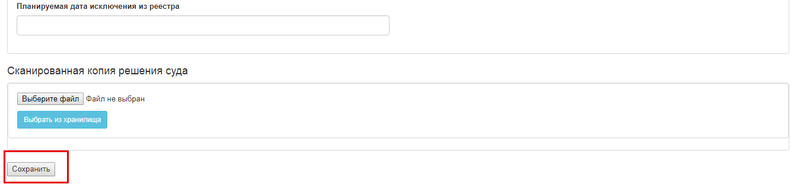
You must fill in the request form and click the "Save" button.
After the request is saved, the "Created" status is set to the request.
The table with requests includes the "Submit to Authorized Body" and "Delete" functions. The "Submit to Authorized Body" and "Delete" functions are displayed if the request with information has the "Created" status After, you shall submit a request with the status "Created" for consideration to the Authorized Body using the "Submit for consideration" button for inclusion into the Register of mala fide vendors
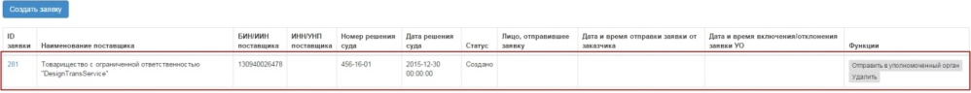
If the system has not detected errors in the Bid when it is submitted to the Authorized Body, the status will change from "Created" to "Waiting":
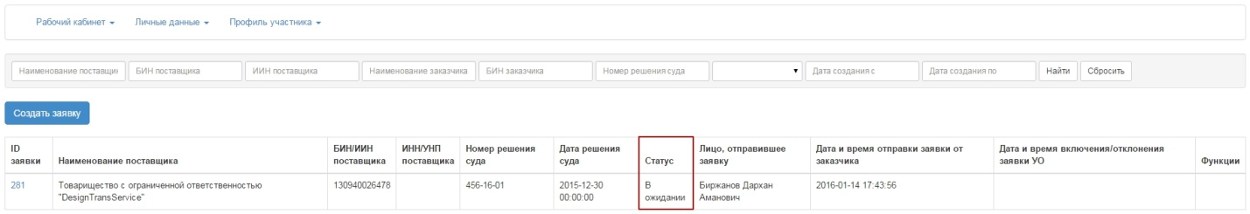
Depending on the action performed in the system, the following Customer and Authorized Body communication statuses are used:
Link status | Description
"Created" | Serves to display a relationship between the Customer and Authorized Body, where the Customer has not submitted the application to the Authorized Body. To be edited
"Waiting" | Serves to display a relationship between the Customer and Authorized Body, in which the Authorized Body does not produce verification/confirmation/rejection. Cannot be edited
"Verified" | Serves to display a relationship between the Customer and Authorized Body, during verification of an application by the Authorized Body. Cannot be edited
"Rejected" | Serves to display a relationship between the Customer and Authorized Body, during rejection of an application by the Authorized Body. Cannot be edited
"Included into the "Register of mala fide vendors" | Serves to display a relationship between the Customer and Authorized Body, during confirmation of an application by the Authorized Body. Cannot be edited
ATTENTION! Applications with status "Waiting", "Verified", "Rejected" and "included into the Register of mala fide vendors" are not editable or re-sendable for editing. In case of successful verification by the Authorized Body, in the application with information in the "Status" column, the meaning "Waiting" changes to "Verified":
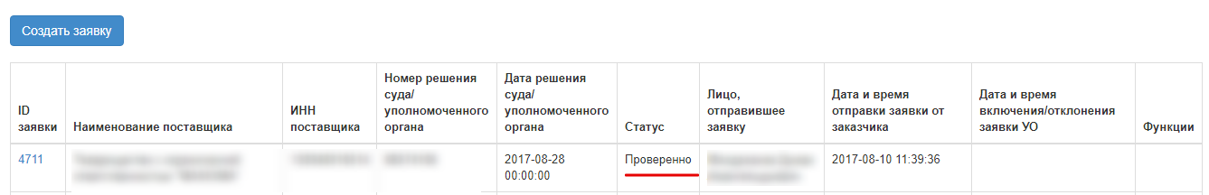
If the Authorized Body rejects the application, then information in the "Status" column is changed from "Waiting" to "Rejected":
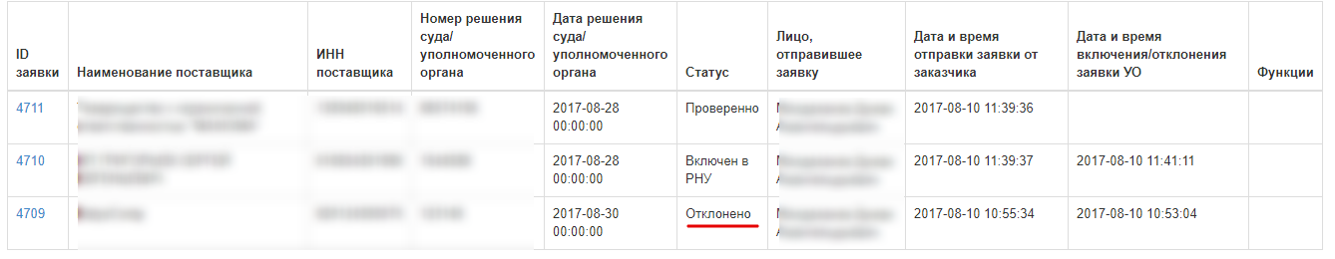
When you click on active link "Number of application" you need to review the reason for application rejection by the Authorized Body.
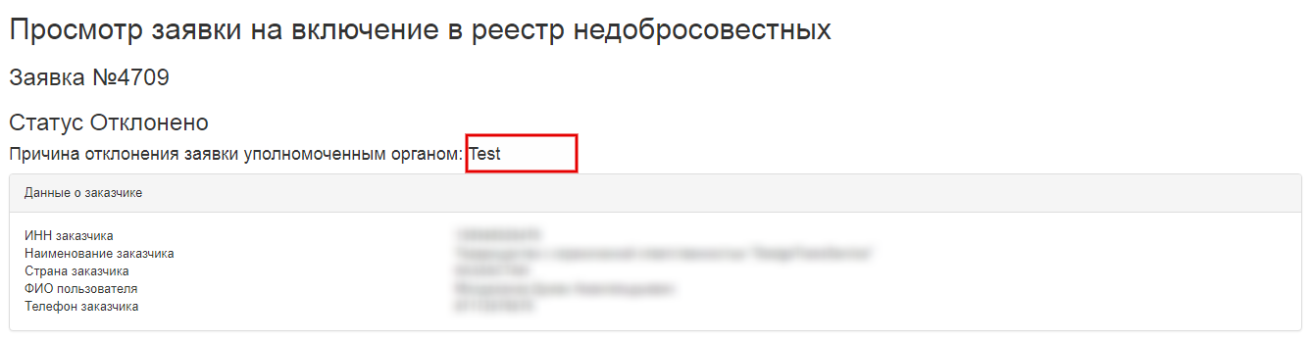
Then you can create a new Application with information and re-submit it to the Authorized Body. In the event of a successful confirmation by the Authorized Body, in the application in the "Status" column the meaning changes to "included into the "Register of mala fide vendors":
