Instruction of the Procurement Organizer

Contents
Contents 1
Organization and conduct of procurement by the Request for Quotations method 3
Create an announcement 3
Preparation of documentation. 8
Generating Technical Specification 9
Formation of a draft agreement. 11
Generate a "List of lots" document 13
Generate the "Delivery terms" document. 13
Pre-review of the announcement. 13
Approving the draft announcement 15
Extension of the deadline for submision of bids. 17
Change of documentation 17
Explanation of provisions of documentation 19
Bidding Opening 20
Consideration of bids 21
Control over consideration of bids 26
Conclusion of the voting 27
Formation and publication of data on preliminary admission 28
Reconsideration of the bids for participation by the method "Request for Quotations" 31
Formation of final protocol 33
Publication of final protocol 37
Change the customer/organizer's representatives 39
Cancel of the Purchase 40
Organization and conduct of procurement using the method "Unlimited bidding" 44
Adding Commission 47
Preparation of documentation. 48
Generating Technical Specification 49
Formation of a draft agreement. 52
Generation of the document "the list of Lots" and tender documentation 53
Generate the "Delivery terms" document. 54
Pre-review of the announcement. 54
Approving the draft announcement 56
Extension of the deadline for submision of bids. 59
Change of documentation 60
Explanation of provisions of documentation 62
Bidding Opening 63
Consideration of bids 64
Control over consideration of bids 69
Conclusion of the voting 71
Generate information on preliminary admission 72
Approval of data on preliminary admission. 74
Publication of data on preliminary admission 75
Re-consideration of bids for the purchase with "Unlimited bidding" method 77
Filling conditional discount 78
Formation of final protocol 81
Approval of final protocol 83
Publication of final protocol 86
Modification of the Commission 88
Cancel of the Purchase 89
Organization and conduct of purchases by the "Limited Bidding" method 93
Create an announcement 93
Adding Commission 97
Preparation of documentation. 98
Generating Technical Specification 98
Formation of a draft agreement. 101
Formation of the document "List of lots" and tender documents 103
Generate the "Delivery terms" document. 103
Pre-review of the announcement. 103
Approving the draft announcement 105
Extension of the deadline for submision of bids. 108
Change of documentation 109
Explanation of provisions of documentation 111
Bidding Opening 112
Consideration of bids 113
Control over consideration of bids 118
Conclusion of the voting 120
Generate information on preliminary admission 121
Approval of data on preliminary admission. 123
Publication of data on preliminary admission 124
Re-consideration of bids for the purchase with "Unlimited bidding" method 126
Filling conditional discount 127
Formation of final protocol 130
Approval of final protocol 132
Publication of final protocol 135
Modification of the Commission 136
Cancel of the Purchase 137
Organization and conduct of "Single-source" method procurement 141
Create an announcement 142
Adding Commission 146
Preparation of documentation. 147
Generating Technical Specification 147
Formation of a draft agreement. 150
Generate the "Delivery terms" document. 152
Pre-review of the announcement. 152
Approving the draft announcement 153
Publish announcement 155
Extension of the deadline for submision of bids. 155
Discussion of documentation 156
Description of the "Complete documentation discussion" button 158
Bidding Opening 162
Consideration of bids 162
Control over consideration of bids 167
Conclusion of the voting 168
Formation of final protocol 169
Approval of final protocol 171
Publication of final protocol 174
Modification of the Commission 175
Cancel of the Purchase 176

Organization and conduct of procurement by the Request for Quotations method

Create an announcement
To create an announcement you should go to the "Personal account" section and select "Create announcement". To create announcement the user should have the role "organizer"
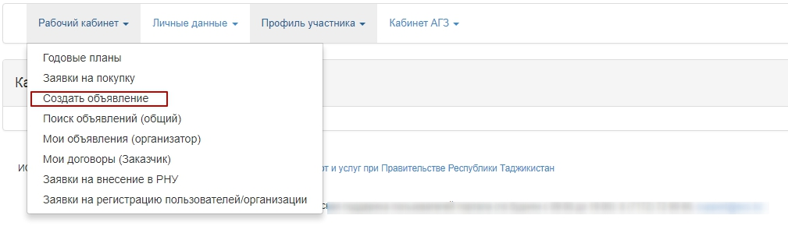
Next, you will see a form for creating a draft of announcement.
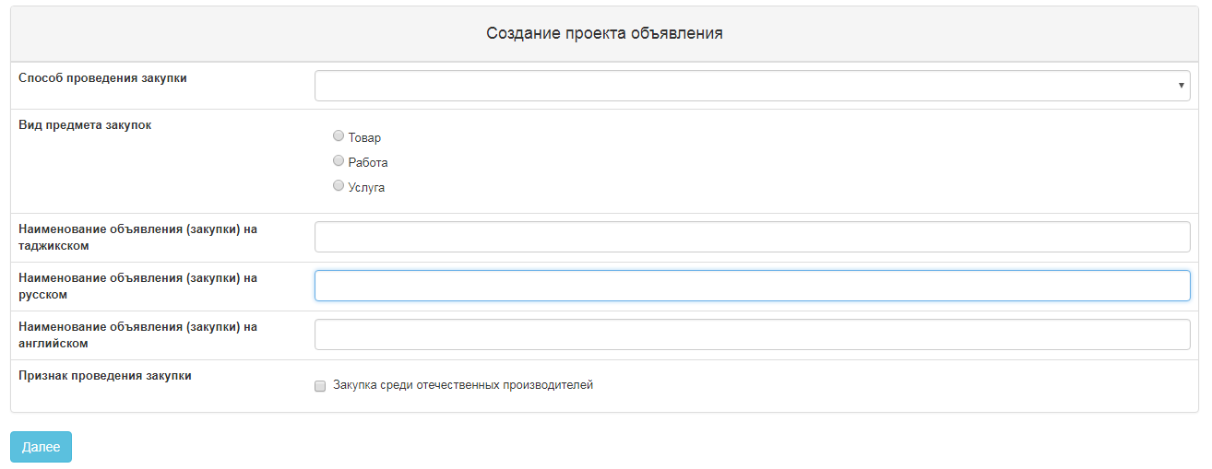
Section "Creation of a draft of announcement" contains the following fields and buttons:
Item | Action
Type of procurement item | Filled in manually. One of the values is selected:  Work;  Service;  Goods.
Title of (procurement) announcement in the Tajik | Filled in manually
Title of (procurement) announcement in the Russian | Filled in manually
Title of (procurement) announcement in the English | Filled in manually
Indication of purchase | If the bidding is required for procurement among the organizations of domestic manufacturers, a check mark should be placed on the line with this indication.
Next | When clicking the button, the System shall check for filling in all mandatory fields
If the bidding is required among the organizations of domestic manufacturers it is necessary to put an indication - "domestic producer" in the draft of announcement.
After you fill in all the fields, click "Next".
Note. After you move to the next step, the system automatically saves the announcement in the status "Draft" in the section "Work Office" - "My announcements (organizer)":
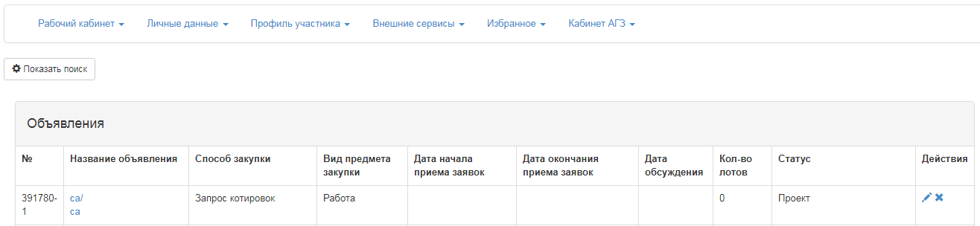
The icon allows to edit, the icon allows to delete announcements with the status "Draft" when you click "Next", lots that meet the specified criteria by method, item type, and purchase indication are displayed. It is necessary to mark Lot (s) and click "Add selected" button:
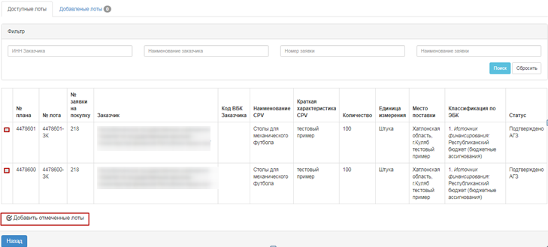
To select a lot, you shall mark the required lot and click "Add marked lots" button. Then you go to the added Lot view page. If you want to delete selected lot, mark required lot with a check mark and click "Delete marked Lots" button, and if you want to add lots to the purchase project, go to the "Available Lots" tab and perform selection of additional lots. To go to the next page, click "Next".
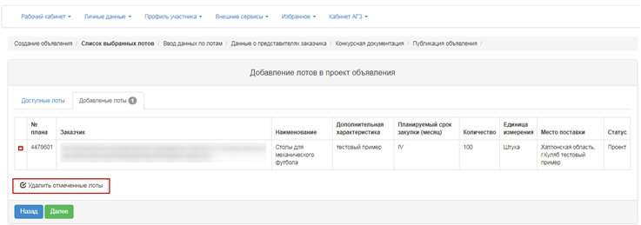
The section "Enter data by lot" contains the following fields for filling in the delivery terms for each lot:
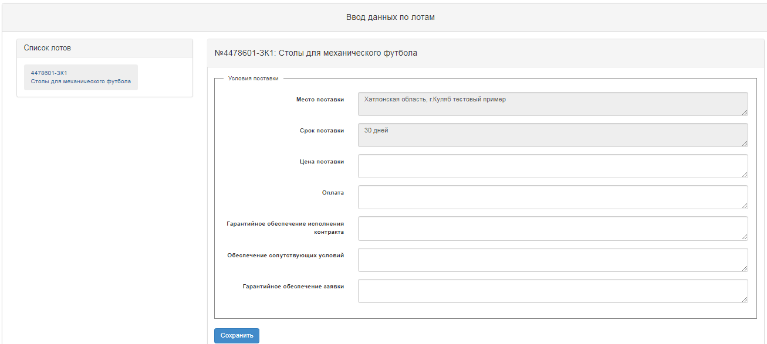
Place of delivery | Automatically filled in by the system from the annual plan
Delivery Period | Automatically filled in by the system from the annual plan
Price of delivery | Filled in manually
Payment | Filled in manually
Contract Performance Guarantee | Filled in manually
Related Services | Filled in manually
Bid Security | Filled in manually
On the page for adding data on representatives, it is necessary to specify the expiration date of the application and fill in the data on organizer and customer's representatives. To fill in the information about the organizer, click the active link for the organizer's name. The following form appears.
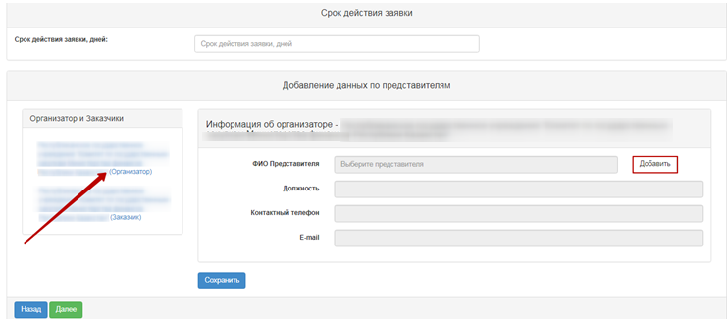
This form has the following fields and controls
Field name | Description
Expiration date of the application | Filled in manually. The text and numeric value.
Organizer Information
Name of the representative | Filled in manually. When clicking the "Add" button a pop-up window is displayed. By default, only users who have the Organizer powers are displayed. You can use the "Select" button to select a user. Search for a user can be performed by using a set of filters (by company/user INN or name).
Position Held | Automatically filled in out of representative's registration data.
Contact phone number | Automatically filled in out of representative's registration data.
E-mail | Automatically filled in out of representative's registration data.

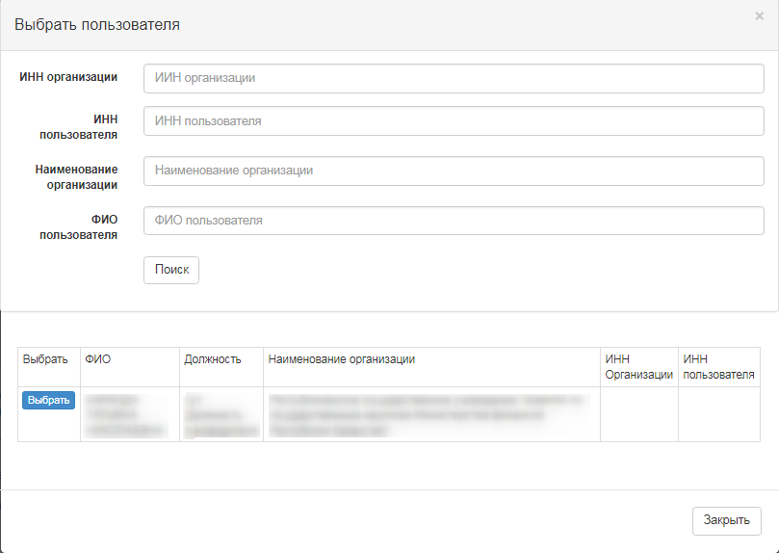
After you have activated the "Add" button, the following window appears.
To fill in the information about the organizer, click the active link for the organizer's name. The following form appears.
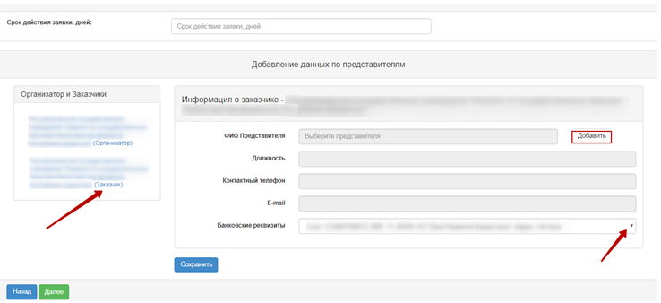

Field name | Description
Expiration date of the application | Filled in manually. The text and numeric value.
Customer Information
Name of the representative | Filled in manually. When clicking the "Add" button a pop-up window is displayed. By default, only users who have the Organizer powers are displayed. You can use the "Select" button to select a user. Search for a user can be performed by using a set of filters (by company/user INN or name).
Position Held | Automatically filled in out of representative's registration data.
Contact phone number | Automatically filled in out of representative's registration data.
E-mail | Automatically filled in out of representative's registration data.
Bank details | Main account from the "Bank accounts" table is filled in automatically with the option to select a different account from the drop-down list.
Note: In the "Request for quotations" procurement method, a person with the organizer role is reviewing vendors' claims.

Preparation of documentation.
"Document Preparation" step displays a list of required documents to participate in the bidding according to the rules for conducting public e-procurement. If the vendors are required to provide certain documents to participate in the bidding, the Secretary should be required to provide a sign "mandatory for the vendor". To view information about a document, click its name in the "Document Name" field.
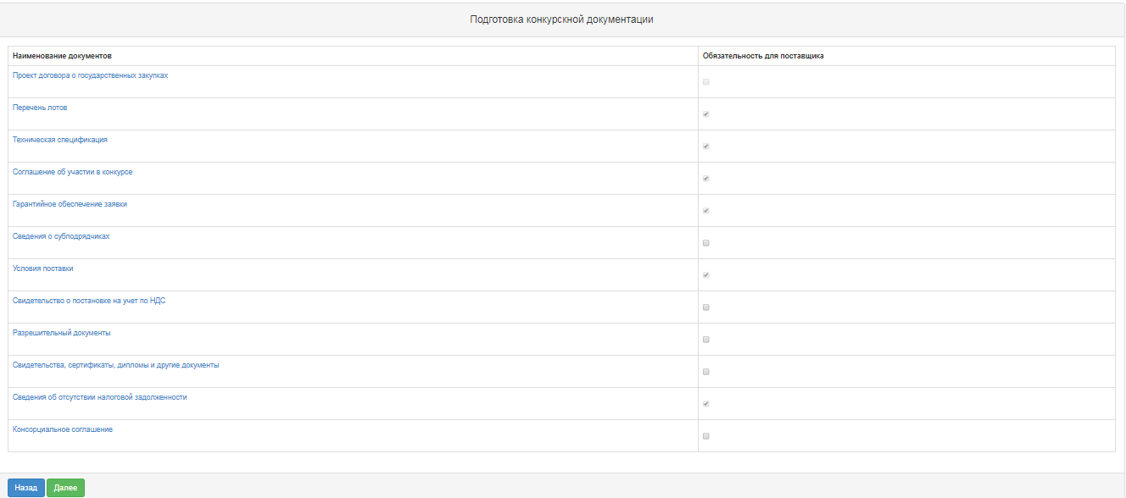

Generating Technical Specification
To go to the "Technical Specification" section, in the general documentation list click the active hyperlink "Technical specification". It is necessary to confirm the file of technical specification that describes the goods, work, or services, for this you should click the active link on the lot line "View".

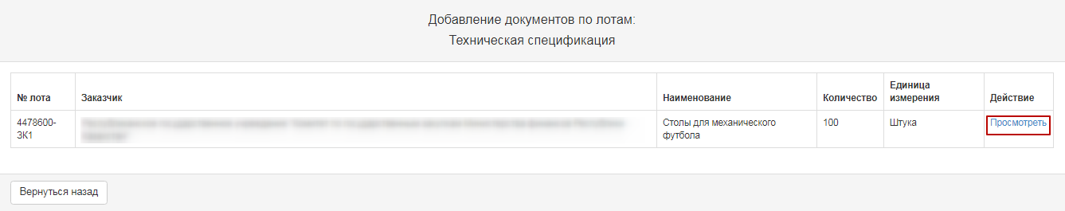
The new window displays the system-generated technical specification from the bid for the bidding. If the Organizer needs to change Technical Specification prepared by the Customer, it is necessary to:
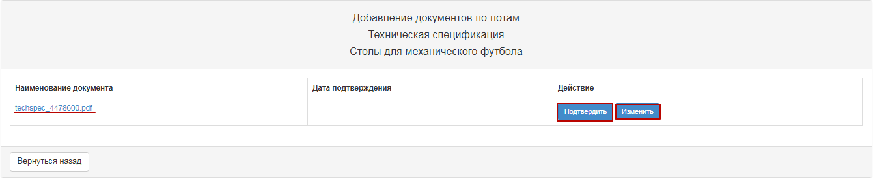

When you click "Edit", a window is displayed for editing in the state and Russian languages.
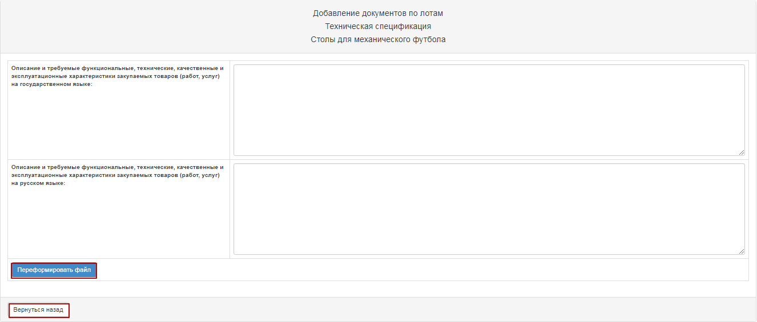
After amending it is necessary to confirm by clicking the "Reforming the file" button. If no changes are required, you can use the "Go Back" button to exit without modification.
When you approve Technical Specification Document, the system fills in the confirmation date.
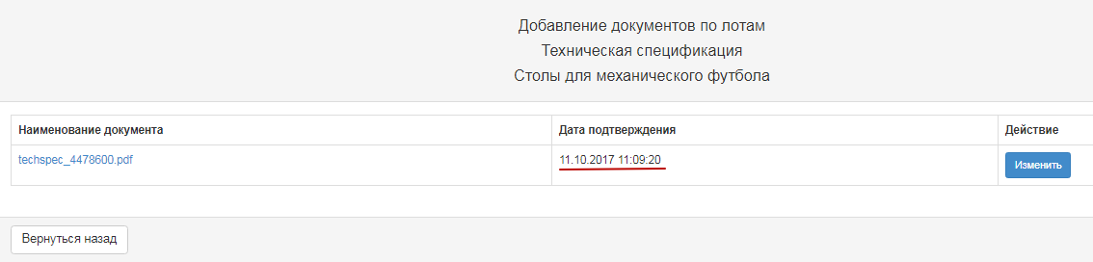
For items of a service or job, click the "View" button to display the following window:
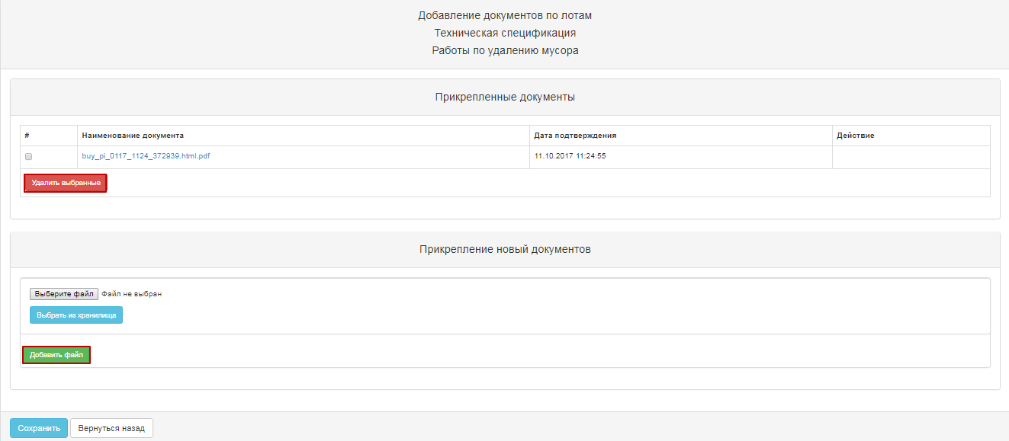
If necessary, you can delete Technical Specification that was generated by the Customers in the purchase bid and/or add another file of Technical Specification.
If you add a new file using the "Select File" button, a window opens to find the file you want. After the file is selected, open it, and then click "Save".

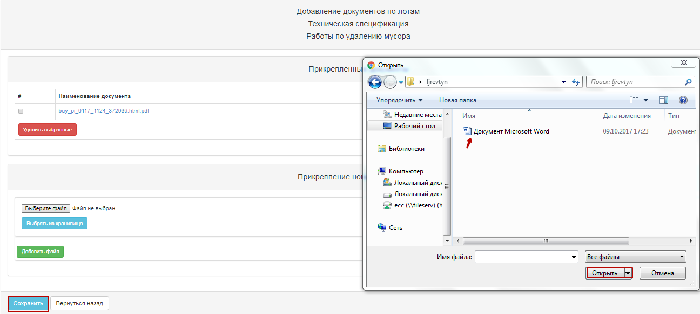
If you add a new file using the "Select from Storage" button, a window will open with previously downloaded files in the participant profile - File directory. After you select the file, you should "Save" it.
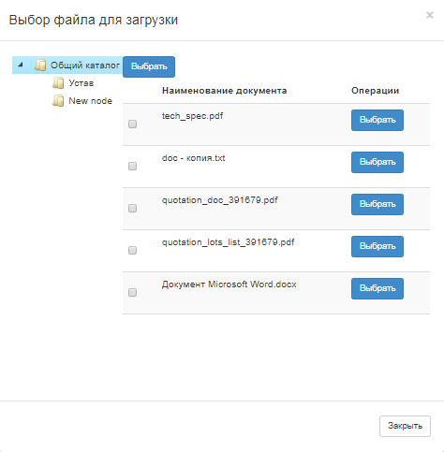
To return to the shared document list, click the "Go Back" button.

Formation of a draft agreement.
To review the draft Agreement in this section form, click the "View draft Agreement" link button.
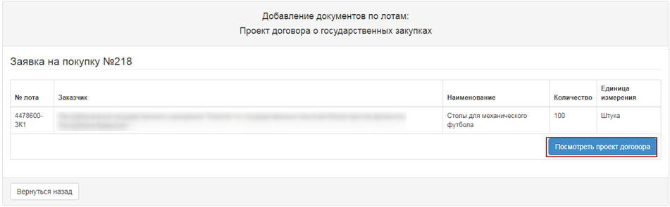
If necessary, you can delete attached draft agreement and/or add another file.
If you add a new file using the "Select File" button, a window opens to find the file you want. After the file is selected, open it, and then click "Save".
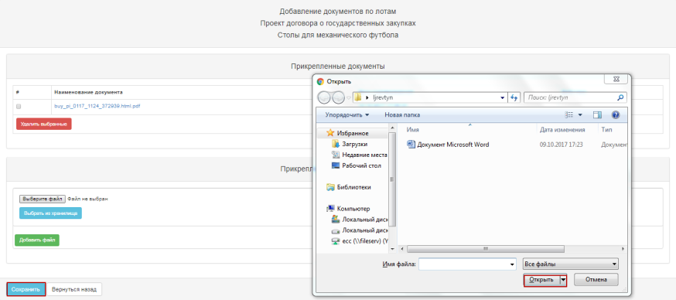
If you add a new file using the "Select from Storage" button, a window will open with previously downloaded files in the participant profile - File directory. After you select the file, you should "Save" it.

To return to the shared document list, click the "Go Back" button.

Generate a "List of lots" document
At the step "Preparation of Documentation" click the active link "List of lots". In the pop-up window, you need to "Confirm", and then close the window.
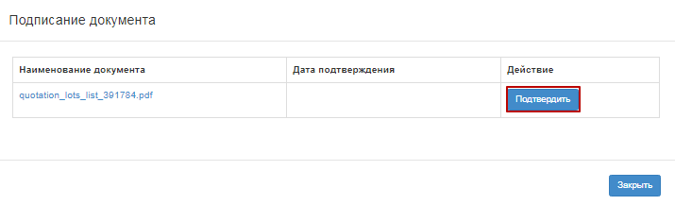

Generate the "Delivery terms" document.
At the step "Preparation of Documentation" click the active link to "Delivery terms". In the pop-up window, you need to "Confirm", and then close the window.

Pre-review of the announcement.
The form "Pre-review of the announcement" contains general information on the bidding, information about the organizer, and the representatives of the Customer and the Organizer.
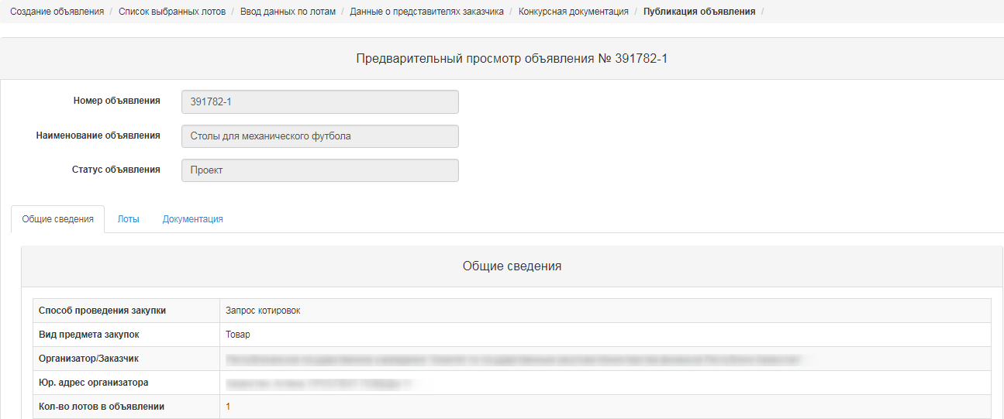
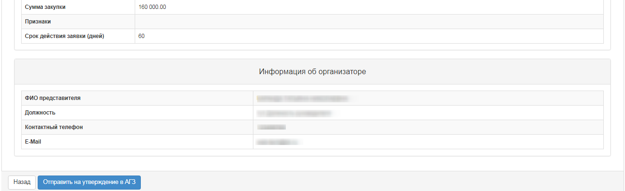

Note. On procurement, which is organized by Qualified procuring Organizations (QPO) concerning the methods of procurement in "Request for Quotation", "Restricted participation Bidding", "Unrestricted participation Bidding", "Single Source Selection", draft of bidding document should be agreed with the Public Procurement Agency (PPA of the RT).
For procurement, organized by the RT PPA no approval is required.

When you click the button "Submit for approval to the RT PPA", the system displays a pop-up window that requires you to confirm the action.
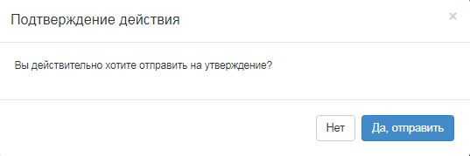
If the draft is successfully submitted to the RT PPA, the purchase is assigned the status "Sent to PPA for approval.
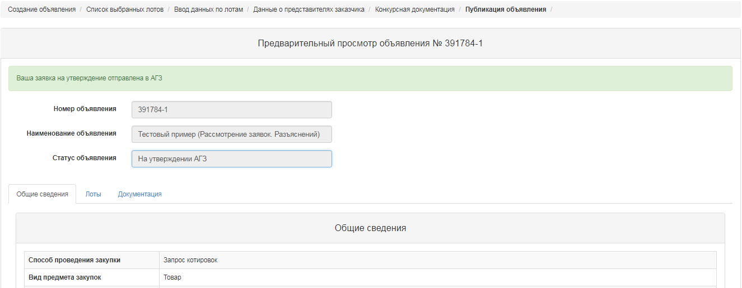

System sends a notification to users with the role "Approval of announcement" on the need to approve the announcement.

Approving the draft announcement
In the event that the purchase was refused in agreement, the purchase is assigned the status "Rejected by the RT PPA" with subsequent possibility of editing by Secretary of the announcement.
The Secretary should go to the "Personal account" - "My announcements" (Organizer).

When you click the icon, a pre-review of announcement is displayed, and the reason for the rejection is listed at the bottom.

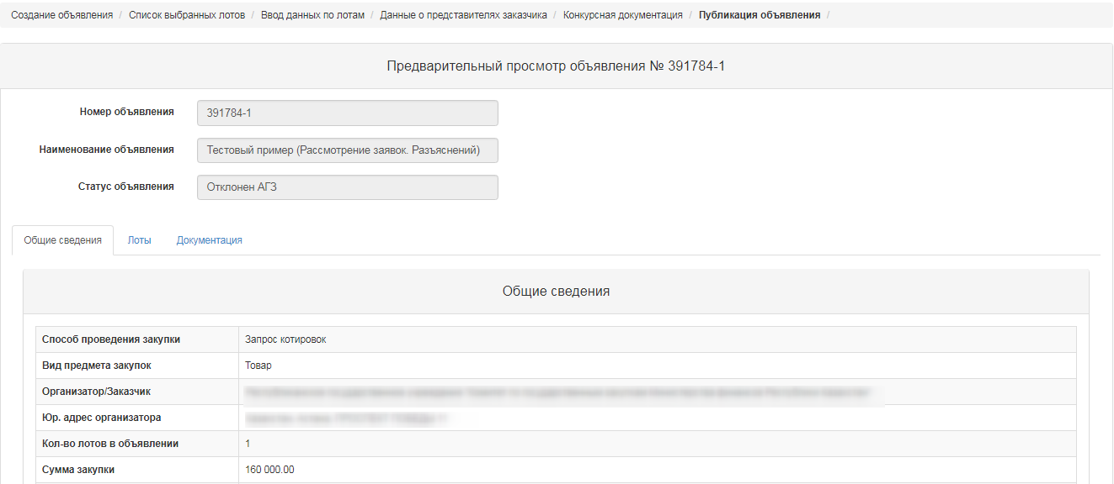
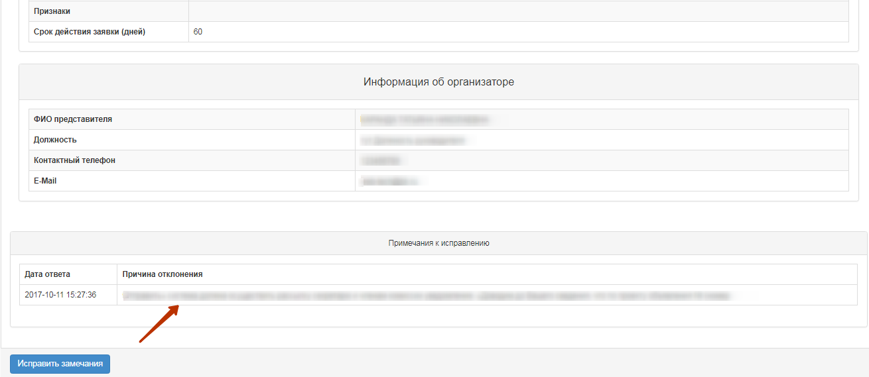
After you select "Correct comments", you will see a pop-up window with the need to confirm the action.
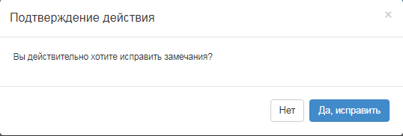
If you select the "Approve" function, the purchase is assigned the status "Approved by the RT PPA".
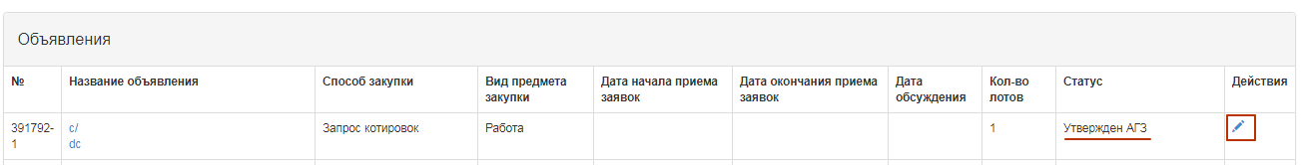
When you click the icon, a pre-review of announcement and the "Publish" button is displayed. In this form, you should specify the start and end time for accepting the bids.
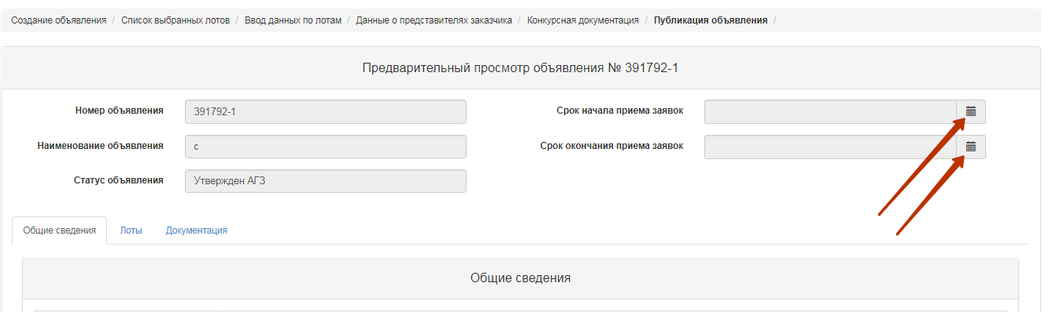
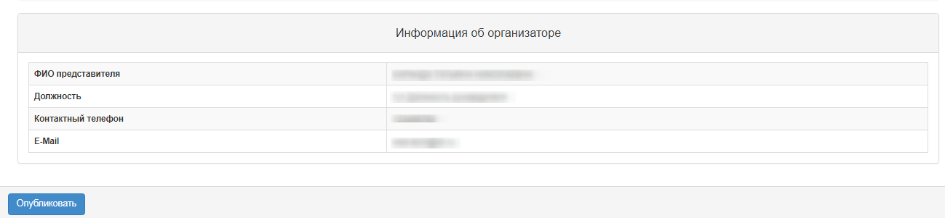
However, the date and time when the bids are received should be not earlier the current date of the publication.
If a publication is successful, the status of announcement is set as "Published". Otherwise, the system issues an error message.

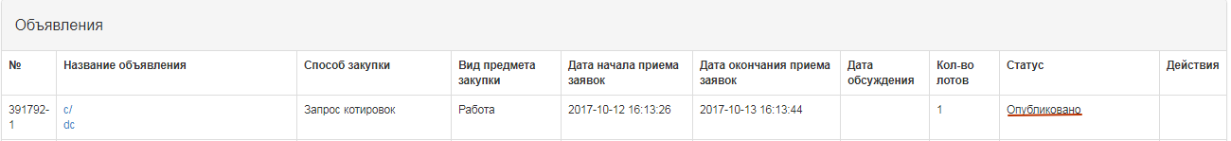

Extension of the deadline for submision of bids.
The Secretary in the form of announcement view has the action "Extension of the bidding" for the bidding with statuses "Published", "Published (acceptance of the bids)".
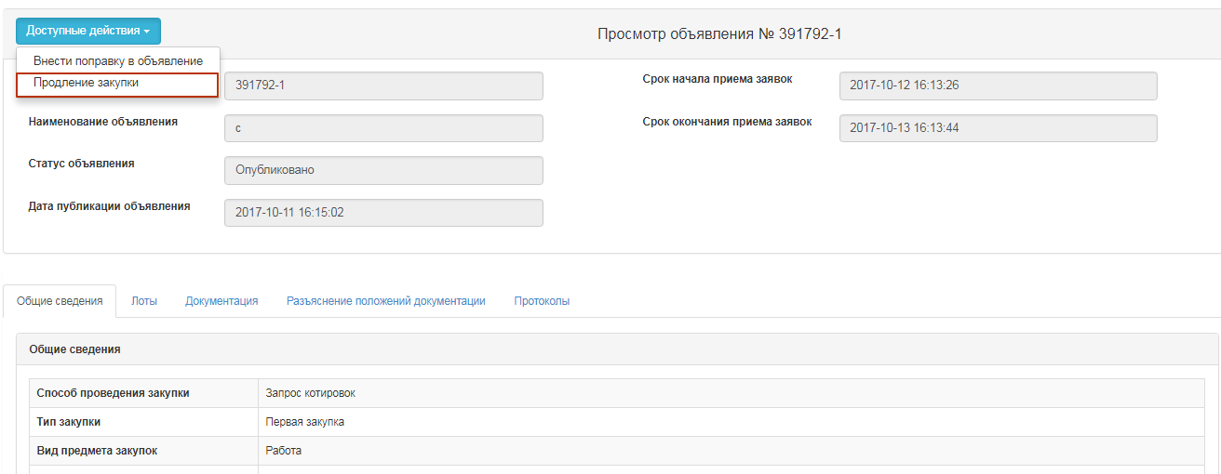
By clicking on the button "Extension of the bidding", the Secretary is given the opportunity to enter data in the filed "Reason for extension of the bidding", which is mandatory.
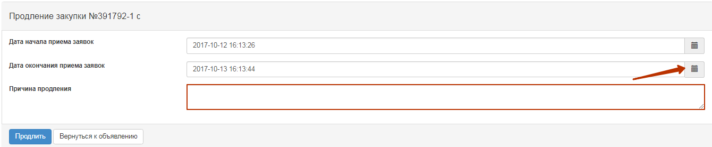
After that, the system displays a success message.
Note. In case of extension of the bidding in the announcement with the status "Published, acceptance of the bids", after changing the deadline for receipt of bids, the system sends an extension notice to the members of the Commission and to the vendors who applied for participation.
Note. The system allows changes to be made only to the bid submission deadline term, and the start date remains unchanged.

Change of documentation
The Secretary in the form of announcement view has the action "Amending the announcement" for the bidding with statuses "Published", "Published (acceptance of the bids)".
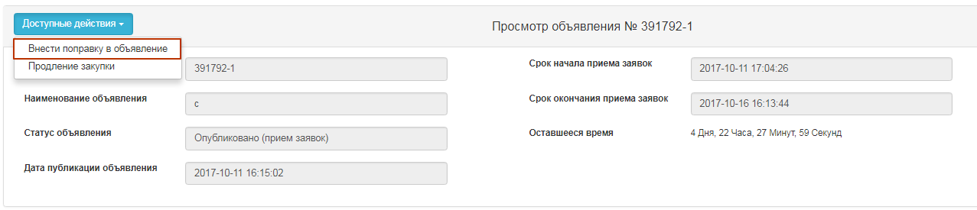
After you select an amendment to the announcement, the Registrar should fill in the filed "Reason for amending".
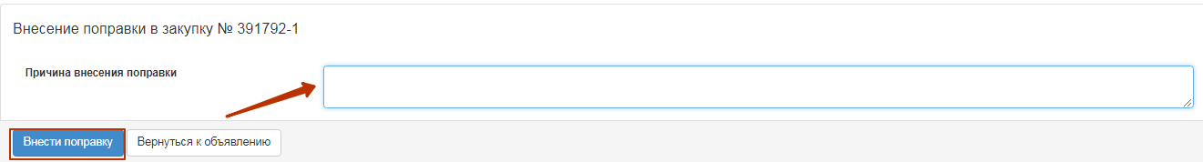
After you complete the action "Amending" the purchase project is automatically created with index 2. Original announcement (with index 1) is assigned the status "Modified documentation".
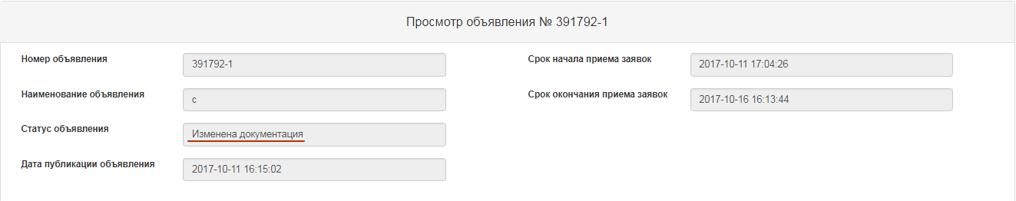
To edit announcement with index 2, the Secretary needs to go to the "Personal account" - "My announcements" (Organizer), click the icon in the actions.
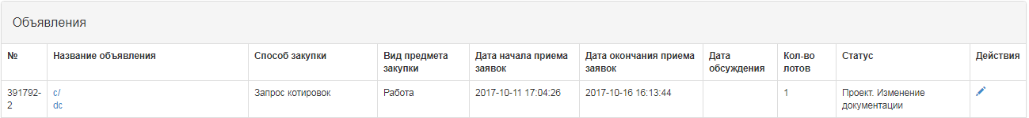
The system displays the form of editing the announcement.
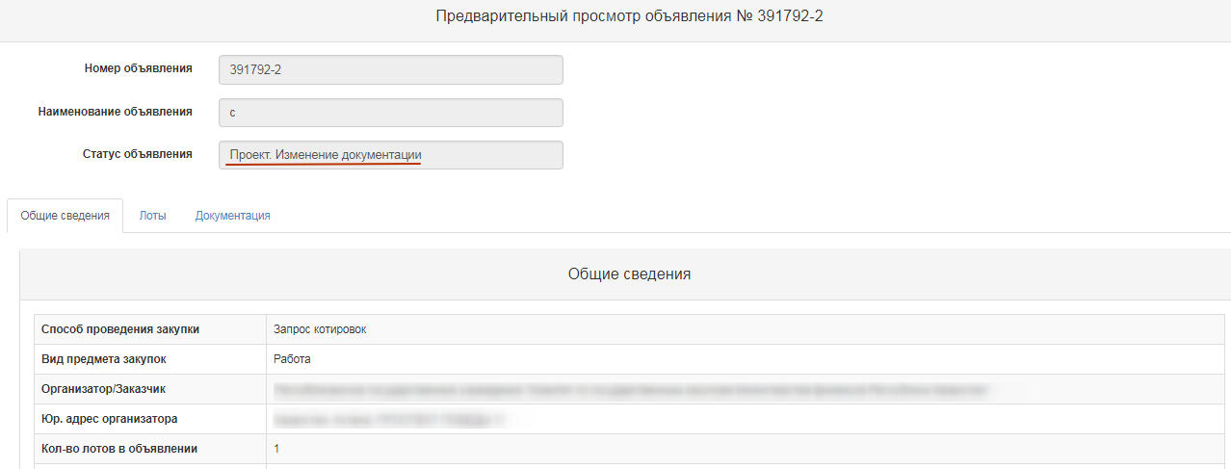
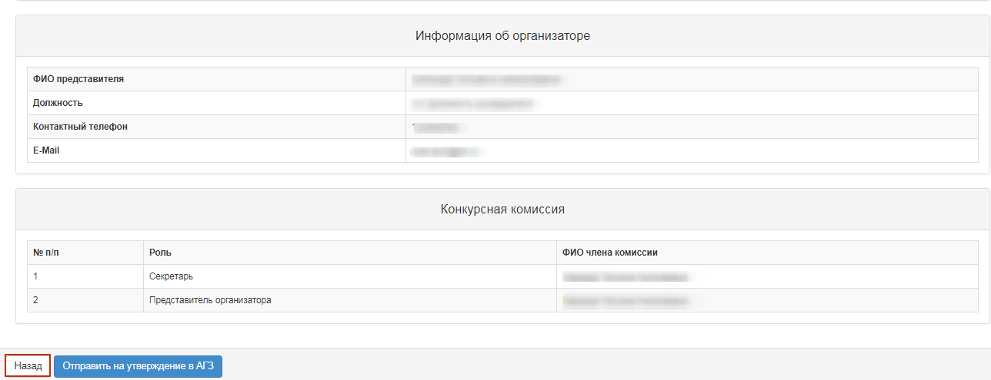
To change the documentation, click the "Back" button.
As you have amended the draft announcement, you should click on "submit to the RT PPA for approval". Further harmonization is carried out according to the instructions (see Approving the draft announcement).

Explanation of provisions of documentation
In the event that there are comments on the documentation, as well as requests for clarification of the provisions of documentation, the vendor may write a message to organizer within the period of bid acceptance in the announcement in the status of "Published acceptance of the bids".
Notifications on received bids go to the Secretary, the Organizer's representative and the Customer's representative. To view the bids from vendors, go to the "Clarification of Document Provisions " tab, click on the subject of the message.
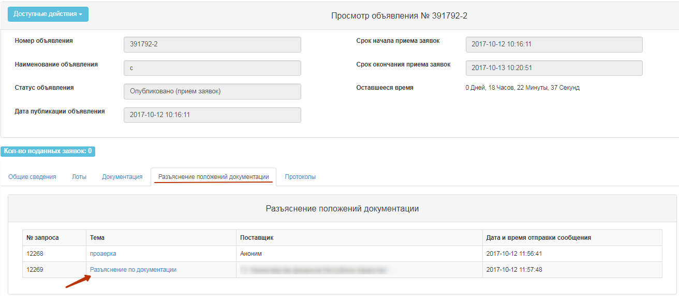
The message text and provider data are displayed.
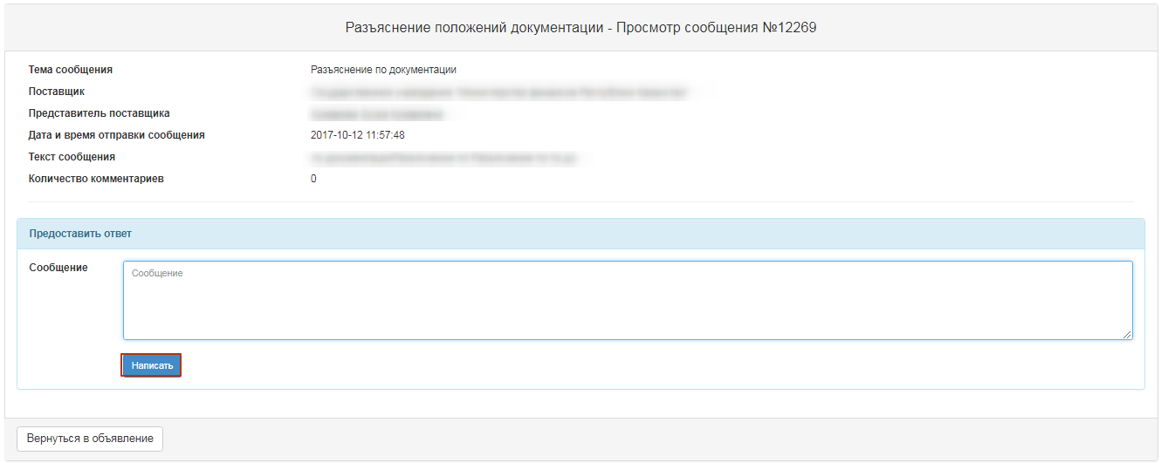
After that the response text is then displayed on the screen.
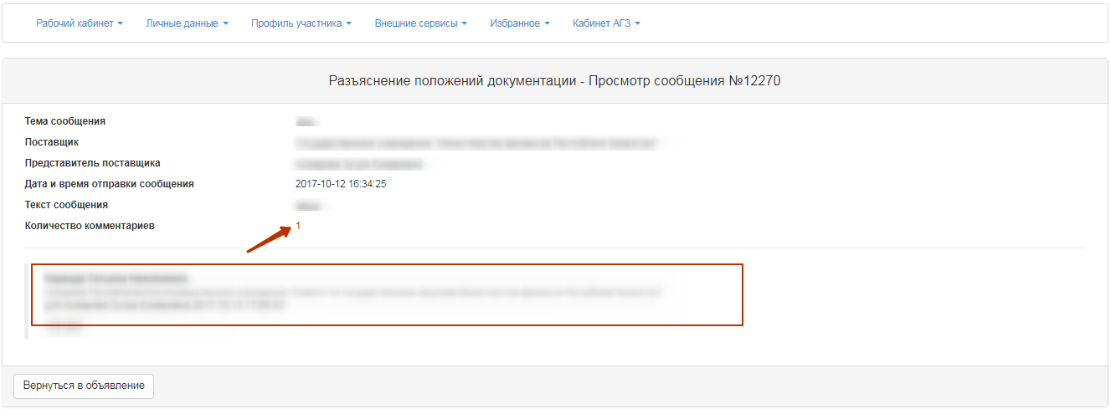

Bidding Opening
The system automatically uncovers the Bidding when the deadline for submission of bids expires:
• If there are submitted bids from vendors for at least one lot in the announcement, the system changes the status of the announcement, lot(s) and bids of suppliers to "Consideration of the bid" and sends notification to the suppliers that submitted bids, the secretary, commission members in the private office and mail about the publication of the Bid opening protocol.
• If the vendor has submitted an application with a price offer above the amount allocated, the system skips its application, but at the opening it automatically rejects and in the opening/summary protocol assigns the status "rejected by the web portal" with the reason "the vendor's price proposal exceeds the allocated amount for procurement".
• If there are no submitted bids for at least one lot from vendors to participate in the procurement, the system automatically generates and publishes the summary protocol. The system sends notification to the suppliers who submitted their bids, to the secretary, to the members of the commission in their private office and to e-mail.

Consideration of bids
If the deadline for receipt of the bids has come and there are submitted bids, the System automatically opens the purchase. After the opening of the bids, the system changes the status of the announcement from the "Acceptance of bids is published" to the "Consideration of bids", sends a notification to private office of the organizer's representative about the need to consider the bid.
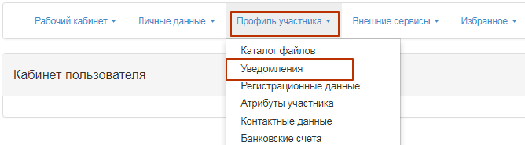
You can also view notifications by clicking the icon in the upper right corner of the page. To view all notifications, click the "All Notifications" link.
Transition to the announcement can be done from the notification by a link or go to the section "Personal account", and select the menu "My announcements (Facilitator)".
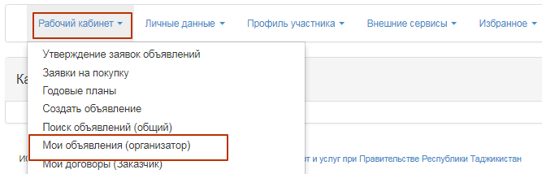
To review the bids submitted by suppliers, on the form of viewing the announcement in the section "Available Actions" in the list select "View the bids".
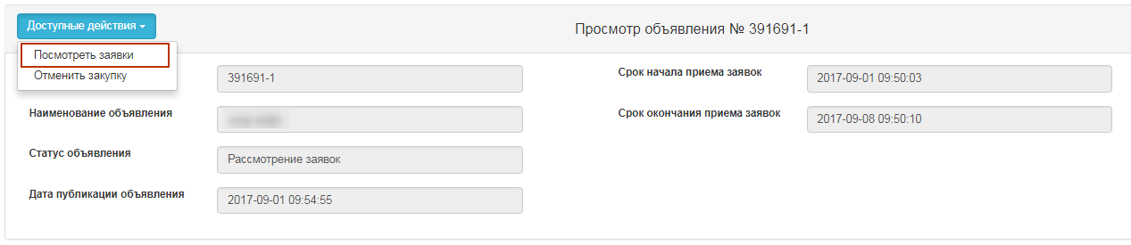
To view information about vendors who have submitted the bids for the procurement, you are to click the Bid Number link.
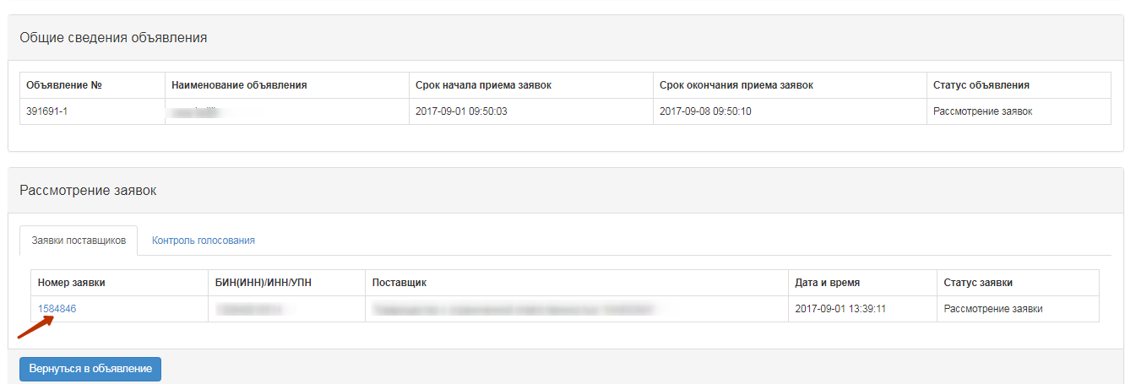
In the "Vendor Details" tab, the name, details, vendor address and information about the supplier's representative are indicated.
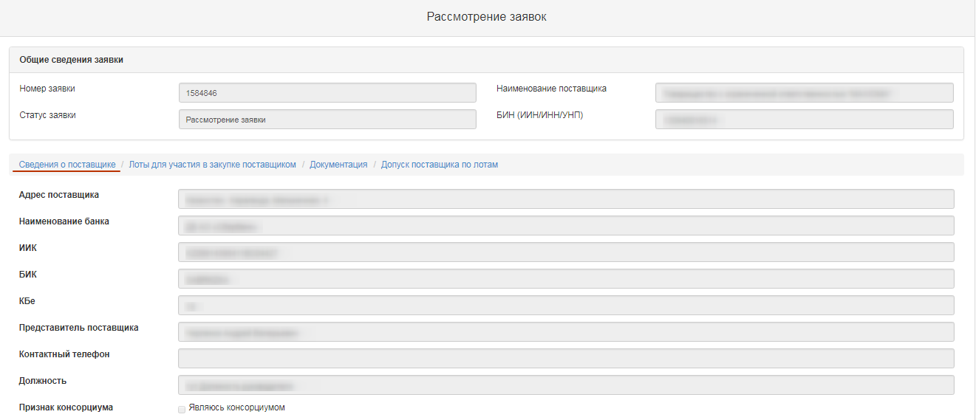
In the "Lots for participation in procurement by the vendor" tab, lots are placed for which the vendor submitted its bid.
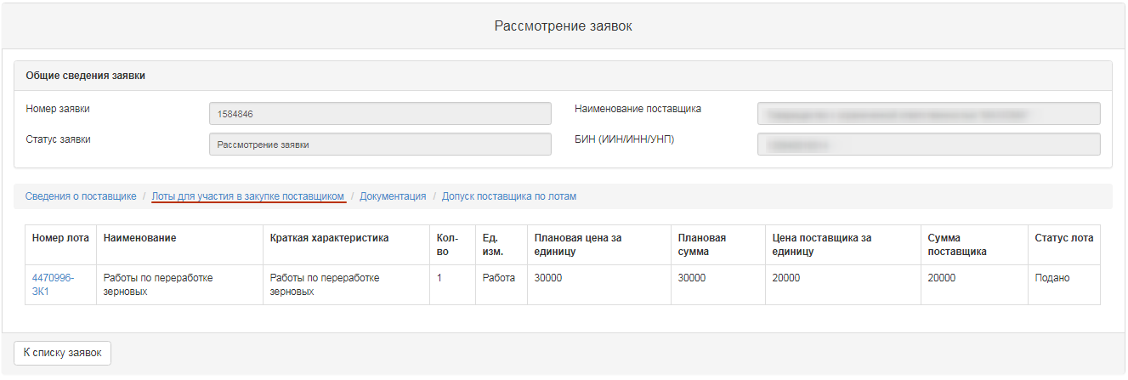
"Documents" tab provided by the vendor are placed in the "Documentation" tab. The line with the document name the number of files that have been attached is indicated. It is necessary to click the section name to display the attached files. To view and download the document, you should click the active link for the document name.
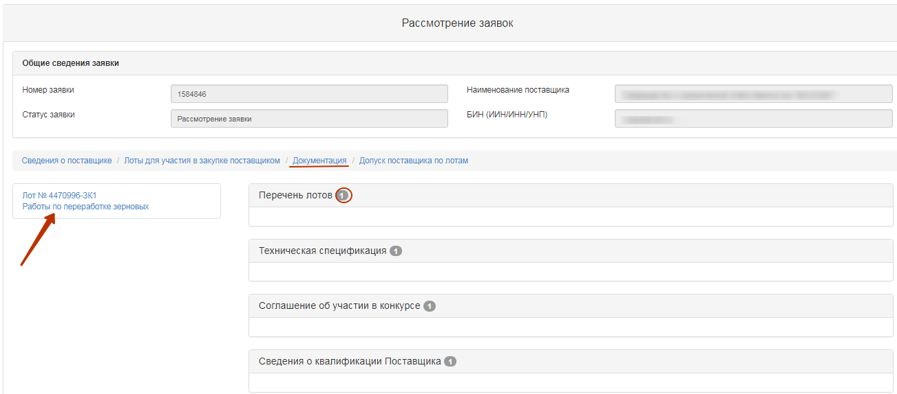
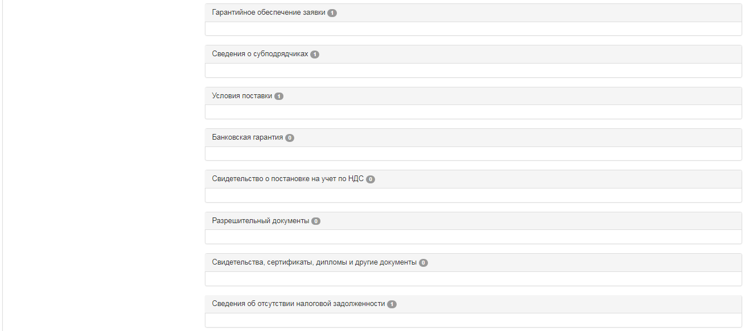
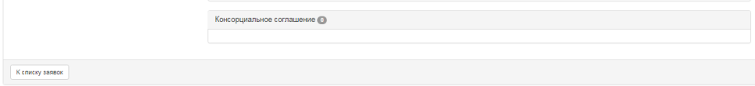
To vote on Admission / Rejection of the vendor, go to the tab "Admission of vendor by lots".
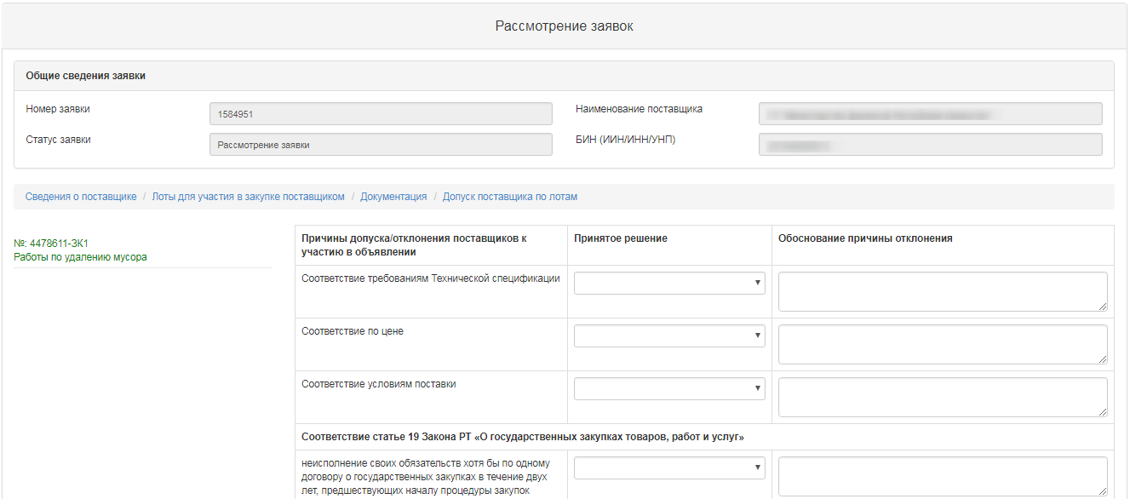
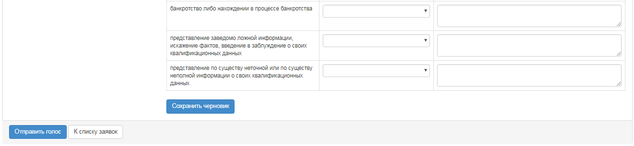
Admission of vendor by lot includes categories:
- Compliance with technical specification requirements
- compliance with the Price
- Compliance with terms of delivery
-Compliance with article 19 of the Law of the RT "on public procurement of goods, works and services"
The category "conformity with article 19 of the Law on public procurement of goods, works and services" contains the following sub-categories:
- Failure to fulfill its obligations at least in one public procurement contract within two years prior to commencement of the procurement procedure;
- Declaration of bankruptcy or being in the process of bankruptcy;
- submission of false information, distortion of facts, deception of their qualifications;
- Providing substantive or incomplete information on their qualifications.

To make a decision by category, you should select one of the following values from the drop-down list "Made decision":
- Admit
- Reject. - Request for clarification
- Reject without the right to clarify
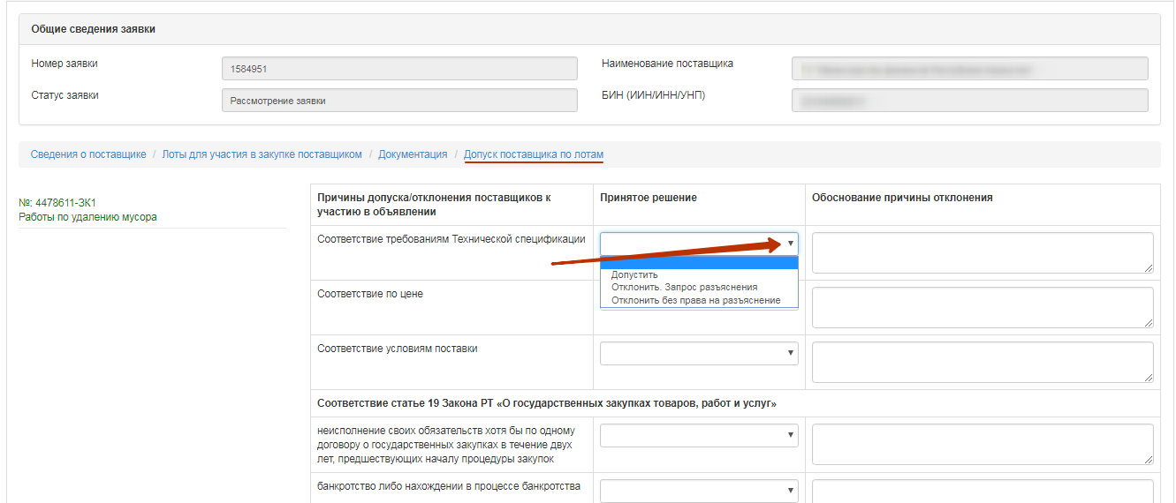

If you select "Reject". In the "Request for clarification"/"reject without right to clarify" you need to fill in the reason for the rejection.
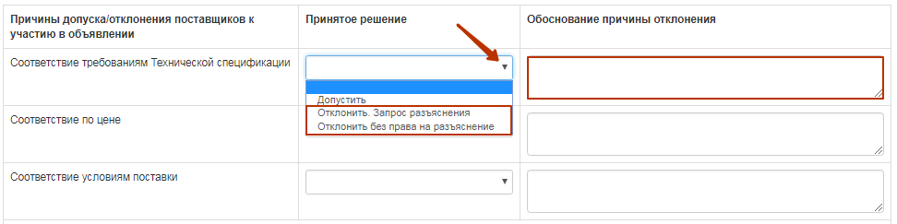
Attention! In the event that the Organizer has taken a decision to "Reject without the right of clarification" in sub-category 3 of compliance with Art. 19 (submission of knowingly false information, distortion of facts, misleading about their qualifications), the system automatically applies this solution to all lots in which the vendor participates. The vendor will not be able to provide clarification on the bid for the purchase.
In case of deviation by subcategory 1,2,4-deviation is made for each lot.
Attention! If the organizer has decided to reject. "Request for clarification", the system shall, upon completion of the voting, form the"Information on provisional admissions ".
After the decision on all categories is accepted, it is required to press the button "Save draft" After saving the solution, the line with the section will display the accepted decision (Admit, Reject. Request for clarification, Reject without the right to clarify).
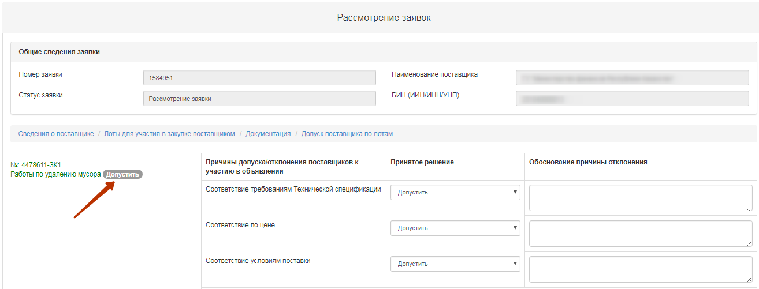
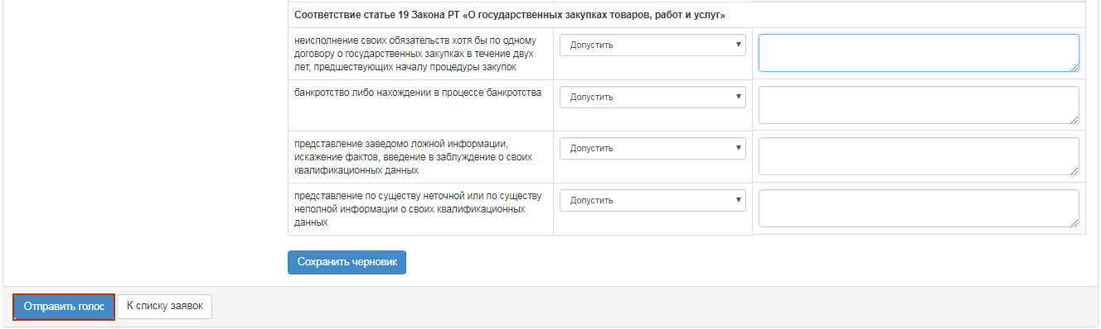
To end voting on all lots, you need to click on the "Send the Vote" button.
Attention! Before the end of voting, the system gives the opportunity to withdraw its vote using the function "Recall the Vote".
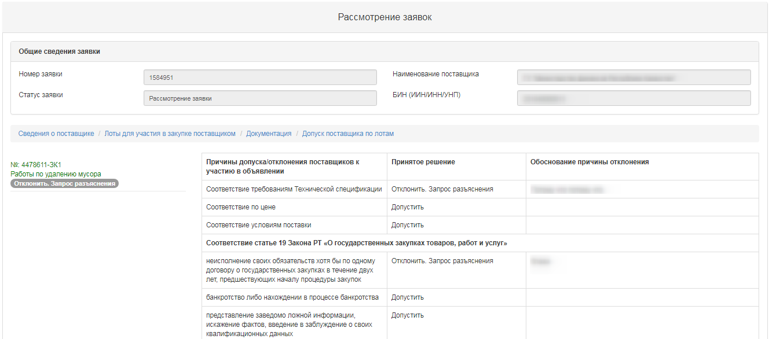
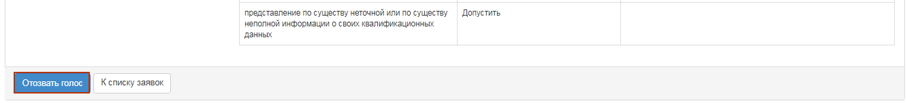

Control over consideration of bids
The secretary on the announcement viewing form with the status "Consideration of bids" / "Consideration of bids (clarifications)" has the functional for monitoring the voting process. To use this functional, in the "Available Actions" section, select the item "View the bids".
To view the voting information, it is necessary to go to the "Voting Control" tab and click on the line with the lot number.
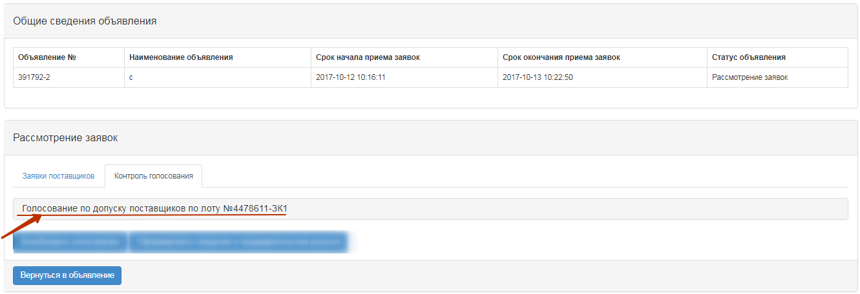
The system displays the following form with a list of bids.
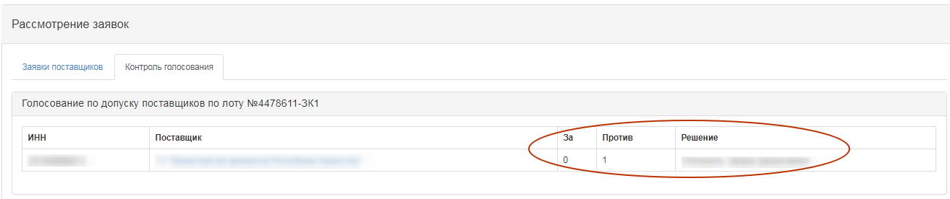
The Solution field indicates
- Admit
- Reject. - Request for clarification
- Reject without the right to clarify
The "For" field contains information on the number of commission members who allowed a potential vendor to participate in the purchase by the lot for which he applied. The field "Against" contains information about the number of commission members who did not allow the potential vendor to participate in the purchase by lot, to which he applied.

Conclusion of the voting

To complete the voting, the secretary should select "View the bids" in the "Available Actions" field.
Then you need to go to the tab "Control of Voting". If there is a quorum of votes, the "Completion of voting" button is available on the "Voting Control" tab.
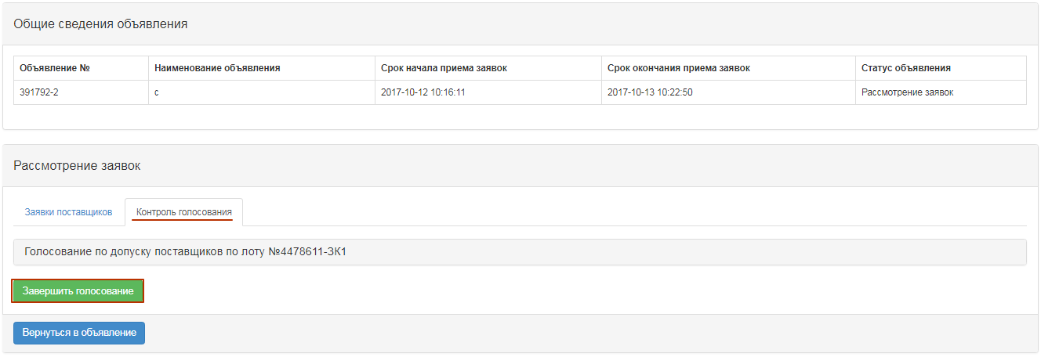
Once the voting has been completed, it is possible to resume the voting by means of an appropriate button.
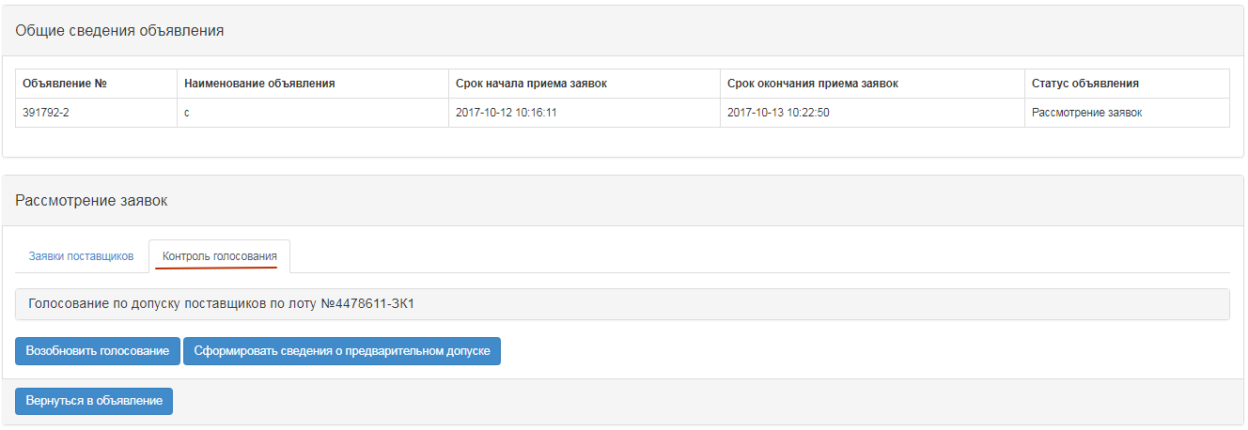
Note. In the event that, based on the results of the procurement vote, there is a rejected bid(s) with a request for clarification, a button "Generate information on preliminary admission" will be available on the voting control form upon completion.

Formation and publication of data on preliminary admission
If in the procurement one or more potential suppliers were rejected with clarifications, after the voting is over, the Secretary in the "Control of voting" should choose "Generate information on preliminary admission."
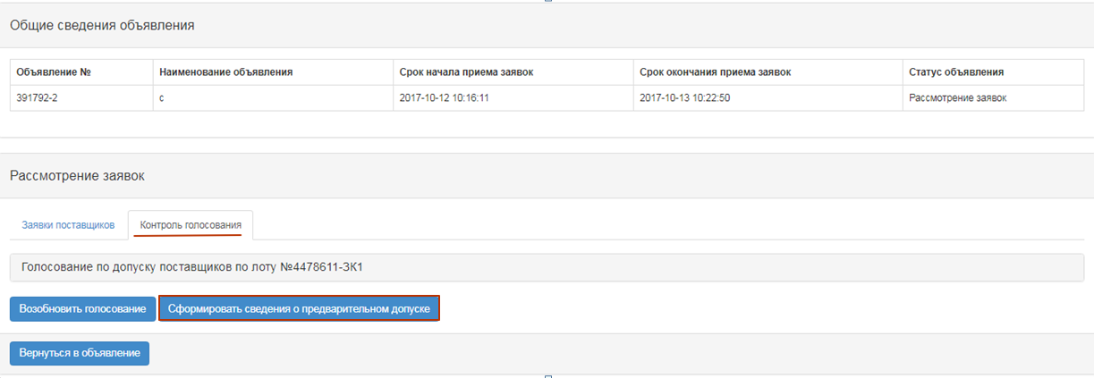
After that, the status of the announcement will be changed to "Formulation of preliminary admission protocol"
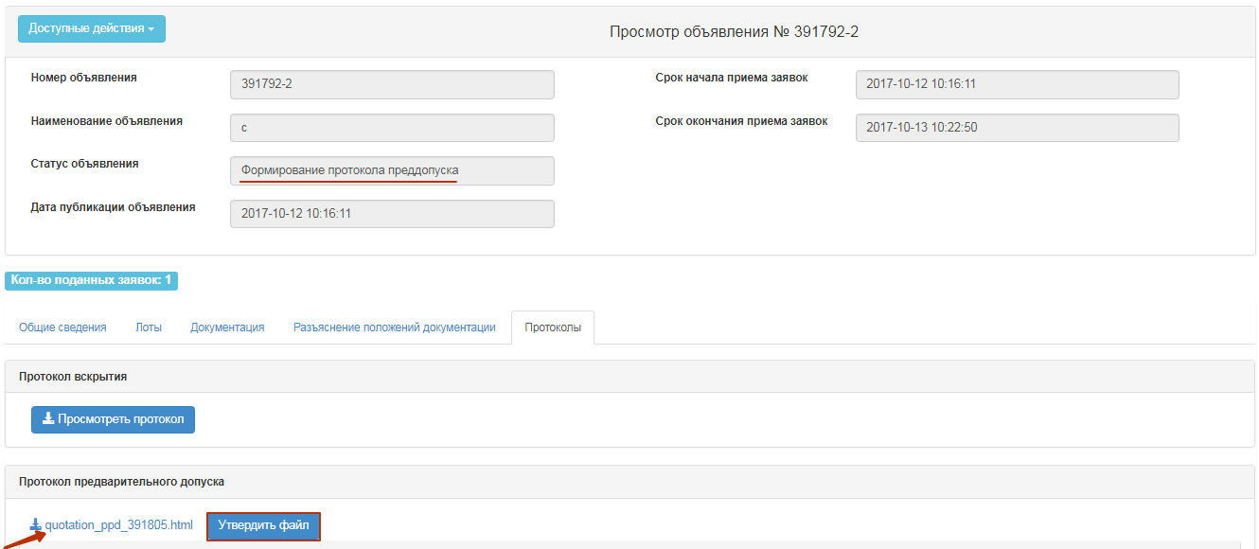
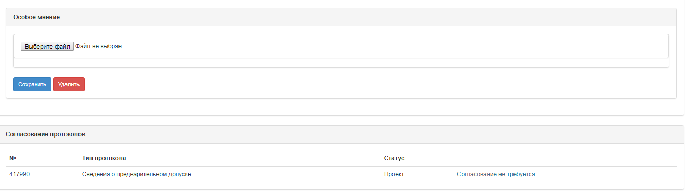
To view and download the document, you should click the active link for the document name. If it is necessary to attach a special opinion to the Secretary, you need to click on the "Choose a file" button and save the selected document.
To approve the protocol, click the "Approve File" button.
In the announcement view form, you can specify the start / end dates for the re-submission (addition) of the bid.
Note. For the method "Request for Quotations", approval of information on preliminary admission by the RT PPA is not required.
Attention! The system automatically sets the deadline for the receipt of clarifications as 3 working days from the date of publication of the information.

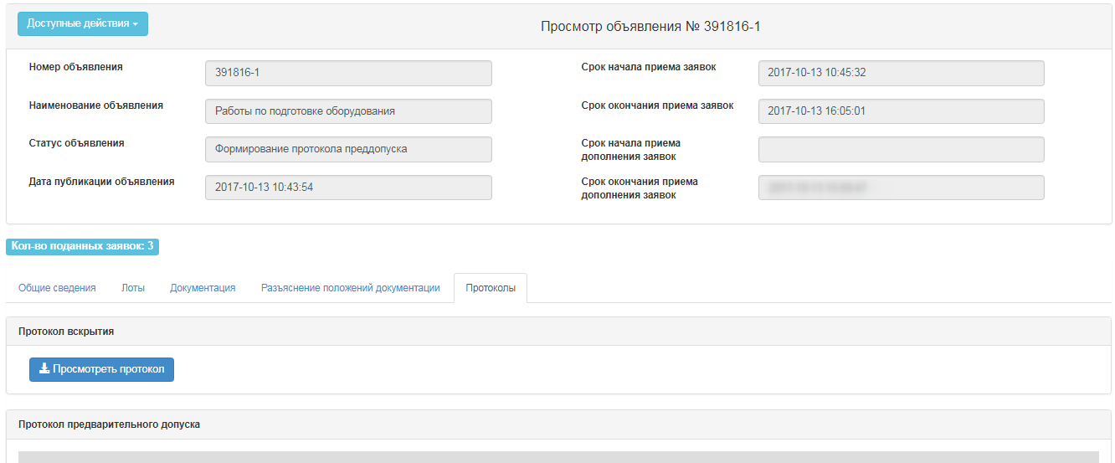
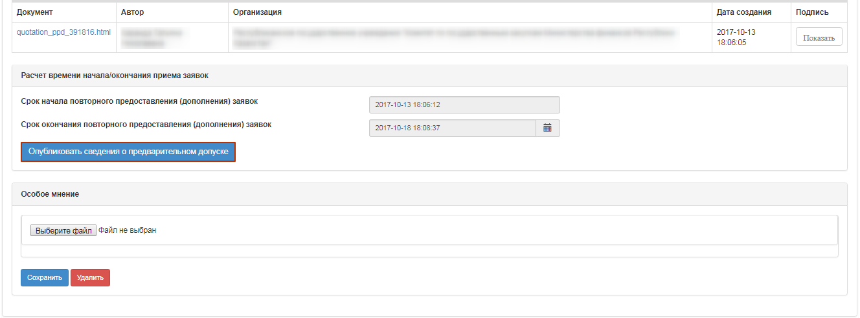
To publish the authorization Information protocol, you must click the "Publish pre-admission information" button.
In case of confirmation, the protocol of preliminary admission will be published, the status of the announcement and lots will be changed to "Published (request for clarification)".
In the form of the announcement view, the remaining time and terms of the beginning and the end of the receipt of clarifications of the bids will be displayed.
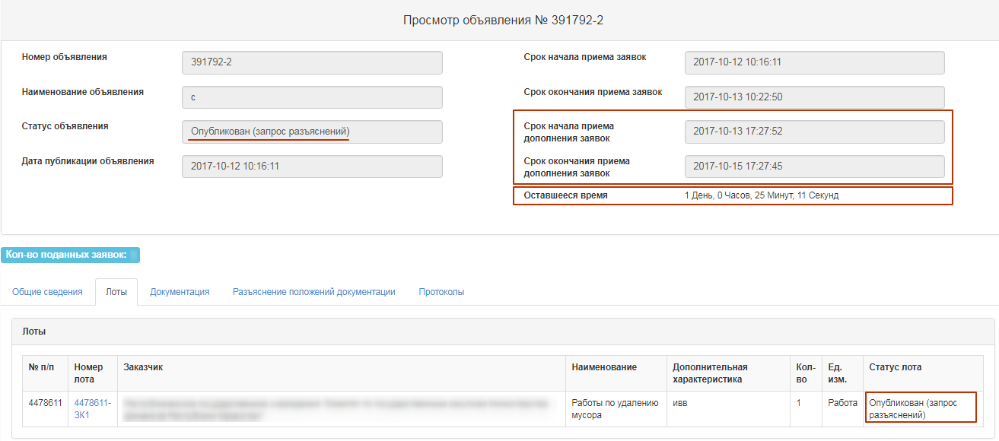

Reconsideration of the bids for participation by the method "Request for Quotations"
Upon expiration of the deadline for receiving clarifications of bids, the status of the announcement changes to "Consideration of applications (clarifications)", the system sends to the Organizer's Representative a notice on the need to review applications. For consideration of clarifications, on the form of viewing the announcement in the list of available actions, choose "View the bids".
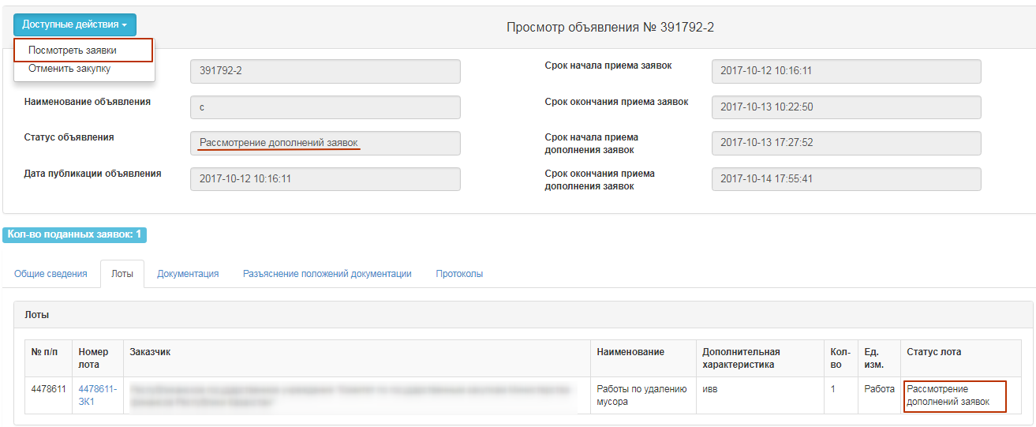
It is necessary to consider the bids in the status of "Consideration of the bids" (clarification). To view information about the vendors who have clarified the bids for participation in the procurement, click on the reference number of the bid.
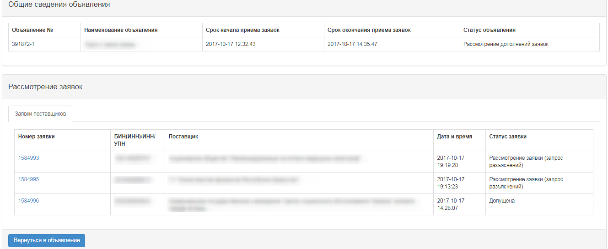
The "Vendor's Clarification" tab contains the text of the clarification. To view the documents that the vendor has attached to, click the file name.
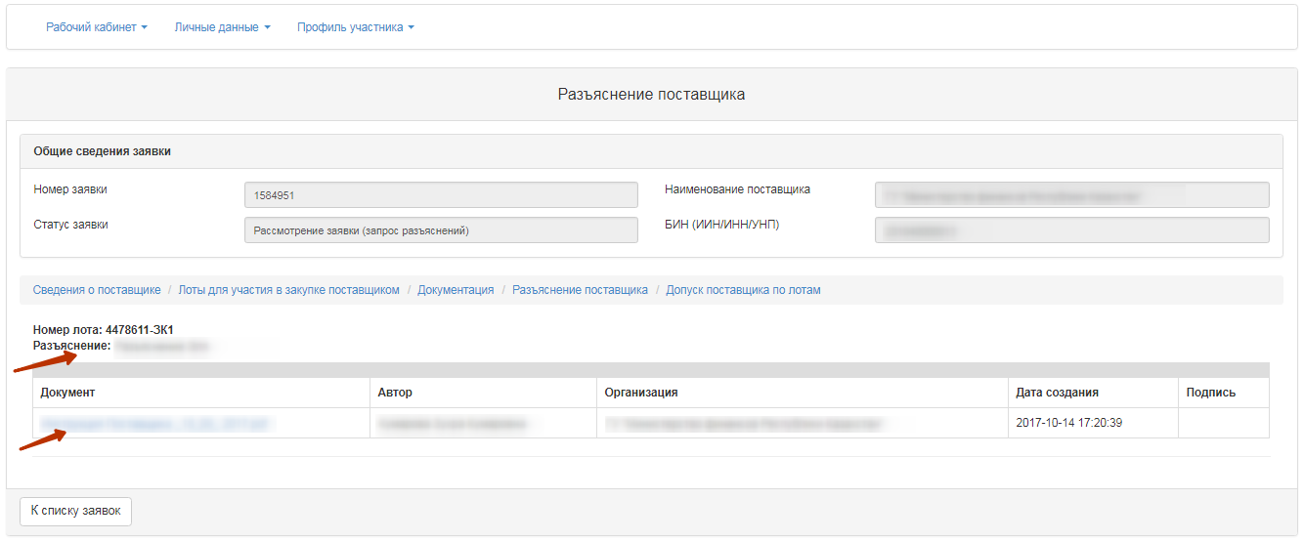
To vote for Admitted / Rejected, it is necessary to go to the tab "Admission of the vendor across the lots" in the form of announcement view. The system displays only the sections and the documents on which the vendor was rejected.
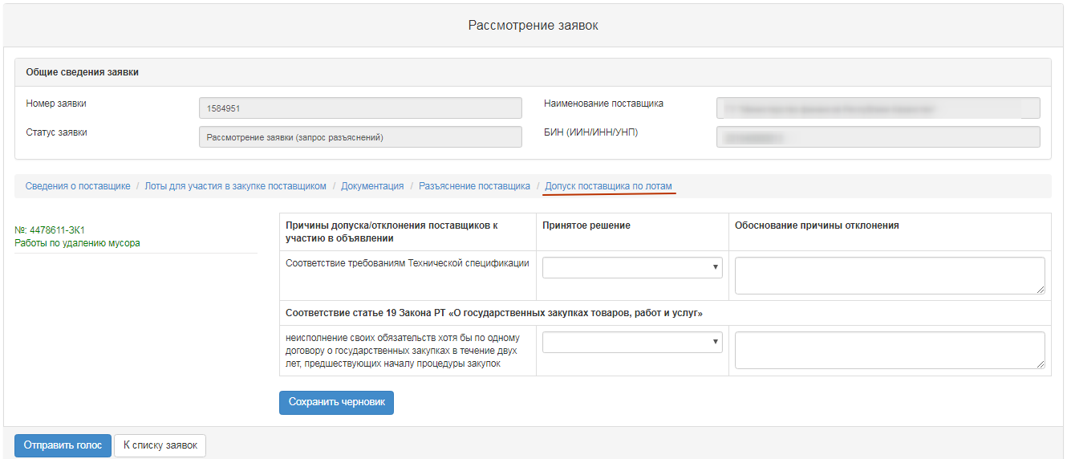
A second vote shall be carried out in the same manner as the "Consideration of bids.

Formation of final protocol
To form the final protocol the Secretary on the form for viewing the announcement with the status "Consideration of bids" / "Consideration of bids (clarifications)", in the section "Available actions", select the item "View the bids".
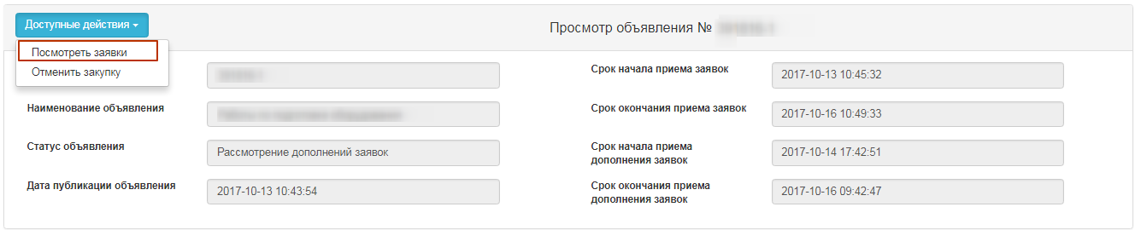
Then go to the tab "Voting control" and click on the button "Formation of the final protocol".
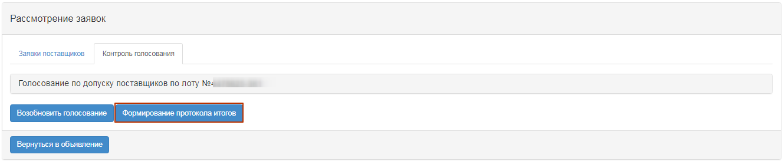
After choosing the action "Generate final protocol", the statuses of the bids, lot (s) and announcements will be changed to "Formation of the final protocol".
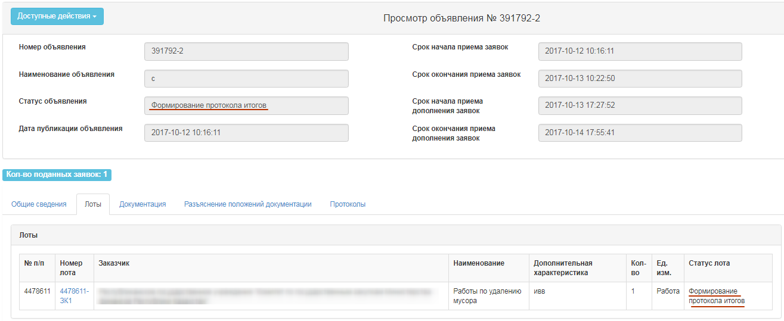
As a result, the log file will be created in the state, English and Russian languages on the form of viewing the announcement in the "Protocols" tab. The secretary of the announcement must approve this protocol.
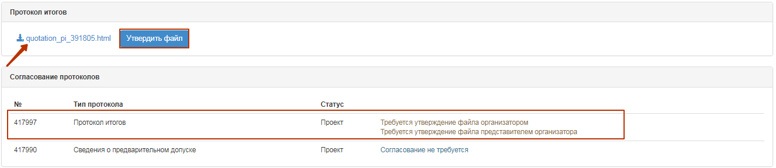
Note. In the event that the purchase method is a Request for Quotations and the Purchaser is the QPE, the minutes of the results will need to be sent for approval to the Rt PPA.
In the event that the purchase method is a Request for Quotations and the Purchaser is the PPA, and the customer is another organization, the record of the results must be sent for agreement to the Customer of the Organization.

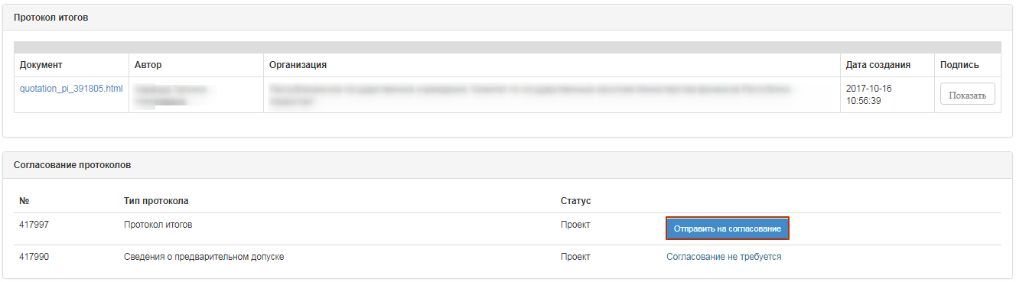
After clicking on the button "Send for approval", the final protocol will have the status "On approval".
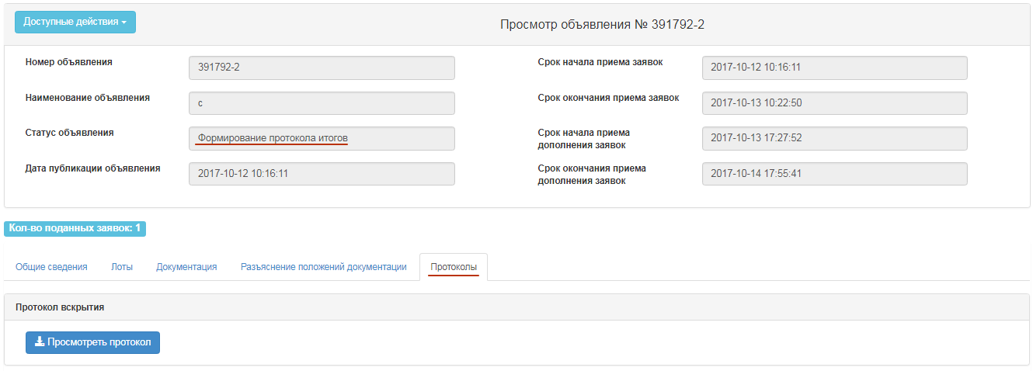
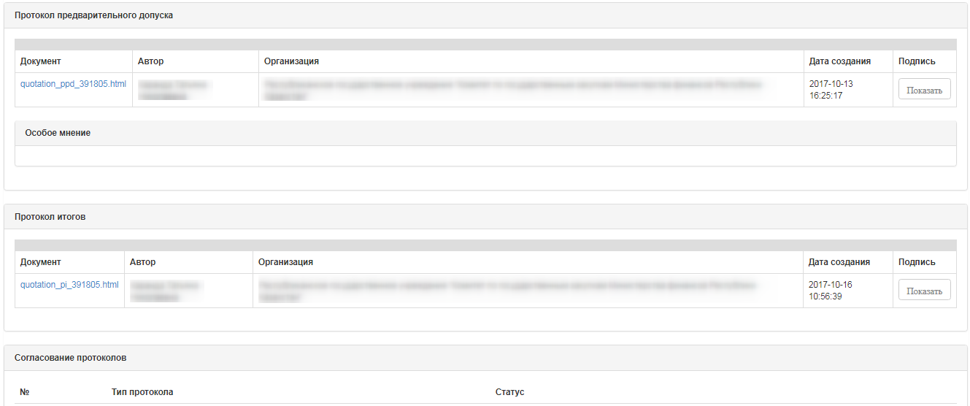
The system sends a notification to the users of the PPA with the role of "Approving protocols" about the need to agree on a protocol of results.
The system sends notification to the Customer with the role of "Approving Results" on the need to agree on a protocol of results in the event that the organizer is the Rt PPA, and the Customer is another organization.

Approval of final protocol
Information on agreement of summary protocol is displayed in the announcement, the "Protocols" tab.
If the employee with "Protocols sign-off user/person" role makes a positive decision, system displays the summary protocol with the status "Approved". The Secretary will be able to publish summary protocol.
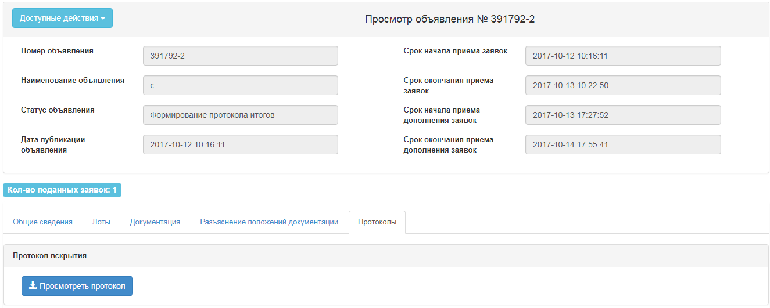
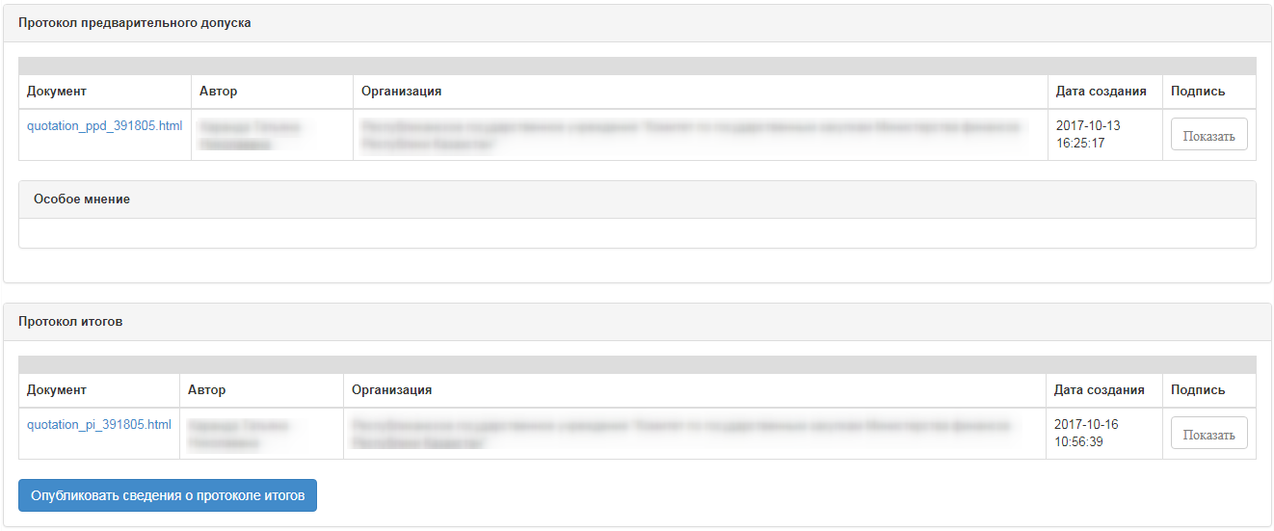
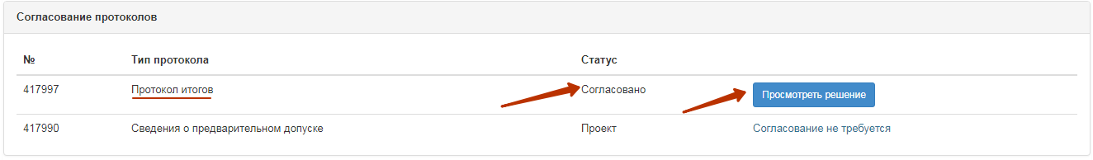
In the event that the user with the "Approve protocols" role has a negative decision, the system displays the summary protocol with the status "Rejected". And only the Procurement Cancellation procedure will be available to the secretary.
In case if the user with the "Approving Results" (Customer) role has made a negative decision, the functions and publications of the protocol and cancellation of the purchase will be available to the Organizer - Rt PPA. The decision is made by the organizer - the RT PPA.
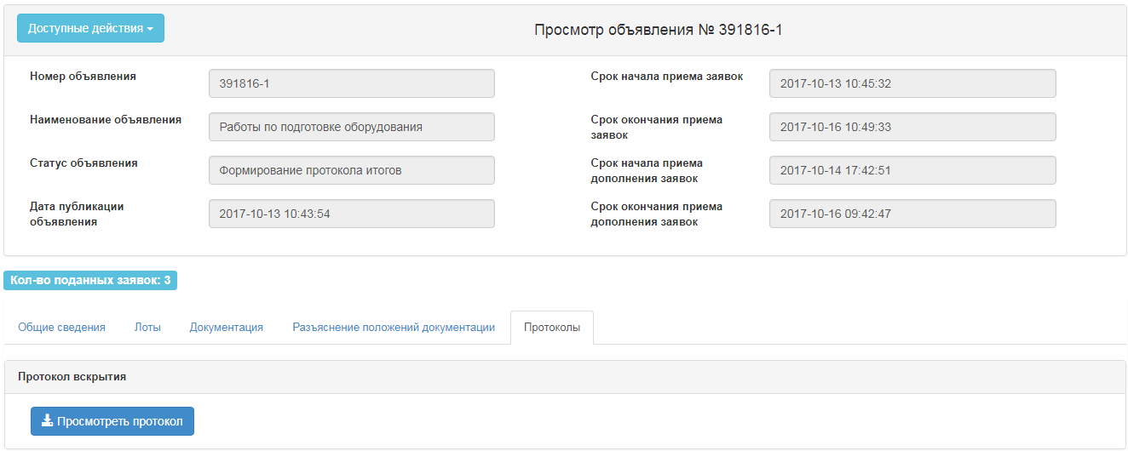
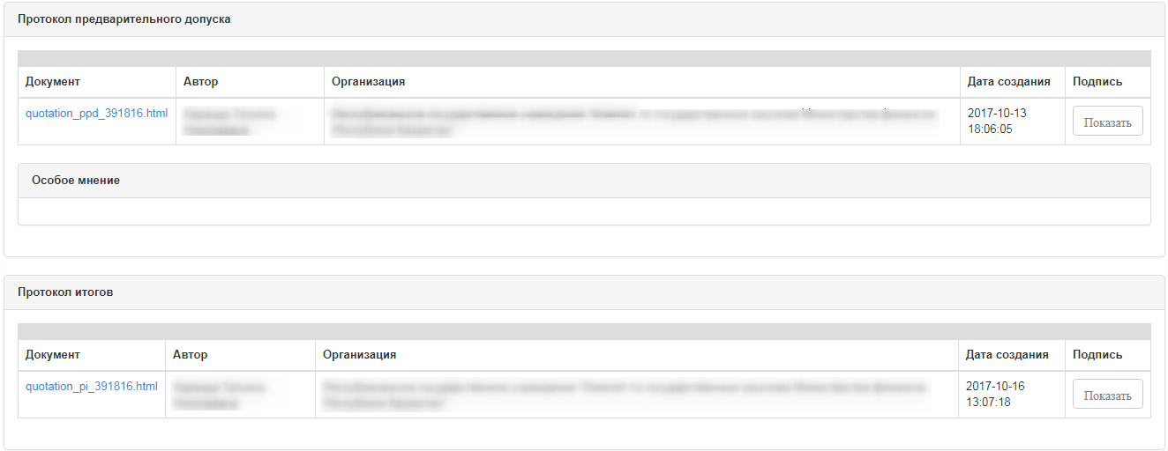
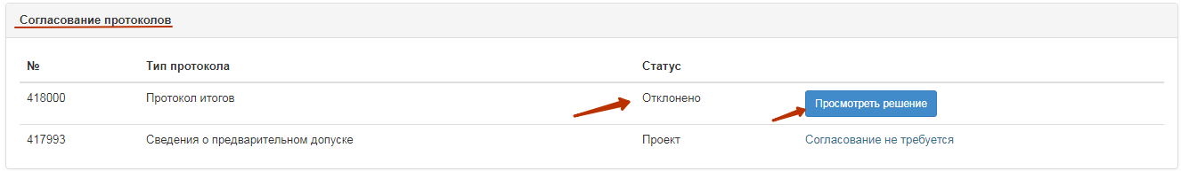
When you click on the "View Solution" button, information is displayed on the negotiating summary protocol, there is also an active link for downloading the document attached to the agreement.
In the final protocol with the status "Rejected", the reason for the rejection is additionally displayed.
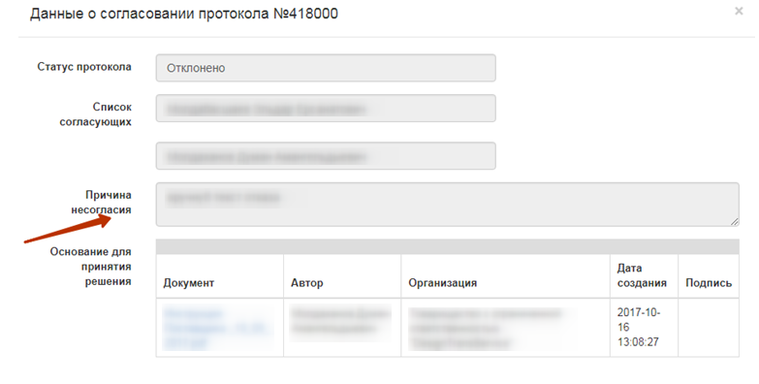

Publication of final protocol
Generated summary protocol is displayed in the announcement in the protocols tab. On the form of review, the Secretary has the functionality to publish the protocol:
- if the approval of the summary protocol is not required by the RT APP;
- if it is required to agree the final protocol with the RT PPA and the status of the protocol "Agreed".
- if the organizer is the RT PPA, the customer is another organization, regardless of the status of approval of the protocol by the Customer.
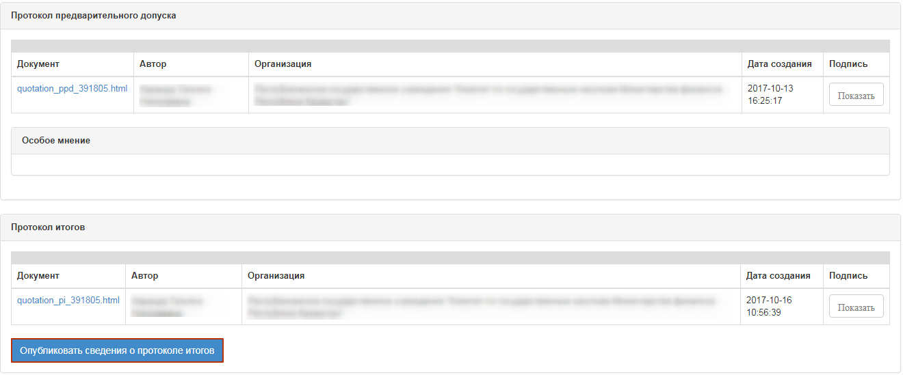
After clicking on the button "Publish information about the final protocol", the status of the announcement is changed to "Completed". "Protocols" tab displays the active link for downloading summary protocol.
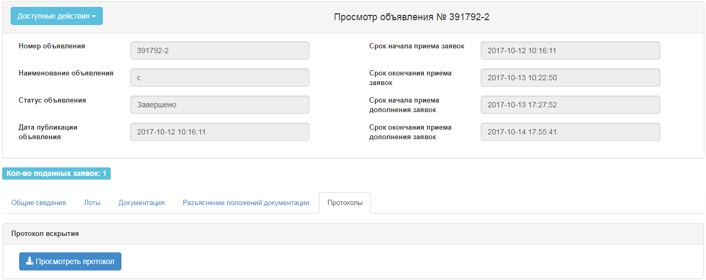
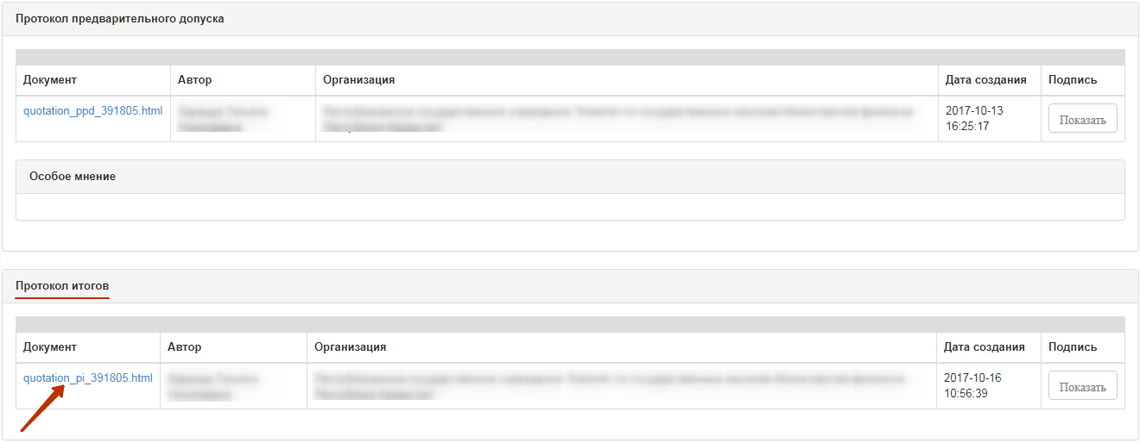
Note. Public procurement is considered to be valid if at least one bid of a potential supplier is eligible for participation by lot. At the same time, a potential supplier whose application for participation is the only one admitted is recognized by the web portal as the winner in these public purchases.
ATTENTION! After publication of final protocol within 24 hours, the lots of the purchase are not available for creation of the contract or for repeated publication of the purchase. This period is reserved for submission of complaints by vendors. In the event that complaints are received within the specified period, the authorized body will carry out procedure for completing the appeal with decisions on reviewing the results, canceling the purchase or refusing to satisfy vendor's complaints.

Change the customer/organizer's representatives
The functional of changing the representative of the organizer is available only to the Secretary in the announcement with the status "Published", "Submission of bids", "Published (request for clarification)", "Consideration of bids", "Consideration of bids (clarifications)", "Formulation of the protocol of preliminary admission."
To change the representative of the organizer, click on the "Edit representative data" item in the "Available actions" menu.
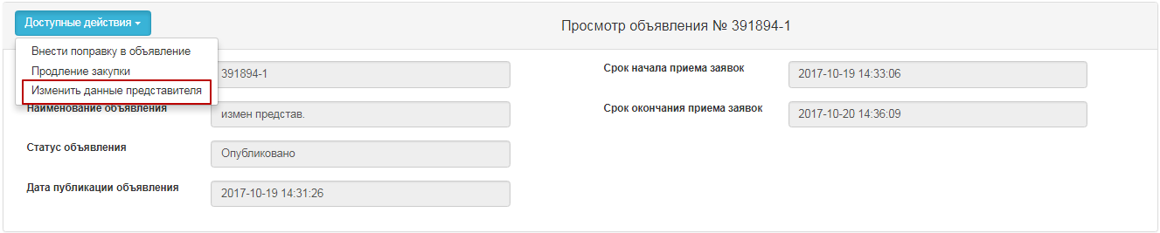
In the opened form, change the data of the representative of the organizer.
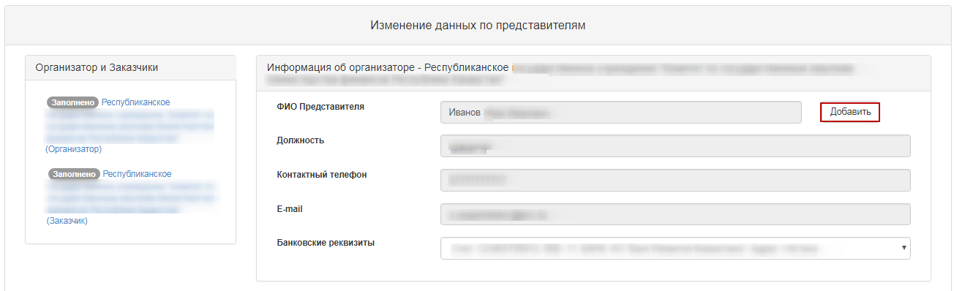
After you have activated the "Add" button, the following window appears.
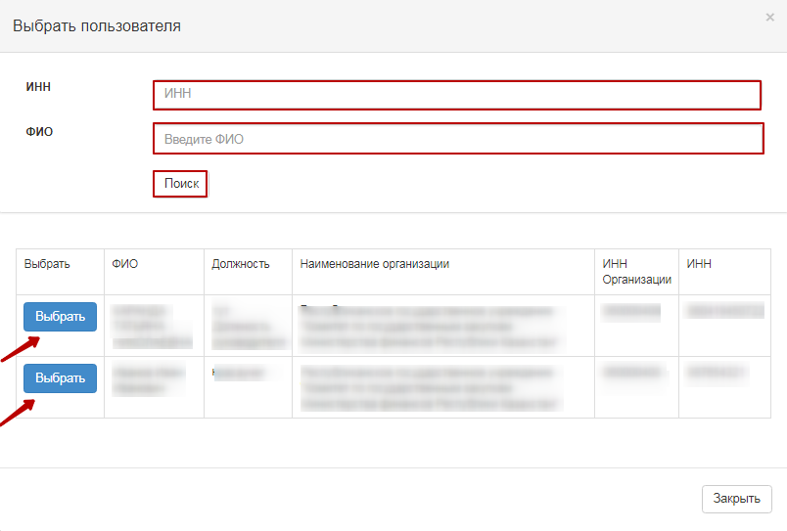
Then save the changes and return to the announcement.
Note. In the event that the protocols are not formed, but a vote has been completed and the representatives are to be changed, the system will annul the results of the previous representative's vote after the representative has changed. The voting procedure should be repeated.

Cancel of the Purchase
Cancel of functionality is available from the moment as the announcement is opened to creation of the contract in announcements with the statuses "Consideration of bids", "Consideration of bids (clarifications)", "Formation of information on the preliminary admission", "Formation of the minutes of results", "Filling in conditional discounts", "Completed ".
In order to cancel the purchase, the Secretary needs to select the "Cancel the purchase" action in the list of actions in the announcement view form.
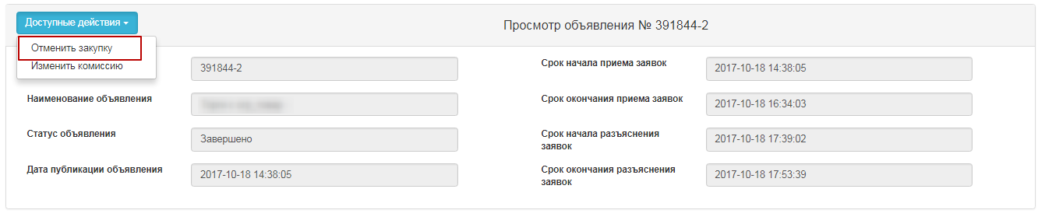
Cancel of the purchase is possible for the entire purchase, as well as for individual lots, if there are several lots in the purchase. After this action is completed, a warning message is displayed.
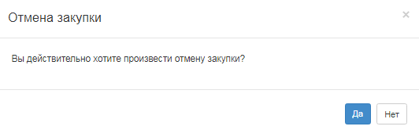
When you click the "No" button, the system returns to the purchase review form. To cancel, click "Yes" to display the lot selection form.
The choice of lots is carried out by putting a tick in the line with the lot, then you need to click on the "Cancel the purchase for selected lots" button.

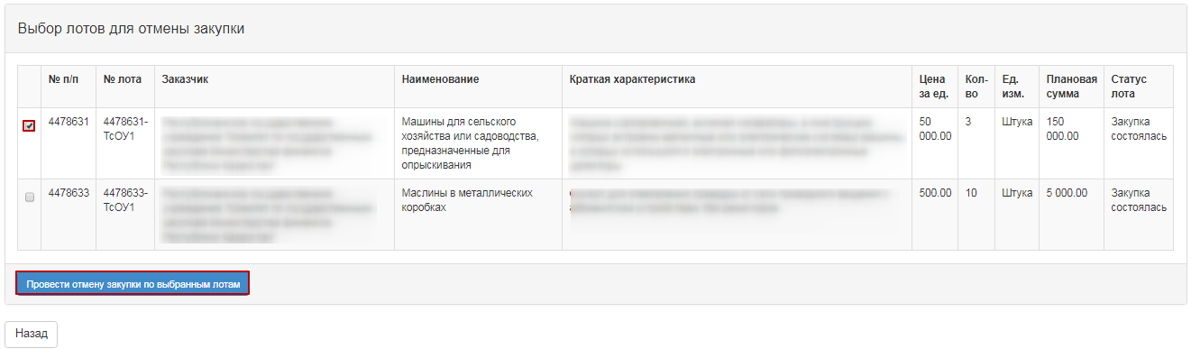
A cancel form appears where it is necessary to attach the scanned electronic document that is the basis for cancellation and fill in the information on the basis for cancellation.
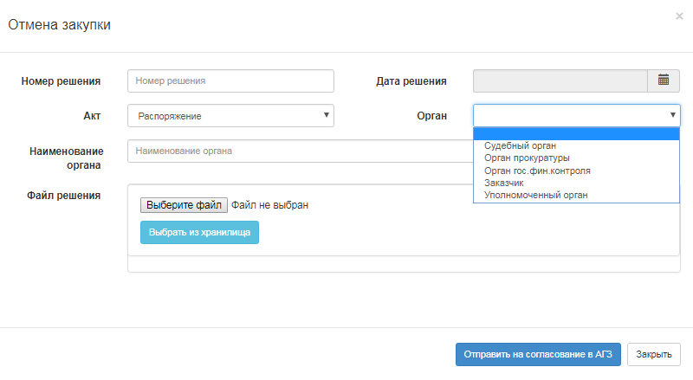
The purchase cancellation form contains the following fields:
Field name | Field value
Solution number | The field is text and is available for manual input. An act number must be entered in this field.
Resolution Date | This field shows the date on which the relevant act was issued, and is filled in by using the "Calendar" icon.
Act | Select from the drop-down list the position of the directory of the types of acts with the values:  - Resolution;  - Definition;  - View;  - Notification;  - Decree  - Order  -Order
- Authority | In this field, an authority from the directory of authorities with the values shall be selected:  - Judicial authority;  - Prosecutor's office;  - State finanacial control authority.  - Customer  - Authorized Body
- Name of the Authority | The field is text and is available for manual input. In this field, you should specify the full name of the authority.
Select a File | The button is used to attach a document that is the basis for the cancellation.
Attention!
Note for QPE: On procurement, which is organized by qualified procuring entities (QPE) on "Request for quotation", "limited bidding", "unlimited bidding", "single source" procurement methods, it is necessary to agree on the cancellation of purchase with the Public Procurement agency (PPA RT) by clicking the "Submit for PPA approval" button
For the QPE organizer, if there is a generated, but unpublished, pre-admission /final protocol and an application for cancellation of procurement is sent to the PPA, the system will not allow to publish this protocol.
For the QPE organizer in the case where the pre-acceptance /final protocol is sent to agreement with the PPA, but the organizer performs cancellation of the procurement, the system automatically removes the request for protocol approval and sends only the cancellation request.
For the QPE Facilitator in the event that a pre-acceptance / final protocol is not in place, but there is an application to cancel the procurement, system prevents the secretary from forming protocols.
Note for the RT PPA: For procurement, the Facilitator of which is the PPA, no approval of procurement cancellation is required.
After filling in all fields and attaching the file, click the "Cancel Purchase" button. System will automatically decide to cancel the bid/lots
Note for all: When you cancel all lots, the purchase automatically generates a summary protocol that indicates the reason for cancellation, at any stage of the announcement. If the purchase has multiple lots, when one lot is canceled, the lot status changes to "Canceled", and the protocol, after it is published, specifies the reason for the cancellation of this lot. Also, canceled lot is returned to the pool to publish new purchase.
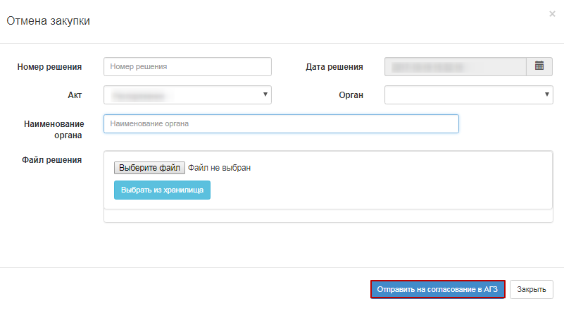
System sends a notification to users with the "Approve Cancellation" role to approve purchase cancellation.
Information on the lots that are being produced or canceled is displayed in the "Review/Cancel" tab of the announcement form.
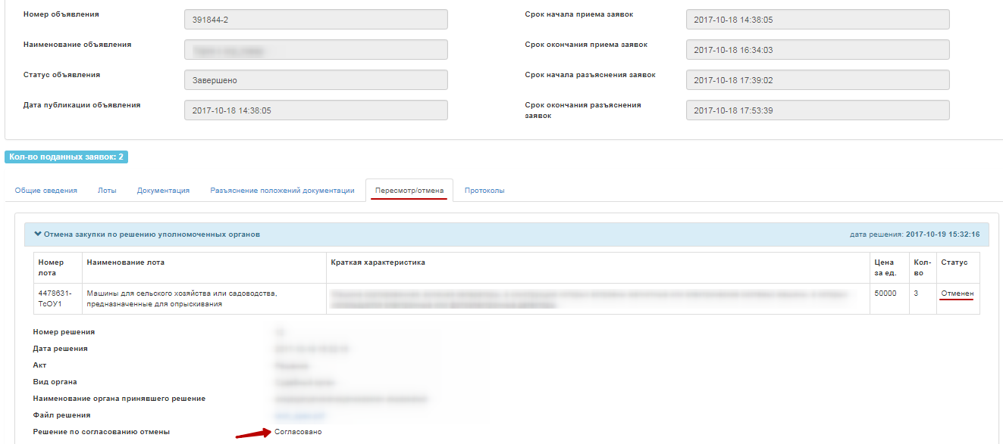
Decision on approval may be made:
-Approved
-Rejected

Organization and conduct of procurement using the method "Unlimited bidding"

Create an announcement
To create an announcement you should go to the "Personal account" section and select "Create announcement". Accessible to a user with the "Organizer" role.
Next, you will see a form for creating a draft of announcement.
Section "Creation of a draft of announcement" contains the following fields and buttons:
Item | Action
Type of procurement item | Filled in manually. One of the values is selected:  Work;  Service;  Goods.
Title of (procurement) announcement in the Tajik | Filled in manually
Title of (procurement) announcement in the Russian | Filled in manually
Title of (procurement) announcement in the English | Filled in manually
Indication of purchase | If the bidding is required for procurement among the organizations of domestic manufacturers, a check mark should be placed on the line with this indication.
Next | When clicking the button, the System shall check for filling in all mandatory fields
If the bidding is required among the organizations of domestic manufacturers it is necessary to put an indication - "domestic producer" in the draft of announcement.
After you fill in all the fields, click "Next".
Note. After you move to the next step, the system automatically saves the announcement in the status "Draft" in the section "Work Office" - "My announcements (organizer)":
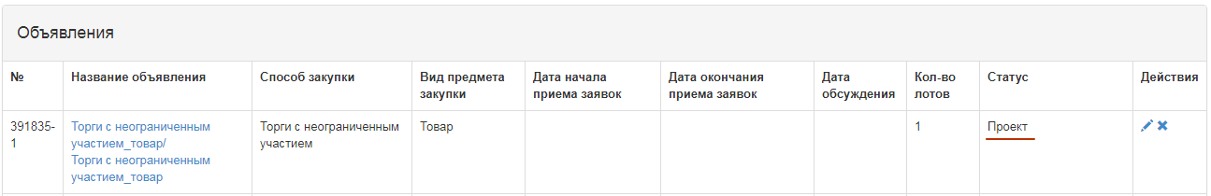
The icon allows to edit, the icon allows to delete announcements with the status "Draft" when you click "Next", lots that meet the specified criteria by method, item type, and purchase indication are displayed. It is necessary to mark Lot (s) and click "Add selected" button:
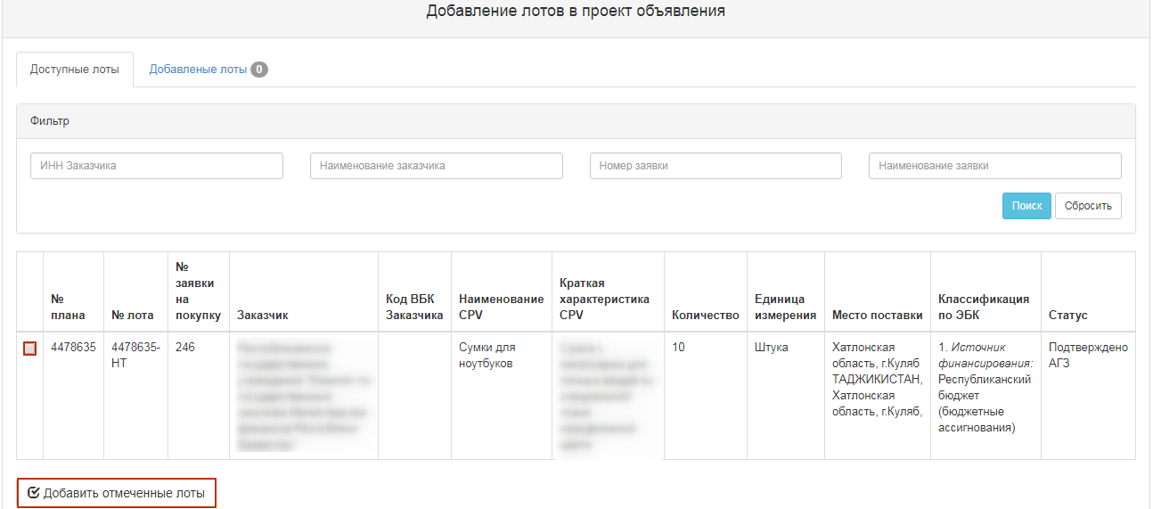
To select a lot, you shall mark the required lot and click "Add marked lots" button. Then you go to the added Lot view page. If you want to delete selected lot, mark required lot with a check mark and click "Delete marked Lots" button, and if you want to add lots to the purchase project, go to the "Available Lots" tab and perform selection of additional lots. To go to the next page, click "Next".
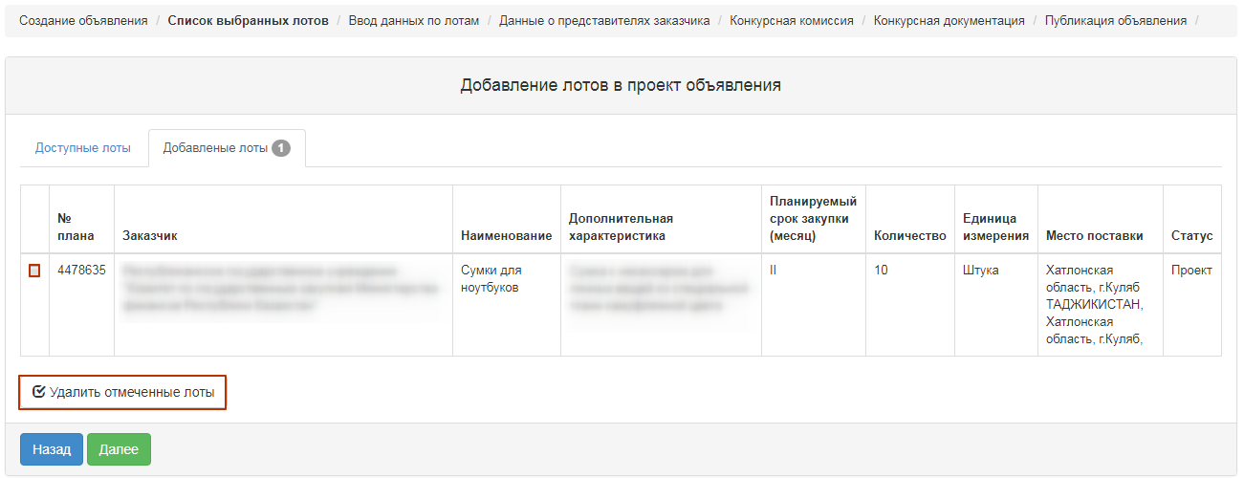
"Enter data by lot" section contains the following fields:
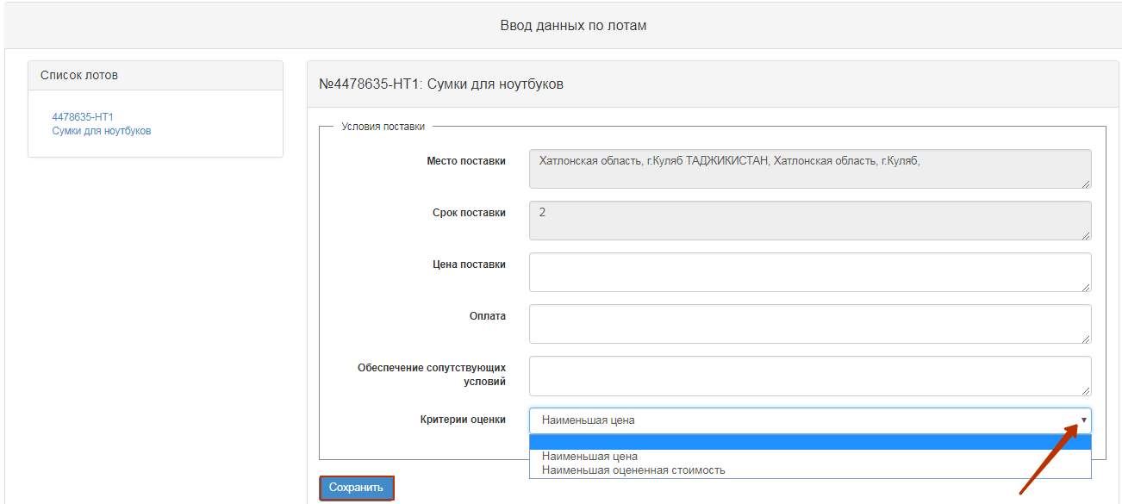
Place of delivery | Automatically filled in by the system from the annual plan
Delivery Period | Automatically filled in by the system from the annual plan
Price of delivery | Filled in manually
Payment | Filled in manually
Related Services | Filled in manually
Criteria of evaluation | Select from the drop-down list
Upon activation of the Next button, the following window appears.

Adding Commission
The next step in creating a draft announcement is to add the Commission.
Minimal composition of the commission - the Chairman and two members of the commission. Odd number.
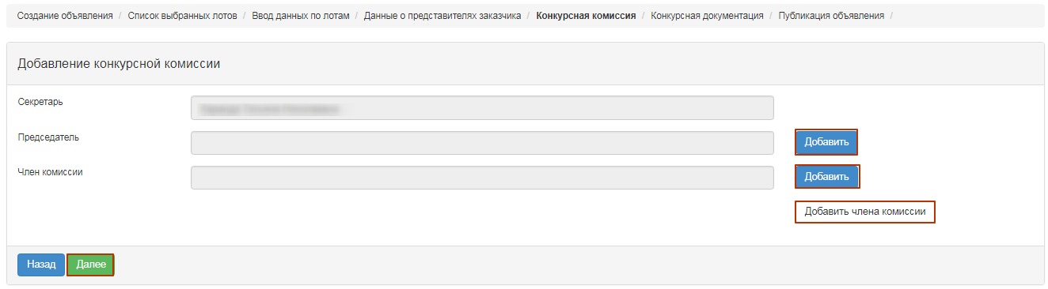
"Add" button to select a commission member. A pop-up window appears. Search may be performed by following filtration parameters values:
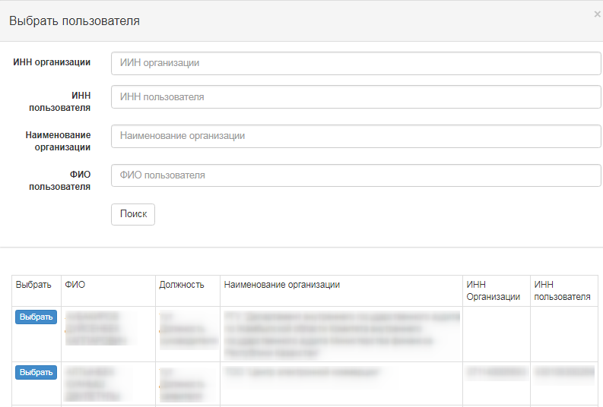
Adding a member of the Commission is carried out by clicking the "Add commission member" button.

Preparation of documentation.
"Document Preparation" step displays a list of required documents to participate in the bidding according to the rules for conducting public e-procurement. If the vendors are required to provide certain documents to participate in the bidding, the Secretary should be required to provide a sign "mandatory for the vendor". To view information about a document, click its name in the "Document Name" field.
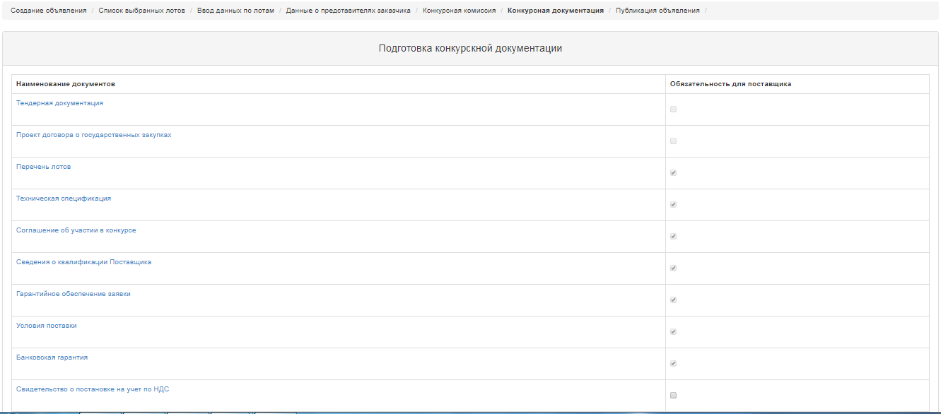
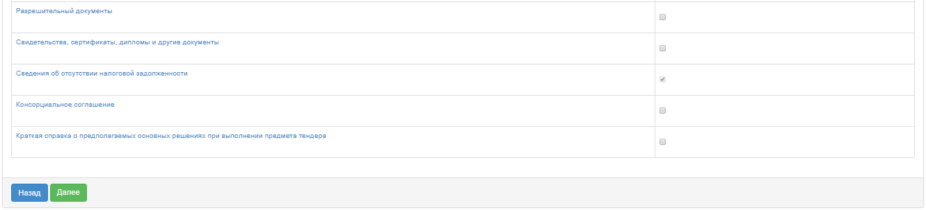

Generating Technical Specification
To go to the "Technical Specification" section, in the general documentation list click the active hyperlink "Technical specification". It is necessary to confirm the file of technical specification that describes the goods, work, or services, for this you should click the active link on the lot line "View".
The new window displays the system-generated technical specification from the bid for the bidding. If the Organizer needs to change Technical Specification prepared by the Customer, it is necessary to:
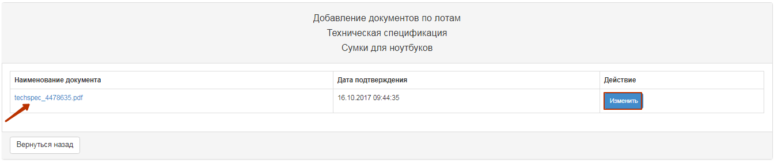
When you click "Edit", a window is displayed for editing in the state and Russian languages.
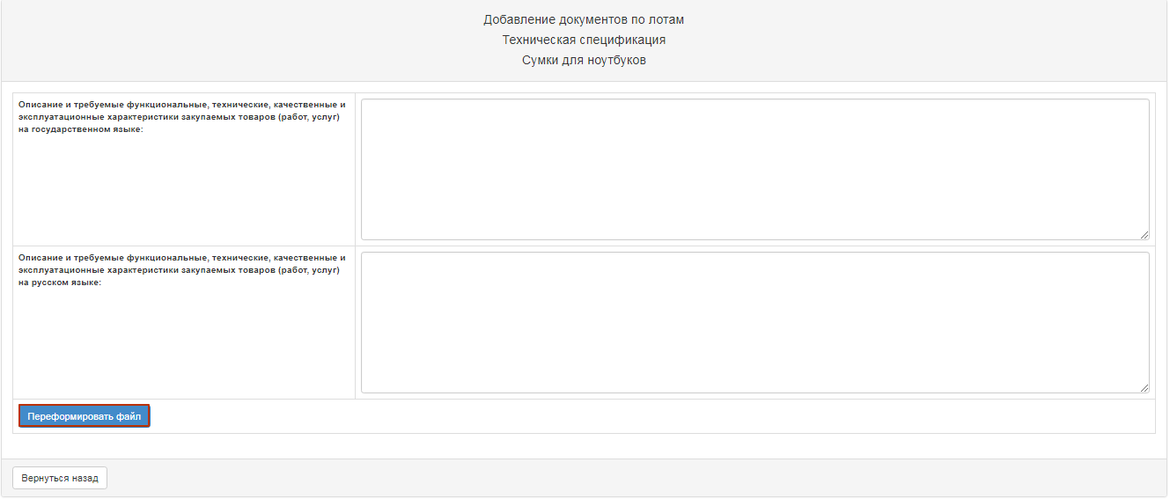
After amending it is necessary to confirm by clicking the "Reforming the file" button. If no changes are required, you can use the "Go Back" button to exit without modification.
When you approve Technical Specification Document, the system fills in the confirmation date.
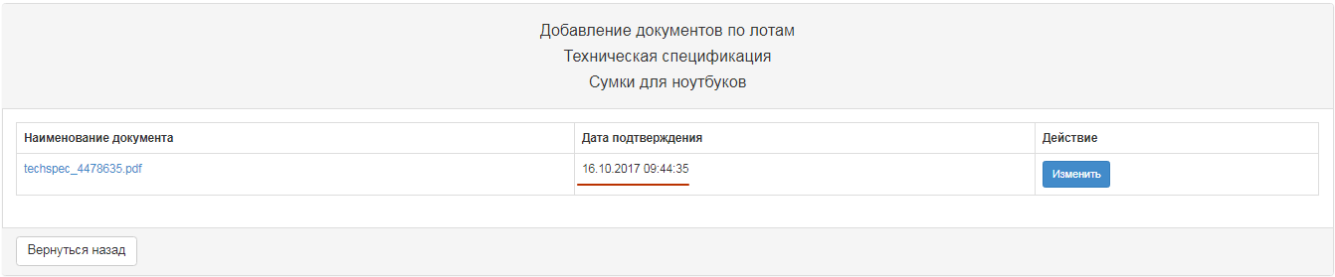
For items of a service or job, click the "View" button to display the following window:

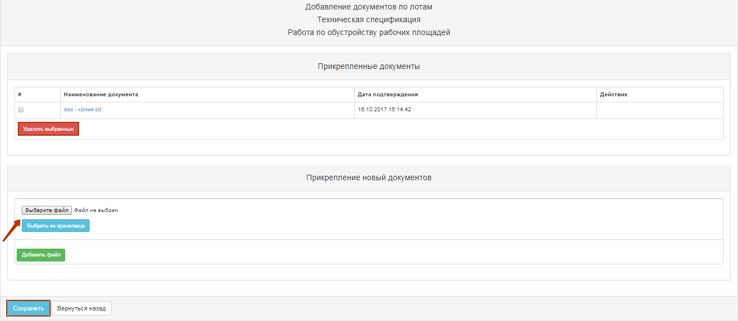
If necessary, you can delete attached technical specification and/or add another technical specification file.
If you add a new file using the "Select File" button, a window opens to find the file you want. After the file is selected, open it, and then click "Save".

If you add a new file using the "Select from Storage" button, a window will open with previously downloaded files in the participant profile - File directory. After you select the file, you should "Save" it.
To return to the shared document list, click the "Go Back" button.

Formation of a draft agreement.
To review the draft contract in the purchase creation form, click the "View draft contract" link button.
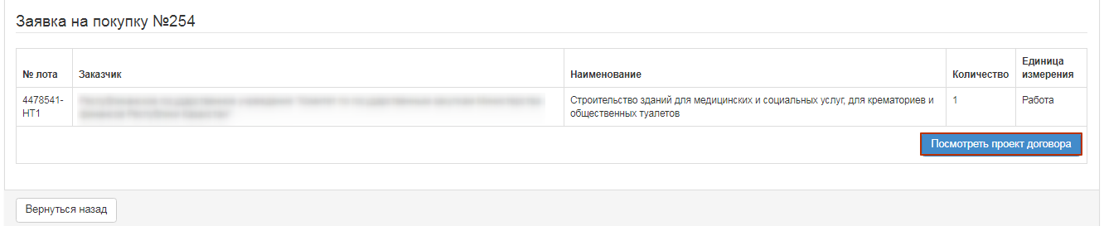
If necessary, you can delete attached draft contract and/or add another technical specification file.
If you add a new file using the "Select File" button, a window opens to find the file you want. After the file is selected, open it, and then click "Save".
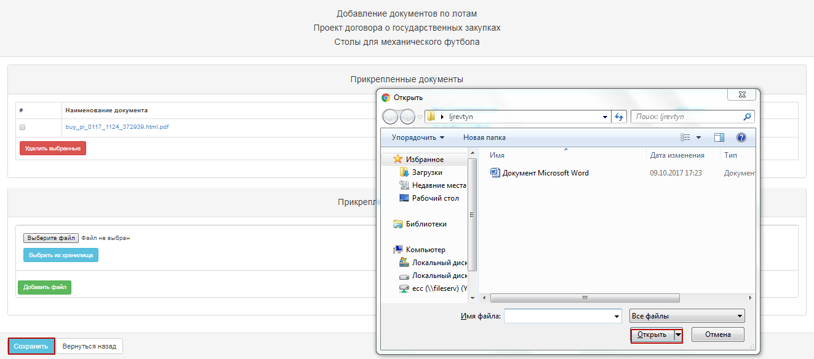
If you add a new file using the "Select from Storage" button, a window will open with previously downloaded files in the participant profile - File directory. After you select the file, you should "Save" it.
To return to the shared document list, click the "Go Back" button.

Generation of the document "the list of Lots" and tender documentation
At the stage "Preparation of documentation" for the document name as an active link. In the pop-up window, you need to "Confirm", and then close the window.

Generate the "Delivery terms" document.
At the step "Preparation of Documentation" click the active link to "Delivery terms". In the pop-up window, you need to "Confirm", and then close the window.

Pre-review of the announcement.
The form of "Announcement Preview" contains general information on the purchase, information about the organizer, and the comission.
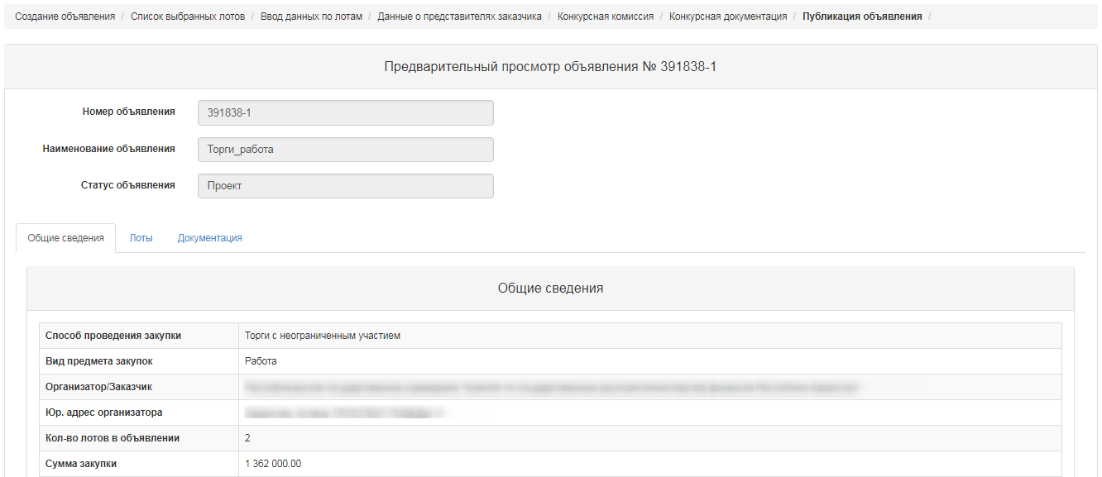
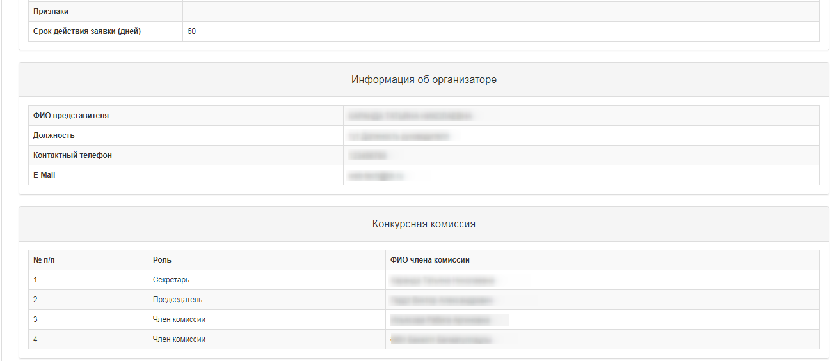
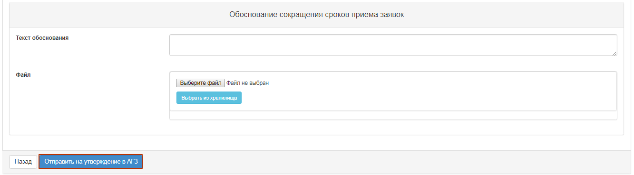
Note. On procurement, which is organized by Qualified procuring Enterprises (QPE) concerning the methods of procurement in "Request for Quotation", "Limited Bidding", "Unlimited Bidding", "Single Source Procurement", draft of bidding document should be agreed with the Public Procurement Agency (RT PPA).
For procurement, organized by the RT PPA no approval is required.
When you click the button "Submit for APP approval", the system displays a pop-up window that requires you to confirm the action.
If a publication is successful, the status of announcement is set as "On PPA Approval".
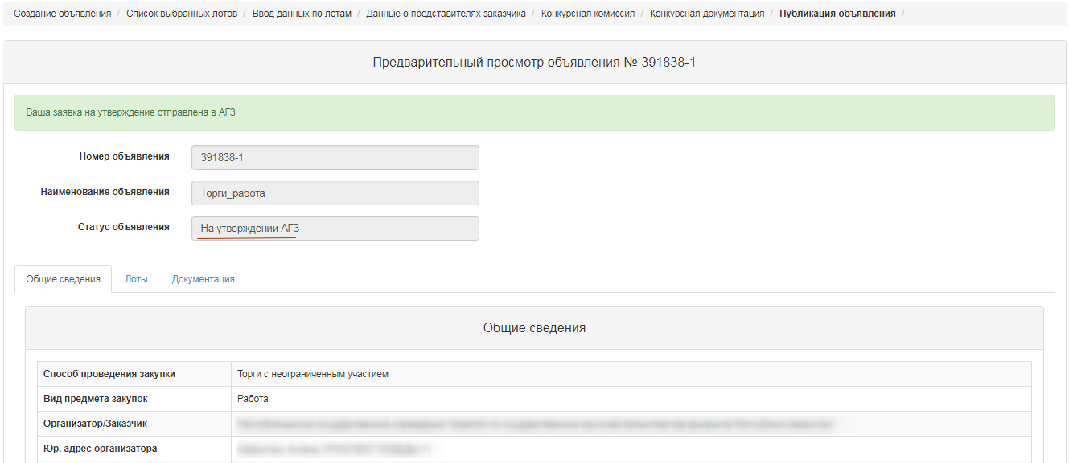
System sends a notification to users with the role "Approval of announcement" on the need to approve the announcement.

Approving the draft announcement
In the event that the purchase was refused in agreement, the purchase is assigned the status "Rejected by the RT PPA" with subsequent possibility of editing by Secretary of the announcement.
The Secretary should go to the "Personal account" - "My announcements" (Organizer).
When you click the icon, a pre-review of announcement is displayed, and the reason for the rejection is listed at the bottom.

After you select "Correct comments", you will see a pop-up window with the need to confirm the action.
If you select the "Approve" function, the purchase is assigned the status "Approved by the RT PPA".
When you click the icon, a pre-review of announcement and the "Publish" button is displayed. In this form, you should specify the start and end time for accepting the bids.
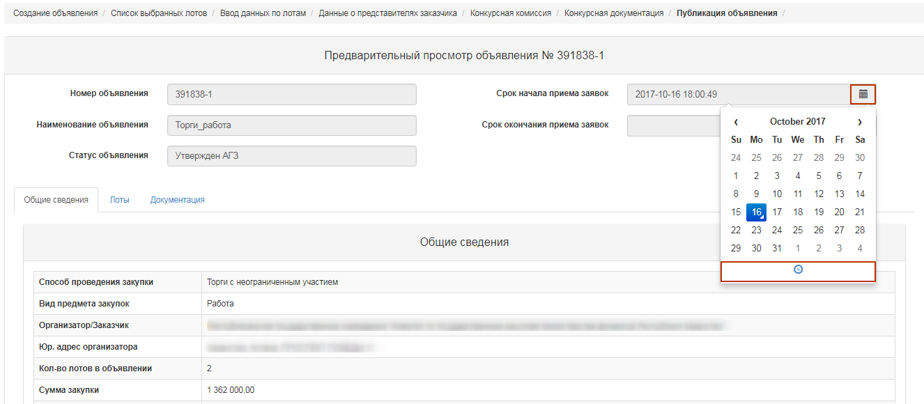
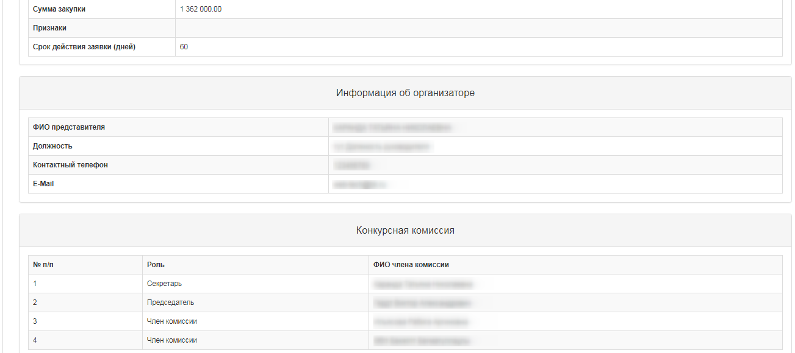
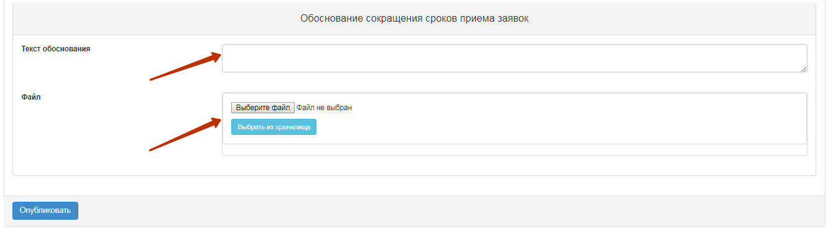
However, the date and time when the bids are received should be not earlier the current date of the publication.
Note. For the "Unlimited bidding" method, the minimum interval between the start and end of the approval period is 21 calendar days.
To publish announcement with a term of less than 21 calendar days, you should provide a reason and attach supporting document to reduce the deadlines for accepting the bids.
If a publication is successful, the status of announcement is set as "Published". Otherwise, the system issues an error message.
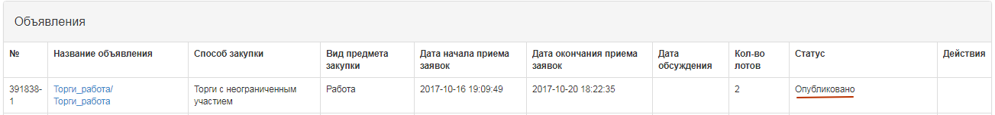
Information on the reason of reducing the interval appears on the "General" tab.
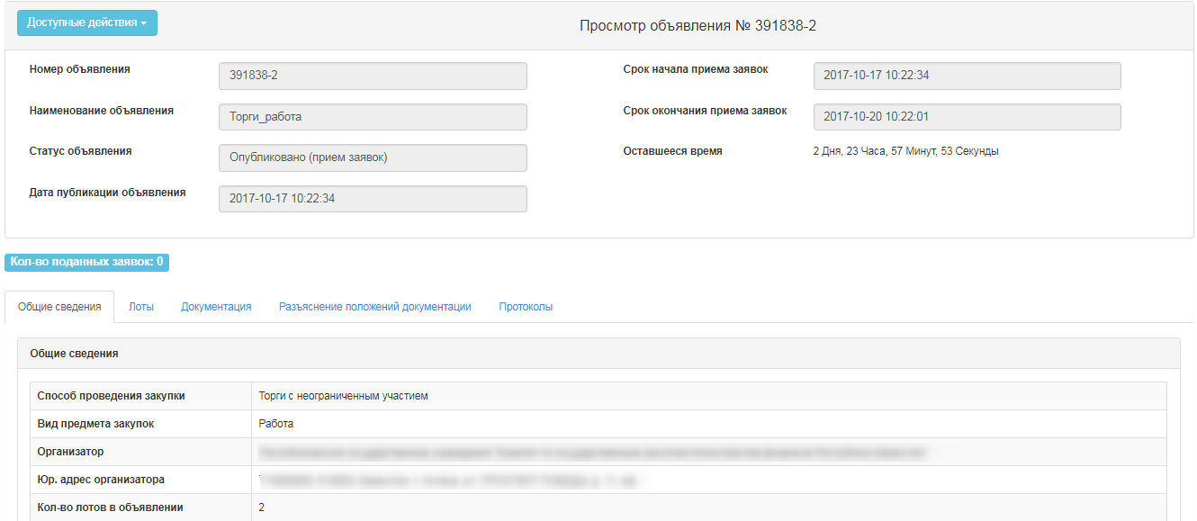
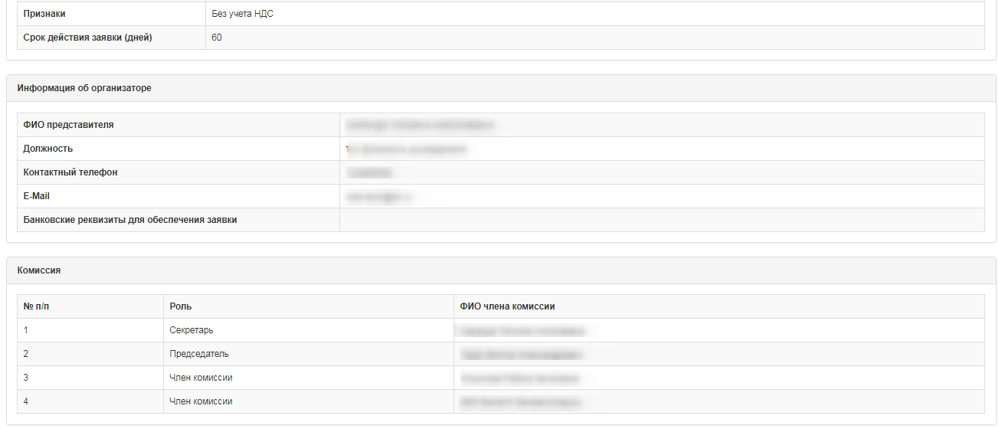
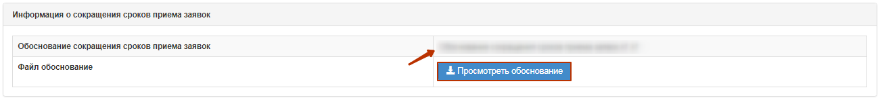

Extension of the deadline for submision of bids.
The Secretary in the form of announcement view has the action "Extension of the bidding" for the bidding with statuses "Published", "Published (acceptance of the bids)".
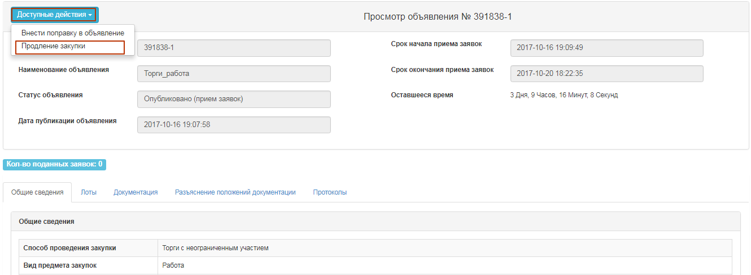
By clicking on the button "Extension of the bidding", the Secretary is given the opportunity to enter data in the filed "Reason for extension of the bidding", which is mandatory.
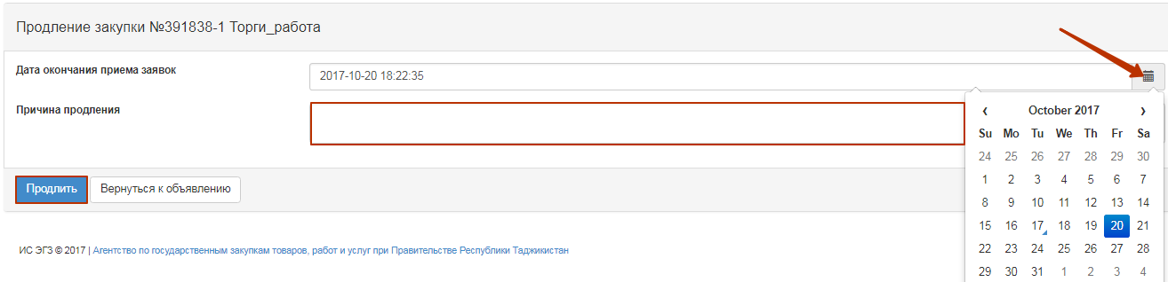
After that, the system displays a success message.
Note. In case of extension of the bidding in the announcement with the status "Published, acceptance of the bids", after changing the deadline for receipt of bids, the system sends an extension notice to the members of the Commission and to the vendors who applied for participation.
Note. The system allows changes to be made only to the bid submission deadline term, and the start date remains unchanged.

Change of documentation
The Secretary in the form of announcement view has the action "Amending the announcement" for the bidding with statuses "Published", "Published (acceptance of the bids)".
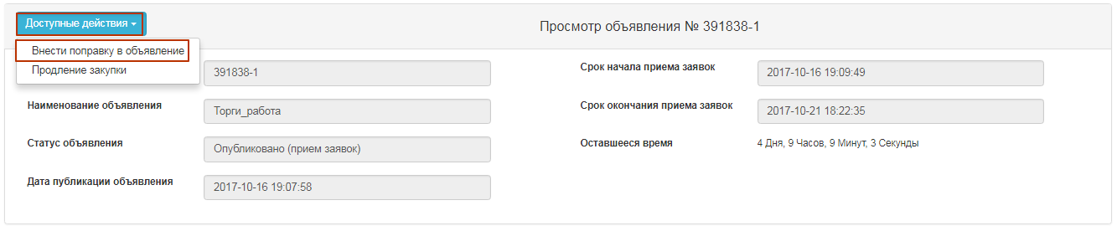
After you select an amendment to the announcement, the Registrar should fill in the filed "Reason for amending".
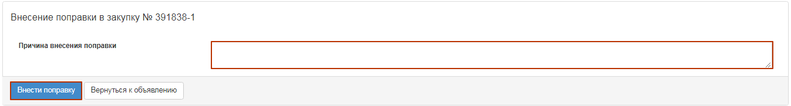
After you complete the action "Amending" the purchase project is automatically created with index 2. Original announcement (with index 1) is assigned the status "Modified documentation".
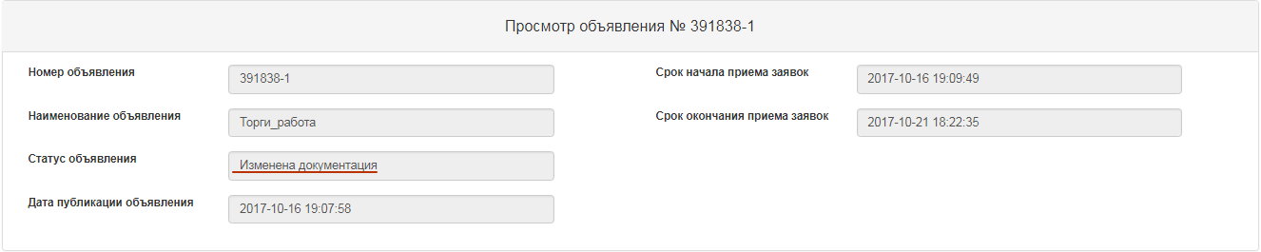
To edit announcement with index 2, the Secretary needs to go to the "Personal account" - "My announcements" (Organizer), click the icon in the actions.
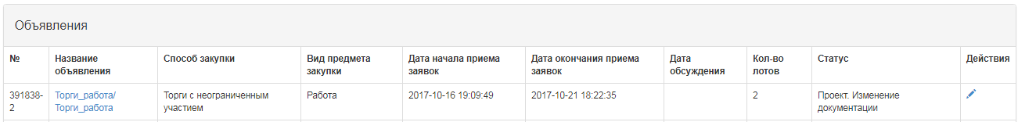
The system displays the form of editing the announcement.
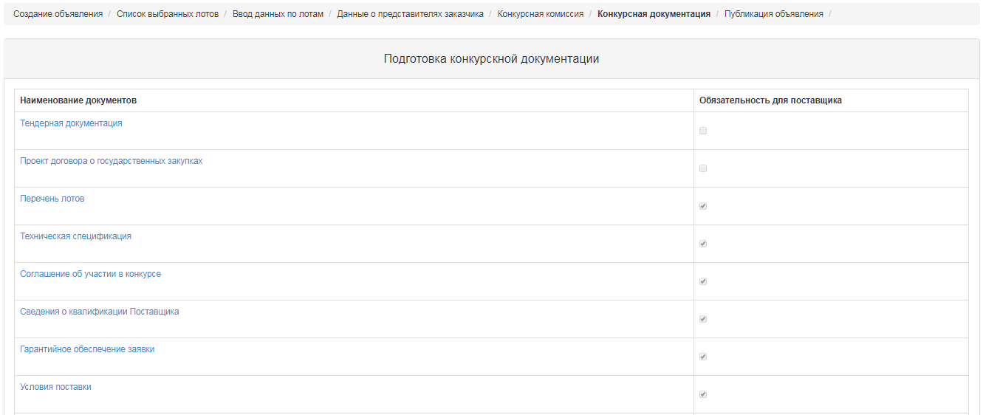
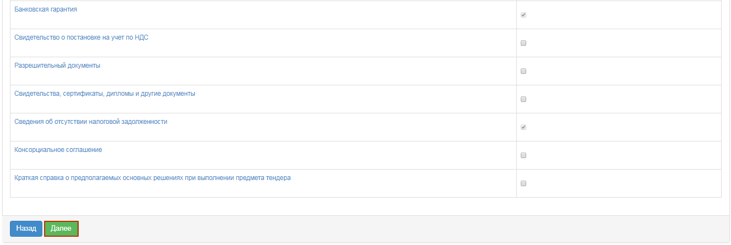
As you have amended the draft announcement, you should click on "submit to the RT PPA for approval". Further harmonization is carried out according to the instructions (see Approving the draft announcement).

Explanation of provisions of documentation
If there are comments on the documentation, as well as the calls for clarification of the provisions of documentation, the vendor may write a message to organizer within the period of bid acceptance in the announcement in the status of "Published acceptance of the bids".
Notifications on received bids go to the Secretary, the Organizer's representative and the Customer's representative. To view the bids from vendors, go to the "Clarification of Document Provisions " tab, click on the subject of the message.
The message text and provider data are displayed.
After that the response text is then displayed on the screen.

Bidding Opening
The system automatically uncovers the Bidding when the deadline for submission of bids expires:
• If there are submitted bids from vendors for at least one lot in the announcement, the system changes the status of the announcement, lot(s) and bids of suppliers to "Consideration of the bid" and sends notification to the suppliers that submitted bids, the secretary, commission members in the private office and mail about the publication of the Bid opening protocol.
• If the vendor applied with the bid where the price quote is above the amount that is allocated, the system will accept this bid, but when opened it is automatically rejects and has the status of "Rejected by the Web portal" with the result of "price quote of the supplier exceeds the amount that is allocated for purchase."
• If there are no submitted bids for at least one lot from vendors to participate in the procurement, the system automatically generates and publishes the summary protocol. The system sends notification to the suppliers who submitted their bids, to the secretary, to the members of the commission in their private office and to e-mail.

Consideration of bids
By the end of the deadline for the submission of bids to the members of the Commission, the system will automatically send notification of the need to review vendor requests. To transit to the Notifications section, you should open the "Participant profile" menu.
You can also view notifications by clicking the icon in the upper right corner of the page. To view all notifications, click the "All Notifications" link.
Transition to the announcement can be done from the notification by a link or go to the section "Personal account", and select the menu "My announcements (Facilitator)".
To review the bids submitted by suppliers, on the form of viewing the announcement in the section "Available Actions" in the list select "View the bids".
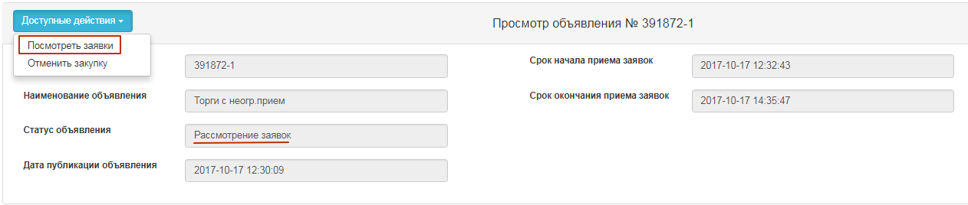
To view information about vendors who have submitted the bids for the procurement, you are to click the Bid Number link.
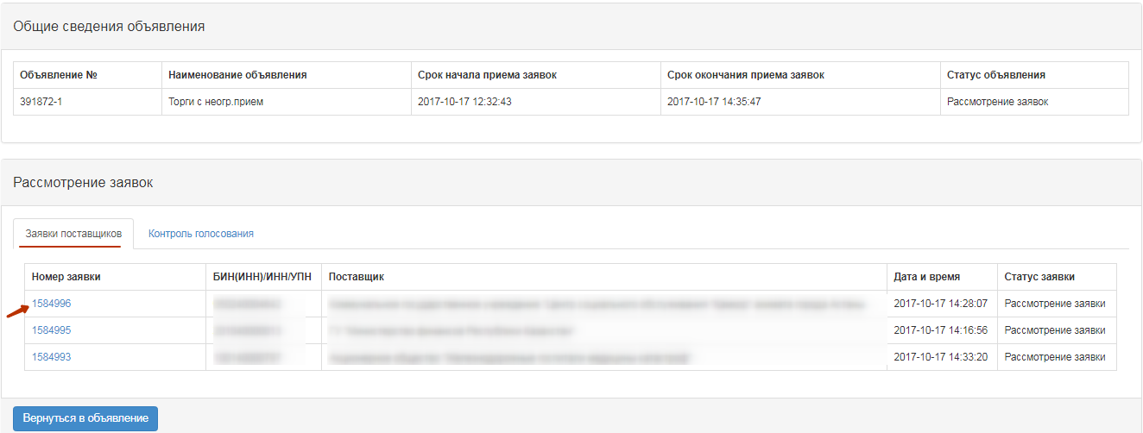
In the "Vendor Details" tab, the name, details, vendor address and information about the supplier's representative are indicated.
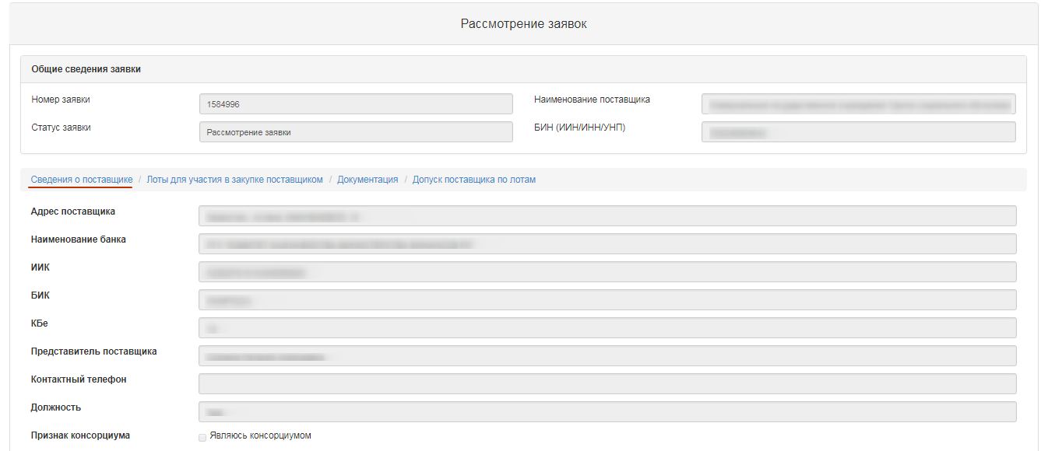
In the "Lots for participation in procurement by the vendor" tab, lots are placed for which the vendor submitted its bid.
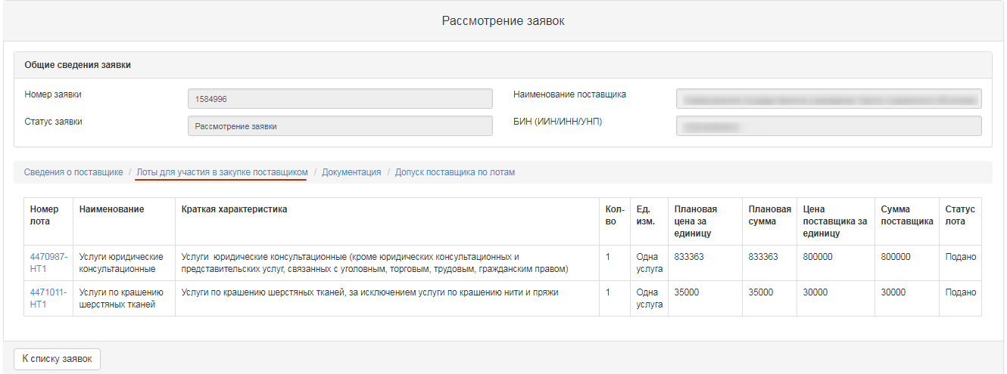
"Documents" tab provided by the vendor are placed in the "Documentation" tab. The line with the document name the number of files that have been attached is indicated. It is necessary to click the section name to display the attached files. To view and download the document, you should click the active link for the document name.

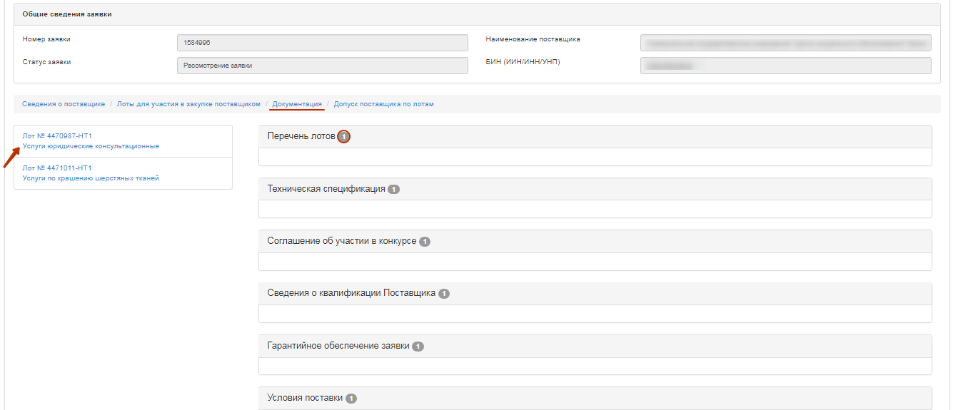
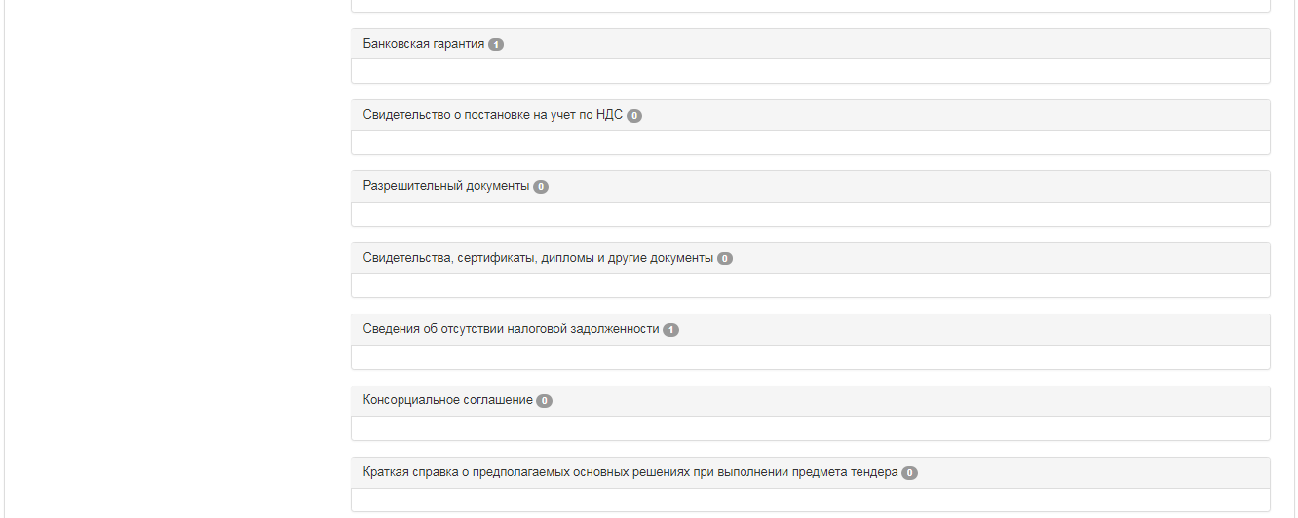

To vote on Admission / Rejection of the vendor, go to the tab "Admission of vendor by lots".
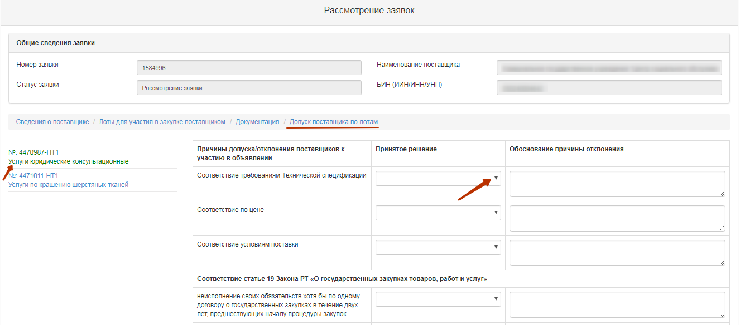
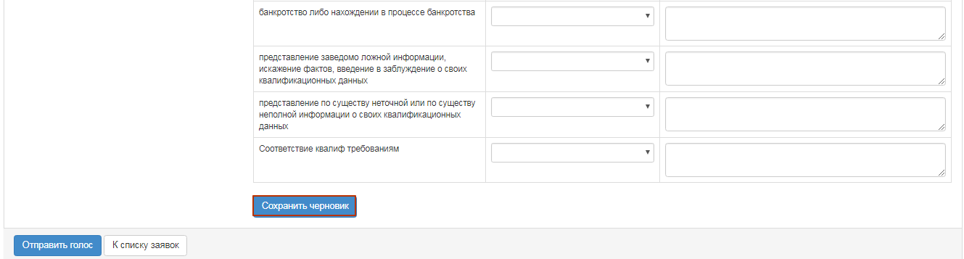
Admission of vendor by lot includes categories:
- Compliance with Qualification requirements
- Compliance with technical specification requirements
- compliance with the Price
- Compliance with terms of delivery
-Compliance with article 19 of the Law of the RT "on public procurement of goods, works and services"
The category "conformity with article 19 of the Law on public procurement of goods, works and services" contains the following sub-categories:
- Failure to fulfill its obligations at least in one public procurement contract within two years prior to commencement of the procurement procedure;
- Declaration of bankruptcy or being in the process of bankruptcy;
- submission of false information, distortion of facts, deception of their qualifications;
- Providing substantive or incomplete information on their qualifications.
To make a decision by category, you should select one of the following values from the drop-down list "Made decision":
- Admit
- Reject. - Request for clarification
- Reject without the right to clarify

If you select "Reject". In the "Request for clarification"/"reject without right to clarify" you need to fill in the reason for the rejection.
Attention! In the event that the Organizer has taken a decision to "Reject without the right of clarification" in sub-category 3 of compliance with Art. 19 (submission of knowingly false information, distortion of facts, misleading about their qualifications), the system automatically applies this solution to all lots in which the vendor participates. This vendor will not be able to submit the bid to participate in the purchase again.
In case of deviation by subcategory 1,2,4-deviation is made for each lot.
Attention! If the organizer has decided to "Reject". Request for clarification, "Information on preliminary admission" is generated by the system after the voting is completed.
After the decision on all categories is accepted, it is required to press the button "Save draft" After saving the solution, the line with the section will display the accepted decision (Admit, Reject. Request for clarification, Reject without the right to clarify).
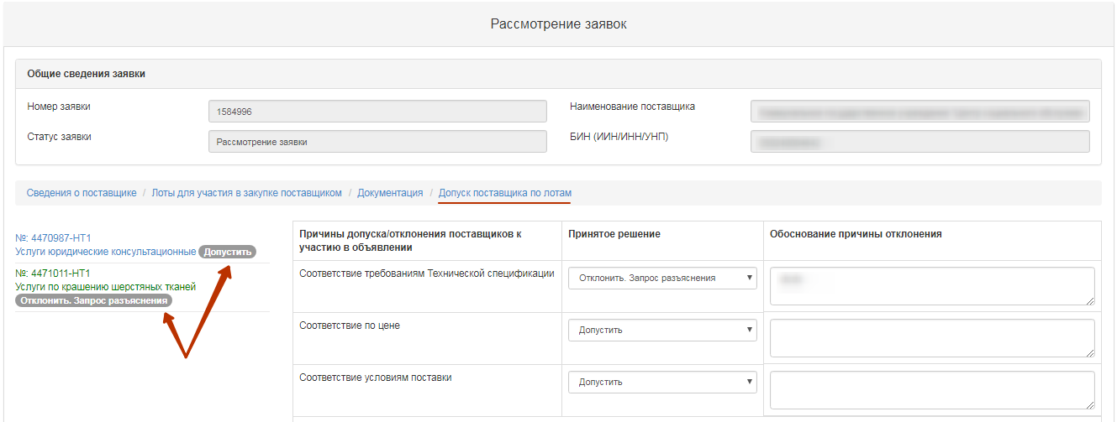
To end voting on all lots, you need to click on the "Send the Vote" button.
Attention! Before the end of voting, the system gives the opportunity to withdraw its vote using the function "Recall the Vote".

Control over consideration of bids
The secretary on the announcement viewing form with the status "Consideration of bids" / "Consideration of bids (clarifications)" has the functional for monitoring the voting process. To use this functional, in the "Available Actions" section, select the item "View the bids".
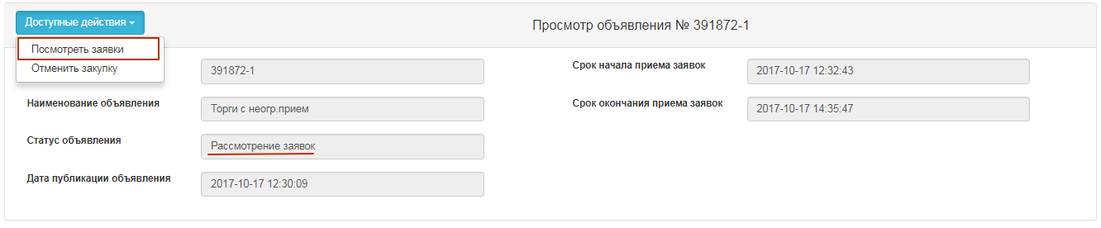
To view the voting information, it is necessary to go to the "Voting Control" tab and click on the line with the lot number.
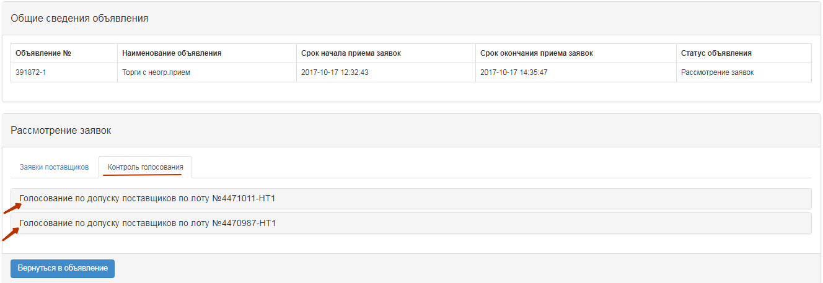
The system displays the following form with a list of bids.
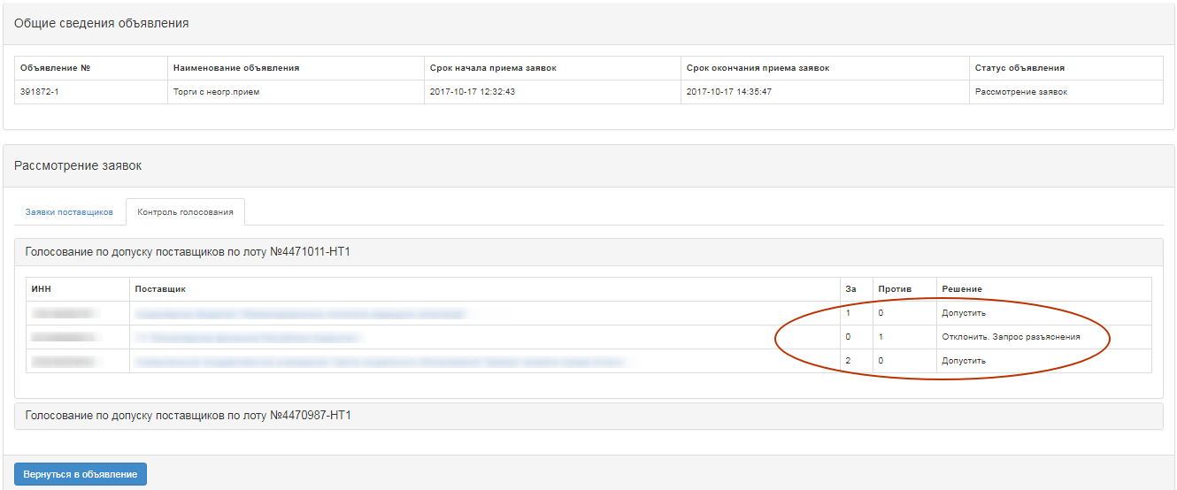
The Solution field indicates
- Admit
- Reject. - Request for clarification
- Reject without the right to clarify
The "For" field contains information on the number of commission members who allowed a potential vendor to participate in the purchase by the lot for which he applied. The field "Against" contains information about the number of commission members who did not allow the potential vendor to participate in the purchase by lot, to which he applied.

Conclusion of the voting
To complete the voting, the secretary should select "View the bids" in the "Available Actions" field.
Then you need to go to the tab "Control of Voting". If there is a quorum of votes, the "Completion of voting" button is available on the "Voting Control" tab.

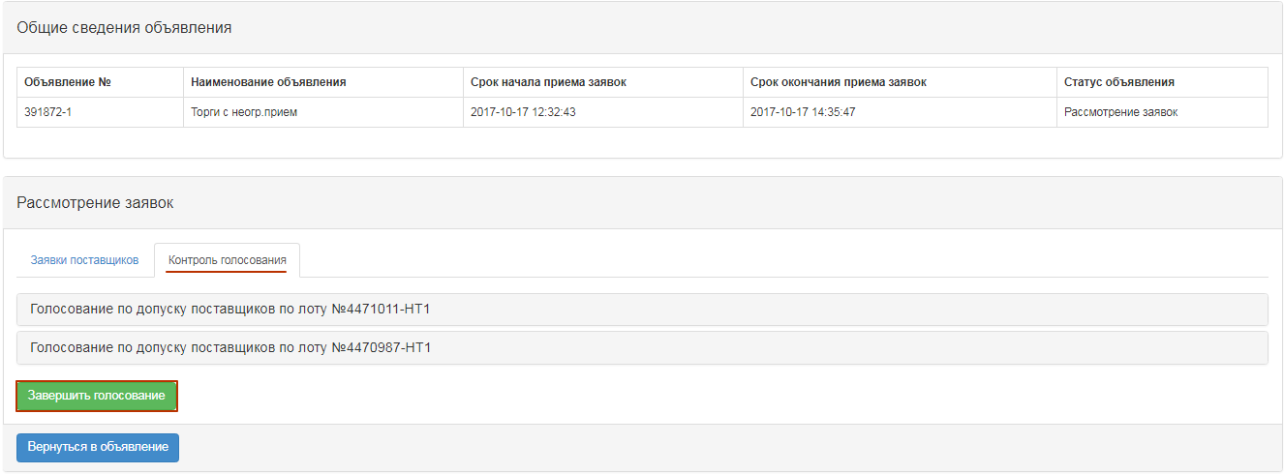
Once the voting has been completed, it is possible to resume the voting by means of an appropriate button.
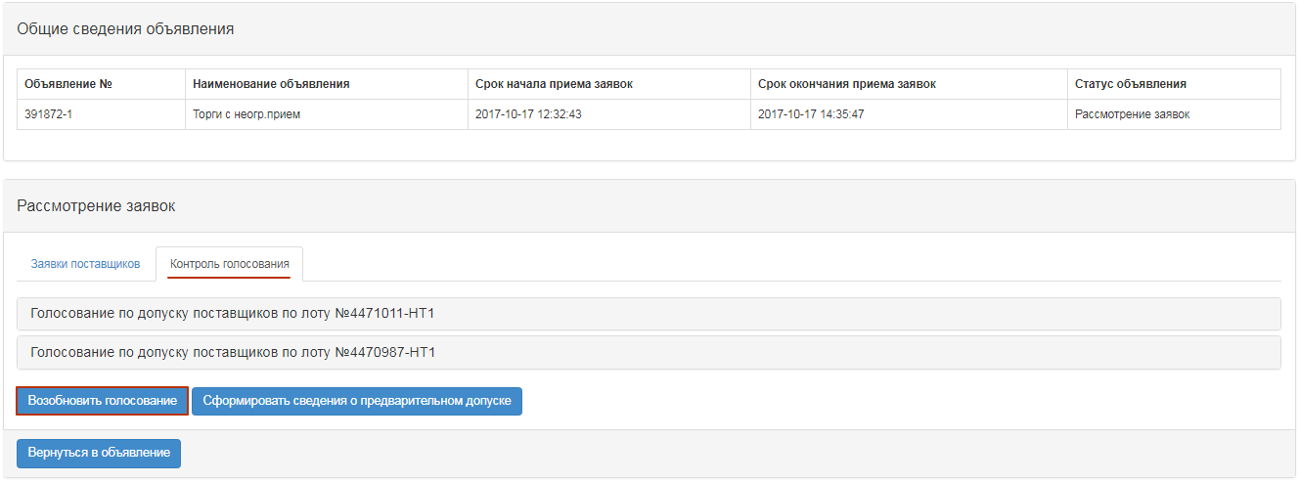
Note. In the event that, based on the results of the procurement vote, there is a rejected bid(s) with a request for clarification, a button "Generate information on preliminary admission" will be available on the voting control form upon completion.

Generate information on preliminary admission
If in the procurement one or more potential suppliers were rejected with clarifications, after the voting is over, the Secretary in the "Control of voting" should choose "Generate information on preliminary admission."
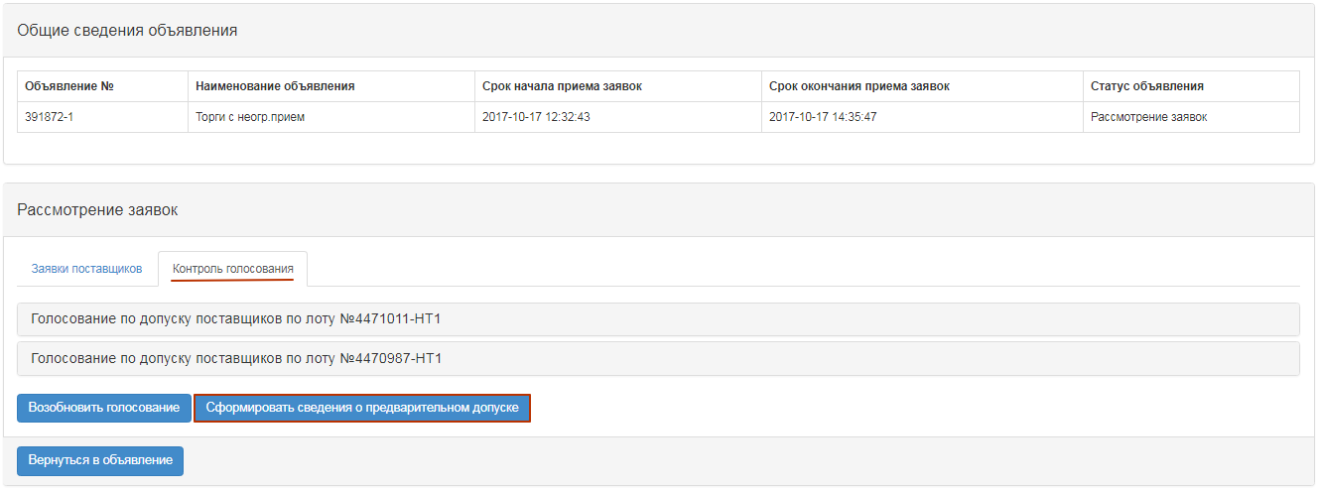
After that, the status of the announcement will be changed to "Formulation of preliminary admission protocol"
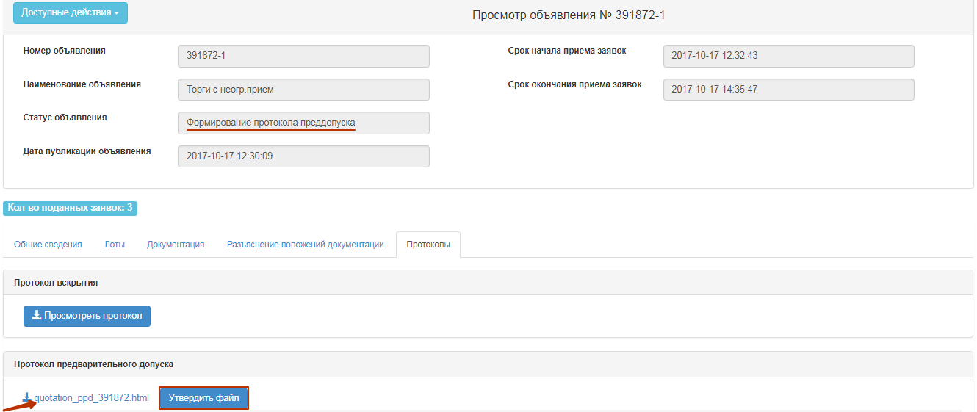
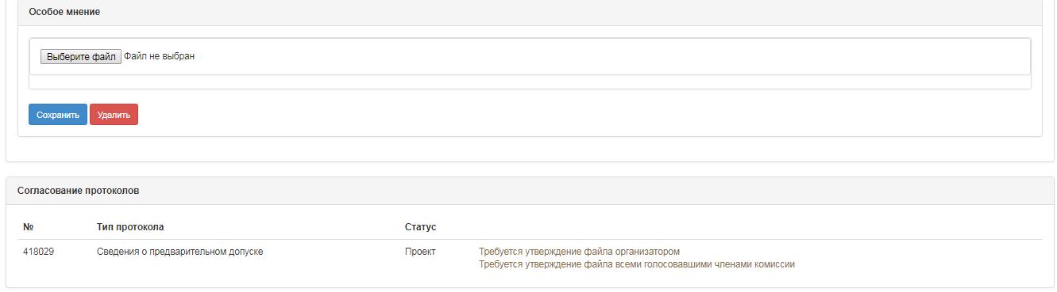
To view and download the document, you should click the active link for the document name. If it is necessary to attach a special opinion to the Secretary, you need to click on the "Choose a file" button and save the selected document.
Further on the Committee members/Organizer's representative having voted at the bid review stage must confirm data on preliminary admission in the "Protocols" tab;
To approve the protocol, click the "Approve File" button.
Note for QPE: As soon as the members of the Commission have approved data on preliminary acceptance in the "Protocols" tab, the Secretary has a "Submit for agreement" button on the "Protocols" tab in the announcement view form.
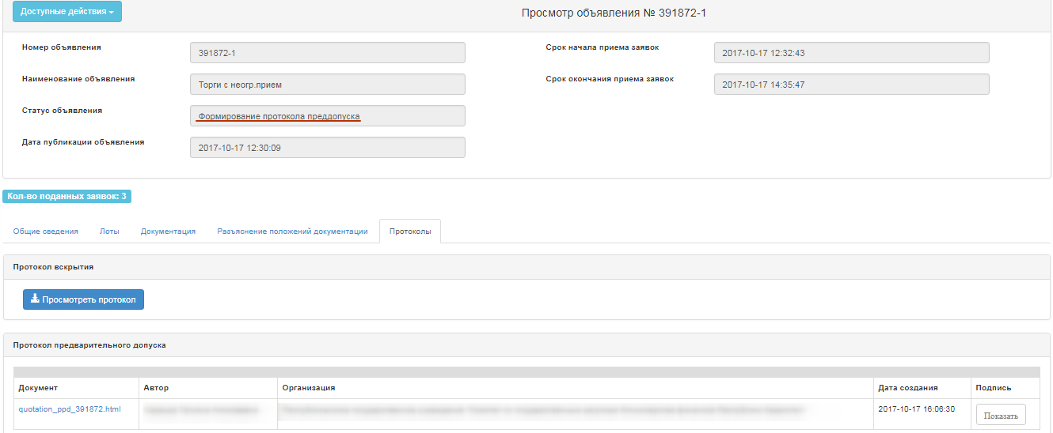
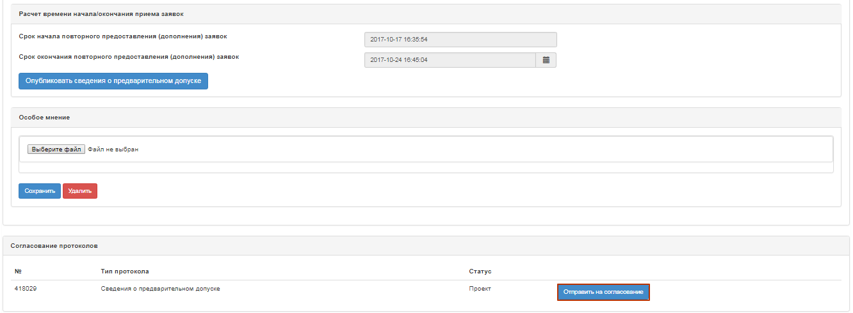
The status of the protocol will then be "on agreement".

System sends a notification to the users of the RT PPA with the role of "Protocols sign-off person/user" about the need to approve a summary protocol.
Note for the RT PPA: At method of purchase of "Limited bidding", "Unlimited bidding", in case when the purchase Organizer is the RT PPA, data on preliminary admission is not the subject to agreement, upon confirmation of data, functionality of specification of terms for receipt of explanations from suppliers is available for secretary, whereupon data are published.

Approval of data on preliminary admission.
Information on agreement of the data on preliminary admission is displayed in the announcement, the "Protocols" tab.
If the employee who "Approve protocols" makes a positive decision, the system displays the summary protocol with the status "Agreed". The Secretary is required to indicate the start and end date of call for clarifications received from the vendors, and functionality of publishing preliminary admission information will also be available.
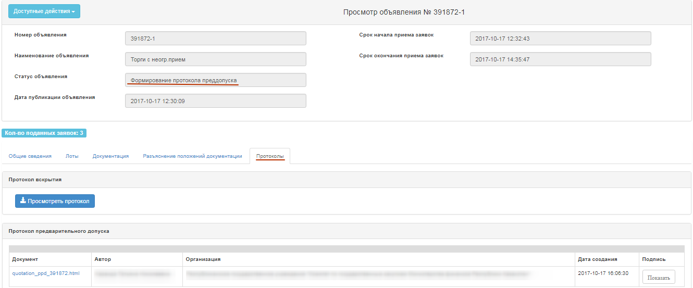
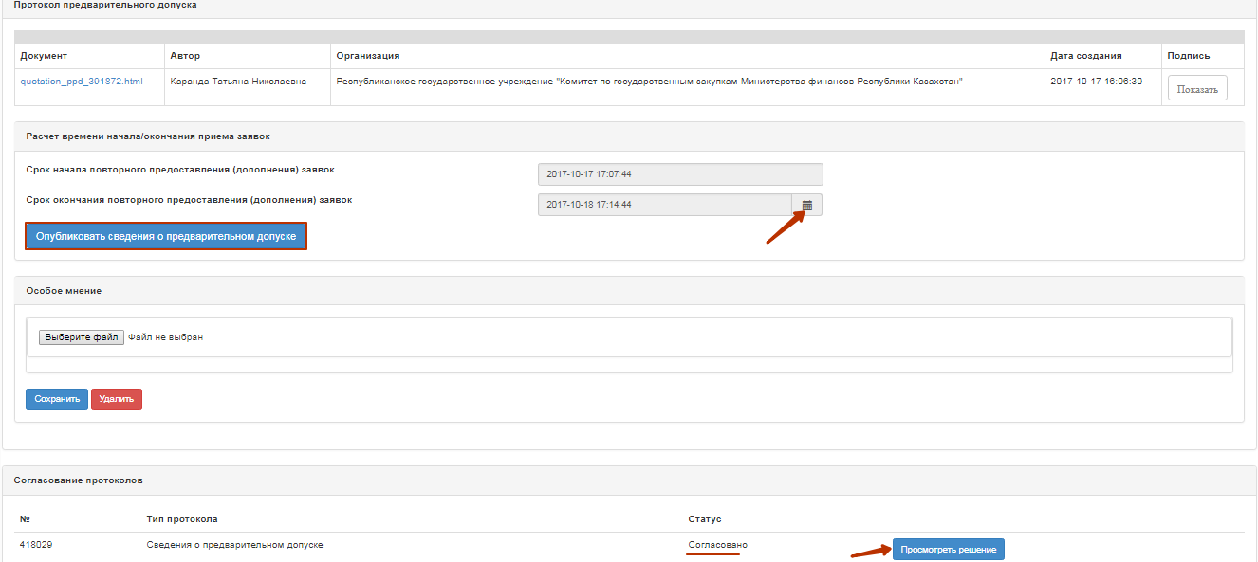
If the employee with "Protocols sign-off user/person" role makes a negative decision, system displays information on preliminary admission with the status "Rejected".
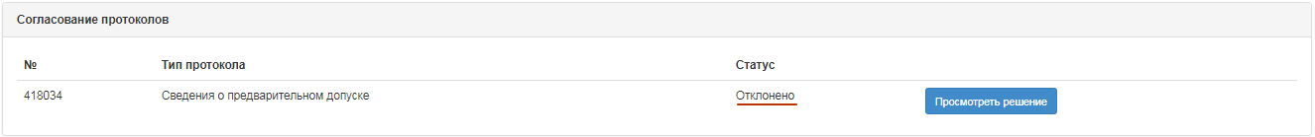
When you click on the "View the Decision" button, information is displayed on those who approve it, and there is also an active link for downloading the document attached by RT PPA during approval process.
In the information on preliminary admission with the "Rejected" status, further on the reason for rejection is displayed.
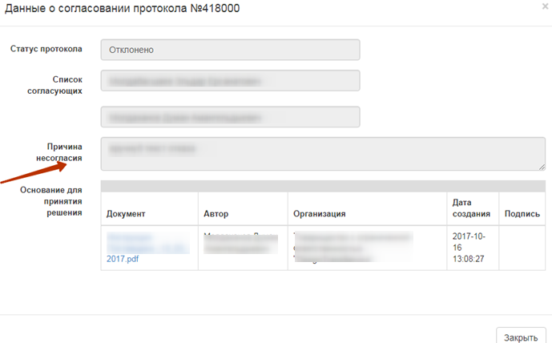
Note. If the information is rejected by the RT PPA, the Secretary of the Commission is available to resume voting (see. Voting closing) or indication of the deadline for call for clarifications, with further publication information on preliminary admission (see. Publication of data on preliminary admission). Decision relating to re-opening of voting or publication of data in in its existing form, is taken by the QPE.
If, after the information is rejected, a decision is taken to resume the voting, then re-agreement with the RT PPA is not required.

Publication of data on preliminary admission
To publish information on preliminary admission, you must click the "Publish information on preliminary admission" button.
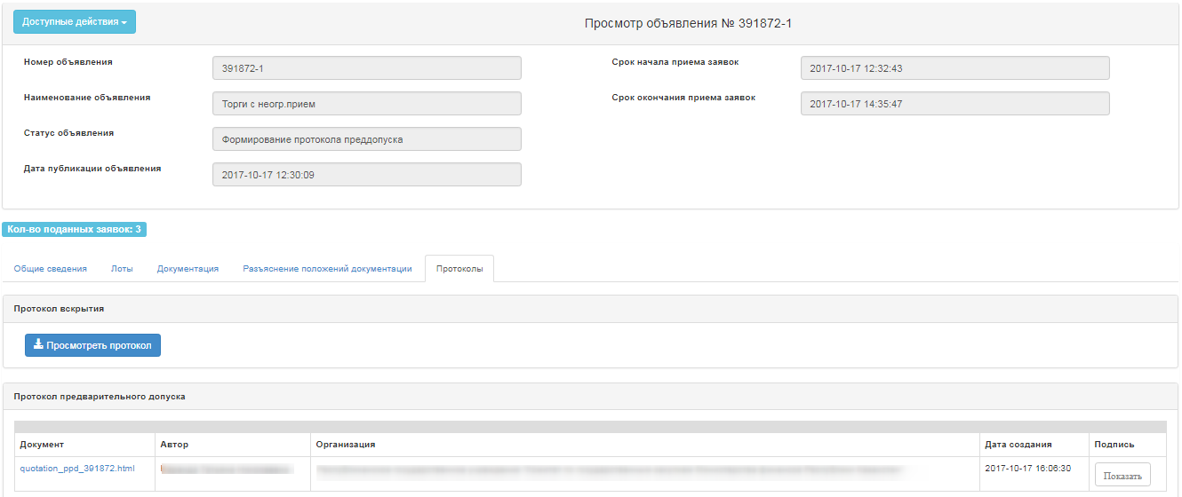
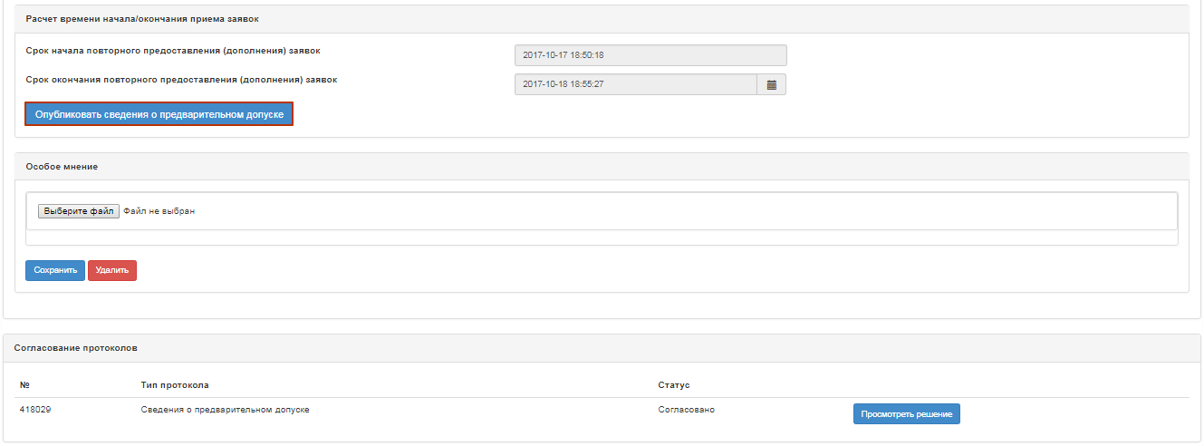
In case of confirmation, information on preliminary admission will be published, the status of the announcement and lots will be changed to "Published (call for clarification)".
In the form of announcement view, the remaining time and terms of the beginning and the end of call for clarifications of the bids will be displayed.
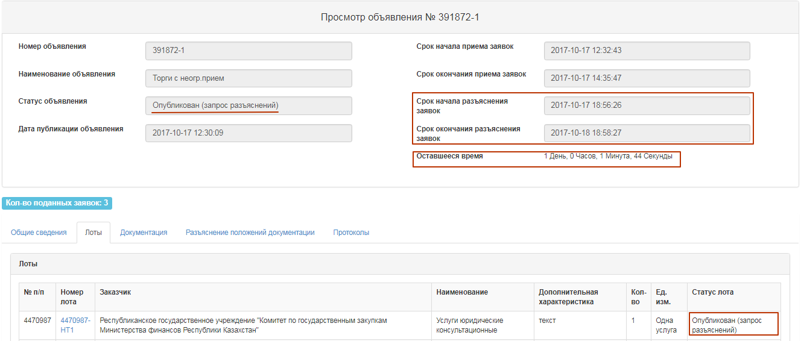

Re-consideration of bids for the purchase with "Unlimited bidding" method
By the end of the deadline for call for clarifications to the bids, the status of announcement is changed to "Consideration of the bids (clarifications)", the members of the Commission provide notification on the need to review the bids. For consideration of clarifications, on the form of viewing the announcement in the list of available actions, choose "View the bids".
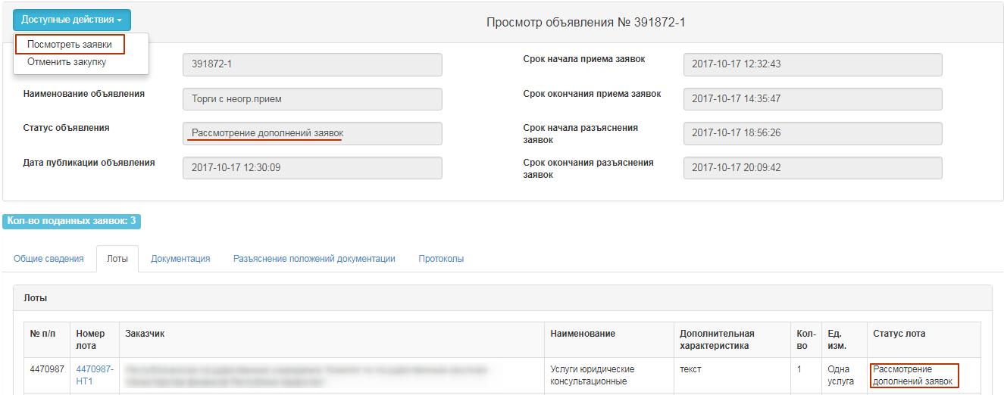
It is necessary to consider the bids in the status of "Consideration of the bids" (clarification). To view information about the vendors who have clarified the bids for participation in the procurement, click on the reference number of the bid.
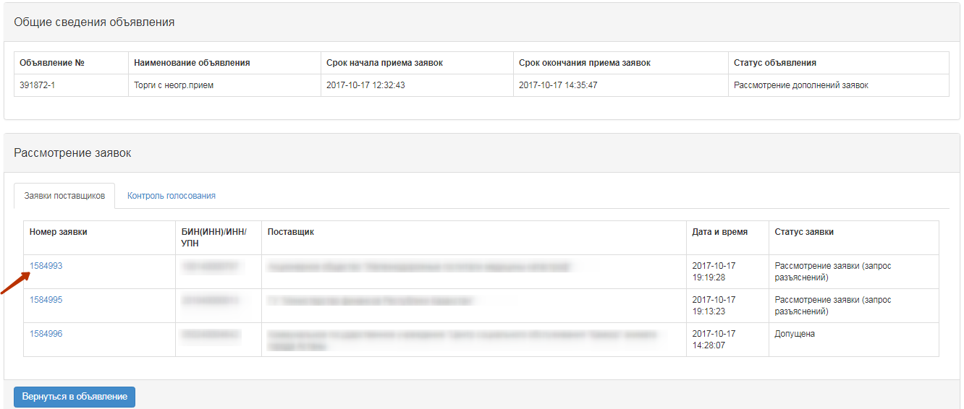The "Vendor's Clarification" tab contains the text of the clarification.
To view the documents that the vendor has attached to, click the file name.
To vote for Admitted / Rejected, it is necessary to go to the tab "Admission of the vendor across the lots" in the form of announcement view. The system displays only the sections and the documents on which the vendor was rejected.
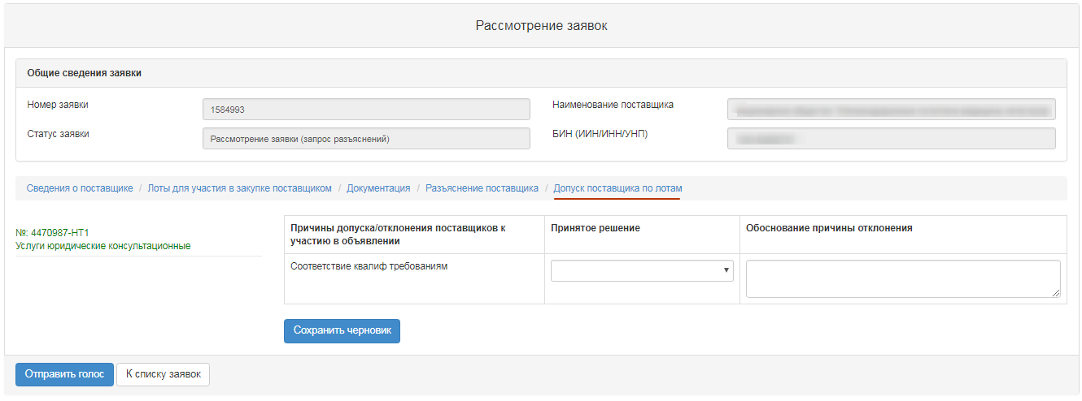
A second vote shall be carried out in the same manner as the "Consideration of bids.

Filling conditional discount
After completion of voting, to enter percentage of conditional discount for the lot(s) with the criterion of the "Lowest estimated value" evaluation criteria, the Secretary should select the "View the bids" action on the form of viewing announcement in the "Available Actions" field.
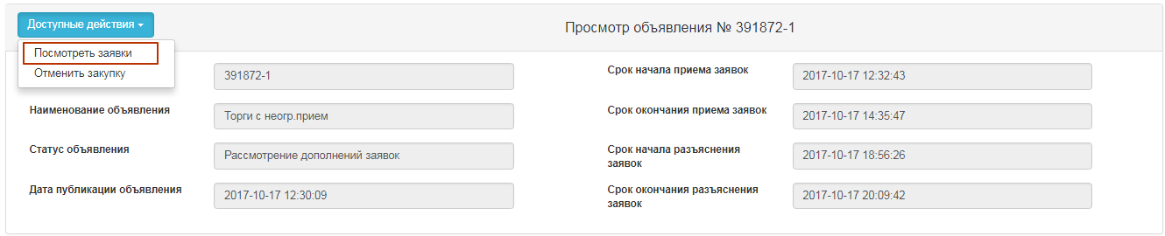
Next, you must go to the "Voting Control" tab. If there is a quorum of votes, the "Filling in conditional discounts" button is available on the "Voting Control" tab.
Attention! The system makes an active form of filling in conditional discounts, only for admitted lots in the vendor's application with the status "Admitted" and for lots with the criterion of "Lowest estimated value".
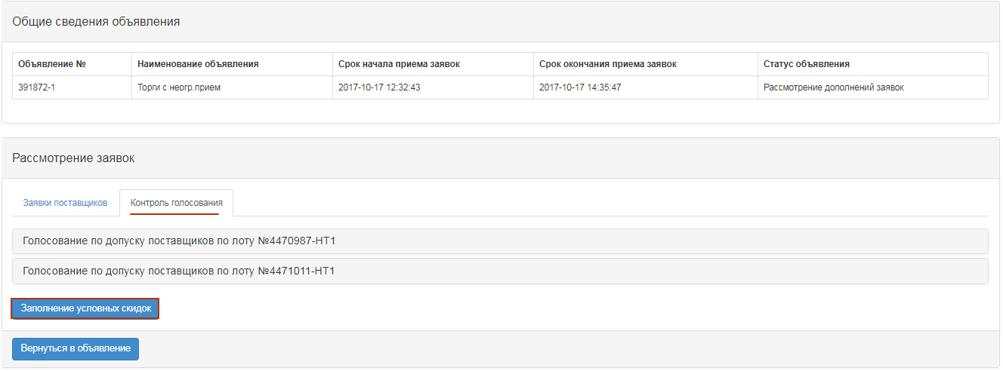
After clicking on the "Fill in conditional discounts" button, the Secretary in the "Conditional discounts" field should click on the "Filling in is required" link.
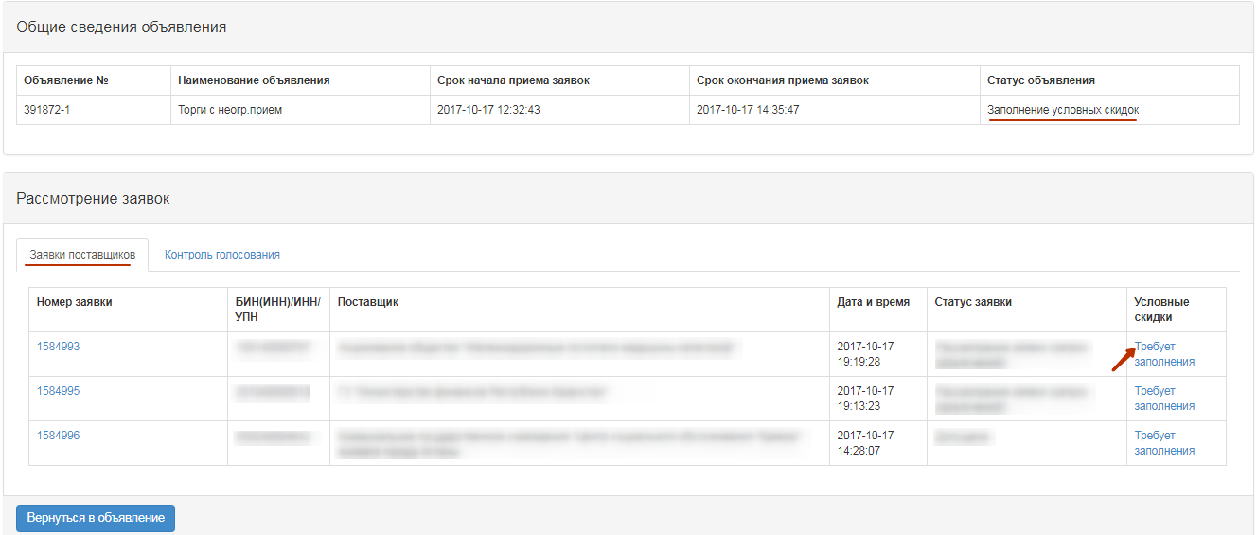
As a result, a form will be displayed on the screen to fill in conditional discounts for each of the criteria. The form of filling in conditional discounts is displayed separately for each lot, in order to open the form of a certain lot, you need to click on the lot number.
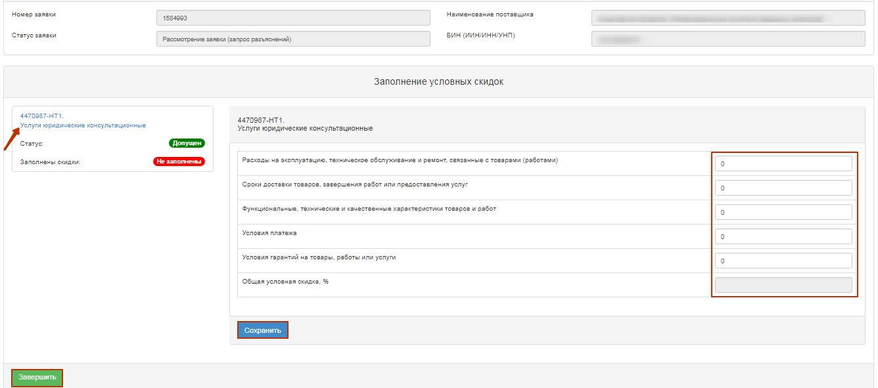
On the form of filling in conditional discounts, the following fields will be displayed:
Field name | Description
Operation, maintenance and repair costs related to goods (works) | Numeric value
Terms of delivery of goods, completion of work or provision of services | Numeric value
Functional, technical and quality characteristics of goods and works | Numeric value
Payment terms | Numeric value
Conditions of guarantee for goods, work or services | Numeric value
Total conditional discount, % | Automatically filled in by the sum of the fields. Total Conditional discount for the vendor
Once you have filled in the field, you should click on the "Save" button. After conditional discounts are filled in for all lots, you need to click on the "Finish" button.
Attention! All fields on conditional discount form are required to be filled in. If there is no discount on any criterion, put 0 in this field. After completion of procedure for setting criteria for conditional discounts, the status in the section "Conditional discounts" is changed to "Completed".
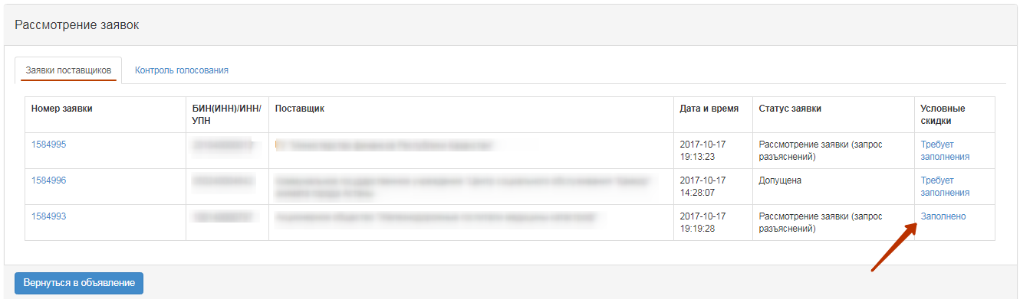

Formation of final protocol
To form final protocol, the Secretary on the form for announcement viewing with the status "Filling in conditional discounts" / "Consideration of bids" / "Consideration of bids (clarification)" / Revising the results, in the section "Available actions", select the item "View the bids".
Then go to the tab "Voting control" and click on the button "Formation of the final protocol".
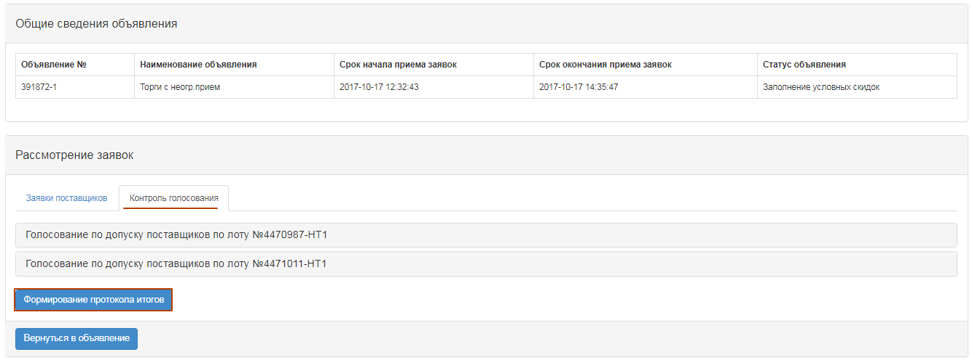
After choosing the action "Generate final protocol", the statuses of the bids, lot (s) and announcements will be changed to "Formation of the final protocol".
As a result, the log file will be created in the state and Russian languages on the form of viewing the announcement in the "Protocols" tab.
Secretary of the announcement and the members of the Commission should approve the protocol.
Attention for QPE!
After confirming the protocol by the secretary and members of the Commission that carried out the vote, the secretary should send final protocol for approval to the RT PPA. After clicking on the button "Send for approval", the final protocol will have the status "On approval".
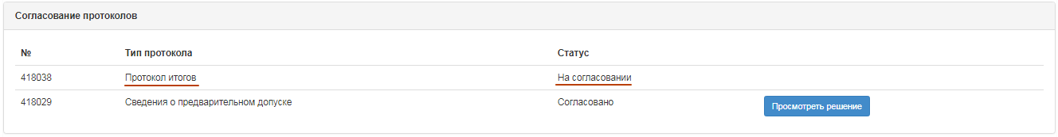
System sends a notification to the users of the RT APP with the role of "Protocols sign-off person/user" about the need to approve a summary protocol.
Attention for RT PPA!
In the event that the purchaser is the RT APP, there is no need to approve on a summary protocol. Once the summary protocol is approved by the Secretary and voted members of the Commission, the "Publish Summary Protocol" button becomes available to the Secretary.

Approval of final protocol
Information on agreement of summary protocol is displayed in the announcement, the "Protocols" tab.
If the employee with "Protocols sign-off user/person" role makes a positive decision, system displays the summary protocol with the status "Approved". The Secretary will be able to publish summary protocol.
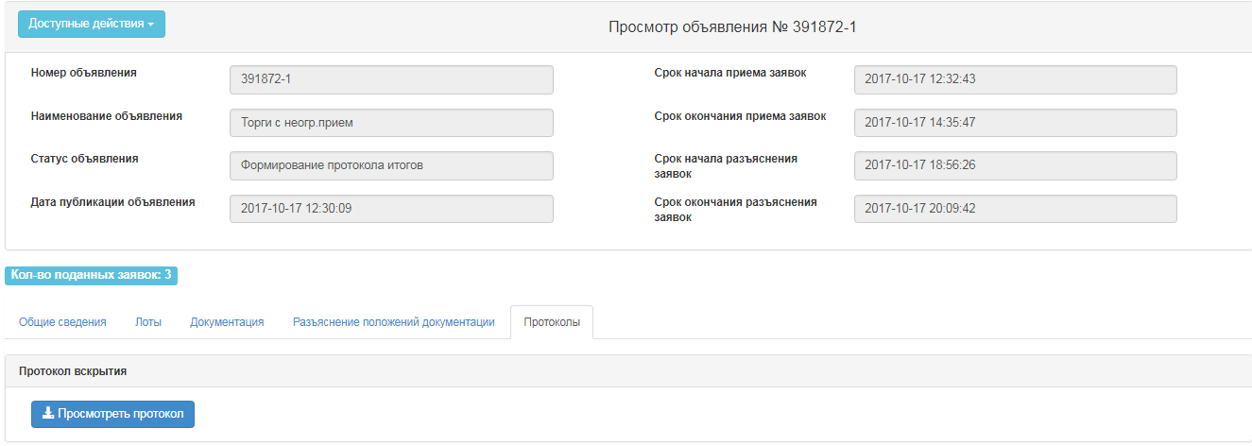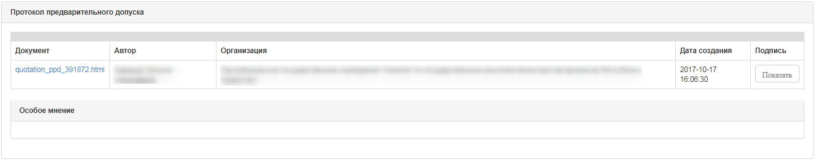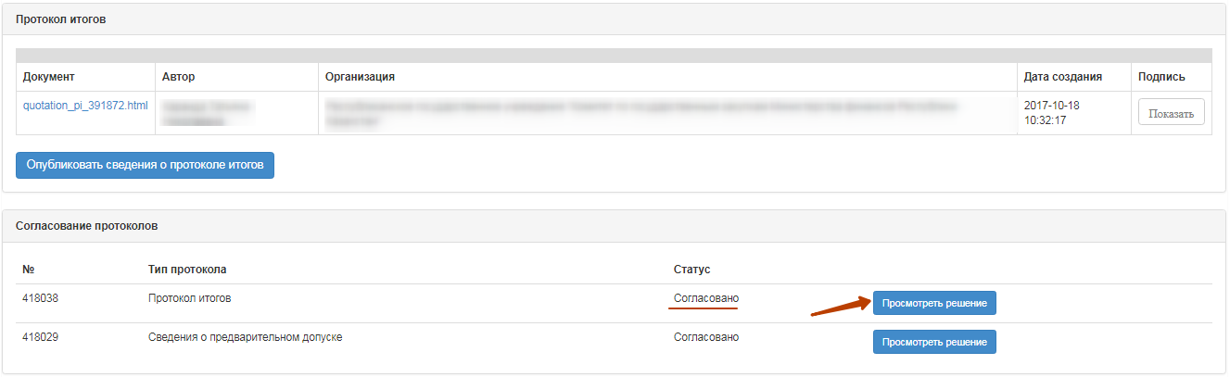
If the employee with "Protocols sign-off user/person" role makes a negative decision, system displays the summary protocol with the status "Rejected". And the "Purchase Cancel" will be available to the Secretary.
When you click on the "View Decision" button, information is displayed on the summary protocol sign-off persons/users, there is also an active link for downloading the document attached by RT APP at the approval.
In the final protocol with the status "Rejected", the reason for the rejection is additionally displayed.
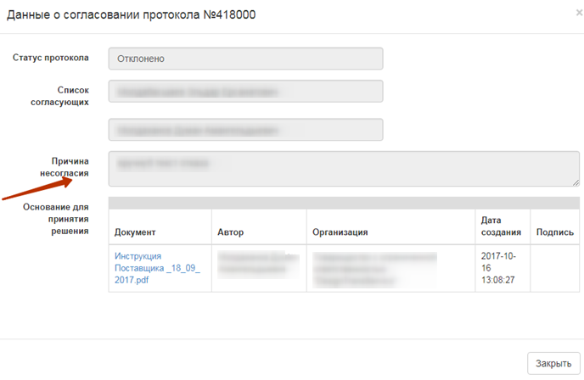

Publication of final protocol
Generated summary protocol is displayed in the announcement in the protocols tab. On the form of review, the Secretary has the functionality to publish the protocol:
- if the approval of the summary protocol is not required by the RT APP;
- if it is required to agree the final protocol with the RT PPA and the status of the protocol "Agreed".
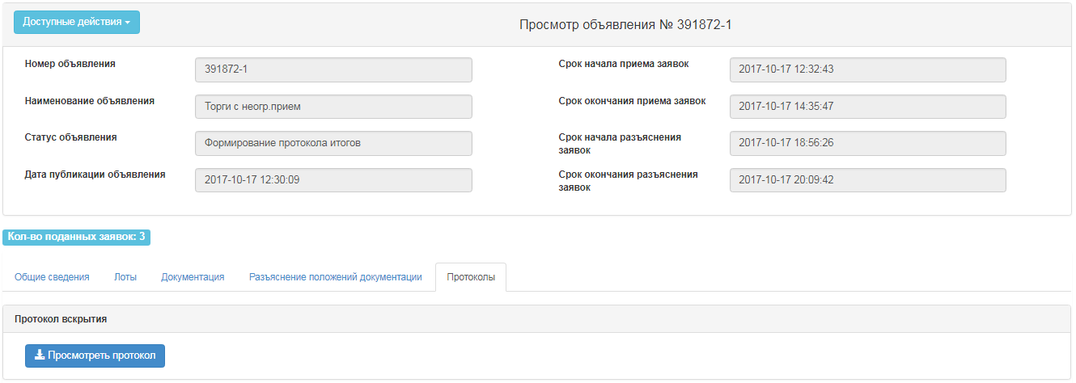
After clicking on the button "Publish summary protocol", the status of the announcement is changed to "Completed". "Protocols" tab displays the active link for downloading summary protocol.
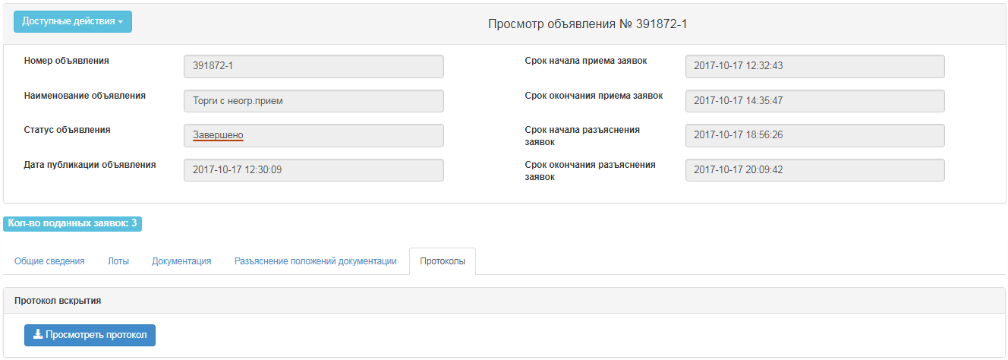
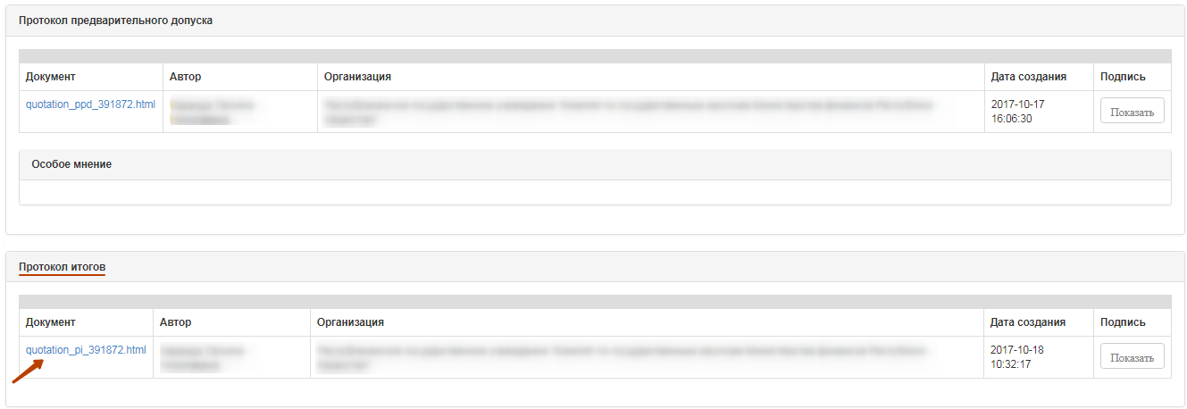
Note. Public procurement is considered to be valid if at least one bid of a potential supplier is eligible for participation by lot. At the same time, a potential vendor whose bid for participation is the only one admitted is recognized by the web portal as the winner in these public purchases.
attention! After publication of the summary protocol within 3 working days, the lots of the purchase are not available for creation of the contract or for re-publication of the purchase. This period is reserved for submission of complaints by vendors. In the event that complaints are received within the specified period, the authorized body will carry out procedure for completing the appeal with decisions on reviewing the results, canceling the purchase or refusing to satisfy vendor's complaints.

Modification of the Commission
"Change Commission" action is available to the Secretary in the announcement view form with the status "Published", "Published call for bids", "Published (Request for clarification)", "Draft. Change of documentation", "Consideration of bids", "Consideration of bids (clarifications)".

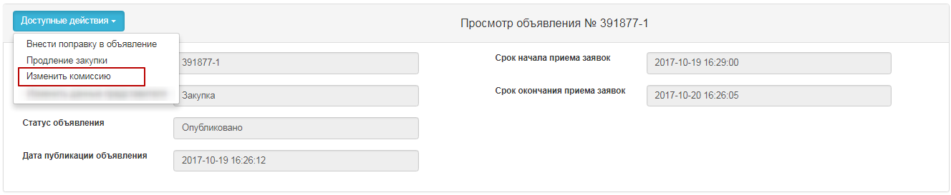
After performing this action, the form of changing the commission will be displayed on the screen.
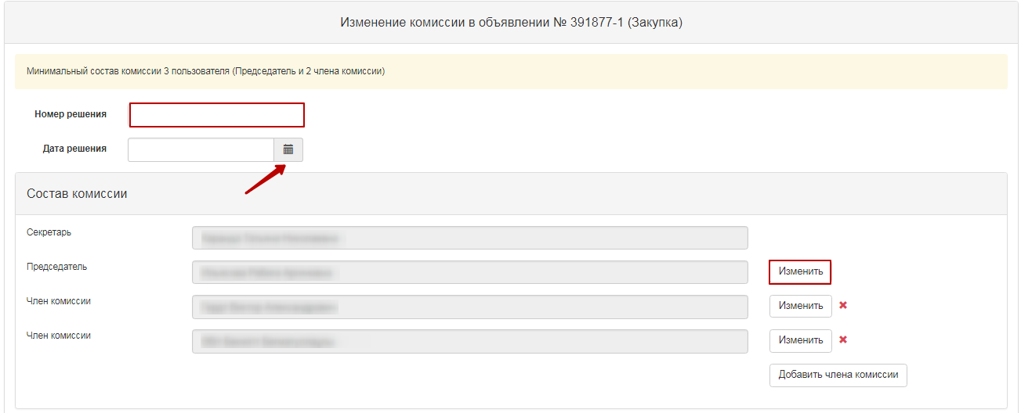
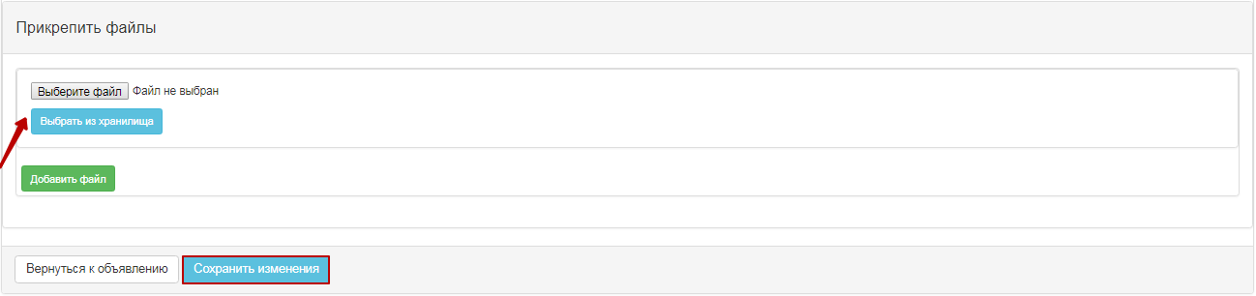
To change the commission member, click the "Change" button. You can add a new member to the Commission by using the "Add Commission member" button, and you can use the button to delete it. "Decision number", "Decision date" fields are required. To save your changes, you must attach a file that is the basis for the Commission change, and click "Save Changes".
Note. If the status of the announcement and lot is "Consideration of bids", but the voting has been completed, that is, the voting status of vendors bids by lots "Admitted and/or Rejected", system does not allow for modification of the Commission.

Cancel of the Purchase
Cancel of functionality is available from the moment as the announcement is opened to creation of the contract in announcements with the statuses "Consideration of bids", "Consideration of bids (clarifications)", "Formation of information on the preliminary admission", "Formation of the minutes of results", "Filling in conditional discounts", "Completed ".
In order to cancel the purchase, the Secretary needs to select the "Cancel the purchase" action in the list of actions in the announcement view form.
Cancel of the purchase is possible for the entire purchase, as well as for individual lots, if there are several lots in the purchase. After this action is completed, a warning message is displayed.
When you click the "No" button, the system returns to the purchase review form. To cancel, click "Yes" to display the lot selection form.
The choice of lots is carried out by putting a tick in the line with the lot, then you need to click on the "Cancel the purchase for selected lots" button.
A cancel form appears where it is necessary to attach the scanned electronic document that is the basis for cancellation and fill in the information on the basis for cancellation.
The purchase cancellation form contains the following fields:
Field name | Field value
Solution number | The field is text and is available for manual input. An act number must be entered in this field.
Resolution Date | This field shows the date on which the relevant act was issued, and is filled in by using the "Calendar" icon.
Act | Select from the drop-down list the position of the directory of the types of acts with the values:  - Resolution;  - Definition;  - View;  - Notification;  - Decree  - Order  -Order
- Authority | In this field, an authority from the directory of authorities with the values shall be selected:  - Judicial authority;  - Prosecutor's office;  - State finanacial control authority.  - Customer  - Authorized Body
- Name of the Authority | The field is text and is available for manual input. In this field, you should specify the full name of the authority.
Select a File | The button is used to attach a document that is the basis for the cancellation.
Attention!
Note for QPE: On procurement, which is organized by qualified procuring entities (QPE) on "Request for quotation", "limited bidding", "unlimited bidding", "single source" procurement methods, it is necessary to agree on the cancellation of purchase with the Public Procurement agency (PPA RT) by clicking the "Submit for PPA approval" button
For the QPE organizer, if there is a generated, but unpublished, pre-admission /final protocol and an application for cancellation of procurement is sent to the PPA, the system will not allow to publish this protocol.
For the QPE organizer in the case where the pre-acceptance /final protocol is sent to agreement with the PPA, but the organizer performs cancellation of the procurement, the system automatically removes the request for protocol approval and sends only the cancellation request.
For the QPE organizer, in the event that the pre-admission / summary protocol is not formed, but there is an application for cancellation of the purchase, the system blocks for the Secretary the possibility of forming protocols
Note for the RT PPA: For procurement, the Facilitator of which is the PPA, no approval of procurement cancellation is required.
After filling in all fields and attaching the file, click the "Cancel Purchase" button. System will automatically decide to cancel the bid/lots
Note for all: When you cancel all lots, the purchase automatically generates a summary protocol that indicates the reason for cancellation, at any stage of the announcement. If the purchase has multiple lots, when one lot is canceled, the lot status changes to "Canceled", and the protocol, after it is published, specifies the reason for the cancellation of this lot. Also, canceled lot is returned to the pool to publish new purchase.
System sends a notification to users with the "Approve Cancellation" role to approve purchase cancellation.
Information on the lots that are being produced or canceled is displayed in the "Review/Cancel" tab of the announcement form.
Decision on approval may be made:
-Approved
-Rejected

Organization and conduct of purchases by the "Limited Bidding" method

Create an announcement
To create an announcement you should go to the "Personal account" section and select "Create announcement". Accessible to a user with the "Organizer" role.
Next, you will see a form for creating a draft of announcement.
Section "Creation of a draft of announcement" contains the following fields and buttons:
Item | Action
Type of procurement item | Filled in manually. One of the values is selected:  Work;  Service;  Goods.
Title of (procurement) announcement in the Tajik | Filled in manually
Title of (procurement) announcement in the Russian | Filled in manually
Title of (procurement) announcement in the English | Filled in manually
Indication of purchase | If the bidding is required for procurement among the organizations of domestic manufacturers, a check mark should be placed on the line with this indication.
Next | When clicking the button, the System shall check for filling in all mandatory fields

If the bidding is required among the organizations of domestic manufacturers it is necessary to put an indication - "domestic producer" in the draft of announcement.
After you fill in all the fields, click "Next".
Note. After you move to the next step, the system automatically saves the announcement in the status "Draft" in the section "Work Office" - "My announcements (organizer)":
The icon allows to edit, the icon allows to delete announcements with the status "Draft" when you click "Next", lots that meet the specified criteria by method, item type, and purchase indication are displayed. It is necessary to mark Lot (s) and click "Add selected" button:
To select a lot, you shall mark the required lot and click "Add marked lots" button. Then you go to the added Lot view page. If you want to delete selected lot, mark required lot with a check mark and click "Delete marked Lots" button, and if you want to add lots to the purchase project, go to the "Available Lots" tab and perform selection of additional lots. To go to the next page, click "Next".
After selecting lots, in the procurement method "Limited bidding" in the next step "Vendors", the system displays the list of vendors that were selected as participants in the purchase order by the Customer.
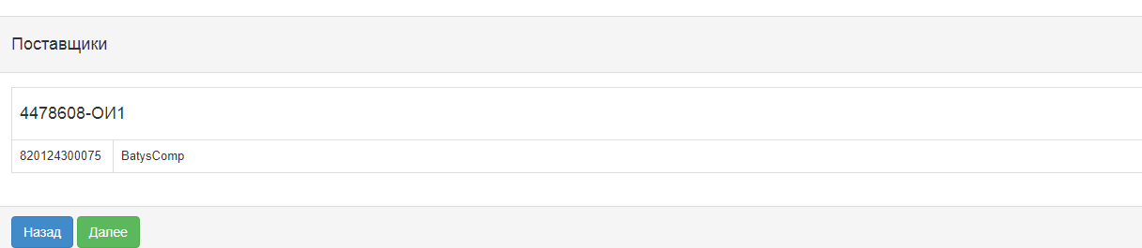
If it is necessary to supplement this list of invited participants, then in the next step the Secretary needs to add vendors for each lot. If addition of vendors is not required and the list should be left unchanged, the secretary should click on the "Next" button to go to the next step.
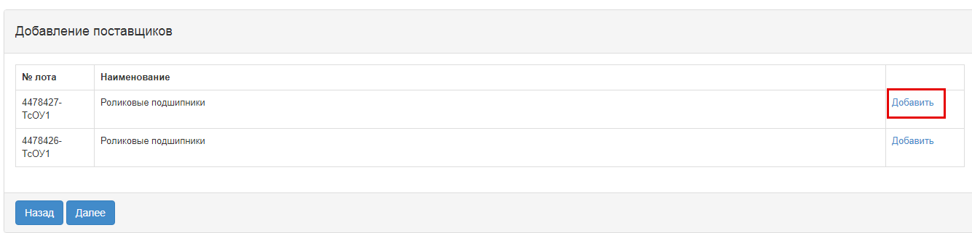
Note. In the "Limited bidding" method, only those vendors who have been selected as invited can participate in the purchase.
After addition of vendors, the next step is to fill in the data for the lots -delivery conditions. "Enter data by lot" section contains the following fields:
Place of delivery | Automatically filled in by the system from the annual plan
Delivery Period | Automatically filled in by the system from the annual plan
Price of delivery | Filled in manually
Payment | Filled in manually
Related Services | Filled in manually
Criteria of evaluation | Select from the drop-down list
Upon activation of the Next button, the following window appears.

Adding Commission
The next step in creating a draft announcement is to add the Commission.
Minimal composition of the commission - the Chairman and two members of the commission. Odd number.
"Add" button to select a commission member. A pop-up window appears. Search may be performed by following filtration parameters values:
Adding a member of the Commission is carried out by clicking the "Add commission member" button.

Preparation of documentation.
"Document Preparation" step displays a list of required documents to participate in the bidding according to the rules for conducting public e-procurement. If the vendors are required to provide certain documents to participate in the bidding, the Secretary should be required to provide a sign "mandatory for the vendor". To view information about a document, click its name in the "Document Name" field.

Generating Technical Specification
To go to the "Technical Specification" section, in the general documentation list click the active hyperlink "Technical specification". It is necessary to confirm the file of technical specification that describes the goods, work, or services, for this you should click the active link on the lot line "View".

The new window displays the system-generated technical specification from the bid for the bidding. If the Organizer needs to change Technical Specification prepared by the Customer, it is necessary to:
When you click "Edit", a window is displayed for editing in the state and Russian languages.
After amending it is necessary to confirm by clicking the "Reforming the file" button. If no changes are required, you can use the "Go Back" button to exit without modification.
When you approve Technical Specification Document, the system fills in the confirmation date.
For items of a service or job, click the "View" button to display the following window:

If necessary, you can delete attached technical specification and/or add another technical specification file.
If you add a new file using the "Select File" button, a window opens to find the file you want. After the file is selected, open it, and then click "Save".
If you add a new file using the "Select from Storage" button, a window will open with previously downloaded files in the participant profile - File directory. After you select the file, you should "Save" it.
To return to the shared document list, click the "Go Back" button.

Formation of a draft agreement.
To review the draft contract in the purchase creation form, click the "View draft contract" link button.
If necessary, you can delete attached draft contract and/or add another technical specification file.
If you add a new file using the "Select File" button, a window opens to find the file you want. After the file is selected, open it, and then click "Save".
If you add a new file using the "Select from Storage" button, a window will open with previously downloaded files in the participant profile - File directory. After you select the file, you should "Save" it.
To return to the shared document list, click the "Go Back" button.

Formation of the document "List of lots" and tender documents
At the stage "Preparation of documentation" for the document name as an active link. In the pop-up window, you need to "Confirm", and then close the window.

Generate the "Delivery terms" document.
At the step "Preparation of Documentation" click the active link to "Delivery terms". In the pop-up window, you need to "Confirm", and then close the window.

Pre-review of the announcement.
The form of "Announcement Preview" contains general information on the purchase, information about the organizer, and the comission.
Note. On procurement, which is organized by Qualified procuring Enterprises (QPE) concerning the methods of procurement in "Request for Quotation", "Limited Bidding", "Unlimited Bidding", "Single Source Procurement", draft of bidding document should be agreed with the Public Procurement Agency (RT PPA).
For procurement, organized by the RT PPA no approval is required.
When you click the button "Submit for APP approval", the system displays a pop-up window that requires you to confirm the action.
If a publication is successful, the status of announcement is set as "On APP Approval".
System sends a notification to users with the role "Approval of announcement" on the need to approve the announcement.

Approving the draft announcement
In the event that the purchase was refused in agreement, the purchase is assigned the status "Rejected by the RT PPA" with subsequent possibility of editing by Secretary of the announcement.
The Secretary should go to the "Personal account" - "My announcements" (Organizer).
When you click the icon, a pre-review of announcement is displayed, and the reason for the rejection is listed at the bottom.

After you select "Correct comments", you will see a pop-up window with the need to confirm the action.
If you select the "Approve" function, the purchase is assigned the status "Approved by the RT PPA".
When you click the icon, a pre-review of announcement and the "Publish" button is displayed. In this form, you should specify the start and end time for accepting the bids.
However, the date and time when the bids are received should be not earlier the current date of the publication.
Note. For the "Unlimited bidding" method, the minimum interval between the start and end of the approval period is 21 calendar days.
To publish announcement with a term of less than 21 calendar days, you should provide a reason and attach supporting document to reduce the deadlines for accepting the bids.
If a publication is successful, the status of announcement is set as "Published". Otherwise, the system issues an error message.
Information on the reason of reducing the interval appears on the "General" tab.

Extension of the deadline for submision of bids.
The Secretary in the form of announcement view has the action "Extension of the bidding" for the bidding with statuses "Published", "Published (acceptance of the bids)".
By clicking on the button "Extension of the bidding", the Secretary is given the opportunity to enter data in the filed "Reason for extension of the bidding", which is mandatory.
After that, the system displays a success message.
Note. In case of extension of the bidding in the announcement with the status "Published, acceptance of the bids", after changing the deadline for receipt of bids, the system sends an extension notice to the members of the Commission and to the vendors who applied for participation.
Note. The system allows changes to be made only to the bid submission deadline term, and the start date remains unchanged.

Change of documentation
The Secretary in the form of announcement view has the action "Amending the announcement" for the bidding with statuses "Published", "Published (acceptance of the bids)".
After you select an amendment to the announcement, the Registrar should fill in the filed "Reason for amending".
After you complete the action "Amending" the purchase project is automatically created with index 2. Original announcement (with index 1) is assigned the status "Modified documentation".
To edit announcement with index 2, the Secretary needs to go to the "Personal account" - "My announcements" (Organizer), click the icon in the actions.
The system displays the form of editing the announcement.
As you have amended the draft announcement, you should click on "submit to the RT PPA for approval". Further harmonization is carried out according to the instructions (see Approving the draft announcement).

Explanation of provisions of documentation
If there are comments on the documentation, as well as the calls for clarification of the provisions of documentation, the vendor may write a message to organizer within the period of bid acceptance in the announcement in the status of "Published acceptance of the bids".
Notifications on received bids go to the Secretary, the Organizer's representative and the Customer's representative. To view the bids from vendors, go to the "Clarification of Document Provisions " tab, click on the subject of the message.
The message text and provider data are displayed.
After that the response text is then displayed on the screen.

Bidding Opening
The system automatically uncovers the Bidding when the deadline for submission of bids expires:
• If there are submitted bids from vendors for at least one lot in the announcement, the system changes the status of the announcement, lot(s) and bids of suppliers to "Consideration of the bid" and sends notification to the suppliers that submitted bids, the secretary, commission members in the private office and mail about the publication of the Bid opening protocol.
• If the vendor applied with the bid where the price quote is above the amount that is allocated, the system will accept this bid, but when opened it is automatically rejects and has the status of "Rejected by the Web portal" with the result of "price quote of the supplier exceeds the amount that is allocated for purchase."
• If there are no submitted bids for at least one lot from vendors to participate in the procurement, the system automatically generates and publishes the summary protocol. The system sends notification to the suppliers who submitted their bids, to the secretary, to the members of the commission in their private office and to e-mail.

Consideration of bids
By the end of the deadline for the submission of bids to the members of the Commission, the system will automatically send notification of the need to review vendor requests. To transit to the Notifications section, you should open the "Participant profile" menu.
You can also view notifications by clicking the icon in the upper right corner of the page. To view all notifications, click the "All Notifications" link.
Transition to the announcement can be done from the notification by a link or go to the section "Personal account", and select the menu "My announcements (Facilitator)".
To review the bids submitted by suppliers, on the form of viewing the announcement in the section "Available Actions" in the list select "View the bids".
To view information about vendors who have submitted the bids for the procurement, you are to click the Bid Number link.
In the "Vendor Details" tab, the name, details, vendor address and information about the supplier's representative are indicated.
In the "Lots for participation in procurement by the vendor" tab, lots are placed for which the vendor submitted its bid.
"Documents" tab provided by the vendor are placed in the "Documentation" tab. The line with the document name the number of files that have been attached is indicated. It is necessary to click the section name to display the attached files. To view and download the document, you should click the active link for the document name.

To vote on Admission / Rejection of the vendor, go to the tab "Admission of vendor by lots".
Admission of vendor by lot includes categories:
- Compliance with Qualification requirements
- Compliance with technical specification requirements
- compliance with the Price
- Compliance with terms of delivery
-Compliance with article 19 of the Law of the RT "on public procurement of goods, works and services"
The category "conformity with article 19 of the Law on public procurement of goods, works and services" contains the following sub-categories:
- Failure to fulfill its obligations at least in one public procurement contract within two years prior to commencement of the procurement procedure;
- Declaration of bankruptcy or being in the process of bankruptcy;
- submission of false information, distortion of facts, deception of their qualifications;
- Providing substantive or incomplete information on their qualifications.
To make a decision by category, you should select one of the following values from the drop-down list "Made decision":
- Admit
- Reject. - Request for clarification
- Reject without the right to clarify

If you select "Reject". In the "Request for clarification"/"reject without right to clarify" you need to fill in the reason for the rejection.
Attention! In the event that the Organizer has taken a decision to "Reject without the right of clarification" in sub-category 3 of compliance with Art. 19 (submission of knowingly false information, distortion of facts, misleading about their qualifications), the system automatically applies this solution to all lots in which the vendor participates. This vendor will not be able to submit the bid to participate in the purchase again.
In case of deviation by subcategory 1,2,4-deviation is made for each lot.
Attention! If the organizer has decided to "Reject". Request for clarification, "Information on preliminary admission" is generated by the system after the voting is completed.
After the decision on all categories is accepted, it is required to press the button "Save draft" After saving the solution, the line with the section will display the accepted decision (Admit, Reject. Request for clarification, Reject without the right to clarify).
To end voting on all lots, you need to click on the "Send the Vote" button.
Attention! Before the end of voting, the system gives the opportunity to withdraw its vote using the function "Recall the Vote".

Control over consideration of bids
The secretary on the announcement viewing form with the status "Consideration of bids" / "Consideration of bids (clarifications)" has the functional for monitoring the voting process. To use this functional, in the "Available Actions" section, select the item "View the bids".
To view the voting information, it is necessary to go to the "Voting Control" tab and click on the line with the lot number.
The system displays the following form with a list of bids.
The Solution field indicates
- Admit
- Reject. - Request for clarification
- Reject without the right to clarify
The "For" field contains information on the number of commission members who allowed a potential vendor to participate in the purchase by the lot for which he applied. The field "Against" contains information about the number of commission members who did not allow the potential vendor to participate in the purchase by lot, to which he applied.

Conclusion of the voting
To complete the voting, the secretary should select "View the bids" in the "Available Actions" field.
Then you need to go to the tab "Control of Voting". If there is a quorum of votes, the "Completion of voting" button is available on the "Voting Control" tab.

Once the voting has been completed, it is possible to resume the voting by means of an appropriate button.
Note. In the event that, based on the results of the procurement vote, there is a rejected bid(s) with a request for clarification, a button "Generate information on preliminary admission" will be available on the voting control form upon completion.

Generate information on preliminary admission
If in the procurement one or more potential suppliers were rejected with clarifications, after the voting is over, the Secretary in the "Control of voting" should choose "Generate information on preliminary admission."
After that, the status of the announcement will be changed to "Formulation of preliminary admission protocol"
To view and download the document, you should click the active link for the document name. If it is necessary to attach a special opinion to the Secretary, you need to click on the "Choose a file" button and save the selected document.
Further on the Committee members/Organizer's representative having voted at the bid review stage must confirm data on preliminary admission in the "Protocols" tab;
To approve the protocol, click the "Approve File" button.
Note for QPE: As soon as the members of the Commission have approved data on preliminary acceptance in the "Protocols" tab, the Secretary has a "Submit for agreement" button on the "Protocols" tab in the announcement view form.
The status of the protocol will then be "on agreement".
System sends a notification to the users of the RT PPA with the role of "Protocols sign-off person/user" about the need to approve a summary protocol.
Note for the RT PPA: At method of purchase of "Limited bidding", "Unlimited bidding", in case when the purchase Organizer is the RT PPA, data on preliminary admission is not the subject to agreement, upon confirmation of data, functionality of specification of terms for receipt of explanations from suppliers is available for secretary, whereupon data are published.

Approval of data on preliminary admission.
Information on agreement of the data on preliminary admission is displayed in the announcement, the "Protocols" tab.
If the employee who "Approve protocols" makes a positive decision, the system displays the summary protocol with the status "Agreed". The Secretary is required to indicate the start and end date of call for clarifications received from the vendors, and functionality of publishing preliminary admission information will also be available.
If the employee with "Protocols sign-off user/person" role makes a negative decision, system displays information on preliminary admission with the status "Rejected".
When you click on the "View the Decision" button, information is displayed on those who approve it, and there is also an active link for downloading the document attached by RT PPA during approval process.
In the information on preliminary admission with the "Rejected" status, further on the reason for rejection is displayed.
Note. If the information is rejected by the RT PPA, the Secretary of the Commission is available to resume voting (see. Voting closing) or indication of the deadline for call for clarifications, with further publication information on preliminary admission (see. Publication of data on preliminary admission). Decision relating to re-opening of voting or publication of data in in its existing form, is taken by the QPE.
If, after the information is rejected, a decision is taken to resume the voting, then re-agreement with the RT PPA is not required.

Publication of data on preliminary admission
To publish information on preliminary admission, you must click the "Publish information on preliminary admission" button.

In case of confirmation, information on preliminary admission will be published, the status of the announcement and lots will be changed to "Published (call for clarification)".
In the form of announcement view, the remaining time and terms of the beginning and the end of call for clarifications of the bids will be displayed.

Re-consideration of bids for the purchase with "Unlimited bidding" method
By the end of the deadline for call for clarifications to the bids, the status of announcement is changed to "Consideration of the bids (clarifications)", the members of the Commission provide notification on the need to review the bids. For consideration of clarifications, on the form of viewing the announcement in the list of available actions, choose "View the bids".
It is necessary to consider the bids in the status of "Consideration of the bids" (clarification). To view information about the vendors who have clarified the bids for participation in the procurement, click on the reference number of the bid.
The "Vendor's Clarification" tab contains the text of the clarification.
To view the documents that the vendor has attached to, click the file name.
To vote for Admitted / Rejected, it is necessary to go to the tab "Admission of the vendor across the lots" in the form of announcement view. The system displays only the sections and the documents on which the vendor was rejected.
A second vote shall be carried out in the same manner as the "Consideration of bids.

Filling conditional discount
After completion of voting, to enter percentage of conditional discount for the lot(s) with the criterion of the "Lowest estimated value" evaluation criteria, the Secretary should select the "View the bids" action on the form of viewing announcement in the "Available Actions" field.
Next, you must go to the "Voting Control" tab. If there is a quorum of votes, the "Filling in conditional discounts" button is available on the "Voting Control" tab.
Attention! The system makes an active form of filling in conditional discounts, only for admitted lots in the vendor's application with the status "Admitted" and for lots with the criterion of "Lowest estimated value".
After clicking on the "Fill in conditional discounts" button, the Secretary in the "Conditional discounts" field should click on the "Filling in is required" link.
As a result, a form will be displayed on the screen to fill in conditional discounts for each of the criteria. The form of filling in conditional discounts is displayed separately for each lot, in order to open the form of a certain lot, you need to click on the lot number.
On the form of filling in conditional discounts, the following fields will be displayed:
Field name | Description
Operation, maintenance and repair costs related to goods (works) | Numeric value
Terms of delivery of goods, completion of work or provision of services | Numeric value
Functional, technical and quality characteristics of goods and works | Numeric value
Payment terms | Numeric value
Conditions of guarantee for goods, work or services | Numeric value
Total conditional discount, % | Automatically filled in by the sum of the fields. Total Conditional discount for the vendor
Once you have filled in the field, you should click on the "Save" button. After conditional discounts are filled in for all lots, you need to click on the "Finish" button.
Attention! All fields on conditional discount form are required to be filled in. If there is no discount on any criterion, put 0 in this field. After completion of procedure for setting criteria for conditional discounts, the status in the section "Conditional discounts" is changed to "Completed".

Formation of final protocol
To form final protocol, the Secretary on the form for announcement viewing with the status "Filling in conditional discounts" / "Consideration of bids" / "Consideration of bids (clarification)" / Revising the results, in the section "Available actions", select the item "View the bids".
Then go to the tab "Voting control" and click on the button "Formation of the final protocol".
After choosing the action "Generate final protocol", the statuses of the bids, lot (s) and announcements will be changed to "Formation of the final protocol".
As a result, the log file will be created in the state and Russian languages on the form of viewing the announcement in the "Protocols" tab.
Secretary of the announcement and the members of the Commission should approve the protocol.
Attention for QPE!
After confirming the protocol by the secretary and members of the Commission that carried out the vote, the secretary should send final protocol for approval to the RT PPA. After clicking on the button "Send for approval", the final protocol will have the status "On approval".
System sends a notification to the users of the RT APP with the role of "Protocols sign-off person/user" about the need to approve a summary protocol.
Attention for RT PPA!
In the event that the purchaser is the RT APP, there is no need to approve on a summary protocol. Once the summary protocol is approved by the Secretary and voted members of the Commission, the "Publish Summary Protocol" button becomes available to the Secretary.

Approval of final protocol
Information on agreement of summary protocol is displayed in the announcement, the "Protocols" tab.
If the employee with "Protocols sign-off user/person" role makes a positive decision, system displays the summary protocol with the status "Approved". The Secretary will be able to publish summary protocol.
If the employee with "Protocols sign-off user/person" role makes a negative decision, system displays the summary protocol with the status "Rejected". And the "Purchase Cancel" will be available to the Secretary.
When you click on the "View Decision" button, information is displayed on the summary protocol sign-off persons/users, there is also an active link for downloading the document attached by RT APP at the approval.
In the final protocol with the status "Rejected", the reason for the rejection is additionally displayed.

Publication of final protocol
Generated summary protocol is displayed in the announcement in the protocols tab. On the form of review, the Secretary has the functionality to publish the protocol:
- if the approval of the summary protocol is not required by the RT APP;
- if it is required to agree the final protocol with the RT PPA and the status of the protocol "Agreed".
After clicking on the button "Publish summary protocol", the status of the announcement is changed to "Completed". "Protocols" tab displays the active link for downloading summary protocol.
Note. Public procurement is considered to be valid if at least one bid of a potential supplier is eligible for participation by lot. At the same time, a potential vendor whose bid for participation is the only one admitted is recognized by the web portal as the winner in these public purchases.
ATTENTION! After publication of the summary protocol within 3 working days, the lots of the purchase are not available for creation of the contract or for re-publication of the purchase. This period is reserved for submission of complaints by vendors. In the event that complaints are received within the specified period, the authorized body will carry out procedure for completing the appeal with decisions on reviewing the results, canceling the purchase or refusing to satisfy vendor's complaints.

Modification of the Commission
"Change Commission" action is available to the Secretary in the announcement view form with the status "Published", "Published call for bids", "Published (Request for clarification)", "Draft. Change of documentation", "Consideration of bids", "Consideration of bids (clarifications)".

After performing this action, the form of changing the commission will be displayed on the screen.
To change the commission member, click the "Change" button. You can add a new member to the Commission by using the "Add Commission member" button, and you can use the button to delete it. "Decision number", "Decision date" fields are required. To save your changes, you must attach a file that is the basis for the Commission change, and click "Save Changes".
Note. If the status of the announcement and lot is "Consideration of bids", but the voting has been completed, that is, the voting status of vendors bids by lots "Admitted and/or Rejected", system does not allow for modification of the Commission.

Cancel of the Purchase
Cancel of functionality is available from the moment as the announcement is opened to creation of the contract in announcements with the statuses "Consideration of bids", "Consideration of bids (clarifications)", "Formation of information on the preliminary admission", "Formation of the minutes of results", "Filling in conditional discounts", "Completed ".
In order to cancel the purchase, the Secretary needs to select the "Cancel the purchase" action in the list of actions in the announcement view form.
Cancel of the purchase is possible for the entire purchase, as well as for individual lots, if there are several lots in the purchase. After this action is completed, a warning message is displayed.
When you click the "No" button, the system returns to the purchase review form. To cancel, click "Yes" to display the lot selection form.
The choice of lots is carried out by putting a tick in the line with the lot, then you need to click on the "Cancel the purchase for selected lots" button.
A cancel form appears where it is necessary to attach the scanned electronic document that is the basis for cancellation and fill in the information on the basis for cancellation.
The purchase cancellation form contains the following fields:
Field name | Field value
Solution number | The field is text and is available for manual input. An act number must be entered in this field.
Resolution Date | This field shows the date on which the relevant act was issued, and is filled in by using the "Calendar" icon.
Act | Select from the drop-down list the position of the directory of the types of acts with the values:  - Resolution;  - Definition;  - View;  - Notification;  - Decree  - Order  -Order
- Authority | In this field, an authority from the directory of authorities with the values shall be selected:  - Judicial authority;  - Prosecutor's office;  - State finanacial control authority.  - Customer  - Authorized Body
- Name of the Authority | The field is text and is available for manual input. In this field, you should specify the full name of the authority.
Select a File | The button is used to attach a document that is the basis for the cancellation.
Attention!
Note for QPE: On procurement, which is organized by qualified procuring entities (QPE) on "Request for quotation", "limited bidding", "unlimited bidding", "single source" procurement methods, it is necessary to agree on the cancellation of purchase with the Public Procurement agency (PPA RT) by clicking the "Submit for PPA approval" button
For the QPE organizer, if there is a generated, but unpublished, pre-admission /final protocol and an application for cancellation of procurement is sent to the PPA, the system will not allow to publish this protocol.
For the QPE organizer in the case where the pre-acceptance /final protocol is sent to agreement with the PPA, but the organizer performs cancellation of the procurement, the system automatically removes the request for protocol approval and sends only the cancellation request.
For the QPE Facilitator in the event that a pre-acceptance / final protocol is not in place, but there is an application to cancel the procurement, system prevents the secretary from forming protocols.
Note for the RT PPA: For procurement, the Facilitator of which is the PPA, no approval of procurement cancellation is required.
After filling in all fields and attaching the file, click the "Cancel Purchase" button. System will automatically decide to cancel the bid/lots
Note for all: When you cancel all lots, the purchase automatically generates a summary protocol that indicates the reason for cancellation, at any stage of the announcement. If the purchase has multiple lots, when one lot is canceled, the lot status changes to "Canceled", and the protocol, after it is published, specifies the reason for the cancellation of this lot. Also, canceled lot is returned to the pool to publish new purchase.
System sends a notification to users with the "Approve Cancellation" role to approve purchase cancellation.
Information on the lots that are being produced or canceled is displayed in the "Review/Cancel" tab of the announcement form.
Decision on approval may be made:
-Approved
-Rejected

Organization and conduct of "Single-source" method procurement
When you create a purchase bid by using a "Single source" method, you select one of the following "justifications for using the method":
- signing of the contract in the conduct of research, experiments or the preparation of a scientific opinion
- given goods, works, services are available only from a particular vendor or contractor or a certain vendor or contractor has exclusive rights in respect of the goods, works or services
- carrying out procurement for a creative project or creative activity in art or culture sphere
- In the event of an urgent need for procurement due to circumstances that the procuring entity was unable to foresee (procurement procedure), an announcement is created.
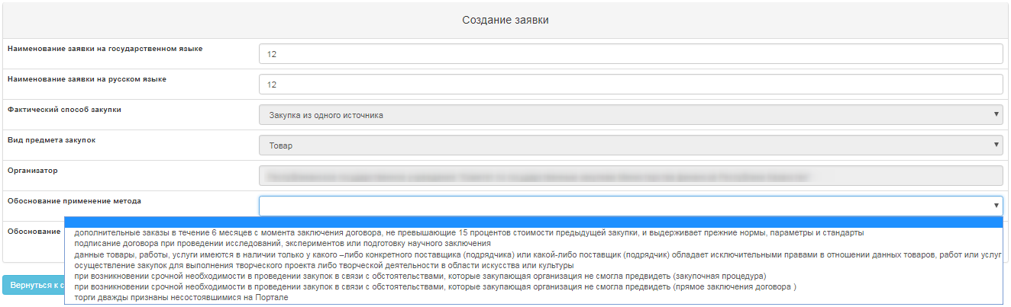

Create an announcement
To create an announcement you should go to the "Personal account" section and select "Create announcement". Available to a user with the "Facilitator" role.
Next, you will see a form for creating a draft of announcement.
Section "Creation of a draft of announcement" contains the following fields and buttons:
Item | Action
Type of procurement item | Filled in manually. One of the values is selected:  Work;  Service;  Goods.
Title of (procurement) announcement in the Tajik | Filled in manually
Title of (procurement) announcement in the Russian | Filled in manually
Title of (procurement) announcement in the English | Filled in manually
Indication of purchase | If the bidding is required for procurement among the organizations of domestic manufacturers, a check mark should be placed on the line with this indication.
Next | When clicking the button, the System shall check for filling in all mandatory fields
If the bidding is required among the organizations of domestic manufacturers it is necessary to put an indication - "domestic producer" in the draft of announcement.
After you fill in all the fields, click "Next".
Note. After you move to the next step, the system automatically saves the announcement in the status "Draft" in the section "Work Office" - "My announcements (organizer)":
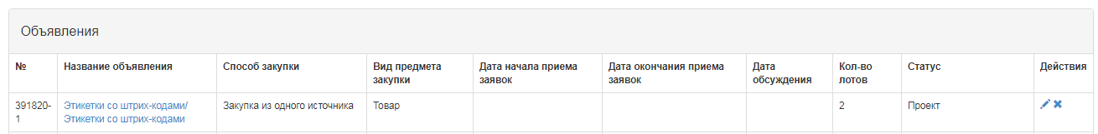
The icon allows to edit, the icon allows to delete announcements with the status "Draft" when you click "Next", lots that meet the specified criteria by method, item type, and purchase indication are displayed. It is necessary to mark Lot (s) and click "Add selected" button:
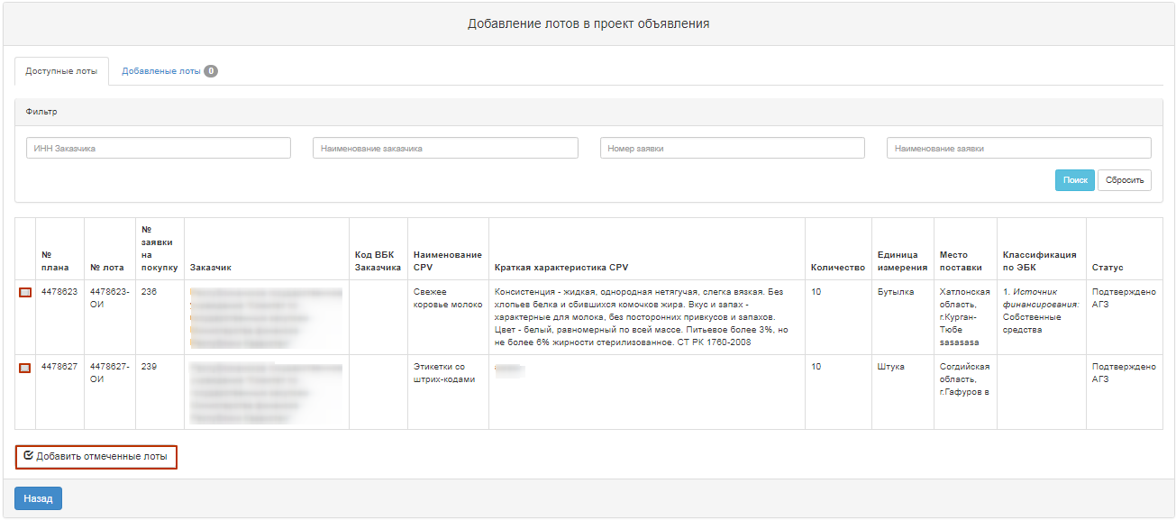
To select a lot, you shall mark the required lot and click "Add marked lots" button. Then you go to the added Lot view page. If you want to delete selected lot, mark required lot with a check mark and click "Delete marked Lots" button, and if you want to add lots to the purchase project, go to the "Available Lots" tab and perform selection of additional lots. To go to the next page, click "Next".
When navigating, the vendors that were added when the customer created the bid are displayed.
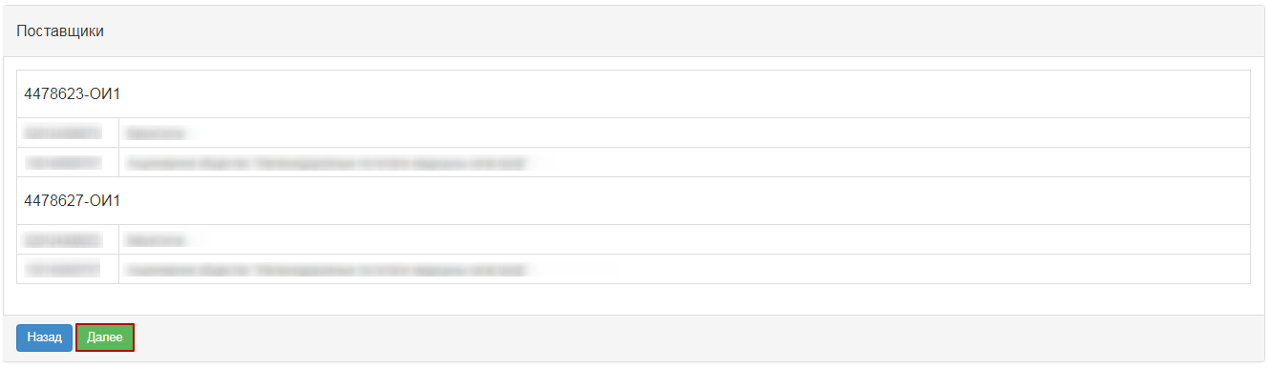
To add additional vendors to send an invitation to procurement, you must navigate "Next" and click the "Add" button next to the lot that you want to send the invitation on.
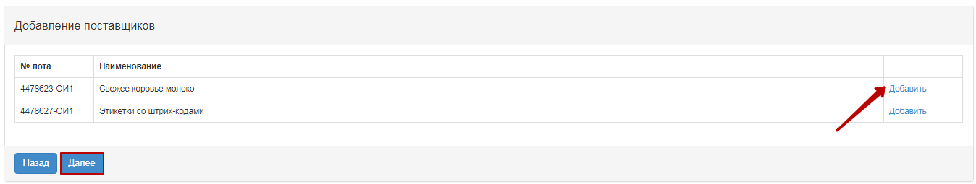
When clicking the "Select" button the organization search form opens. Search is available by the company's INN and name.
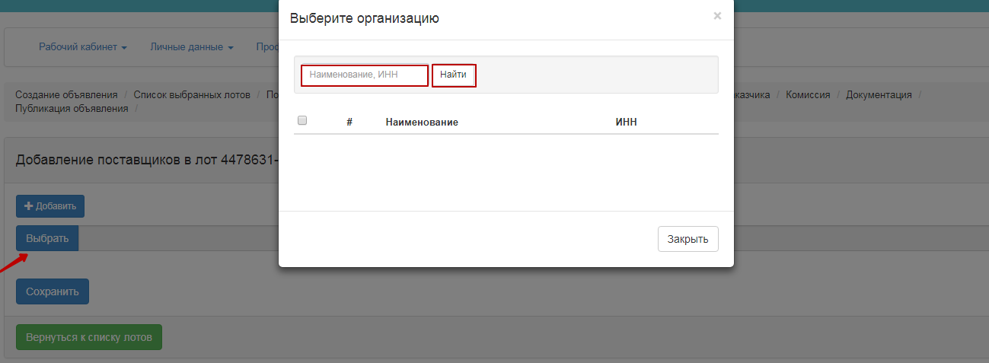
If adding additional vendors is not required, click "Next"
"Enter data by lot" section contains the following fields:
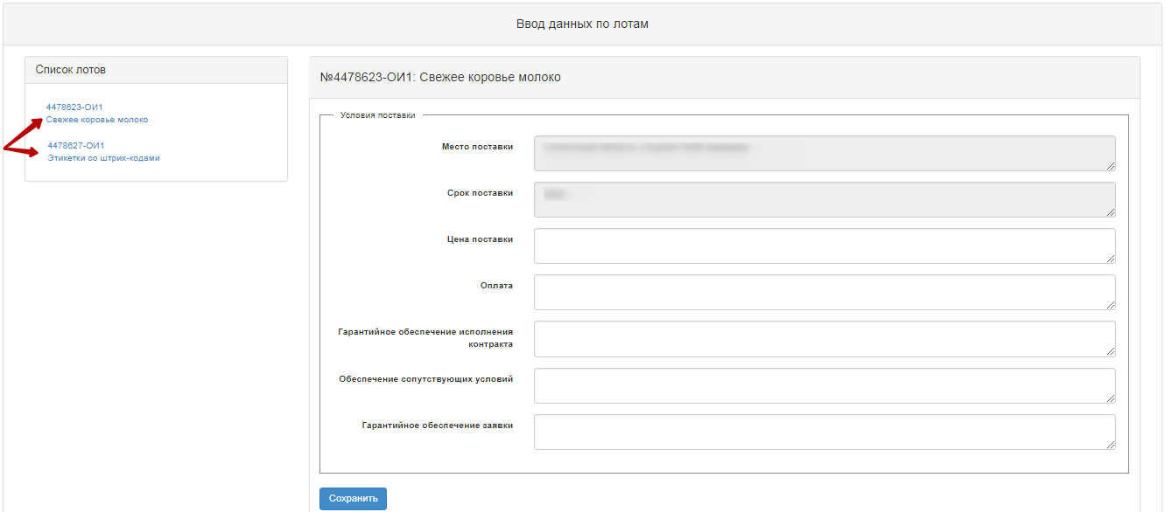
Place of delivery | Automatically filled in by the system from the annual plan item
Delivery Period | Automatically filled in by the system from the annual plan item
Price of delivery | Filled in manually
Payment | Filled in manually
Contract Performance Guarantee | Filled in manually
Related Services | Filled in manually

Adding Commission
The next step in creating a draft announcement is to add the Commission.
Minimal composition of the commission - the Chairman and two members of the commission. Odd number.
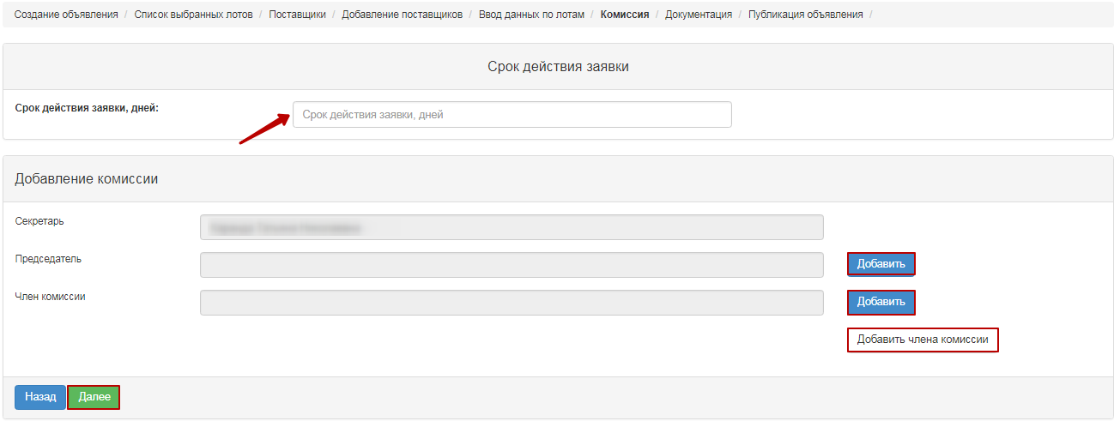
"Add" button to select a commission member. A pop-up window appears. Search may be performed by following filtration parameters values:
Adding a member of the Commission is carried out by clicking the "Add commission member" button.

Preparation of documentation.
"Document Preparation" step displays a list of required documents to participate in the bidding according to the rules for conducting public e-procurement. To view information about a document, click its name in the "Document Name" field.
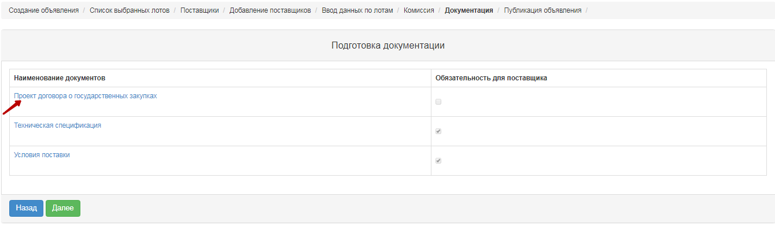

Generating Technical Specification
To go to the "Technical Specification" section, in the general documentation list click the active hyperlink "Technical specification". It is necessary to confirm the file of technical specification that describes the goods, work, or services, for this you should click the active link on the lot line "View".
The new window displays the system-generated technical specification from the bid for the bidding. If the Organizer needs to change Technical Specification prepared by the Customer, it is necessary to:
When you click "Edit", a window is displayed for editing in the state and Russian languages.
After amending it is necessary to confirm by clicking the "Reforming the file" button. If no changes are required, you can use the "Go Back" button to exit without modification.
When you approve Technical Specification Document, the system fills in the confirmation date.
For items of a service or job, click the "View" button to display the following window:

If necessary, you can delete attached technical specification and/or add another technical specification file.
If you add a new file using the "Select File" button, a window opens to find the file you want. After the file is selected, open it, and then click "Save".
If you add a new file using the "Select from Storage" button, a window will open with previously downloaded files in the participant profile - File directory. After you select the file, you should "Save" it.
To return to the shared document list, click the "Go Back" button.

Formation of a draft agreement.
To review the draft contract in the purchase creation form, click the "View draft contract" link button.
If necessary, you can delete attached draft agreement and/or add another file.
If you add a new file using the "Select File" button, a window opens to find the file you want. After the file is selected, open it, and then click "Save".
If you add a new file using the "Select from Storage" button, a window will open with previously downloaded files in the participant profile - File directory. After you select the file, you should "Save" it.
To return to the shared document list, click the "Go Back" button.

Generate the "Delivery terms" document.
At the step "Preparation of Documentation" click the active link to "Delivery terms". In the pop-up window, you need to "Confirm", and then close the window.

Pre-review of the announcement.
The form of "Announcement Preview" contains general information on the purchase, information about the Facilitator, and the comission.
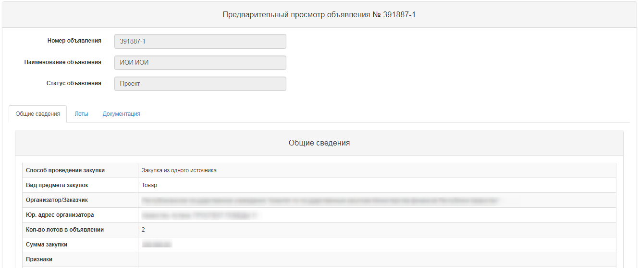
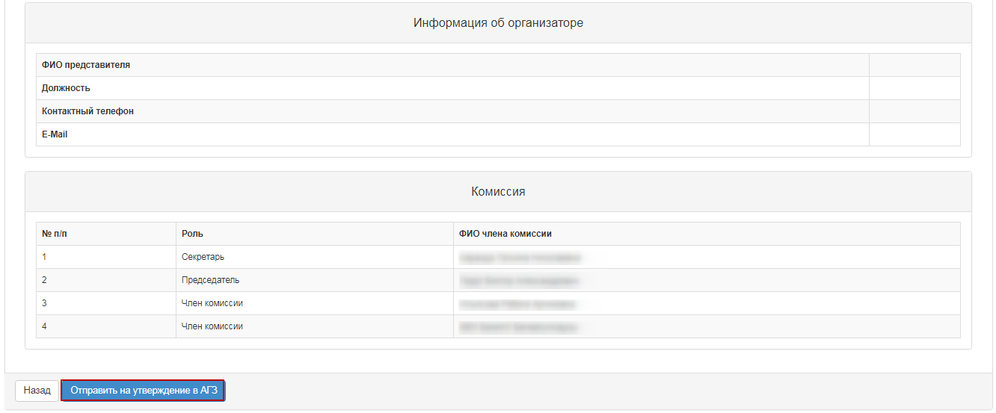
Note. On procurement, which is organized by Qualified procuring Enterprises (QPE) concerning the methods of procurement in "Request for Quotation", "Limited Bidding", "Unlimited Bidding", "Single Source Procurement", draft of bidding document should be agreed with the Public Procurement Agency (RT PPA).
For procurement, organized by the RT PPA no approval is required.
When you click the button "Submit for APP approval", the system displays a pop-up window that requires you to confirm the action.
If a publication is successful, the status of announcement is set as "On PPA Approval".
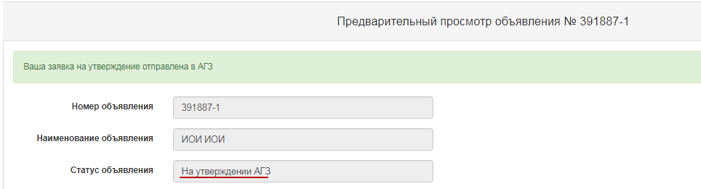
System sends a notification to users with the role "Approval of announcement" on the need to approve the announcement.

Approving the draft announcement
In the event that the purchase was refused in agreement, the purchase is assigned the status "Rejected by the RT PPA" with subsequent possibility of editing by Secretary of the announcement.
The Secretary should go to the "Personal account" - "My announcements" (Organizer).
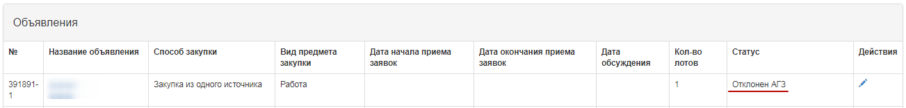
When you click the icon, a pre-review of announcement is displayed, and the reason for the rejection is listed at the bottom.
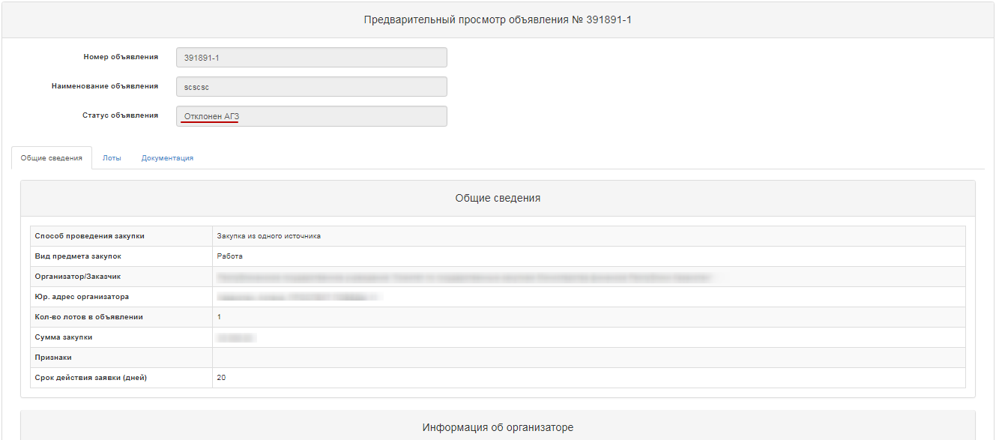
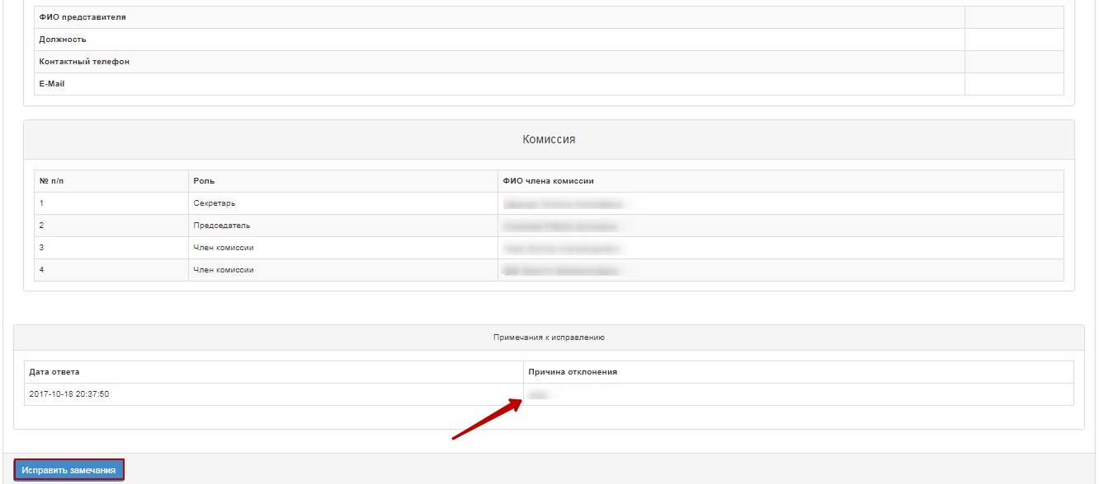
After you select "Correct comments", you will see a pop-up window with the need to confirm the action.
If you select the "Approve" function, the purchase is assigned the status "Approved by the RT PPA".
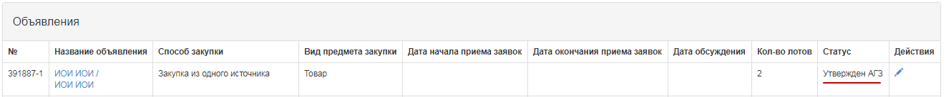
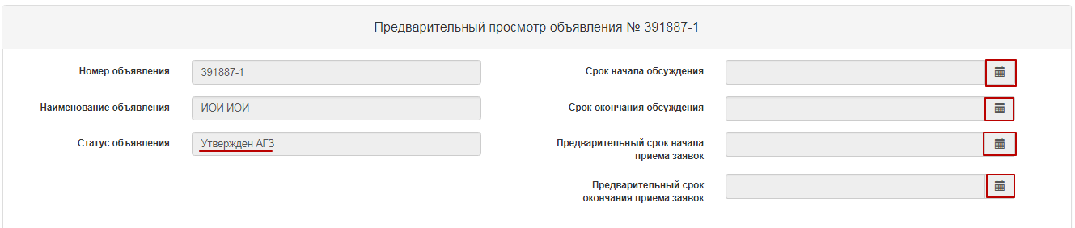

Publish announcement
When you click the icon, a pre-review of announcement and the "Publish" button is displayed. In this form, it is required to specify the start and end deadlines for call for bids, and the due date for the documentation discussion.
When a deadline is specified, system checks:
- Start of the discussion should be at least the announcement publication date;
The end of the discussion is not earlier than the start date for the discussion. There are no time requirements (days).
- The deadline for receiving requisitions must be at least the end date of the discussion;
- Deadline for receiving bids is no less than the call for bids start date. There are no time requirements (days).
If a publication is successful, the status of announcement is set as "Published". Otherwise, the system issues an error message.
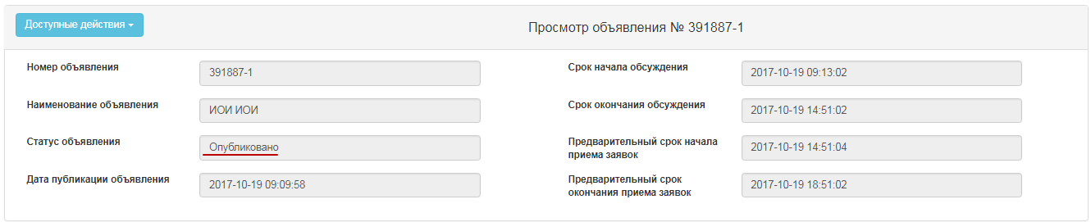

Extension of the deadline for submision of bids.
The Secretary in the form of announcement view has the action "Extension of the bidding" for the bidding with statuses "Published", "Published (acceptance of the bids)".
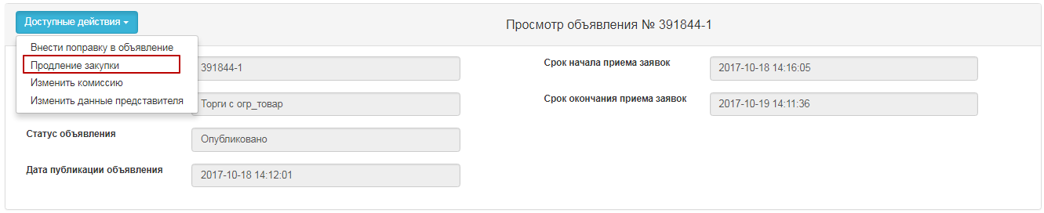
By clicking on the button "Extension of the bidding", the Secretary is given the opportunity to enter data in the filed "Reason for extension of the bidding", which is mandatory.
After that, the system displays a success message.
Note. In case of extension of the bidding in the announcement with the status "Published, acceptance of the bids", after changing the deadline for receipt of bids, the system sends an extension notice to the members of the Commission and to the vendors who applied for participation.
Note. The system allows changes to be made only to the bid submission deadline term, and the start date remains unchanged.

Discussion of documentation
In the event that there are comments on the documentation draft, as well as requests for clarification of the documentation provisions, vendor may write a message to Facilitator within the period of discussion.
Notifications of incoming requests come from the Secretary, members of the Commission. To view requests from vendors, go to the "Document Provisions Discussion" tab, click on the subject of the message.
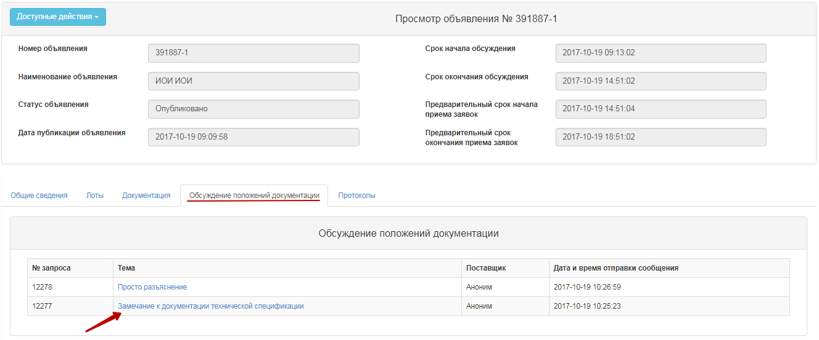
Message text is displayed. All discussion messages from vendors are displayed anonymously automatically.
To respond to the request, click the "Provide response" button
Attention! "Provide response" button will be available only after the documentation discussion period has expired.
Response to a vendor request can be made only once by the members of the Commission. When the button is activated, a menu is displayed to select the decision.
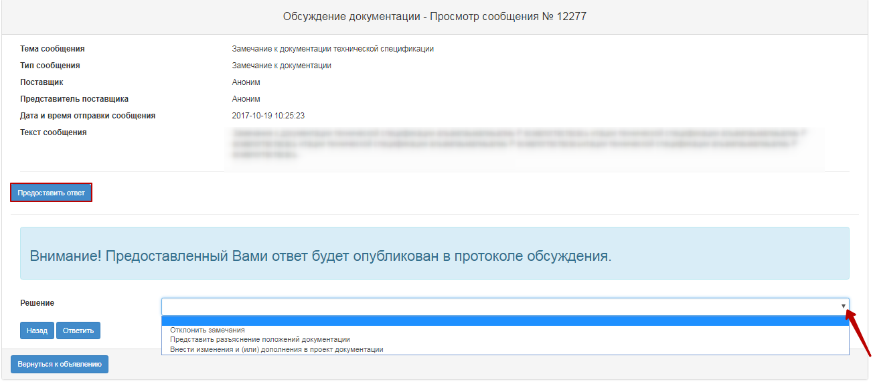
Select one of the following values from the drop-down list:
- To amend and/or supplement the draft documentation;
- Reject comments;
- Clarify the provisions of the documentation.
If you decide to reject the comments or provide a clarification of the documentation provisions, you must fill in the mandatory "rejection reason/explanation text" field.
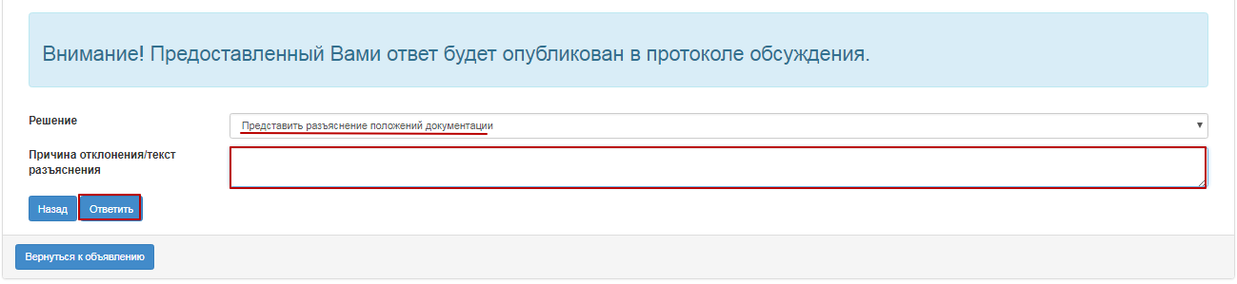
After you specify the solution, click "Reply". System displays a pop-up window that requires to confirm the action.
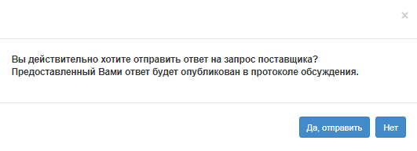
Secretary may edit the responses provided in the query preview form using the "Edit" button if the discussion protocol has not yet been generated.
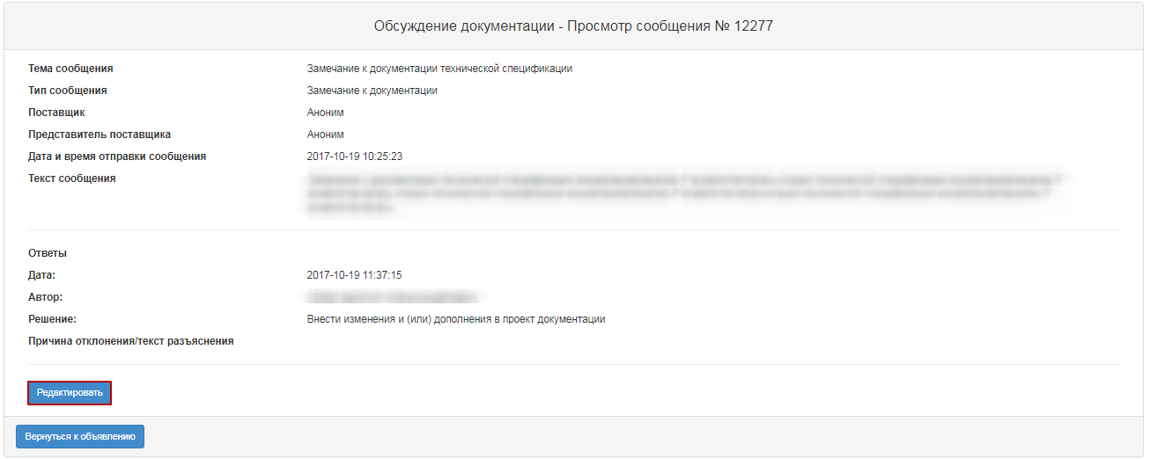

Description of the "Complete documentation discussion" button
If you have responded to all requests from vendors, Secretary will activate the documentation discussion completion on the "Document provisions discussion" tab.
To proceed with the purchase, click on the "Available Actions" "Complete the documentation discussion" section.
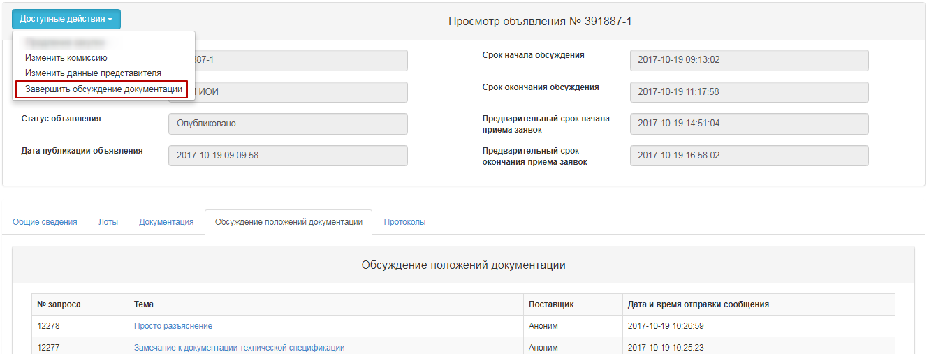
Next, you must confirm the action.
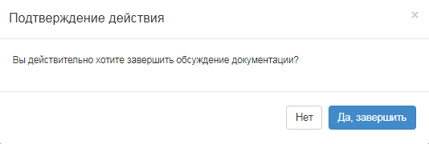
After the discussion is complete, the Protocols tab displays the Discussion Protocol.
Discussion protocol can only be deleted by the Secretary until confirmation if necessary. After protocol is deleted, you will be able to edit the responses to the queries. To download and view the protocol, you must click the active link of the document. To approve, click the "Approve File" button.
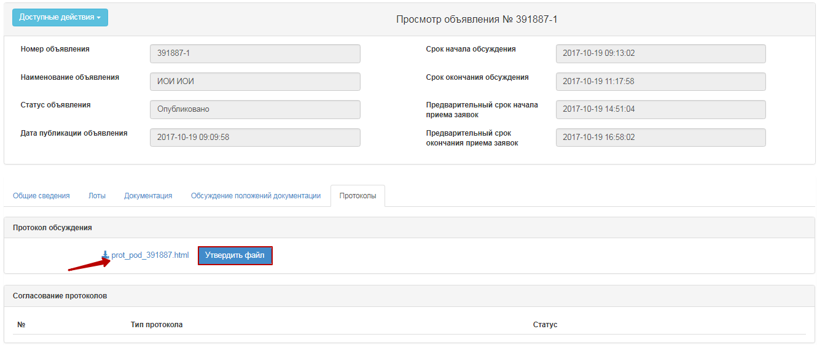
Next, you will see the "Publish" button active on the "Protocols" tab of the Secretary.
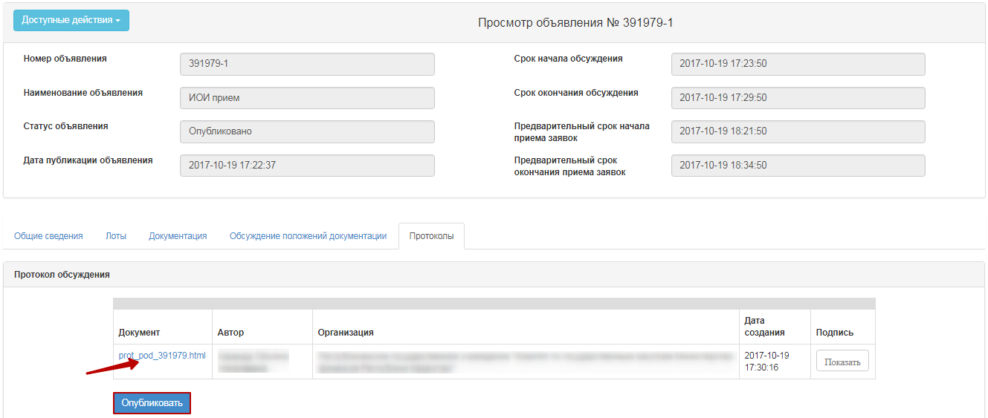
ATTENTION! In the event that a decision has been made to amend or supplement the draft documentation after the publication of the discussion protocol, system automatically creates a purchase draft with index 2. Original announcement (with index 1) is assigned the status "Modified documentation". Preview form displays a notification that a decision has been made on the announcement, with links to announcements, and an option to download the discussion protocol.
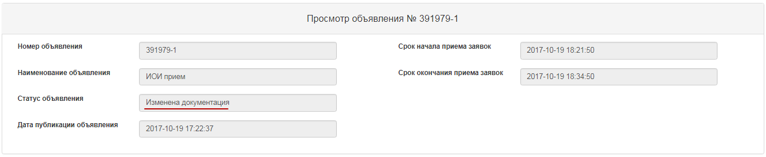
To make changes to the announcement draft, you need to go to the "work account" - "My Announcements" section, search for the announcement, and click the icon .
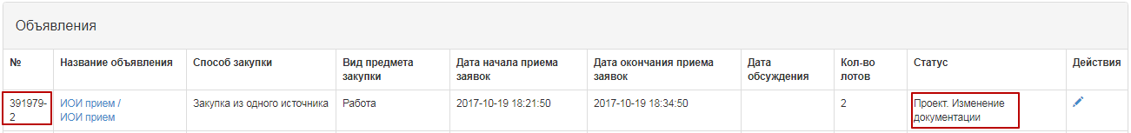
The system displays the form of editing the announcement.
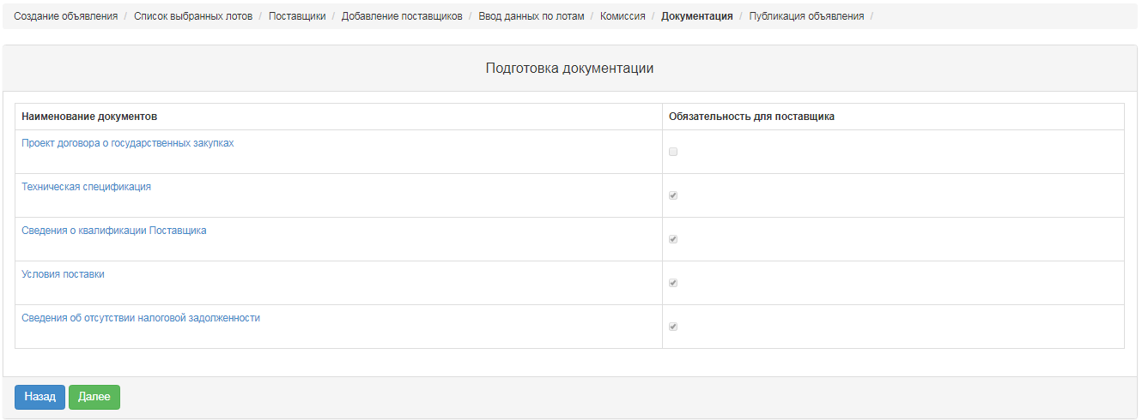
To go to the previous step, click the "Back" button.
Advertisement secretary is allowed to modify the following information in the draft announcement:
- Members of the Commission;
- Deadline for the call for bids;
- Documentation.
Note. Вocumentation must be reapproved.
After changes are made to the draft announcement, approval and publication of the announcement is similar to items (see Preview the announcement, negotiate the draft announcement, and Publishing the announcement).
Note. When publishing announcement, after changes are made to the vendor request documentation, deadline for call for bids is the current date and time (cannot be edited).
Note. In the event that no requests have been received from vendors during the discussion of the documentation, discussion protocol is generated and published automatically by the system when the discussion ends. This protocol is located on the "Protocols" tab.
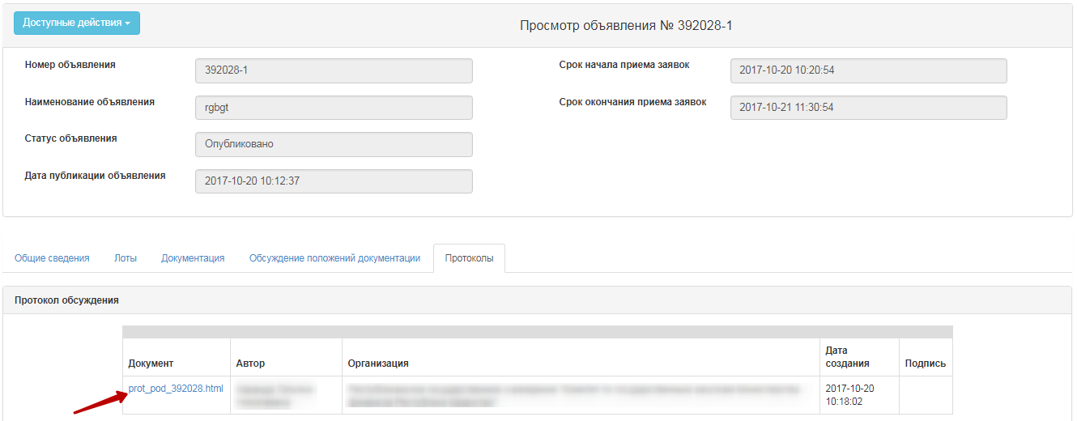
System changes the name of the "Preliminary call for bids start time" fields to "Call for bids start time" and "Preliminary call for bids expiration time" for the "Call for bids expiration of applications". When call for bids begins, status of the announcement changes automatically to "Published" (call for bids).

Bidding Opening
The system automatically uncovers the Bidding when the deadline for submission of bids expires:
• If there are submitted bids from vendors for at least one lot in the announcement, the system changes the status of the announcement, lot(s) and bids of suppliers to "Consideration of the bid" and sends notification to the suppliers that submitted bids, the secretary, commission members in the private office and mail about the publication of the Bid opening protocol.
• If a vendor has applied for a price quote above the amount that is allocated, the system will let the bid through, but at revealing automatically rejects it, and in the revealing/summary protocol, the status of "Rejected by the Web portal" with the reason "Vendor proposal exceeds the amount that is allocated for purchase."
• If there are no submitted bids for at least one lot from vendors to participate in the procurement, the system automatically generates and publishes the summary protocol. The system sends notification to the suppliers who submitted their bids, to the secretary, to the members of the commission in their private office and to e-mail.

Consideration of bids
By the end of the deadline for the submission of bids to the members of the Commission, the system will automatically send notification of the need to review vendor requests. To transit to the Notifications section, you should open the "Participant profile" menu.
You can also view notifications by clicking the icon in the upper right corner of the page. To view all notifications, click the "All Notifications" link.
Transition to the announcement can be done from the notification by a link or go to the section "Personal account", and select the menu "My announcements (Facilitator)".
To review the bids submitted by suppliers, on the form of viewing the announcement in the section "Available Actions" in the list select "View the bids".
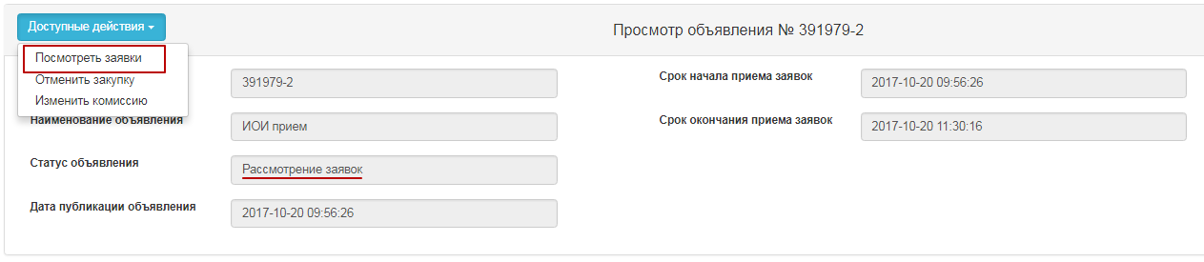
To view information about vendors who have submitted bids for the procurement, click the Bid Number link.
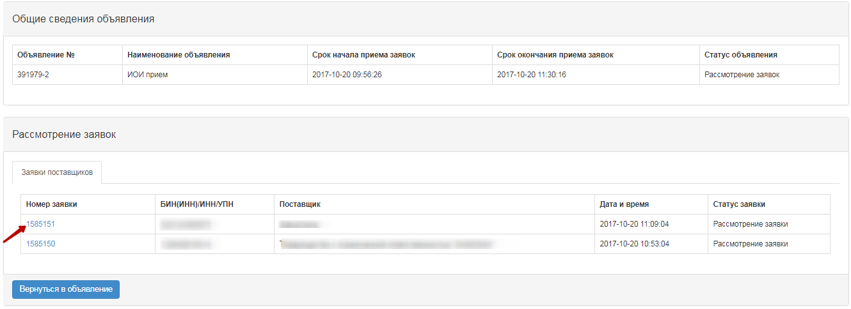
In the "Vendor Details" tab, the name, details, vendor address and information about the supplier's representative are indicated.
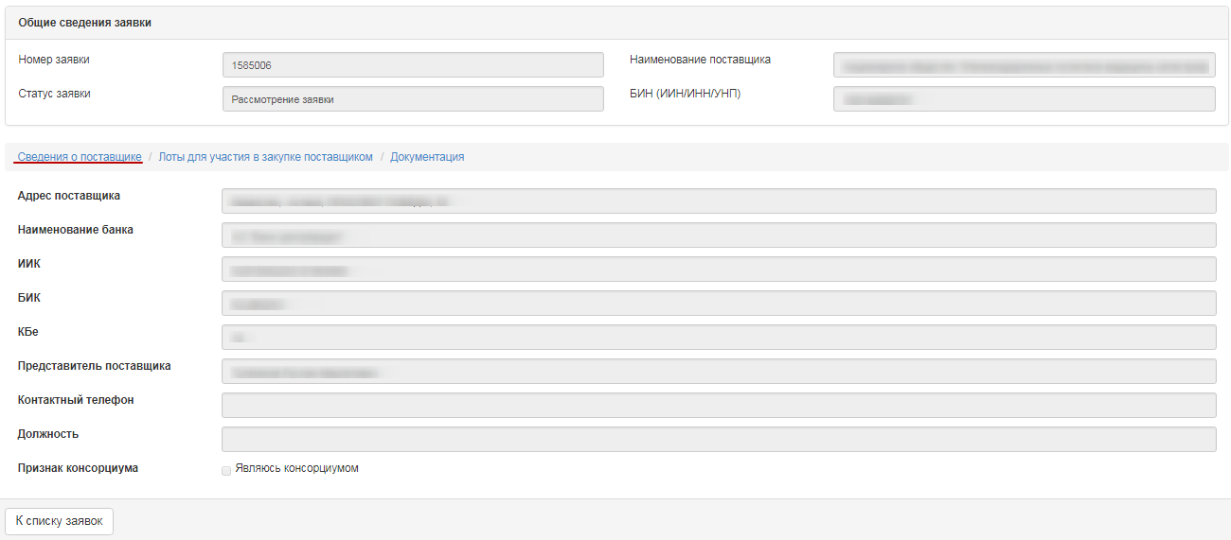
In the "Lots for participation in procurement by the vendor" tab, lots are placed for which the vendor submitted its bid.
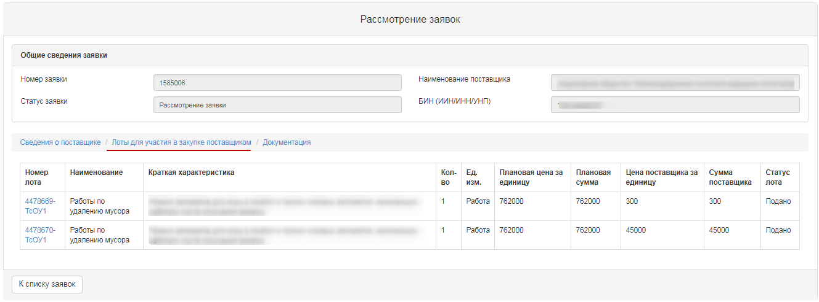
"Documents" tab provided by the vendor are placed in the "Documentation" tab. The line with the document name the number of files that have been attached is indicated. It is necessary to click the section name to display the attached files. To view and download the document, you should click the active link for the document name.
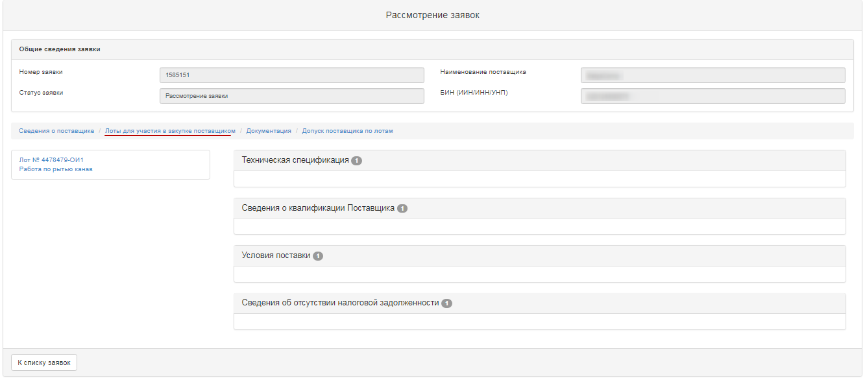
To vote on Admission / Rejection of the vendor, go to the tab "Admission of vendor by lots".
Admission of vendor by lot includes categories:
- Compliance with technical specification requirements
- compliance with the Price
- Compliance with terms of delivery
-Compliance with article 19 of the Law of the RT "on public procurement of goods, works and services"
The category "conformity with article 19 of the Law on public procurement of goods, works and services" contains the following sub-categories:
- Failure to fulfill its obligations at least in one public procurement contract within two years prior to commencement of the procurement procedure;
- Declaration of bankruptcy or being in the process of bankruptcy;
- submission of false information, distortion of facts, deception of their qualifications;
- Providing substantive or incomplete information on their qualifications.
To make a decision by category, you should select one of the following values from the drop-down list "Made decision":
- Admit
- Reject
If you select "Reject", you must fill in the reason for the rejection.
Attention! In the event that the Facilitator has taken a decision to "Reject" in sub-category 3 of compliance with Art. 19 (submission of knowingly false information, distortion of facts, misleading about their qualifications), system automatically applies this decision to all lots in which vendor participates.
In case of deviation by subcategory 1,2,4-deviation is made for each lot.
After the decision on all categories is accepted, it is required to press the button "Save draft" After saving the solution, line with the section will display the accepted decision (Accept, Reject).
To end voting on all lots, you need to click on the "Send the Vote" button.
Attention! Before the end of voting, the system gives the opportunity to withdraw its vote using the function "Recall the Vote".

Control over consideration of bids
The secretary on the announcement viewing form with the status "Consideration of bids" / "Consideration of bids (clarifications)" has the functional for monitoring the voting process. To use this functional, in the "Available Actions" section, select the item "View the bids".
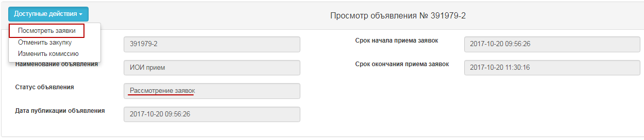
To view the voting information, it is necessary to go to the "Voting Control" tab and click on the line with the lot number.
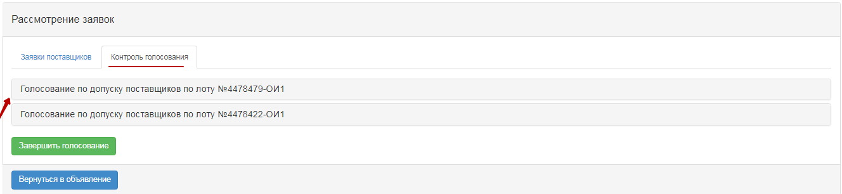
The system displays the following form with a list of bids.
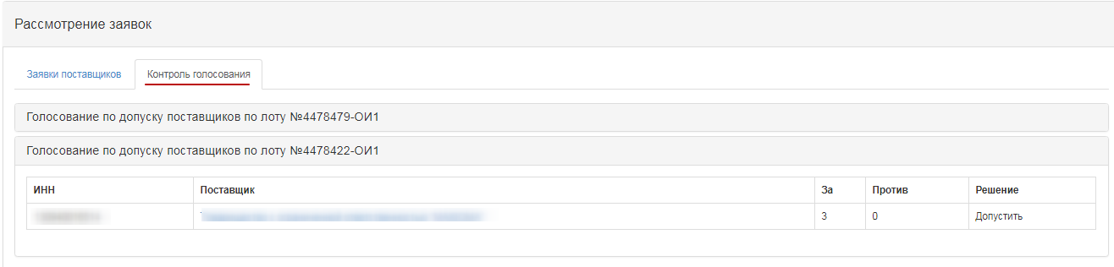
The Solution field indicates
- Admit
- Reject.
"For" field contains information on the number of bidding commission members who allowed a potential vendor to participate in the purchase on the lot for which it applied a bid. "Against" field contains information about the number of bidding commission members who did not allow the potential vendor to participate in the purchase on a lot, to which it applied a bid.

Conclusion of the voting
To complete the voting, the secretary should select "View the bids" in the "Available Actions" field.
Then you need to go to the tab "Control of Voting". If there is a quorum of votes, the "Completion of voting" button is available on the "Voting Control" tab.
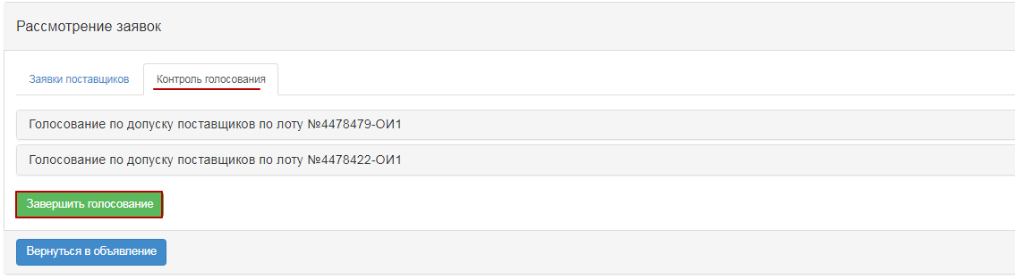
Once the voting has been completed, it is possible to resume the voting by means of an appropriate button.
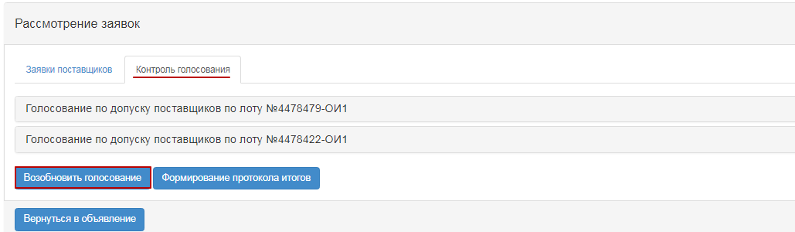

Formation of final protocol
To form the summary protocol the Secretary on the form for viewing the announcement with the status "Consideration of bids" / "Consideration of bids (clarifications)", in the section "Available actions", select the item "View bids".
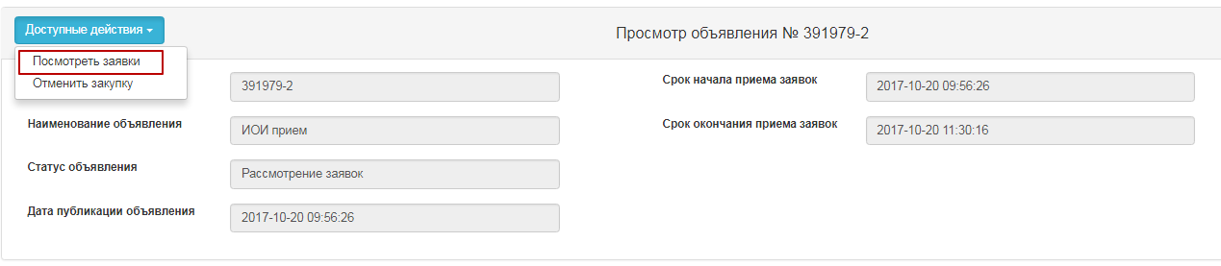
Then go to the tab "Voting control" and click on the button "Formation of the final protocol".
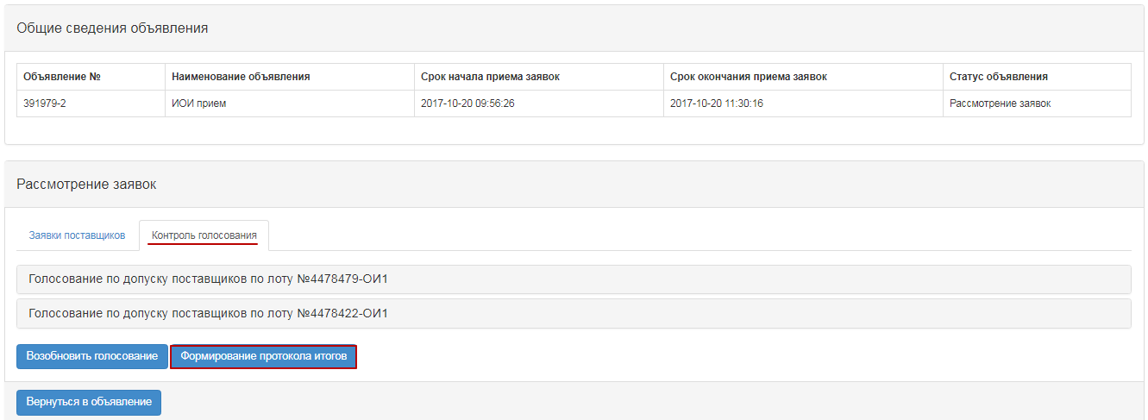
After choosing the action "Generate final protocol", the statuses of the bids, lot (s) and announcements will be changed to "Formation of the final protocol".
As a result, the log file will be created in the state and Russian languages on the form of viewing the announcement in the "Protocols" tab.
Secretary of the announcement and the members of the Commission should approve the protocol.
Attention for QPE! After clicking on the button "Send for approval", the final protocol will have the status "On approval".
System sends a notification to the users of the RT APP with the role of "Protocols sign-off person/user" about the need to approve a summary protocol.
Attention for RT PPA! In the event that the purchaser is the RT APP, there is no need to approve on a summary protocol. Once the summary protocol is approved by the Secretary and voted members of the Commission, the "Publish Summary Protocol" button becomes available to the Secretary.

Approval of final protocol
Information on agreement of summary protocol is displayed in the announcement, the "Protocols" tab.
If the employee with "Protocols sign-off user/person" role makes a positive decision, system displays the summary protocol with the status "Approved". The Secretary will be able to publish summary protocol.
If the employee with "Protocols sign-off user/person" role makes a negative decision, system displays the summary protocol with the status "Rejected". And the "Purchase Cancel" will be available to the Secretary.
When you click on the "View Decision" button, information is displayed on the summary protocol sign-off persons/users, there is also an active link for downloading the document attached by RT APP at the approval.
In the final protocol with the status "Rejected", the reason for the rejection is additionally displayed.

Publication of final protocol
Generated summary protocol is displayed in the announcement in the protocols tab. On the form of review, the Secretary has the functionality to publish the protocol:
- if the approval of the summary protocol is not required by the RT APP;
- if it is required to agree the final protocol with the RT PPA and the status of the protocol "Agreed".
After clicking on the button "Publish summary protocol", the status of the announcement is changed to "Completed". "Protocols" tab displays the active link for downloading summary protocol.
Note. Public procurement is considered to be valid if at least one bid of a potential supplier is eligible for participation by lot. At the same time, a potential vendor whose bid for participation is the only one admitted is recognized by the web portal as the winner in these public purchases.

Modification of the Commission
"Change Commission" action is available to the Secretary in the announcement view form with the status "Published", "Published call for bids", "Published (Request for clarification)", "Draft. Change of documentation", "Consideration of bids", "Consideration of bids (clarifications)".
After completing this action, form for the Auction Commission change form is displayed on the screen.
To change the commission member, click the "Change" button. You can add a new member to the Commission by using the "Add Commission member" button, and you can use the button to delete it. "Decision number", "Decision date" fields are required. To save your changes, you must attach a file that is the basis for the Commission change, and click "Save Changes".
Note. If the status of the announcement and lot is "Consideration of bids", but the voting has been completed, that is, the voting status of vendors bids by lots "Admitted and/or Rejected", system does not allow for modification of the Commission.

Cancel of the Purchase
Purchase cancellation functionality is available from the time the announcement is uncovered before the creation of the contract in announcements with the status of "Review of bids", "Generation of the summary protocol", "Conditional discount fill", and "Completed".
In order to cancel the purchase, the Secretary needs to select the "Cancel the purchase" action in the list of actions in the announcement view form.
Cancel of the purchase is possible for the entire purchase, as well as for individual lots, if there are several lots in the purchase. After this action is completed, a warning message is displayed.
When you click the "No" button, the system returns to the purchase review form. To cancel, click "Yes" to display the lot selection form.
The choice of lots is carried out by putting a tick in the line with the lot, then you need to click on the "Cancel the purchase for selected lots" button.
A cancel form appears where it is necessary to attach the scanned electronic document that is the basis for cancellation and fill in the information on the basis for cancellation.
The purchase cancellation form contains the following fields:
Field name | Field value
Solution number | The field is text and is available for manual input. An act number must be entered in this field.
Resolution Date | This field shows the date on which the relevant act was issued, and is filled in by using the "Calendar" icon.
Act | Select from the drop-down list the position of the directory of the types of acts with the values:  - Resolution;  - Definition;  - View;  - Notification;  - Decree  - Order  -Order
- Authority | In this field, an authority from the directory of authorities with the values shall be selected:  - Judicial authority;  - Prosecutor's office;  - State finanacial control authority.  - Customer  - Authorized Body
- Name of the Authority | The field is text and is available for manual input. In this field, you should specify the full name of the authority.
Select a File | The button is used to attach a document that is the basis for the cancellation.
Attention!
Note for QPE: On procurement, which is organized by qualified procuring entities (QPE) on "Request for quotation", "limited bidding", "unlimited bidding", "single source" procurement methods, it is necessary to agree on the cancellation of purchase with the Public Procurement agency (PPA RT) by clicking the "Submit for PPA approval" button
For the QPE organizer, if there is a generated, but unpublished, pre-admission /final protocol and an application for cancellation of procurement is sent to the PPA, the system will not allow to publish this protocol.
For the QPE organizer in the case where the pre-acceptance /final protocol is sent to agreement with the PPA, but the organizer performs cancellation of the procurement, the system automatically removes the request for protocol approval and sends only the cancellation request.
For the QPE Facilitator in the event that a pre-acceptance / final protocol is not in place, but there is an application to cancel the procurement, system prevents the secretary from forming protocols.
Note for the RT PPA: For procurement, the Facilitator of which is the PPA, no approval of procurement cancellation is required.
After filling in all fields and attaching the file, click the "Cancel Purchase" button. System will automatically decide to cancel the bid/lots
Note for all: When you cancel all lots, the purchase automatically generates a summary protocol that indicates the reason for cancellation, at any stage of the announcement. If the purchase has multiple lots, when one lot is canceled, the lot status changes to "Canceled", and the protocol, after it is published, specifies the reason for the cancellation of this lot. Also, canceled lot is returned to the pool to publish new purchase.
System sends a notification to users with the "Approve Cancellation" role to approve purchase cancellation.
Information on the lots that are being produced or canceled is displayed in the "Review/Cancel" tab of the announcement form.
Decision on approval may be made:
-Approved
-Rejected

